SOLID-LIQUID EXTRACTION OF HEAVY METALS IN AQUEOUS SOLUTIONS USING CHELATING LIGANDS ANCHORED ON SOLID SUPPORTS

IAN THARAU KABOGO (BSc)

A THESIS SUBMITTED IN PARTIAL FULFILLMENT OF THE REQUIREMENTS FOR THE AWARD OF THE DEGREE OF MASTER OF SCIENCE IN CHEMISTRY OF THE UNIVERSITY OF EMBU

AUGUST, 2024

DECLARATION
This thesis is my original work and has not been presented elsewhere for a degree or any other award.
Signature……………………………………… Date……………………………
Ian Tharau Kabogo
Department of Physical Sciences
B523/1491/2021

This thesis has been submitted for examination with our approval as the University supervisors.

Signature……………………………………… Date………………………
Dr. Simba Nyamato
Department of Physical Sciences
University of Embu

Signature……………………………………… Date………………………
Dr. Joanne Ogunah
Department of Physical Sciences
University of Embu

Signature……………………………… Date…………………….
Prof. Stephen Ojwach
School of Chemistry and Physics
University of KwaZulu-Natal

DEDICATION
I dedicate this thesis to my God, Who’s grace, favor and goodness has seen me through this entire journey. To my family, whose unwavering support and encouragement have been my driving force throughout this journey. To my mother, Eunice Kabogo, who has been my rock and pillar of support during challenging times. To all my friends, for their consistent and constant belief in me. Additionally, to all those who have inspired me along the way, this work is a testament to your impact and input in my life and academic pursuits.

ACKNOWLEDGEMENT
I would wish to thank my God for sufficiently giving me the strength and virtue to conduct this research. I would also like express my deepest gratitude to my research mentor and advisor, Professor Stephen Ojwach, for his invaluable guidance, encouragement, tutelage and unwavering support throughout this research endeavor. I’m also indebted to my supervisors, Dr. George Nyamato and Dr. Joanne Ogunah, for their expertise, insights and support which have been very instrumental in my research journey. Special thanks to Alphonsine Mukherezi, Esther Wanjiru, Francis Migwi, Judith Kibue, Lucy Karanja, Saniksha Somaru and Siphosethu Maqinana, for their immense support during this challenging yet rewarding journey. Lastly, I would like to acknowledge the support of the University of Embu, Kenya, School of Chemistry and Physics of the University of KwaZulu-Natal, South Africa, and Fachbereich Chemie, RPTU Kaiserslautern-Landau, Erwin-Schrödinger, Kaiserslautern, Germany, whose financial assistance and technical support made this research plausible.

TABLE OF CONTENTS
DECLARATION ii
DEDICATION iii
ACKNOWLEDGEMENT iv
TABLE OF CONTENTS v
LIST OF TABLES vii
LIST OF FIGURES viii
LIST OF SCHEMES x
LIST OF APPENDICES xi
LIST OF ABBREVIATIONS AND ACRONYMS xii
ABSTRACT xiii
CHAPTER ONE 1
INTRODUCTION 1
1.1 Background of the study 1
1.2 Statement of the Problem 2
1.3 Justification 3
1.4 General Objective 3
1.4.1 Specific objectives 3
1.5 Hypothesis 4
1.6 Scope of the study 4
CHAPTER TWO 5
LITERATURE REVIEW 5
2.1 Heavy metals 5
2.2 Removal of heavy metal cations by chelating agents 7
2.2.1 Silica Support 8
2.2.2 Zeolite/clay support materials 12
2.2.3 Polymer support 13
2.2.4 Magnetic nanoparticles 14
2.2.5 Chelated metal-organic frameworks 16
CHAPTER THREE 18
3.1 MATERIALS AND METHODS 18
3.1.1 Materials and chemicals 18
3.1.2 Synthesis of functionalized Schiff base ligands 18
3.1.3 Immobilization of Schiff base chelating ligands on SBA-15 19
3.1.4 Characterization 20
3.1.5 Adsorption experiments 20
3.1.6 Data analysis 23
3.2 Results and Discussion 23
3.2.1 Synthesis of functionalized Schiff base ligands 23
3.2.2 Incorporation and characterization of immobilized SBA-15 26
3.2.3 Adsorption studies 32
3.2.4 Adsorbent-metal interactions 42
3.3 Conclusion 46
CHAPTER FOUR 47
4.1 Experimental section 47
4.1.1 Materials and chemicals 47
4.1.2 Preparation of Fe₃O₄ MNPs 47
4.1.3 Immobilization of Schiff base chelating ligands on MNPs 47
4.1.4 Adsorption experiments 48
4.1.5 Data analysis 48
4.2 Results and discussion 48
4.2.1 Synthesis and characterization of immobilized MNPs 48
4.2.2 Adsorption studies 54
4.2.3 Adsorbent-metal interaction 64
4.3 Conclusion 68
CHAPTER FIVE 70
CONCLUSIONS AND RECOMMENDATIONS 70
5.1 Conclusions 70
5.2 Recommendations 70
REFERENCES 71

LIST OF TABLES
Table 1: Standard levels of some selected heavy metals in drinking water in mg/L 6
Table 2: Multi-adsorbate adsorption isotherms 21
Table 3: Multi-adsorbate adsorption kinetic models 22
Table 4: The physical properties of SBA-15 immobilized systems 29
Table 5: % Removal efficiencies by variation of pH 32
Table 6: % Removal efficiencies by variation of initial metal concentration 34
Table 7: Separation factor (RL) values for the sorption of metal cations based on Langmuir isotherm 34
Table 8: Adsorption isotherms and their respective parameters 36
Table 9: % Removal efficiencies by contact time variation 38
Table 10: Kinetic models and other statistical parameters 40
Table 11: % Removal efficiencies by adsorbent dose variation 41
Table 12: Physical properties and removal efficiencies of metal cations using different adsorbents. 43
Table 13: Vibration frequencies (cm⁻¹) of various functional groups in L1@SBA-15 to L3@SBA-15 43
Table 14: The physical and magnetic properties of Fe₃O₄ immobilized systems 51
Table 15: % Removal efficiencies of metal cations by variation of pH 53
Table 16: % Removal efficiencies by variation of initial metal concentration 55
Table 17: Separation factor (RL) values for the adsorption of metal cations based on Langmuir isotherm using L1@Fe₃O₄ 55
Table 18: Isotherm models and other statistical parameters of adsorption using L1@Fe₃O₄ 58
Table 19: % Removal efficiencies of metal cations by contact time variation 59
Table 20: Kinetic models and other statistical parameters of adsorption using L1@Fe₃O₄ 61
Table 21: Physical properties and removal efficiencies of metal cations using different adsorbents. 64
Table 22: Vibration frequencies (cm-1) of various functional groups in L1@Fe₃O₄ to L3@Fe₃O₄ 65

LIST OF FIGURES
Figure 1: (a) Sodium thiocarbonate (STC); (b) sodium dimethyldithiocarbamate (SDTC); (c) 2,4,6-Trimercaptotiazine, trisodium salt nonahydrate (TMT); (d) 1,3-benzenediamidoethanethiol dianion (BDET). 7
Figure 2: Schematic diagram representing SPE, SPME and DSPE 8
Figure 3: Silica immobilized chelating ligands for the removal of metal cations from aqueous solution [47]. 9
Figure 4: Silica immobilized salicylaldehyde based chelating ligands for the removal of Pb(II) and Cu(II) cations from aqueous solution [48]. 10
Figure 5: Different silica-based supports functionalized with chelating agents for the removal of Ni(II) cations from plating wastewater [49]. 10
Figure 6: Silica immobilized N^N bidentate ligands for the removal of metal cations from aqueous solution. 12
Figure 7: Clay immobilized triazole(pyridine) chelating agents for the removal of Co(II), Pb(II) and Zn(II) cations from wastewater [56]. 13
Figure 8: Polymer immobilized ambidentate chelating ligands for the removal of metal cations from wastewater. 14
Figure 9: Magnetic nanoparticles immobilized chelating ligands for the removal of Pb(II) cations from aqueous solution and wastewater. 15
Figure 10: Magnetic nanoparticles immobilized N^N-donor chelating ligand for the removal of Pb(II) cations from aqueous solution [71]. 16
Figure 11: Polymer immobilized chelating ligands for the removal of metal cations from water. 17
Figure 12: ¹H-NMR for L1 showing azomethine proton at 8.35 ppm 24
Figure 13: ¹H-NMR for L2 showing the azomethine proton at 8.39 ppm 24
Figure 14: ¹H-NMR for L3 showing the azomethine proton at 8.38 ppm 25
Figure 15: Stacked FT-IR spectra of L1 to L3 showing the υ_{(C=N)} between 1620-1670 cm⁻¹ 25
Figure 16: FT-IR spectra of adsorbents L1@SBA-15, L2@SBA-15 and L3@SBA-15 showing the υ_{(C=N)} and υ_{(Si-O-Si)} resonating between 1630-1650 cm⁻¹ and 1020-1040 cm⁻¹, respectively. 27
Figure 17: TGA and DSC plots, a and b respectively, showing the decomposition patterns of L1@SBA-15 to L3@SBA-15. 28
Figure 18: PXRD patterns of L1@SBA-15 to L3@SBA-15 immobilized systems. 30
Figure 19: TEM micrographs, L1@SBA15 (a), L2@SBA-15 (b), L3@SBA-15 (c). SEM micrographs, L1@SBA-15 (d), L2@SBA-15 (e), L3@SBA-15 (f). 31
Figure 20: % Removal efficiencies of L1@SBA-15 showing the effect of (a)-pH, (b)-contact time, (c)-adsorbent dosage, (d)-initial metal concentration. 33
Figure 21: Linear adsorption isotherm studies for Cr(VI), Cd(II) and Pb(II) cations on L1@SBA-15. Langmuir isotherm (inset, Pb(II) isotherm) (a), Freundlich isotherm (inset, Pb(II) isotherm) (b), Redlich-Peterson isotherm (inset, Pb(II) isotherm) (c) and Temkin isotherm (inset, Pb(II) isotherm) (d). 37
Figure 22: % Removal efficiency for different metal cations using L1@SBA-15 to L3@SBA-15. 42
Figure 23: Nature of coordination (N^N^O, N^N^N, and N^N^S) of the immobilized Schiff base chelating ligands to the metal cations. 44
Figure 24: FT-IR spectra of compounds L1@Fe₃O₄, L2@Fe₃O₄ and L3@Fe₃O₄ adsorbent systems showing υ(C=N) resonating between 1620-1670 cm⁻¹ confirming successful immobilization. 48
Figure 25: TEM micrographs: pure Fe₃O₄ MNPs (a), L1@Fe₃O₄ (b), L3@Fe₃O₄ (c), L3@Fe₃O₄ (d). SEM micrographs, pure Fe₃O₄ MNPs (e), L1@Fe₃O₄ (f), L2@Fe₃O₄ (g), L3@Fe₃O₄ (h). 49
Figure 26: Magnetic properties analysis of MNPs and sorbent L1@Fe₃O₄ to L3@Fe₃O₄. 50
Figure 27: TGA and DSC plots, a and b respectively, showing the decomposition patterns of L1@Fe₃O₄ to L3@Fe₃O₄. 52
Figure 28: % Removal efficiencies of L1@Fe3O4 showing the effect of (a)-pH, (b)- initial metal concentration, (c)-contact time, (d)- adsorbent dosage 54
Figure 29: Linear adsorption isotherm studies for Cr(VI), Cd(II) and Pb(II) cations on L1@Fe3O4. Langmuir isotherm (inset, Pb(II) isotherm) (a), Freundlich isotherm (inset, Pb(II) isotherm) (b), Redlich-Peterson isotherm (inset, Pb(II) isotherm) (c) and Temkin isotherm (inset, Pb(II) isotherm) (d). 57
Figure 30: % Removal efficiency for different metal cations using L1@Fe₃O₄ to L3@Fe₃O₄ 63
Figure 31: Nature of the varied coordination (N^N^O, N^N^N, and N^N^S) of the chelating agents to the metal cations resulting in different removal efficiencies. The formation of bis(chelates) to give the more preferred octahedral complexes is most likely. 66

LIST OF SCHEMES
Scheme 1: Synthesis of functionalized Schiff base ligands L1 to L3; dry methanol, reflux 24 h, Dean-Stark condensation (i-iii). 23
Scheme 2: Immobilization of functionalized Shiff base ligands on SBA-15 to give L1@SBA to 15 - L3@SBA-15; dry toluene, reflux 24 h under nitrogen atmosphere (i-iii). 26

LIST OF APPENDICES
Appendix 1: ¹³C-NMR for L1 showing the C=N carbon at 161 ppm 82
Appendix 2: ¹³C-NMR for L2 showing the C=N carbon at 153 ppm 82
Appendix 3: ¹³C-NMR for L3 showing the C=N carbon at 155 ppm 83
Appendix 4: Pore distribution (according to BHJ) for L1@SBA-15 to L3@SBA-15, a-c respectively. 83
Appendix 5: N₂ adsorption-desorption isotherms for L1@SBA-15-L3@SBA-15, a-c respectively. 84
Appendix 6: N₂ adsorption-desorption isotherms for L1@ Fe₃O₄ to L3@Fe₃O₄, a-c respectively. 84
Appendix 7: Pore-size distribution (according to BJH) for L1@Fe₃O₄ to L3@ Fe₃O₄, a-c respectively. 85
Appendix 8: Stacked FT-IR spectra of fresh and used L1@SBA-15 adsorbent showing the absence of the υ(N-H), υ(O-H) and υ(C-O) peaks in the used adsorbent which is a result of their deprotonation upon metal chelate formation. 85
Appendix 9: Stacked FT-IR spectra of fresh and used L2@SBA-15 adsorbent showing the shift in vibration frequency of υ(C=N) and the absence of υ(N-H) peak in the used adsorbent which is a result of deprotonation upon metal chelate formation. 86
Appendix 10: Stacked FT-IR spectra of fresh and used L3@SBA-15 adsorbent showing the shift in vibration frequency of υ(C=N) and the absence of υ(N-H) and υ(C-S) peaks in the used adsorbent which is a result of deprotonation upon metal chelate formation. 86
Appendix 11: Stacked FTIR spectra of fresh and used L1@Fe₃O₄ adsorbent showing the υ(C=N) at 1666 and 1624 cm⁻¹, respectively, and disappearance of O-H and N-H peaks at 3290 and 3394 cm⁻¹, respectively, in the used adsorbent due to deprotonation upon complexation. 87
Appendix 12: Stacked FT-IR spectra of fresh and used L2@Fe₃O₄ adsorbent showing the υ(C=N) at 1634 and 1643 cm⁻¹, respectively, and disappearance of N-H peak at 3384 cm⁻¹ in the used adsorbent due to deprotonation upon complexation. 87
Appendix 13: Stacked FTIR spectra of the fresh and used L3@Fe₃O₄ adsorbent showing υ(C=N) at 1625 and 1632 cm⁻¹, respectively, and disappearance of N-H peak at 3382 cm⁻¹ in the used adsorbent due to deprotonation upon complexation. 88

LIST OF ABBREVIATIONS AND ACRONYMS
HMs | Heavy Metals
MCM-41 | Mobil Composition of Matter No. 41
SBA-15 | Santa Barbara Amorphous-15
ICP-AES | Inductively Coupled Plasma Atomic Emission Spectroscopy
PXRD | Powder X-Ray Diffraction
TEM | Transmission Electron Microscopy
SEM | Scanning Electron Microscopy
BET | Brunauer-Emmett-Teller
BHJ | Barrett, Joyner and Halenda
NMR | Nuclear Magnetic Resonance
FTIR | Fourier Transform Infra-red
TGA | Thermogravimetric Analysis
DSC | Differential Scanning Calorimetry
Fe₃O₄ MNPs | Iron(III)oxide Magnetic Nanoparticles
AEAPTMS | [3-(2-Aminoethylamino)propyl]trimethoxysilane
IPD | Intraparticle Diffusion
PFO | Pseudo-First-order
PSO | Pseudo-Second-order
Red-Pet | Redlich-Peterson
ANOVA | Analysis of Variance
EPA | Environmental Protective Agency
WHO | World Health Organization

ABSTRACT
The rapid surge of population growth has translated to an unprecedented increase in heavy metal pollution in the environment resulting from various anthropogenic activities. Their non-biodegradable nature, toxicity and persistence in the environment raise a lot of concern. There are various methods for heavy metal removal that have been applied as a means of remediation such as adsorption, chelation, chemical precipitation, and ion exchange among others. These methods, however, pose several disadvantages such as difficulty in treatment of toxic sludge generated and high cost of operation. However, solid-phase chelation removal technique despite not being as widely documented as other methods has been found to be very promising in the effort of remediating polluted environmental components as it averts demerits such as waste generation and poor selectivity. In the effort of designing novel compounds which will be instrumental in the remediation of heavy metal polluted environmental components, Schiff base chelating ligands (E)-2-(3,3-dimethoxy-2-oxa-7,10-diaza-3-silaundec-10-en-11-yl)phenol (L1), (E)-N-(2-((pyridine-2ylmethylene)amino)ethyl)-3-(trimethoxysilyl)propan-1-amine (L2) and (E)-N-(2-((thiophen-2-ylmethylene)amino)ethyl)-3-(trimethoxysilyl)propan-1-amine (L3) were immobilized onto SBA-15 mesoporous silica and Fe₃O₄ magnetic nanoparticles to yield their corresponding adsorbents. The synthesized materials were characterized by a wide array of techniques that included NMR, FT-IR, BET/BHJ, TEM, and SEM. The adsorbents were then used for the solid-liquid removal of Cr(VI), Cd(II) and Pb(II) from aqueous solutions. Various physicochemical parameters were varied during the removal studies where the adsorbents recorded relatively high removal efficiencies of the metal cations ranging from 20-68% for Cr(VI), 48-90% for Cd(II) and 62-99% for Pb(II) which varied significantly (p<0.05) between the two adsorbents. Additionally, the nature of adsorption was evaluated using several adsorption isotherms and kinetic models where the Langmuir isotherm model and pseudo-second-order kinetic model yielded the highest correlation coefficients (R²>0.98) that confirmed the role of chemisorption and monolayer adsorption in the removal experiments. The Hard Soft Acid Base (HSAB) theory of metal-ligand interaction was also observed to influence the removal capability of the Schiff bases immobilized adsorbents. Therefore, the Schiff base chelating ligands immobilized onto SBA-15 and Fe₃O₄ magnetic nanoparticles can be synthesized as potential adsorbents for heavy metal removal from aqueous solutions and they can be used as potential sequestering agents for heavy metal cations in wastewater.

CHAPTER ONE

INTRODUCTION

1.1 Background of the study
Water is a transparent, inorganic, tasteless, odorless chemical substance that is an essential natural resource that forms the main component of the earth’s hydrosphere [1]. For example, water plays a vital role in the global economy with approximately 70% of the freshwater used in agriculture [2]. However, as a result of the rapid increase in global population, intense industrialization, and intensification of agricultural activities, there has been a massive increase in the pollution of water resources. Many developing countries are combating microbiological contamination of the environment which unfortunately, has stolen the attention away from inorganic pollutants [3]. Inorganic pollutants that pose great risks are heavy metal cations because of their toxicity and persistence in the environment [4]. Lead, zinc, copper, arsenic, cadmium, chromium, nickel, and mercury are some of the heavy metals that are of particular concern [5]. Sources of these heavy metals in the environment are quite diverse due to their numerous applications, for example, in the production of fertilizers, motor vehicles and petrochemicals, and construction among others [6], with industrial wastewater being the highest-ranking culprit of water pollution [7].
Heavy metals (HMs) are generally defined as metallic elements that have relatively high atomic numbers or densities, above 5g/cm$³$ [8]. Heavy metals are classified as either essential or non-essential. Essential heavy metals are not toxic at low concentrations, and play important roles as coenzymes in biological processes e.g., hemoglobin and myoglobin contain iron, while vitamin B12 contains cobalt [7]. Non-essential HMs are highly toxic and lethal even at minute concentrations, besides being non-biodegradable they are known to bioaccumulate in the environment [9]. Various technologies have been utilized in the removal of such HMs, for example, ion-exchange, liquid-liquid removal, chemical precipitation, and various forms of solid-phase removal [10]. These methods however, face several setbacks such as high operating costs, inefficiency, inability to be re-used and generation of secondary waste which can be expensive to handle and treat [11, 12].
In recent years, a lot of attention has been directed toward chemical separation techniques because of their inherent ability to enhance the selectivity and efficiency of the techniques through the syntheses of novel removal reagents possessing functional groups of choice [13]. Among these techniques, solid-phase removal has been particularly attractive due to the high cleanup ability, easy operation, low cost, fast phase separation and fast kinetics [14]. Numerous support systems onto which extractive material are immobilized have been developed [15]. Such materials include mesoporous silica, adsorbents, biosorbents and Fe₃O₄ magnetic nanoparticles (MNP) among others. With regard to mesoporous silica, several types are utilized in the industrial sectors such as Santa Barbara Amorphous-15 (SBA-15), Mobil Composition of Matter 48 and 41 (MCM-48 and MCM-41). Among these, SBA-15, developed in 1998, [16], has captured much attention due to its wider pores (ranging from 5-30nm), thicker pore walls (ranging from 3.1-6.4nm) and significantly a larger number of pore volumes as compared to MCM-41. This translates to an improved hydrothermal stability, higher functionalization and removal capabilities [17]. Similarly, Fe₃O₄ magnetic nanoparticles have also emerged as an attractive support due to their large surface area which enhances their tunability aspect. Furthermore, these nanoparticles have been observed to exhibit paramagnetism even at pore volumes of <20nm which enables them to be easily separated from solution by a magnetic field [18]. Thus, this study sought to investigate the removal ability of Schiff bases ligands anchored on SBA-15 mesoporous silica and Fe₃O₄ magnetic nanoparticles.

1.2 Statement of the Problem
There has been a recent increase in heavy metal pollution in the hydrosphere due to a wide array of factors. These heavy metal ions could originate from a vast network of anthropogenic activities such as discharge from industries, discarded oil from nearby garages among others. Heavy metals have been linked to various adverse health complications due to prolonged exposure. Lead and cadmium, for example, are known carcinogens that also negatively affects the central nervous system and the reproductive system, respectively [19]. Several methods have been employed in the mitigation and remediation of these toxic pollutants from contaminated wastewater. Such methods include chemical precipitation, ion-exchange, adsorption, and electrochemical methods. These techniques, however, suffer from low efficiency and selectivity resulting in rather low removal capabilities. There is a need, therefore, to come up with better technologies that can be more efficient and selective. Solid-phase extractants, however, do not generate toxic sludge, are more efficient and can be regenerated and re-used as opposed to its counterparts making it more attractive. In this context, solid-liquid phase removal is a promising technique because it offers an opportunity to design chelating ligands with specific donor atoms that can target specific metal ions.

1.3 Justification
Industrial plant effluents have played a pivotal role in the increase of heavy metal pollution in the hydrosphere. The presence of these heavy metals in the wastewater stream poses an intensive threat to the biosphere at large. This is majorly because HMs are non-biodegradable, and are known to bio-accumulate and bio-magnify in the ecosystem [20]. As a result, there is an urgent need to develop methods that are very efficient and economical in remediating heavy metal polluted wastewaters since besides the detrimental effects on human health, the treatment plants are required to observe permissible levels of HMs in their effluents. In effect, various removal methods of various HMs have been developed in an effort of remediating these harmful pollutants. However, these methods experience significant drawbacks that hinder them from reducing these toxic heavy metals to acceptable levels. Thus, this study aims at developing efficient and selective adsorbents capable of removing heavy metal cations even in trace amounts from wastewater. This will ideally be achieved by designing solid phase extractants consisting of chelating ligands immobilized onto solid supports. This is advantageous because besides targeting the specific heavy metal cations, the technique minimizes the use of organic solvents which is in line with green chemistry principles. Thus, the development of these potentially highly efficient and selective HMs extractants is of substantial significance.

1.4 General Objective
To investigate the ability of chelating ligands anchored onto SBA-15 and Fe₃O₄, respectively, to remove heavy metal cations from aqueous solutions.

1.4.1 Specific objectives
- To synthesize and characterize chelating ligands anchored on SBA-15 and Fe₃O₄ MNPs respectively.
- To determine the removal efficiency of chelating ligands anchored on SBA-15 for Pb(II), Cr(VI), and Cd(II) cations from aqueous solution.
- To determine the removal efficiency of chelating ligands anchored on Fe₃O₄ MNPs for Pb(II), Cr(VI), and Cd(II) cations from aqueous solution.
- To determine the nature of adsorption of Pb(II), Cr(VI) and Cd(II) cations on SBA-15/Fe₃O₄ adsorbents.

1.5 Hypothesis
- The synthesis and characterization of the chelating ligands anchored onto SBA-15 and Fe₃O₄ MNPs is not possible.
- The chelating ligands anchored onto SBA-15 are inefficient in extracting heavy metals from aqueous solutions.
- The chelating ligands anchored onto Fe₃O₄ MNPs are inefficient in extracting heavy metals from aqueous solutions.
- The nature of adsorption of heavy metal cations on SBA-15/Fe₃O₄ cannot be determined.

1.6 Scope of the study
The scope of this study encompasses the synthesis, characterization and application of Schiff base chelating ligands anchored onto SBA-15 and Fe₃O₄ magnetic nanoparticles for the removal of Cr(VI), Cd(II) and Pb(II) cations from aqueous solutions. The Schiff base chelating ligands will be synthesized and characterized using H1-NMR, 13C-NMR and FT-IR after which the ligands will be immobilized onto SBA-15 and Fe₃O₄ MNPs. The characterization of the adsorbents will be done using several techniques such as PXRD, VSM, TEM-SEM and FT-IR to confirm successful immobilization. Thereafter, the adsorbents will be used to remove Cr(VI), Cd(II) and Pb(II) cations from aqueous solutions while varying different physicochemical parameters such as, pH, initial metal concentrations, adsorbent dosage and contact time. The study will not test the removal efficiency of Cr(VI), Cd(II) and Pb(II) cations in real water samples.

CHAPTER TWO

LITERATURE REVIEW

2.1 Heavy metals
Heavy metals (HM), are defined as elements whose density in their standard state is more than 5g/cm³ [21]. There are two basic categories of HMs: essential and non-essential. Essential HMs are those that, within the prescribed levels have beneficial attributes toward living species, while non-essential HMs, even at trace levels, display harmful effects [8]. Essential HMs play vital physiological and biochemical functions, both in animals and plants and a deficiency could cause various ailments and syndromes [21]. Some of these functions include hormone production and functioning (Se), blood composition (Fe), cellular development (Ni), and enzymatic functioning (Mn) among others [22]. Metal cations such as lead (Pb), arsenic (As), mercury (Hg), and cadmium (Cd) have no recognizable physiological or biological functions and are, thus, non-essential HMs [23].
Sources of HMs within the environment vary widely but are mainly attributed to rapid industrialization which results in the use of these metals as raw materials in various processes [24]. The increased use of these metals has led to the rampant pollution of various environmental components such as water, soil, and air [25]. For example, metals such as cadmium, nickel, and platinum are widely used in the manufacture of alloys, solar cells, and batteries (Ni-Cd based) [26]. The negative health effects of heavy metals are manifest in two main ways. First, as they accumulate, they deter the normal functioning of several vital organs which include the heart, liver, brain, and kidney [27]. Secondly, they displace essential nutritional minerals, therefore, inhibiting their physiological and biological functions [28]. For instance, acute exposure to lead and mercury is known to cause gastrointestinal complications, brain and kidney damage, immune system dysfunction, and nervous system complications among others [29]. Aluminum has also been found to affect the normal functioning of enzymes while iron has been found to cause cellular and other organelle damage [30]. Table 1 summarizes the main potential effects and permissible levels of some selected metals in the environment.
Table 1: Standard levels of some selected heavy metals in drinking water in mg/L
Metal | Prevalent route of exposure | Potential health effects | ªWHO[31] | ªEPA[31]
Cadmium | Inhalation (cigarettes)  Oral ingestion (Cd(II))  Dermal contact | Causes pulmonary irritation [27], hepatic injury, and the decline in serotonin levels [32]. | 0.003 | 0.005
Lead | Inhalation (Lead dust)  Dermal contact  Oral ingestion  Endogenous route (trans-placental) | High lead exposure could lead to kidney damage, a decrease in sperm count in men, and spontaneous abortions in women [33, 34] | 0.01 | 0.015
Chromium | Dermal contact  Inhalation [Cr(VI)]  Oral Ingestion (Cr(VI)) | Reproductive system damage and development of stomach tumors [29]. Known to cause lung, sinus, and nasal cancer. Causes severe respiratory damage. | 0.05 | 0.1
Arsenic | Inhalation  Oral Ingestion (trivalent and pentavalent arsenic) | Inhibition of DNA repair [35] Causes cancer of the skin, lungs, liver, prostate, and bladder. Affects the cardiovascular and pulmonary systems. Leads to nerve degeneration and blood vessel damage. | 0.01 | 0.01
Mercury | Oral Ingestion (methyl mercury)  Inhalation (elemental mercury) | Neurotoxicity, adverse kidney damage, and negative effects on a developing fetus [27]. | 0.001 | 0.002

2.2 Removal of heavy metal cations by chelating agents
The use of chelating agents in the removal of heavy metal cations from wastewater can be described as typical precipitation due to the capability of the chelating agents to complex with heavy metals in wastewater to form insoluble complexes which can be easily filtered out [36]. In the recent past, different chelating systems have been investigated for the removal of heavy metal cations from water mainly due to the possibility of being highly efficient, selective, and sensitive in extracting various heavy metals, even at trace levels [37]. One major advantage of chelating agents is they can be designed to maximize their selectivity and removal capacities toward a given heavy metal cation. Secondly, chelating agents are capable of removing metal cations even at minute concentrations [36]. To date, several chelating systems have been developed, with varied coordination behaviors and show diverse removal efficiencies towards different metal cations. Notable examples of commercial chelating agents include sodium dimethyldithiocarbamate (SDTC), sodium thiocarbonate (STC), 2,4,6-trimercaptotiazine, trisodium salt nonahydrate (TMT), and 1,3-benzenediamidoethanethiol dianion (BDET, commercially known as MetX) as shown in Figure 1 [38].
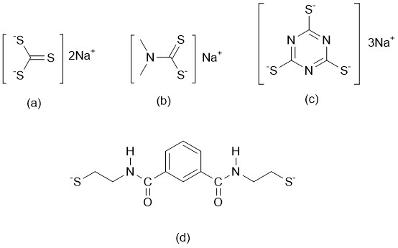
Figure 1: (a) Sodium thiocarbonate (STC); (b) sodium dimethyldithiocarbamate (SDTC); (c) 2,4,6-Trimercaptotiazine, trisodium salt nonahydrate (TMT); (d) 1,3-benzenediamidoethanethiol dianion (BDET).
The removal of heavy metal cations from aqueous media using chelating agents is carried out using two main technologies, namely, solvent removal (liquid-liquid) or solid-phase removal. Solid phase removal (SPE) is a rapidly growing technique utilized in the remediation of polluted environmental components such as water and soil. It has exhibited quite a number of notable advantages such as selectivity, very simple to use, does not use organic solvents making it environmentally friendly, high efficiencies of removal and it’s very versatile [39]. Recent advances have been made in introducing novel sorbents for the sole purpose of aiding removal, they include polymers, metal organic frameworks, functionalized silica supports, zeolite framework supports, nano-adsorbents, bio-sorbents among others [40]. SPE has also been advanced further into various modes such as solid-phase micro removal (SPME) and dispersive SPE (D-SPE). The main mechanism behind the working of this technique, is the sample containing the potential pollutants is passed through a system containing the extractants supported on a solid matrix of which the pollutants have a degree of affinity to [41], as shown in Figure 2 below.
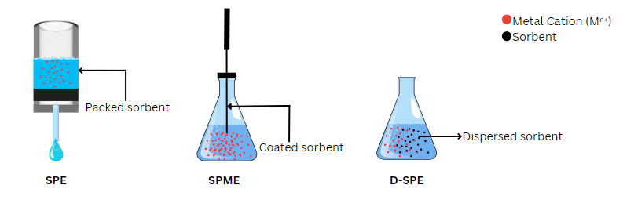
Figure 2: Schematic diagram representing SPE, SPME and DSPE
The main advantage of these solid supports over other support systems is doubled down to two main factors. The first is that it possesses a substantial increase in surface area of about 100-1500m²/g and its increased permeability which does not result in the system losing its selectivity factor [42]. Secondly, there is enhanced capacity in loading the solid support due to the large pore size diameter which enables the support system to hold an impressive quantity of the entity bound to it unlike other biopolymers which have small loading capacities which increases the metal removal capacity of the adsorbents [43].

2.2.1 Silica Support
Silica has been immobilized with various organic molecules to form chelating material for removal of HMs as it offers functional groups that play a pivotal role in selectivity and reusability of the chelating material [44]. Among other silica materials, MCM-41 and SBA-15 have been incorporated into Schiff base ligands to synthesize efficient chelating material for removal of HMs from aqueous solutions. SBA-15 is the most widely used due to its large uniform pores size and advanced mechanical strength [45]. However, it has been said that SBA-15 silica is not as stable as expected in water and at room temperature even though they have thick walls as compared to MCM-41 with thinner walls [46].
Hami et al., synthesized SBA-15 mesoporous silica and further modified it with N-propylsalicyladimine ligand (SBA/SA) (1), aminopropyl (SBA/NH₂) (2) and ethylenediaminopropyl (SBA/En) (3), shown in Figure 3, for comparison on the removal of Pb (II), Cd (II) and Ag (I) cations [47]. The removal capacity of 2 was 29.4, 111.1, and 100.0 mg/g, for 3 it was 8.0, 14.0, and 5.6 mg/g and for 1 it was 7.3, 31.2, and 28.5 mg/g for Pb (II), Cd (II), and Ag (I), respectively. The removal capacity of these chelating agents towards HMs obeyed the order 3>1>2. The average order of removal capacity of the ligands for the metal cations follows the order Cd(II)>Ag(II)>Pb(I) which can be explained by the HSAB theory. Compound 3 contains more N^N binding sites as compared to 2, this particular binding site is more of a soft borderline base therefore an increased affinity towards softer borderline acids is expected. Pb(II) is more of a hard borderline acid as compared to the softer Cd(II) and Ag(I) cations. This, therefore, translates to higher removal capacities for these metal cations [47] explaining the trend observed.
Figure 3: Silica immobilized chelating ligands for the removal of metal cations from aqueous solution [47].
Another study was conducted where SBA-15 silica was functionalized bis-salicylaldehyde Schiff base (SBA-DSA) (4) and mono-salicylaldehyde Schiff base (SBA/SA (5), as shown in Figure 4, for removal of Pb (II) and Cu (II) ions from aqueous solutions [48]. The removal efficiency of 4 was 60.9 and 54.8 mg/g and for 5 it was 36.6 and 31.9 mg/g for Pb(II) and Cu(II) cations, respectively. Even though these chelating agents showed potential for removal of HMs especially Pb(II) cations from multicomponent solution, their removal efficiency was lower compared to other chelating agents reported in literature synthesized from ligands with branched structures. Compound 4 brings forth an extra coordination site which will ultimately improve the removal efficiency of the system as exhibited by the reported results. It was reported that the ligands which also contained similar coordination sites as 4, exhibited high affinities for both Pb(II) and Cu(II) cations which translated to improved removal capacities.
Figure 4: Silica immobilized salicylaldehyde based chelating ligands for the removal of Pb(II) and Cu(II) cations from aqueous solution [48].
He et al., synthesized SBA-15 and MCM-41 via condensation for removal of Ni (II) cations from plating wastewater under acidic and basic conditions [49]. SBA-15 was further functionalized with iminodiacetic acid (NiIMS1) (6), and employed for removal under acidic conditions, while MCM-41 was functionalized with ethanediamine (NiIMS2) (7), as shown in Figure 5, and used for removal under alkaline conditions. These chelating agents showed potential in real wastewater treatment applications with removal efficiency above 92.5% for SBA-15 after several removals and 90.9% for MCM-41. The difference in the results could be attributed to the fact that SBA-15 is more porous and has a higher surface area than MCM-41 [50]. This will result in a better loading capacity and an increase in the binding sites available for removal which will translate into better removal efficiencies as observed for 6 and 7.

Figure 5: Different silica-based supports functionalized with chelating agents for the removal of Ni(II) cations from plating wastewater [49].
Moreover, several studies utilizing potential N^N bidentate ligands anchored on solid supports have also been reported in the last decade. For example, 1,5-dimethyl-1H-pyrazole-3-carbaldehyde immobilized on silica gel (8), shown in Figure 6, has been investigated as a potential adsorbent for the solid-phase removal of Pb(II), Cd(II), Cu(II) and Zn(II) cations from aqueous solutions [51]. Compound (8) showed an increased selective adsorption capacity towards Pb(II) of 74.89 mg/g while Cd(II), Cu(II), and Zn(II) metal cations yielding adsorption capacities of 26.93 mg/g, 22.08 mg/g and 20.43 mg/g, respectively. Remarkably, the adsorbent can be recycled five times and showed no significant decrease in removal percentage. The chelating system within the extractant is borderline due to N^N coordination site this therefore explains the high selectivity towards Pb(II) cation which is also borderline. The other cations involved are softer cations than Pb(II) therefore explaining the low adsorption capacities observed.
In another study by the same group, heavy metal removal performance of up to 99 mg/g with recyclable silica-immobilized (E)-4-((pyridin-2- ylmethylene)amino)phenol Schiff’s base (9), shown in Figure 6, was recorded in the removal of Hg(II), Cd(II), Pb(II) and Zn(II) cations at a pH range 6.5-8 showing a high preference for Pb(II) [52]. Moreover, ethylenediaminopropyl immobilized on SBA-15 mesoporous silica material (10), Figure 6, was investigated for the removal of Pb(II), Cd(II), and Ag(I) cations from aqueous solutions where the adsorbent also showed an improved capacity of adsorption towards Pb(II) cations [47]. Ligand 10 is borderline therefore explaining the high selectivity towards Pb(II) cation which is also a borderline acid as compared to the softer Ag(I) and Cd(II) cations therefore explaining their low removal capacities. Comparison between 9 and 10 shows that N^N chelating ligands have a unique affinity for borderline acids such as Pb(II) as opposed to softer acids such as Cd(II). This provides much insight into the use of N^N coordinating ligands in the removal of metal cations since a general trend is observed in association with HSAB theory.
Figure 6: Silica immobilized N^N bidentate ligands for the removal of metal cations from aqueous solution.

2.2.2 Zeolite/clay support materials
Clay and its composites (such as montmorillonite, halloysite, attapulgite, kaolinite), zeolites and silica are mineral based adsorbents that are employed in removal of HMs from aqueous medium. Clay is a naturally occurring particle that exists on the earth’s surface. It is made up of silica, weathered rocks, and alumina. Clay materials consist of positively charged exchangeable ions such as Na(I), K(I) and Cu(II). However, these materials can be negatively charged due to substitution by other cations such as Al(III) and Si(IV) [53]. Removal capacity of heavy metal ions by clay adsorbents can be improved by pre-treatment which promotes their surface area, pore volume and makes it hydrophobic and organophobic. Also, the porous and high surface area of clay materials is improved by its complex structure, which promotes its chemical and physical interaction with dissolved species.
Zeolites have been employed in the removal of HMs and have similar structural characteristics to clay. However, zeolite minerals have extremely small pores, either nano- or sub-nanosized, which makes the process of extracting HMs very laborious. To enhance zeolites’ binding affinity with heavy metal ions, they are also treated with alkali and surfactants. Zeolites surface can be modified with an amino or organic group to help overcome this restriction [54]. Due to its biocompatibility and environmental friendliness, silica oxide can also be utilized to alter zeolites to further improve their removal capacity towards HMs [55].
Clinochlore, which is a type of clay material that belongs to the chlorite group was utilized to modify triazole (TzlOH@Clin) (11) and triazolium (IL-Tzl-OH@Clin) (12) ligands shown in Figure 7, and utilized for removal of Co(II), Pb(II) and Zn(II) cations from commercial wastewater [56]. The application of the ligands modified with clinochlore was not only limited to the removal of the mentioned HMs, but they were further used in catalytic activities for reduction of nitroarenes to amines. In the end, these materials indicated excellent removal efficiency for Co(II), Pb(II), and Zn(II) cations of 99.40%, 98.50%, and 98.90%, respectively. Furthermore, the extractants 11 and 12 can be considered as borderline ligands, this will therefore explain the high removal efficiencies observed since the metal cations in this study are borderline acids. This is in coherence with the HSAB theory of acid-base interactions.
Figure 7: Clay immobilized triazole(pyridine) chelating agents for the removal of Co(II), Pb(II) and Zn(II) cations from wastewater [56].

2.2.3 Polymer support
Synthetic and natural polymers have been used to modify Schiff basses for removal of HMs due to their physical and chemical properties such as high surface area, pore size distribution and ability to introduce suitable functional groups on their surfaces. They also allow regeneration of HMs after removal using acidic or basic solutions which offer them further applications [57]. However, there are limitations associated with polymers such as poor mechanical strength, swelling, low removal and selectivity [58]. They also have drawbacks such as difficult regeneration and elution, significant pH value variations. The hydrophilicity of the chelating resin degrades because of some polymer resins' large-scale introduction of specific hydrophobic groups in an effort to achieve greater removal selectivity. As a result, the range of applications is somewhat constrained. Additionally, some polymer resins with weak skeletons and difficult processing are created through monomer polymerization [59].
To bind these drawbacks, organic ligands with the desirable functional groups for removal have been used to modify polymers. For instance, Naeimi et al., employed a biodegradable and recoverable bionanopolymer (chitosan) based on shrimp wastes for removal of Co(II) and Pb(II) metal cations from polluted watewater [60]. Graphene oxide (GO) and 4-hydroxy-3-methoxybenzaldehyde were used to modify this bionanopolymer to make Chit-Schiff-GO biosorbent 13, shown in Figure 8. The removal efficiency of Co(II) and Pb(II) cations was 698 and 466 mg/g, respectively. Another study was conducted where small organic molecules containing pyridine and hydroxyl groups were grafted into poly-chloromethyl styrene (CPS-AA) (14), shown in Figure 8, for removal of Ni (II), Pb (II) and Cu (II) cations from wastewater in industrial production [61]. The chelating resin had high removal efficiency of 95.5, 95.1 and 92,3 mg/g for Cu (II), Pb (II) and Ni (II) ions, respectively. A chelating mechanism with multi-tooth coordination which was more stable and efficient for the large removal of HMs, was proposed after the removal mechanism was investigated.
Figure 8: Polymer immobilized ambidentate chelating ligands for the removal of metal cations from wastewater.

2.2.4 Magnetic nanoparticles
In the recent past, much effort has also been directed toward the synthesis of functionalized magnetic nanoparticles for the removal of heavy metals from water [62-64]. The interest in magnetic nanoparticles is driven by their unique properties, particularly the convenient separation from wastewater under a magnetic field [65]. However, application of Fe₃O₄ nanoparticles without modification for removal of HMs is associated with some drawbacks such as low solubility, surface oxidation, leaching under acidic condition and aggregation [66, 67]. Variety of supporting material such as polymers, surfactants, metal oxides and silicon dioxide among others have been used [68]. Schiff bases are the most widely used supporting material due to the desirable functional groups they contain. Modification of magnetic nanoparticles using O-H and N-H groups, among other surface modifiers is the most recently used as it offers chelating material with high removal efficiency[69, 70].
Karami et al., recently synthesized and modified Fe₃O₄ nanoparticles through a heterogeneous approach utilizing bromobenzaldehyde (Fe₃O₄-BA) and 3-aminopropyltriethoxysilane (APTES) (15) as shown in Figure 9 [71]. The synthesized magnetic nanoparticles, Fe₃O₄-BA, were employed for removal of Pb(II) cations from aqueous solutions. The adsorbent had a high removal efficiency above 90% for Pb(II) cations within 12 min at neutral pH. The generated nanoparticles' reusability experiment was conducted across four iterative cycles, and the findings indicated a 10% decrease of Pb(II) cations removal from solution after 4 regeneration cycles. Similarly, a novel epoxy-triazinetrione-functionalized magnetic nano-adsorbent (Fe₃O₄-ETT) (16), shown in Figure 9, was developed and employed to extract malachite green (MG) dye and Pb(II) cations from synthetic wastewater [72]. The study indicated that the Fe₃O₄-ETT extracted MG dye and Pb(II) ion through electrostatic interactions and surface complexation, respectively, with Pb(II) having the highest removal efficiency. Compound 16 possesses an O^O coordination site whereby this borderline ligand exhibited an improved removal efficiency of borderline acid Pb(II) cations owing to the HSAB theory.
Figure 9: Magnetic nanoparticles immobilized chelating ligands for the removal of Pb(II) cations from aqueous solution and wastewater.
As part of the ongoing research on magnetic nano-adsorbents in the sector of water treatment, magnetite (Fe₃O₄) nanoparticles functionalized with (2-Formyl-1H-pyrrole (Fe₃O₄-FP) (17), shown in Figure 10, were recently reported [71]. The synthesized magnetic nanoparticles, Fe₃O₄-FP were employed for the removal of Pb(II) cations from aqueous solutions with removal efficiency above 90% for Pb(II) cations being reported within 12 min at neutral pH. Moreover, the generated nanoparticles' reusability experiment was conducted across four iterative cycles, and the findings indicated only a 10% decrease of Pb (II) ions removal from the solution after 4 regeneration cycles. In comparison with 8, 9, and 10, extractant 17 lies in agreement with the behavior of the extractants towards moderate acids such as Pb(II) due to the availability of N^N coordination site. This, therefore, explains the high removal capability of 17 towards Pb(II) cations due to the HSAB theory of acid-base interaction.
Figure 10: Magnetic nanoparticles immobilized N^N-donor chelating ligand for the removal of Pb(II) cations from aqueous solution [71].

2.2.5 Chelated metal-organic frameworks
Chelated metal-organic frameworks (MOFs) usually comprise of strongly bonded metal cations or organic linkers functionalized with a chelating agent. Chelated MOFs possess the distinct advantage of enhanced adsorptive capacity due to two main attributes, its ultra-high porosity and enormous internal surface areas of up to 90% free volume and extending beyond 6000m²/g, respectively [73]. These two normally enable an increase in the loading factor of these systems, in that a larger amount of functionalization with chelating agents can occur. This, therefore, improves its adsorptive capacity by several orders of magnitude [74]. For example, a study conducted by Esmaeilzadeh et al., consisted of chelated MOFs in the recovery of V(IV) and V(V) from both drinking and river water samples. They synthesized iron-based nanoparticles functionalized with (2-(2,4-dihydroxyphenyl)-3,5,7-trihydroxychromen-4-one) (18), shown in Figure 11, as a chelating extractant otherwise known as morin to yield MIL-101(Fe)/Fe₃O₄ [75]. This system was able to achieve a high recovery of 110 and 96% for drinking water, 104 and 99.3% for river water for V(IV) and V(V), respectively. This shows that 18 can potentially be used on a larger scale for heavy metal sequestration.
These systems have been very efficient in numerous applications such as heavy metal removal owing to their highly porous structure [76]. For example, in a study conducted by Liang et al., novel sulfur functionalized metal-organic frameworks were utilized in the removal of Hg(II) cations from water [77]. They used NCS⁻, Co(II) functionalized with 2,4,6-tri(1-imidazoyl)-1,3,5-triazine 19, shown in Figure 11, (Timt) to yield a system designated as FJI-H12. It is comprised of infinite octahedral M₆L₄ cages which aid in the enhancement of the removal capability of the system. FJI-H12 achieved 100% removal efficiency of Hg(II) from water with an impressive saturation factor of 439.8mg/g together with a distribution coefficient of approximately 1.85×10⁶ ml/g among other chelated MOFs. The isothiocyanato group (NCS⁻) that was present enabled 19 to have an increased affinity for the soft Hg(II) cations thereby translating to the very high efficiencies recorded by the moiety.
Figure 11: Polymer immobilized chelating ligands for the removal of metal cations from water.
In conclusion, it is evident that the use of chelating ligands to remove heavy metal cations from wastewater is a subject of academic and industrial interest. One attractive feature of these chelating agents is their efficiency in heavy metal pollution remediation even at very low concentrations. More significantly, careful choice of the donor atoms in the chelating ligand has the potential to improve targeted heavy metal removal, thus enhancing their selectivity which is very limited in other techniques such as adsorption. However, the separation of the metal chelates from the treated wastewaters has remained a major setback of the process and an industrial challenge. The use of supported chelating agents, as highlighted in this review, has the potential to minimize this hurdle when solid phase removal is adopted. Thus, the use of chelating agents and their supported derivatives have the potential to remove heavy metal cation pollutants from wastewaters even on industrial and commercial scales.
Chapters 3 and 4 describe the results of the work done to advance the search for industrially applicable solid-phase technology, while the overall conclusions and recommendations are summarized in chapter 5.

CHAPTER THREE

3.1 MATERIALS AND METHODS

3.1.1 Materials and chemicals
Mesoporous silica type Santa Barbara Amorphous-15 (SBA-15, 99%), 2-pyridinecarboxaldehyde (PC, 99%), 2-thiophenecarboxaldehyde (TC, 98%), salicylaldehyde (SA, 98%), 3-(2-aminoethyl-aminopropyl)trimethoxysilane (AEAPTMS, 97%), cadmium chloride (CdCl₂, 98%), lead nitrate (Pb(NO₃)₂, 98%), and potassium dichromate (K₂Cr₂O₇, 98%) were purchased from Sigma-Aldrich and were used without further purification.

3.1.2 Synthesis of functionalized Schiff base ligands

3.1.2.1 (E)-2-(3,3-dimethoxy-2-oxa-7,10-diaza-3-silaundec-10-en-11-yl)phenol (L1)
Ligand L1 was prepared using a literature procedure [78]. To a methanol solution of salicylaldehyde (0.50 mL, 4.70 mmol), AEAPTMS (1 mL, 4.60 mmol) was added dropwise. The reaction mixture was refluxed for 24 h at 65℃ after which methanol was removed by evaporation in vacuum to yield L1 as a yellow oily liquid. Yield: 1.46 g (97%). ¹H NMR (400 MHz, CDCl₃): δ_{H} 0.60 (s, 2H, Si-CH₂); 1.56 (s, 3H, CH₂, C-NH), 2.61 (s, 4H, (CH₂)₂), 2.89 (s, 2H, CH₂), 3.55-3.42 (m, 9H, ³J_{HH}=6.32 Hz, O-CH₃), 6.84 (s, 1H, Ph), 6.92 (d, 1H, ³J_{HH}=3.16 Hz, Ph), 7.21 (d, 1H, ³J_{HH}=2.68Hz, Ph), 7.28 (d, 1H, ³J_{HH}=3.44Hz, Ph), 8.35 (s, 1H, C=NH). ¹³C NMR (100 MHz, CDCl₃,): δ 10.16 (Si-CH₂), 23.29 (CH₂), 50.26 (O- CH₃, CH₂-N), 52.43 (CH₂-N), 59.58 (CH₂-N), 116.95 (3-Phe-C), 118.60 (5-Phe-C), 131.29 (4-Phe-C), 132.24 (6-Phe-C), 161.11 (N=C), 165.99 (2-Phe-C-OH). FT-IR (cm⁻¹): υ_{(N-H)}= 3290, υ_{(C-H)}=2983-2923, υ_{(C=N)}=1625, υ_{(C-O)}=1276, υ_{(Si-O)}=744.
Compounds L2 and L3 were prepared following the same procedure as described for compound L1, using the appropriate reagents as shown in Scheme 1.

3.1.2.2 (E)-N-(2-((pyridine-2ylmethylene)amino)ethyl)-3-(Trimethoxysilyl)propan-1-amine (L2)
Compound 2-pyridine-carboxaldehyde (0.50 mL, 5.30 mmol) was reacted with AEAPTMS (1 mL, 4.60 mmol) and isolated as a dark orange oily liquid. Yield 1.43 g (95%). ¹H NMR (400 MHz, CDCl₃): δ_{H} 0.36 (m, 2H, ³J_{HH}=4.12 Hz, CH₂), 1.29 (s, 3H, CH₂, NH), 2.08 (t, 2H, ³J_{HH}=3.46Hz), 2.29 (q, 2H, ³J_{HH}=5.72 Hz, CH₂), 2.94 (t, 2H, ³J_{HH}=2.68Hz, CH₂), 3.16 (s, 9H, O-CH₃), 7.06 (s, 1H, Py), 7.26 (s, 1H, Py), 7.51 (t, 2H, ³J_{HH}=7.43 Hz, Py), 8.39 (s, 1H, NH). ¹³C NMR (100 MHz, CDCl₃,): δ 10.02 (Si-CH₂), 22.04 (CH₂), 49.58 (O- CH₃, CH₂-N), 52.56 (CH₂-N), 55.66 (CH₂-N), 122.72 (3-py-C), 123.29 (5-py-C), 136.63 (4-py-C), 149.32 (6-py-C=N), 153.92 (N=C), 159.01 (C-CH₂). FT-IR (cm⁻¹): υ_{(N-H)}= 3285, υ_{(C-H)}=2804-2931, υ_{(C=N)}= 1650, υ_{(C=Npy)}=1434, υ_{(Si-O)}=764.

3.1.2.3 (E)-N-(2-((thiophen-2-ylmethylene)amino)ethyl)-3-(Trimethoxysilyl)propan-1-amine (L3)
Compound 2-thiophene-carboxaldehyde (0.50 mL, 5.30 mmol) was reacted with AEAPTMS (1 mL, 4.60 mmol) and a dark brown oily liquid was obtained. Yield 0.98 g (65%). ¹H NMR (400 MHz, CDCl₃): δ_{H} 0.58 (s, 2H, CH₂), 1.55 (s, 3H, CH₂, NH), 2.61 (s, 2H, CH₂), 2.88 (s, 2H, CH₂), 3.24 (s, 2H, CH₂), 3.42 (m, 9H, ³J_{HH}=3.24 Hz, O-CH₃), 6.93 (s, 1H, Th), 7.04 (s, 1H, Th), 7.36 (s, 1H, Th), 8.38 (s, 1H, NH). ¹³C NMR (100 MHz, CDCl₃,): δ 9.51 (Si-CH₂), 23.01 (CH₂), 50.30 (O- CH₃, CH₂-N), 52.37 (CH₂-N), 55.69 (CH₂-N), 127.39 (4-Th-C), 128.95 (5-Th-C), 130.64 (3-Th-C), 142.19 (C-CH₂), 155.55 (N=C). FT-IR (cm⁻¹): υ_{(N-H)}=3298, υ_{(C-H)}=2820-2928, υ_{(C=N)}= 1631, υ_{(O-Si)}=744, υ_{(C-S)}=700.

3.1.3 Immobilization of Schiff base chelating ligands on SBA-15

3.1.3.1 Immobilization of L1 onto SBA-15
In a standard reaction, (E)-2-(3,3-dimethoxy-2-oxa-7,10-diaza-3-silaundec-10-en-11-yl)phenol (L1) (1.0 g, 5.3 mmol) was mixed with 0.50 g of SBA-15 dispersed in dry toluene (15 mL). After 40 minutes of sonication, the reaction mixture was refluxed at 100℃ for 24 hours in a nitrogen environment. The result was filtered and washed three times with dry toluene and dichloromethane before being dried in a vacuum at 65℃ for 8 hours to produce L1@SBA-15, a yellow powder. Yield 1.30 g (87%). FT-IR (cm⁻¹): υ_{(N-H)}=3289, υ_{(O-H)}= 3256, υ_{(C-H)}=2838-2932, υ_{(C=N)}= 1630, υ_{(C-O)}=1278, υ_{(Si-O)}=1060.

3.1.3.2 Immobilization of L2 onto SBA-15
Compound L2@SBA-15 was prepared using the same procedure described for L1@SBA-15 by using (E)-N-(2-((pyridine-2ylmethylene)amino)ethyl)-3-(Trimethoxysilyl)propan-1-amine (L2) (1.0 g, 5.3 mmol) and SBA-15 (0.5 g). Yield 1.10 g (73%), FT-IR (cm⁻¹): υ_{(N-H)}= 3290, υ_{(C-H)}=2811-2934, υ_{(C=N)}=1649, υ_{(C=Npy)}= 1434, υ_{(Si-O)}=1029.

3.1.3.3 Immobilization of L3 onto SBA-15
Compound L3@SBA-15 was prepared using the same procedure described for L1@SBA-15 by using (E)-N-(2-((thiophen-2-ylmethylene)amino)ethyl)-3-(Trimethoxysilyl)propan-1-amine (L3) (0.75 g, 5.3 mmol) and SBA-15 (0.5 g). Adsorbent L3@SBA-15, yield 0.85 g (68%), FT-IR (cm⁻¹): υ_{(N-H)}=3294, υ_{(C-H)}=2817-2931, υ_{(C=N)}=1633, υ_{(Si-O)}=1031, υ_{(S-Th)}=700.

3.1.4 Characterization
The ¹H NMR and ¹³C(¹H) NMR (100 MHz) spectra were acquired on a 400 MHz Bruker Ultrashield NMR spectrometer using deuterated solvent (CDCl₃) to validate the integrity of the ligands synthesized. The Perkin-Elmer Spectrum 100 was used for Fourier-Transform Infrared spectroscopy (FTIR) in the 4000-400cm⁻¹ range to confirm the presence of the expected functional groups on both the ligands and adsorbents used in the study. Transmission electron microscopy (TEM) pictures were captured using a TEM microscope (JEOL JEM, 1400 model, Peabody, MA, USA). The surface morphology of the extractants was studied with a ZEISS EVO LS15 scanning electron microscope (SEM) (Thornwood, NY, USA). A thermogravimetric analyzer (Perkin-Elmer TGA 4000 model, Boston, MA, USA) with Pyris software was used to conduct thermal stability analyses of the adsorbents. Nitrogen physisorption studies were carried out using BELSORP MAX from Microtrac Retzsch to ascertain the mesoporous nature and surface area of the adsorbents used. The powder X-ray diffraction (PXRD) spectral data were examined using an XPERT-PRO XRD equipment with CuKα radiation, the 2θ range was selected from 4.01 to 89.9° to establish the crystalline structure of SBA-15 materials.

3.1.5 Adsorption experiments
Batch adsorption studies were carried out in 100 mL glass conical flasks with steady stirring at 425 rpm at room temperature. The adsorption behaviors of L1@SBA-15 to L3@SBA-15 in the removal of Cr(VI), Pb(II), and Cd(II) cations from aqueous solutions were thoroughly investigated. The influence of starting metal ion concentration, contact time, pH, and adsorbent loading on metal cation removal was examined in optimization removal tests utilizing L1@SBA 15. The optimal conditions were then employed for metal cation removal with L2@SBA-15 and L3@SBA-15. To make stock solutions (1000ppm) of Pb(II), Cr(VI), and Cd(II) cations appropriate amounts of Pb(NO₃)₂, K₂Cr₂O₇, and CdCl₂ were dissolved in distilled water.

3.1.5.1 Effect of pH
To prepare for adsorption investigations, each solution's pH was adjusted with diluted 0.1M NaOH and 0.1M HNO₃ solutions. The removal studies were then carried out by suspending 0.02 g (20 mg) of L1@SBA-15 and L3@SBA-15 in 15 mL of aqueous metal ion solution. The effect of pH on metal cation elimination was investigated by adjusting the pH of the aqueous solution between ranges 3.0 and 9.0.

3.1.5.2 Effect of initial metal concentration
Initial metal concentration evaluation studies were carried out using concentrations ranging from 20-60 ppm for Cr(VI), Cd(II) and Pb(II) cations. Several adsorption isotherm studies were used to evaluate the nature of adsorption of Pb(II), Cr(VI), Cd(II) cations on 0.02 g of L1@SBA-15 at various initial concentrations under room temperature. The data obtained was fitted into the isotherms given in Table 2, following the mass balance relationship shown in Equation 2 [79],
$q_{e}=\frac{(C_{o}-C_{e})V}{m}$ Equation 2
where V is the volume of solution (L), and m is the mass (g) of the adsorbent used.
Table 2: Multi-adsorbate adsorption isotherms
Isotherm model | Parameters | References
Linear Langmuir  $$\frac{C_{e}}{q_{e}}=\frac{1}{q_{m}}×\frac{1}{K_{L}}+\frac{C_{e}}{q_{m}}$$ | Ce- Metal cation concentration in equilibrium (mg/L)  q_{m}- Maximum capacity of adsorption (mg/g)  q_{e}- Metal adsorbed in mg/g on the adsorbent’s surface at equilibrium (mg/g)  K_{L}- Energy constant (L/mg) | [80]
Non-linear Langmuir  $$q_{e}=\frac{q_{m}×K_{L}×C_{e}}{1+K_{L}×C_{e}}$$ |  | [80]
Linear Freundlich  $$log(q_{e})=(logK_{F})+\frac{1}{n}×log(C_{e})$$ | Ce- Metal cation concentration in equilibrium (mg/L)  q_{e}- metal adsorbed in mg/g on the adsorbent’s surface at equilibrium (mg/g)  K_{F}- Freundlich constant ((mg/g)(L/mg)^{(1/n)})  1/n- Heterogeneity factor | [81]
Non-linear Freundlich  $$q_{e}=K_{F}×{C_{e}}^{1/n}$$ |  | [81]
Linear Redlich-Peterson  $$\frac{C_{e}}{q_{e}}\text{=}\frac{1}{α_{R}}\text{×(}\frac{1}{q_{m}}\text{×}C_{e})β$$ | Ce- Metal cation concentration in equilibrium (mg/L)  q_{e}- metal adsorbed in mg/g on the adsorbent’s surface at equilibrium (mg/g)  q_{m}- Maximum capacity of adsorption (mg/g)  K_{R}- Isotherm constant at equilibrium (L/g)  α_{R}- Isotherm kinetic constant (L/mg)  β- Exponent | [82]
Non-linear Redlich-Peterson  $$q_{e}=\frac{K_{R}C_{e}}{1+α_{R}C_{e}^{β}}$$ |  | [82]
Linear Temkin  $$q_{e}=Bln(AC_{e})$$ | Ce- Metal cation concentration in equilibrium (mg/L)  q_{e}- metal adsorbed in mg/g on the adsorbent’s surface at equilibrium (mg/g)  A- Isotherm constant at equilibrium (L/g)  B- Isotherm constant (L/g) | [83]
Non-linear Temkin  $$q_{e}=\frac{RT}{b}×ln(A×C_{e})$$ |  | [83]

3.1.5.3 Effect of adsorbent dosage
The effect of adsorbent loading was investigated by altering the adsorbent amount utilized from 0.005-0.02 g.

3.1.5.4 Effect of contact time
Contact time evaluation tests were undertaken with time intervals ranging from 1 to 24 hours. Various kinetic models were utilized to assess the influence of contact time on the maximum adsorption capacity (q_{e}) to contact time. The studies were done using 0.02 g of L1@SBA-15 in 15 mL of different metal concentrations at various time intervals. The kinetic models that were used are given in Table 3.
Table 3: Multi-adsorbate adsorption kinetic models
Kinetic model | Parameters | References
Pseudo-first order  $$ln(q_{e}-q_{t})=lnq_{e}-K_{1}t$$ | q_{t}- metal adsorbed in mg/g on the adsorbent's surface at time t  q_{e}- metal adsorbed in mg/g on the adsorbent’s surface at equilibrium  K₁- adsorption rate constant of Pseudo-first-order in min⁻¹  K₂- adsorption rate constant of Pseudo-second-order in mg/min⁻¹ | [83]
Pseudo-second order  $$\frac{t}{q_{t}}=\frac{1}{K_{2}×q_{e}^{2}}+\frac{1}{q_{e}}t$$ |  | [83]
Elovich  $$q_{e}=\frac{1}{β}ln(αβ)+\frac{1}{β}lnt$$ | α- Initial adsorption rate in mg/(gmin)  β- Surface coverage limit | [84]
Intraparticle diffusion  $$q_{t}=K_{p}t^{0.5}+C$$ | K_{p}- Rate constant (mg/gmin^{1/2})  C- Intercept | [85]

3.1.5.5 Determination of removal efficiency
Following each sorption experiment, the solutions were centrifuged for 30 minutes and filtered; the amount of metal cation remaining in the filtrate was then quantified using a Varian 720-ES inductively coupled plasma atomic emission spectroscopy (ICP-AES) with ICP Expert II software.
The percentage removal efficiency (%Eff) was calculated using Equation 1.
$\%Eff=\frac{C₀-Cf}{C₀}×100$ Equation 1
where Co and Cf are the initial and final metal concentrations respectively.

3.1.6 Data analysis
Data analysis will be done using two-way Analysis of Variance (ANOVA) to determine any significant differences in the extraction efficiencies of Cr(VI), Cd(II) and Pb(II) by L1@SBA-15, L2@SBA-15 and L3@SBA-15.

3.2 Results and Discussion

3.2.1 Synthesis of functionalized Schiff base ligands
Synthesis of the functionalized Schiff base ligands was conducted as shown in Scheme 1, via condensation using 3-(2-aminoethyl-aminopropyl)trimethoxysilane (AEAPTMS) with the appropriate aldehydes which obtained high yields of (E)-2-(3,3-dimethoxy-2-oxa-7,10-diaza-3-silaundec-10-en-11-yl)phenol (L1), N-(2-((pyridine-2ylmethylene)amino)ethyl)-3-(Trimethoxysilyl)propan-1-amine (L2) and N-(2-((thiophen-2-ylmethylene)amino)ethyl)-3-(Trimethoxysilyl)propan-1-amine (L3).
Scheme 1: Synthesis of functionalized Schiff base ligands L1 to L3; dry methanol, reflux 24 h, Dean-Stark condensation (i-iii).
The successful formation of the ligands was established using ¹H NMR, ¹³C NMR, and FT-IR spectroscopy. For example, the ¹H NMR spectra of L1 to L3 showed strong singlet signature peaks of the imine proton at 8.35, 8.39, and 8.38 ppm respectively, which confirmed successful condensation (Figures 12-14). Furthermore, strong intense multiplet peaks were observed at 3.55, 3.16, and 3.42 ppm for L1 to L3, respectively, resonating to methoxy groups (O-CH₃) present on AEAPTMS. ¹³C NMR was also instrumental in confirming the identity of the synthesized compounds L1 to L3 where the signals of the imino carbon (C=N) were observed at 161.11, 153.92, and 155.55 ppm, respectively, (Appendices1-3). The FT-IR spectra of ligands L1 to L3 showed stretching frequencies of 1666, 1634, and 1625 cm⁻¹, respectively, that correspond to the imine functional group [86] (Figure 15).
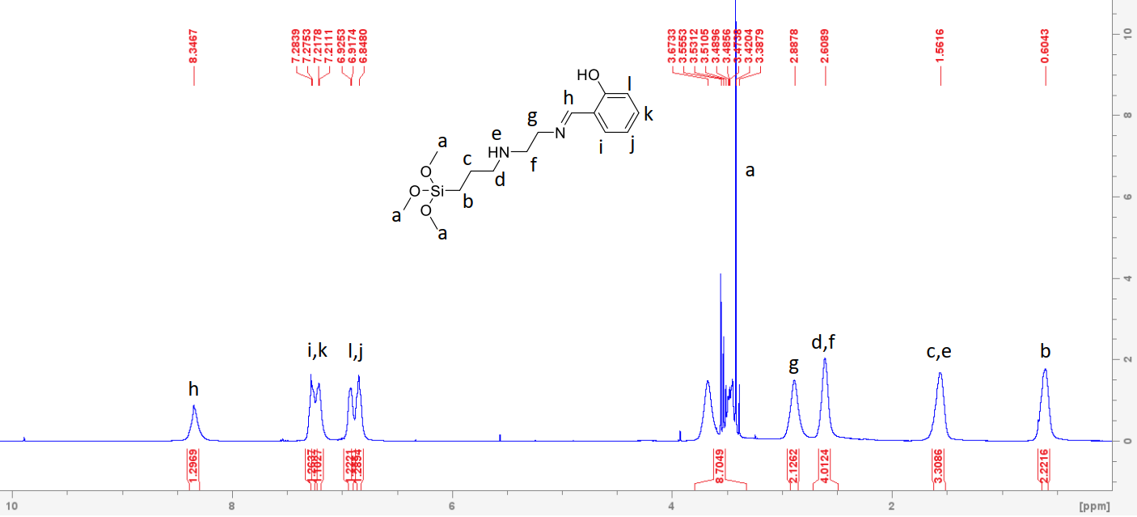
Figure 12: ¹H-NMR for L1 showing azomethine proton at 8.35 ppm

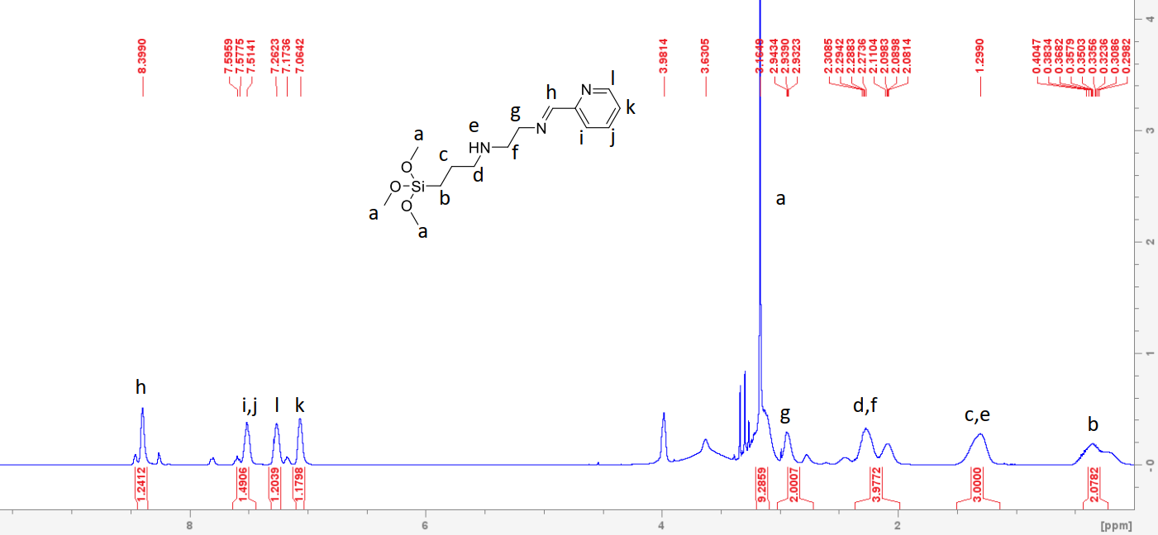
Figure 13: ¹H-NMR for L2 showing the azomethine proton at 8.39 ppm

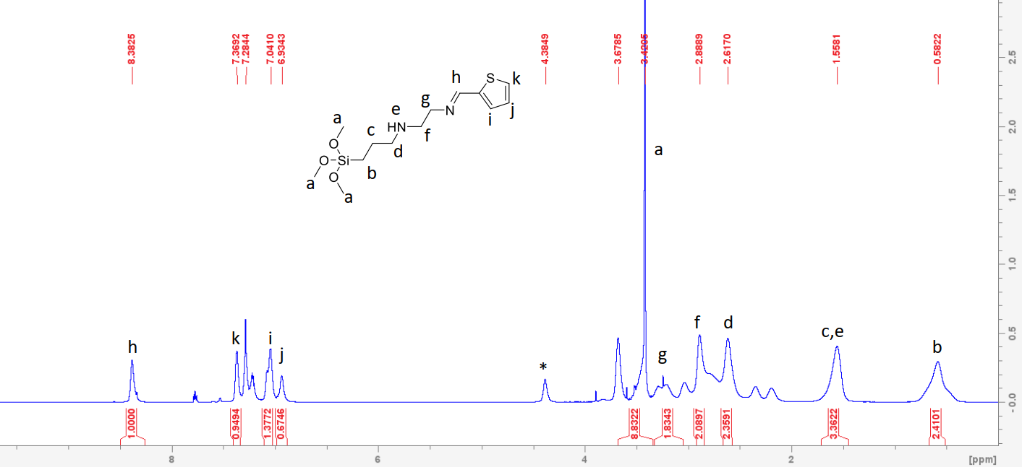
Figure 14: ¹H-NMR for L3 showing the azomethine proton at 8.38 ppm

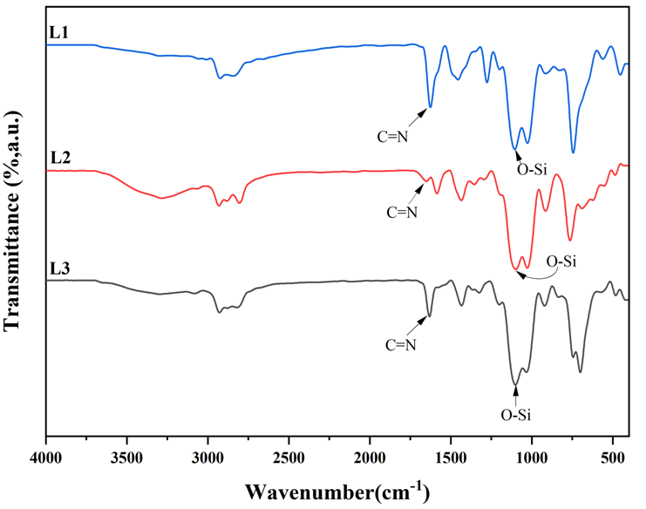
Figure 15: Stacked FT-IR spectra of L1 to L3 showing the υ_{(C=N)} between 1620-1670 cm⁻¹

3.2.2 Incorporation and characterization of immobilized SBA-15
Compounds L1 to L3 were immobilized onto SBA-15 to yield L1@SBA-15 to L3@SBA-15 (Scheme 2). Further characterization of the materials was conducted utilizing several techniques which included PXRD, FT-IR, BET/BHJ and TEM-SEM as discussed in the following sections.
Scheme 2: Immobilization of functionalized Shiff base ligands on SBA-15 to give L1@SBA to 15 - L3@SBA-15; dry toluene, reflux 24 h under nitrogen atmosphere (i-iii).
As shown in Figure 16 the FTIR spectra of L1@SBA-15 to L3@SBA-15 showed very strong band between 1020-1040 cm⁻¹, 750-780 cm⁻¹, and 405-420 cm⁻¹ which were attributed to the asymmetric stretching and bending vibration frequencies of Si-O-Si moieties that are present within the SBA-15 framework [87]. The bending vibrational frequency of secondary amine groups, NH, ranging from 3289-3294 cm⁻¹ were observed for all the compounds synthesized. All the adsorbents displayed sharp peaks ranging from 1630-1650 cm⁻¹ which is due to the azomethine (C=N) stretching vibrations confirming the successful functionalization of the Schiff base ligands onto SBA-15 substrate. Adsorbent L1@SBA-15, exhibited a peak at 3256 cm⁻¹ and 1278 cm⁻¹ which is characteristic to the phenolic O-H and C-O bending vibration frequency, respectively, as reported for similar functional groups [88, 89].
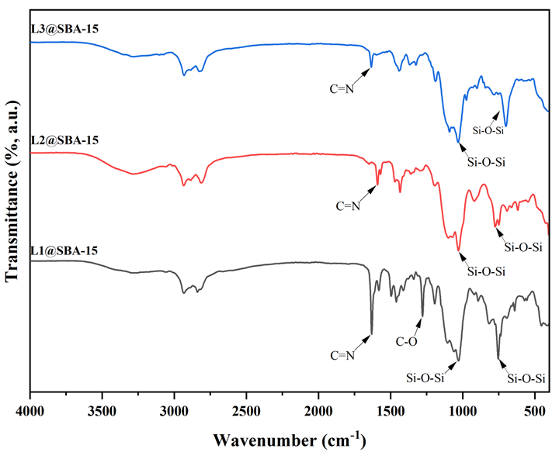
Figure 16: FT-IR spectra of adsorbents L1@SBA-15, L2@SBA-15 and L3@SBA-15 showing the υ_{(C=N)} and υ_{(Si-O-Si)} resonating between 1630-1650 cm⁻¹ and 1020-1040 cm⁻¹, respectively.
Adsorbent L2@SBA-15 also exhibited a characteristic peak at 1434 cm⁻¹, confirming the presence of pyridine moiety within the adsorbent system [90]. Adsorbent L3@SBA-15 also recorded a unique peak at 700cm⁻¹, which was assigned to thiophene ring C-S stretching vibrations [91]. Furthermore, shifts in vibration frequencies were also observed for the Si-O functional group upon immobilization of the chelating ligands onto the solid SBA-15 support. For example, the vibration frequency recorded for υ_{(Si-O)} in L1 is 744 cm⁻¹, however, upon immobilization this value shifted to 1028 cm⁻¹ in L1@SBA-15. The other compounds exhibited similar trends which confirmed the immobilization was successful as similar findings were reported by [92, 93]. The above discussed FT-IR vibrational bands confirmed the successful immobilization of AEAPTMS, and the functionalization of the respective Schiff base ligands affiliated with L1@SBA-15 to L3@SBA-15 on the mesoporous SBA-15 surface.

3.2.2.1 Thermal properties
The thermal properties of L1@SBA-15 to L3@SBA-15 were studied using TGA-DSC coupled thermograms as the decomposition patterns were obtained in the temperature range of 0-800℃ as shown in Figure 17. The materials exhibited a general trend where an increase in temperature resulted in a decrease in the percentage weight of the material. For example, at temperatures of <100℃, all the materials’ weights were observed to decrease which was mainly attributed to the loss of moisture content present within the mesoporous silica moieties [47]. Furthermore, a steady decrease in the adsorbent’s weight was observed between the temperature range 200-800℃ which is a result of the termination/melting of the adsorbents’ organic core (Figure 17). Similarly, the DSC thermograms (Figure 17) also exhibit the phase transition of the compounds in that the peaks observed are indicators of an exothermic process. The change in phase (melting) of the compounds is in alignment with the decomposition patterns observed for TGA analysis for L1@SBA-15 to L3@SBA-15.
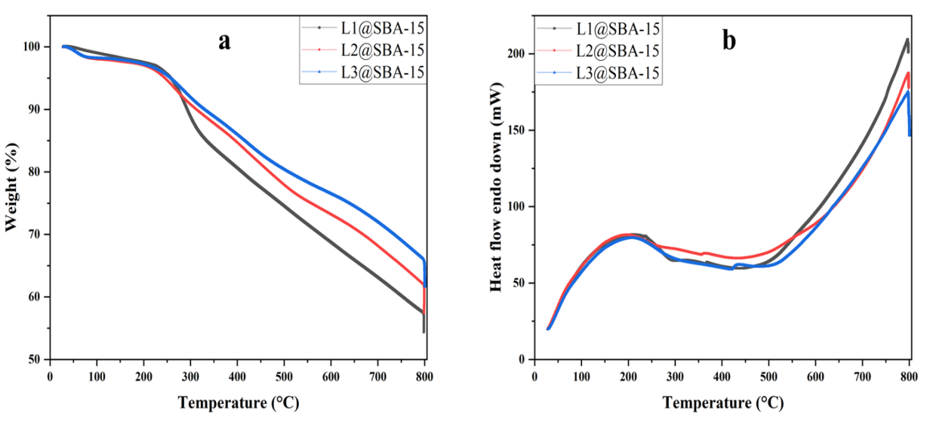
Figure 17: TGA and DSC plots, a and b respectively, showing the decomposition patterns of L1@SBA-15 to L3@SBA-15.

3.2.2.2 Specific surface area
The specific surface areas of the SBA-15 immobilized adsorbent systems were analyzed by nitrogen adsorption/desorption measurements in line with Brunauer, Emmet, Teller (BET), and the overall porosity of the materials was determined using the Barret, Joyner, Halender (BHJ) method given in Table 4 and appendices 4 and 5. According to BHJ, L1@SBA 15 to L3@SBA-15 exhibited a large pore size distribution (appendices 4), the adsorbents recorded pore diameters of <14 nm as highlighted in Table 4. These results depicted that the large surface of the mesoporous silica was efficiently imprinted by the functionalization groups. A H4-type hysteresis loop pattern was observed in the adsorption-desorption nitrogen isotherms obtained for L1@SBA-15 to L3@SBA-15 which is a typical indication of the presence of mesoporous materials [94], appendix 5.
Table 4: The physical properties of SBA-15 immobilized systems
Adsorbent | ªS_{BET} (m²/g) | ^{b}PD (nm)
L1@SBA-15 | 105 | 8.7
L2@SBA-15 | 128 | 8.3
L3@SBA-15 | 58 | 13
ª BET surface area (S_{BET}) measured by N₂ physisorption. ^{b} Pore diameter (AVPD) with respect to BHJ.
The powder X-Ray diffraction patterns were utilized to identify the structural ordering of the mesoporous nature of the adsorbents used in this study. It was observed that L1@SBA-15 to L3@SBA-15 showed the main diffraction peak associated with SBA-15 materials which refers to the crystal plane affiliated with the Miller index (100) as shown in Figure 18.
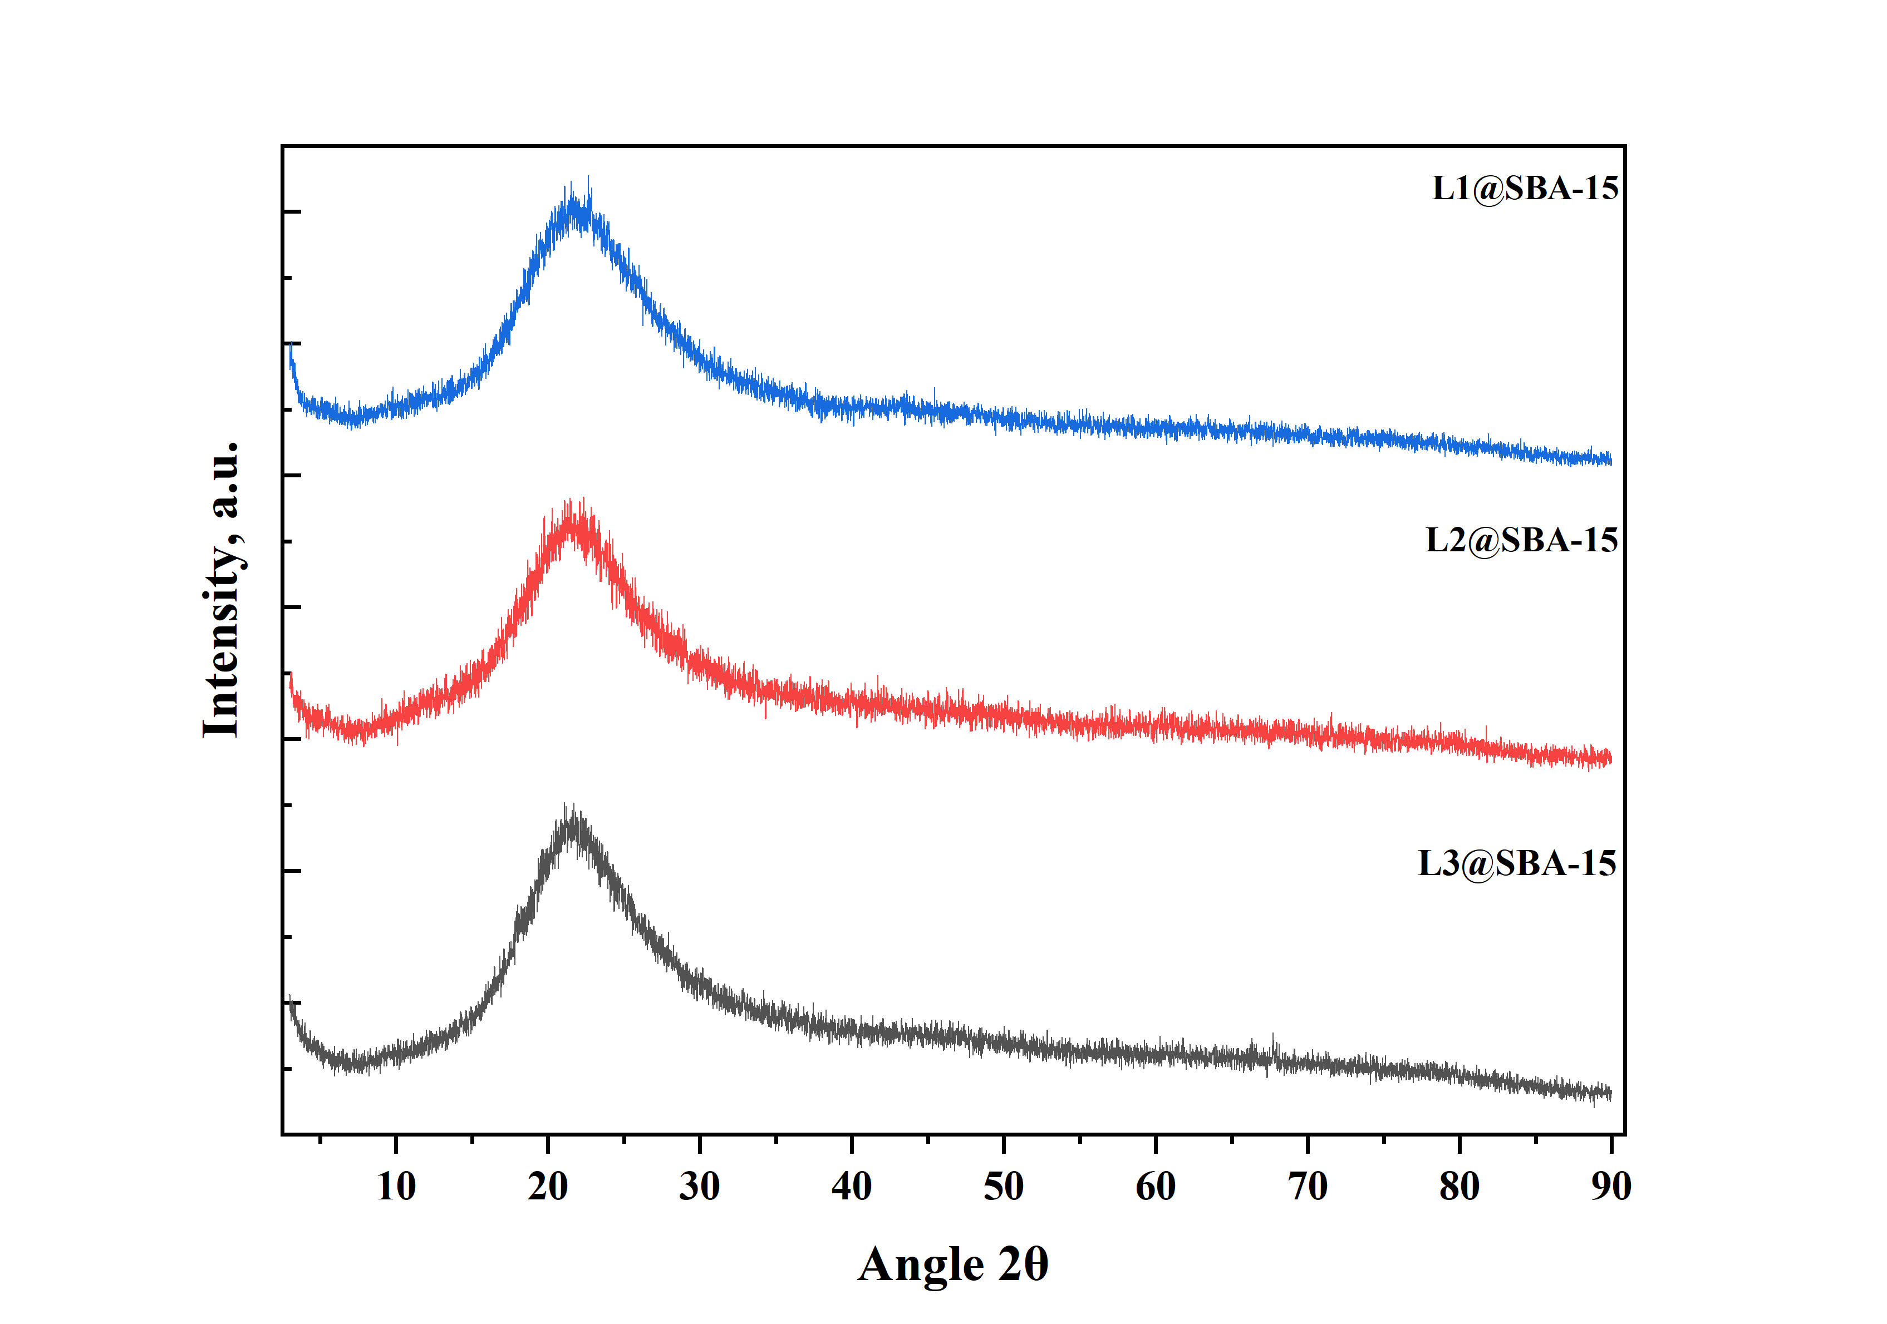
Figure 18: PXRD patterns of L1@SBA-15 to L3@SBA-15 immobilized systems.
This peak is characteristic of a 2-D hexagonal pore arrangement which is commonly found in mesoporous ordered materials such as SBA-15, which depicts a well-defined mesostructured material [94]. Additionally, the d100 value is known to correspond to the distance between two walls in the material’s structure which is unique for SBA-15. It’s also notable that after 2θ=1° there are unresolved peaks which is a typical indicator of a degree of mesoporous arrangement which was confirmed by TEM imaging (Figure 19).

3.2.2.3 Surface morphology
Mesoporous SBA-15 has two distinct appearances while subjected to TEM imaging, they are honeycomb (hexagonal) structures and strip like patterns. The hexagonal/honeycomb structures are attributed to the order in which the pores are packed/stacked. As observed in Figure 19, adsorbents L1@SBA-15 to L3@SBA-15 designated as a-c, respectively, exhibited both these appearances in a uniform fashion, validating the presence and successful immobilization of silica within the systems. Furthermore, the black strips observed are known to portray the silica walls, whereas the white strips are affiliated with the hollow mesopores on the solid’s lattice [95]. Furthermore, an extended and regular pore periodicity was also observed. This indicates that after functionalization with the Schiff base chelating ligands, the textural properties which include particle size, hexagonal pore structure and order of the SBA-15 material were not affected. The adsorbents were further analyzed using SEM imaging technique as shown in Figure 19 (d-f). With regards to surface morphology, the images of the compounds were observed to possess short rod-like structural framework, together with well-defined shapes and a narrow particle size distribution.
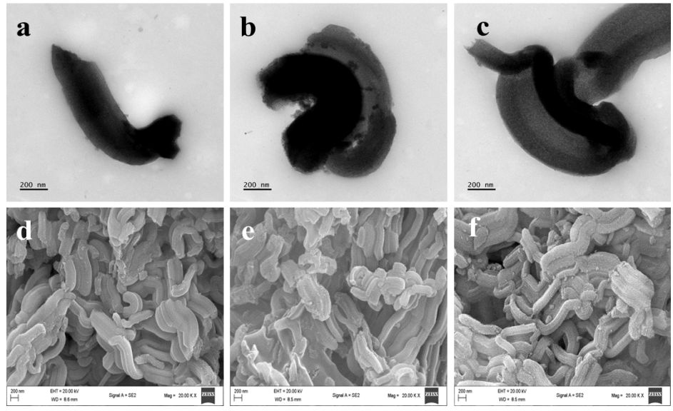
Figure 19: TEM micrographs, L1@SBA15 (a), L2@SBA-15 (b), L3@SBA-15 (c). SEM micrographs, L1@SBA-15 (d), L2@SBA-15 (e), L3@SBA-15 (f).

3.2.3 Adsorption studies

3.2.3.1 Effect of pH on the adsorption of metal cations
The initial pH of a solution is an important component that influences metal cation removal since it impacts not only the surface charge of any sorbent, but also the type of metal cation present in the solution [91]. Therefore, several studies were carried out to assess the influence of pH on the removal of Pb(II), Cr(VI), and Cd(II) cations using L1@SBA-15. The pH range used in this study was between 1-9, higher pH values were not used since at higher pH values metal cations have been found to form precipitates and the reduced stability of functionalized mesoporous silicate materials in high pH solutions [96]. As observed in Table 5, pH 1 recorded the lowest removal efficiency 37%, 24% and 67% for Cr(VI), Cd(II) and Pb(II) respectively. At low pH levels, H⁺ ions compete with metal cations for binding sites on the adsorbent due to their high concentration [97].
Table 5: % Removal efficiencies by variation of pH
pH | % Removal efficiency for different metal cations
pH | Cr(VI) | Pb(II) | Cd(II)
1 | 37.7 | 43.3 | 24.5
3 | 68 | 73.2 | 46.2
5 | 55.4 | 83.3 | 44.5
7 | 45.3 | 98.3 | 40.5
9 | 42.2 | 99.8 | 35.9
Reaction conditions: contact time 24 hrs, adsorbent dose 20 mg, initial metal concentration 20 ppm (Cr(VI), Cd(II), Pb(II)) using L1@SBA-15
For Cd(II) and Cr(VI) cations, the optimum removal efficiency was recorded at pH 3 of 46% and 68% and a decrease in removal efficiency was observed as pH was increased (Figure 20 and Table 5). This could be because as the pH was increased, the metal cations precipitated out as hydroxide ions and at higher pH levels there is an extensive competition for adsorption on the positively charged binding sites between the negatively charged OH⁻ anions and metal cations [98]. However, Pb(II) cation showed a different trend in comparison to the other metal cations in that as the pH was increased so did the removal efficiency, attaining the highest removal efficiency of 99% at pH 9 (Table 5). This is because Pb(II) cations exist as free cations abundantly between the pH ranges of 1-9 because these conditions are acidic enough to prevent the precipitation of Pb(OH₂), therefore, enabling the cations to be viable for removal [99].
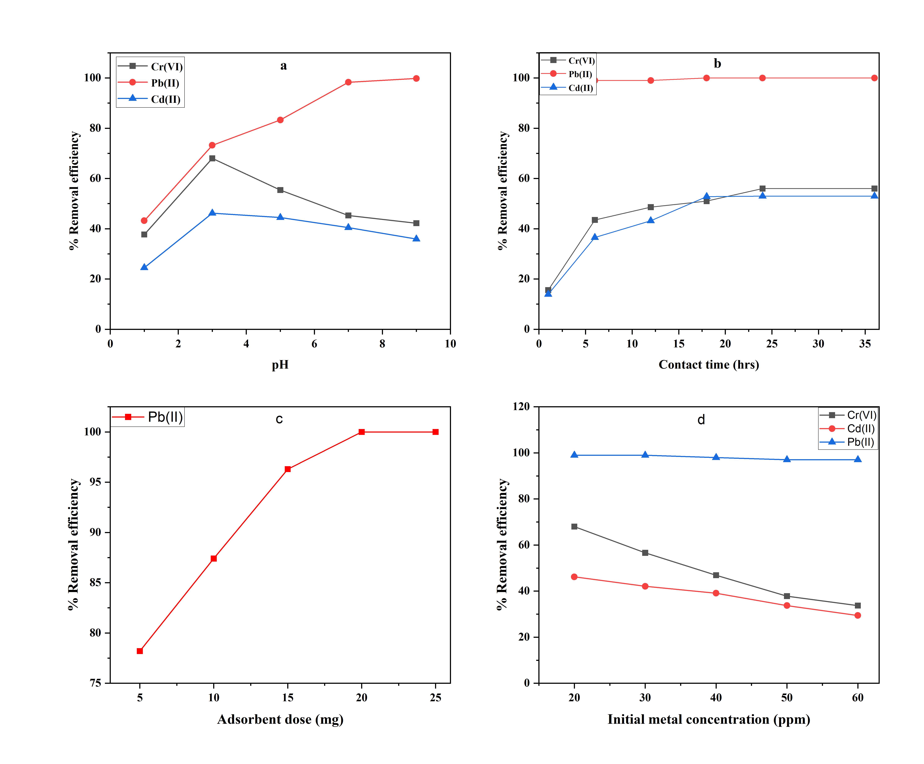
Figure 20: % Removal efficiencies of L1@SBA-15 showing the effect of (a)-pH, (b)-contact time, (c)-adsorbent dosage, (d)-initial metal concentration.

3.2.3.2 Effect of initial metal concentration on adsorption
Heavy metal cations removal by any mesoporous compound normally depends heavily on the bonding mechanism between the donor atoms present on the molecules immobilized on the adsorbent’s and the metal cation. Hence, to study the influence of initial metal cation concentration, 20 mg of L1@SBA-15 was dispersed in 15 mL of Cr(VI), Cd(II) and Pb(II) solution with a concentration range of 20 ppm to 60 ppm. As illustrated in Figure 20(d), the quantity of metal cation adsorbed as a function of initial metal concentrations, and a general trend was seen in which the removal capacity of the adsorbents reduced when the initial metal concentration was increased. The highest removal efficiencies recorded for Cr(VI) and Cd(II) cations were 68% and 46% respectively, at 20 ppm (Table 6), and very high removal efficiencies for Pb(II) cations at >96% also at 20 ppm (Table 6). This trend can be attributed to the difference between the ratio of the total metal cations to the binding sites on the surface of the adsorbent. Thus, at higher metal concentrations, the overall number of metal cations is substantially larger than the number of active binding sites present on the surface of L1@SBA-15, resulting in a drop in removal efficiency. In conclusion, the decrease in adsorption rate can be related to the adsorption/desorption equilibrium attained between the extractant and the metal cations in the solution, as comparable findings have also previously been reported [99, 100].
Table 6: % Removal efficiencies by variation of initial metal concentration
Initial metal concentration (ppm) | % Removal efficiency of different metal cations
Initial metal concentration (ppm) | Cr(VI) | Cd(II) | Pb(II)
20 | 68 | 46.2 | 99
30 | 56.6 | 42.1 | 99
40 | 46.9 | 39.1 | 98
50 | 37.8 | 33.7 | 97
60 | 33.7 | 29.4 | 97
Reaction conditions: contact time 24 hrs, adsorbent dose 20 mg, pH 3 (Cr(VI), Cd(II)) , pH 7 ( Pb(II)) using L1@SBA-15.
Evaluation of the favorableness of adsorption for Cr(VI), Cd(II) and Pb(II) cations, was done by the calculation of the separation factor (R_{L}) and given in Table 7.
Table 7: Separation factor (RL) values for the sorption of metal cations based on Langmuir isotherm
Initial conc. (mg L⁻¹) | Cr(VI) | Cd(II) | Pb(II)
20 | 0.480 | 0.225 | 0.0015
30 | 0.381 | 0.162 | 0.0009
40 | 0.316 | 0.127 | 0.0007
50 | 0.270 | 0.104 | 0.0005
60 | 0.235 | 0.088 | 0.0003

All the metal cations recorded values in the range, 0<R_{L}<1, which is an indicator that the removal of the metal cations was favorable and similar findings reported by [101, 102]. Four adsorption isotherm models listed in Table 8, were employed in evaluating the removal data of Cr(VI), Cd(II) and Pb(II) cations on L1@SBA-15 at different initial metal concentrations. The Langmuir isotherm which presumes that the maximum adsorption capacity of any system can be attained when an adsorbent's surface has a saturated monolayer of adsorbate ions, and the adsorption energy remains constant [103]. Both linear and non-linear forms of the isotherm recorded the highest R² values for the metal cations, >0.99 for Cr(VI) and Pb(II) cations and >0.94 for Cd(II) cations. These results demonstrated that the isotherm is a reasonable match to analyze the removal data, implying that the adsorption process of metal cations may be characterized by the formation of a monolayer on the adsorbent's surface (Figure 21). Freundlich isotherm model recorded R² of 0.9821, 0.8784, 0.9148 for Cr(VI), Cd(II) ad Pb(II) cations respectively, and Temkin isotherm recorded R² >0.90 for the studied metal cations which depicts an avid interaction between the metal cations and the adsorbent’s L1@SBA-15 surface (Table 8). Redlich-Peterson isotherm which includes three adjustable parameters integrated into an empirical system, and is normally and widely used as a combination between Freundlich and Langmuir systems [104], recorded R² of 0.9695, 0.9855 and 0.9943 for Cr(VI), Cd(II) and Pb(II) cations respectively. Similarly, the β values obtained using this isotherm obtained were β≈1 which is an indication that the system is most suitable to fit Langmuir adsorption isotherm which is also confirmed by the high R² values recorded by Langmuir isotherm [105].

Table 8: Adsorption isotherms and their respective parameters
Isotherm Model |  | Cr(VI) ion |  | Cd(II) ion |  | Pb(II) ion
 |  | Parameter | R² | Parameter | R² | Parameter | R²
Langmuir | Linear | q_{m}=36.114  K_{L}=0.054 | 0.9924 | q_{m}=16.631  K_{L}=0.172 | 0.9459 | q_{m}=125  K_{L}=3.721 | 0.9957
Langmuir | Non-linear | q_{m}=36.052  K_{L}=0.051 | 0.9818 | q_{m}=16.280  K_{L}=0.190 | 0.9367 | q_{m}=125.02  K_{L}=3.708 | 0.9884
Freundlich | Linear | K_{F}=3.262  n=1.761 | 0.9821 | K_{F}=5.977  n=4.071 | 0.8784 | K_{F}=83.268  n=12.508 | 0.9148
Freundlich | Non-linear | Kfr =3.517  nfr =1.844 | 0.9793 | Kfr =6.297  nfr =4.366 | 0.8813 | Kfr =85.862  nfr =13.691 | 0.8821
Redlich-Peterson | Linear | α_{R}=0.307  β=0.562 | 0.9695 | α_{R}=0.167  β=0.754 | 0.9855 | α_{R}=0.015  β=0.920 | 0.9943
Redlich-Peterson | Non-linear | K_{R}=1.854  α_{R}=0.038  β=1.338 | 0.9863 | K_{R}=3.095  α_{R}=0.074  β=2.573 | 0.9367 | K_{R}=463.608  α_{R}=0.326  β=11.366 | 0.9884
Temkin | Linear | A=0.426  B=8.546 | 0.9861 | A=4.022  B=2.877 | 0.9043 | A=53835.86  B=7.823 | 0.9151
Temkin | Non-linear | A=0.426  B=8.545 | 0.9861 | A=4.021  B=2.876 | 0.9043 | A=53836  B=7.823 | 0.9150
q_{m}- Maximum adsorption capacity of the adsorbent (mg/g), K_{L}- Energy constant affiliated to heat of adsorption (L/mg), K_{F}- Freundlich constant ((mg/g)(L/mg)^{(1/n)}).
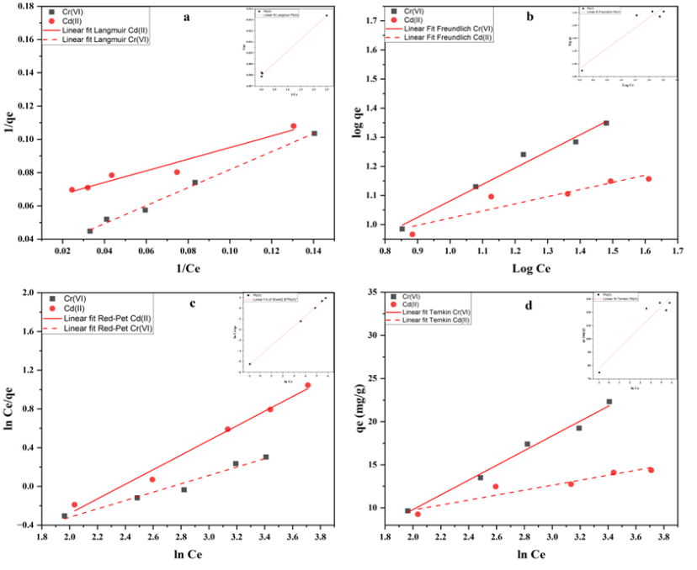
Figure 21: Linear adsorption isotherm studies for Cr(VI), Cd(II) and Pb(II) cations on L1@SBA-15. Langmuir isotherm (inset, Pb(II) isotherm) (a), Freundlich isotherm (inset, Pb(II) isotherm) (b), Redlich-Peterson isotherm (inset, Pb(II) isotherm) (c) and Temkin isotherm (inset, Pb(II) isotherm) (d).

3.2.3.3 Effect of contact time on adsorption
To determine the optimum contact time for the removal of Cr(VI), Cd(II) and Pb(II) cations from aqueous solution using L1@SBA-15, contact time varied between 1-24 h. For every experimental run, 0.02 g of L1@SBA-15 was suspended in 15 mL of metal cation aqueous solutions with constant stirring at 430 rpm at room temperature. As is evident from Figure 20 (b), as the contact time increased so did the removal efficiency. This trend could be ascribed to increased interaction of the metal cations present in solution with the binding sites. Thus, as observed, 1h recorded the least removal efficiency of 16%, 86% and 14% for Cr(VI), Pb(II) and Cd(II) cations, respectively, while 24 h recorded the highest removal efficiency of 56%, 99% and 53% for Cr(VI), Pb(II) and Cd(II) cations, respectively, (Table 9).
Table 9: % Removal efficiencies by contact time variation
Contact time (hrs) | % Removal efficiency of different metal cations
Contact time (hrs) | Cr(VI) | Pb(II) | Cd(II)
1 | 15.5 | 96 | 13.9
6 | 43.5 | 99 | 36.5
12 | 48.6 | 99 | 43.2
18 | 51.1 | 100 | 47.9
24 | 56 | 100 | 53
36 | 56 | 100 | 53
Reaction conditions: initial metal concentration 20 ppm (Cr(VI), Cd(II)), 20 ppm (Pb(II)), adsorbent dose 20 mg, pH 3 (Cr(VI), Cd(II)) , pH 7 ( Pb(II)) using L1@SBA-15

It was also observed that after only 1 h, 96% of Pb(II) cations was extracted from solution exhibiting significantly fast removal kinetics of the metal cations-matrix interaction which can be explained by the increased affinity between the metal cations and the adsorbent depicting a robust adsorbent-metal interaction. This, furthermore, reflects an impressive accessibility of the active chelating sites on the sorbent and relatively a high binding affinity of the metal cations [99].
Various kinetic models were utilized in the study of the nature of adsorption kinetic process of Cr(VI), Cd(II) and Pb(II) cations from aqueous solution using L1@SBA-15. The pseudo-second-order kinetic model (PSO) given in Table 3, is normally utilized in the prediction of the kinetic behavior of adsorption taking into account that chemisorption is the rate-controlling step [106]. It was observed that the removal data was in proper agreement with the PSO model as compared to the other models utilized, where high correlation coefficient values (R²) of 0.9881, 0.9918 and 0.9922 for Cr(VI), Cd(II) and Pb(II) cations respectively were recorded (Table 10). This confirms that the rate determining step is chemisorption and that the removal of metal ions is controlled by a chemical processes. Interestingly, Pb(II) cations showed the least difference between q_{e} exp and q_{e} cal as shown Table 10. This could be attributed to the fact that Pb(II) cations possess a much greater ionic radius and atomic weight, higher electronegativity and a smaller Z/R (charge/radius) ratio as compared to Cd(II) and Cr(VI) cations [107, 108]. Furthermore, this also explains the poor fitness of the removal data with respect to Pseudo-first-order model which assumes that physisorption is the rate determining step of a process, however, the high correlation coefficients recorded in Table 10, indicate otherwise validating that chemisorption is the rate determining step in the adsorption of the metal cations.
The Lagergren pseudo-first-order, gave a large difference between the q_{e} experimental and calculated values (q_{e-exp}- q_{e-cal}) which were 9.66-6.096 for Cr(VI), 9.255-6.615 Cd(II) and 74.7-75.927 (mg/g) for Pb(II) cations respectively, (Table 10). This was a clear indication that the pseudo-first-order kinetic model was a relatively poor fit for the experimental data as similar findings were also reported by [100]. Elovich kinetic model which is founded on a kinetic principle that assumes the number of active binding sites on the sorbent’s surface increases exponentially with adsorption implying that there is a multilayer adsorption [106], recorded R² values of 0.9865, 0.9877 and 0.9906 for Cr(VI), Cd(II) and Pb(II) cations respectively, (Table 10). The intraparticle diffusion model (IPD) which was also used to evaluate the influence of mass transfer resistance on the binding capacity of Cr(VI), Cd(II) and Pb(II) cations onto L1@SBA-15 recorded R² >0.94. Additionally, the C (intercept) obtained for IPD model were 1.752, 1.212, 28.286 for Cr(VI), Cd(II) and Pb(II) cations respectively, depicting that the linear regression obtained for each metal cation did not pass through the origin, which can be explained by the disparity in the rate of mass transfer at both the initial and final stages of metal cation adsorption [100]. In conclusion, the pseudo-second-order model recorded the highest R² values compared to the other models studied, therefore affirming that the nature of adsorption of metal cations onto L1@SBA-15 is through chemisorption.

Table 10: Kinetic models and other statistical parameters
Kinetic model | Parameters | Metal ions solution
Kinetic model | Parameters | Cr(VI)  (20ppm) | Cd(II)  (20ppm) | Pb(II)  (20ppm)
Pseudo-first-order equation | K_{ad} (min⁻ ¹) | 0.067 | 0.067 | 0.213
Pseudo-first-order equation | q_{e} exp (mg/g) | 9.66 | 9.255 | 74.7
Pseudo-first-order equation | q_{e} cal (mg/g) | 6.096 | 6.615 | 75.927
Pseudo-first-order equation | R² | 0.9028 | 0.9658 | 0.8239
Pseudo-second-order equation | K₂ (g mg⁻ ¹ min⁻ ¹) | 0.062 | 0.051 | 0.012
Pseudo-second-order equation | q_{e}, exp (mg/g) | 9.66 | 9.255 | 74.7
Pseudo-second-order equation | q_{e}, cal (mg/g) | 8.646 | 8.204 | 75.075
Pseudo-second-order equation | h (mg g⁻ ¹ min⁻ ¹) | 5.186 | 3.896 | 67.522
Pseudo-second-order equation | R² | 0.9881 | 0.9918 | 0.9922
Elovich equation | α (mg/g min) | 5.931 | 4.14 | 184.824
Elovich equation | β (g/mg) | 0.502 | 4.981 | 0.079
Elovich equation | R² | 0.9865 | 0.9877 | 0.9976
Intraparticle diffusion | K_{diff} (mg/g min^{1/2}) | 1.459 | 1.436 | 9.904
Intraparticle diffusion | C | 1.752 | 1.212 | 28.286
Intraparticle diffusion | R² | 0.8769 | 0.9467 | 0.9345

3.2.3.4 Effect of adsorbent loading on adsorption
The influence of the adsorbent dosage in the removal efficiency of Pb(II) cations utilizing L1@SBA-15 was also studied (Figure 20(c)). The choice of solely using Pb(II) cations was guided by the fact that among the three metal cations under study, it recorded the highest extraction efficiencies, thus propagating the need to establish the influence of dosage variation in its extraction. Doses of 0.005, 0.01, 0.015, 0.02 and 0.025 g of sorbent were used for the removal of Pb(II) cations from 100 ppm aqueous solution. Generally, it was observed that the removal efficiency positively correlated with the adsorbent dosage; as the adsorbent dosage increased so did the removal efficiency. In essence, a higher adsorbent dose implies that there are more active functional groups and binding sites available for the uptake of a metal cation on the sorbent’s surface translating to high removal efficiencies [109, 110]. The maximum removal of Pb(II) cations was achieved at a dose of 0.025g recording an efficiency of 99% (Table 11).
Table 11: % Removal efficiencies by adsorbent dose variation
Adsorbent dose (g) | % Removal efficiency
Adsorbent dose (g) | Pb(II)
0.005 | 78.2
0.01 | 87.4
0.015 | 96.3
0.02 | 100
0.025 | 100
Reaction conditions: initial metal concentration 100 ppm, contact time 24 h, pH 7 using L1@SBA-15.

3.2.4 Adsorbent-metal interactions
Adsorbent L1@SBA-15 was utilized in the optimization process which recorded an optimum removal efficiency of 99% for Pb(II) ion at pH 9, initial metal concentration of 20 ppm and an adsorbent dosage of 25 mg. The optimum removal efficiencies significantly varied (p<0.05) for Cr(VI) and Cd(II) cations which recorded efficiencies of 64% and 62%, respectively, (Figure 22), were pH 3 and initial metal concentration of 20 ppm. These optimum conditions were then utilized in the subsequent removals of the studied metal cations using adsorbents L2@SBA-15 and L3@SBA-15. Adsorbent L2@SBA-15 recorded efficiencies for Cr(VI), Cd(II) and Pb(II) cations of 41%, 66%, and 93%, respectively, and 20%, 88% and 55%, respectively, for L3@SBA-15 (Figure 22).
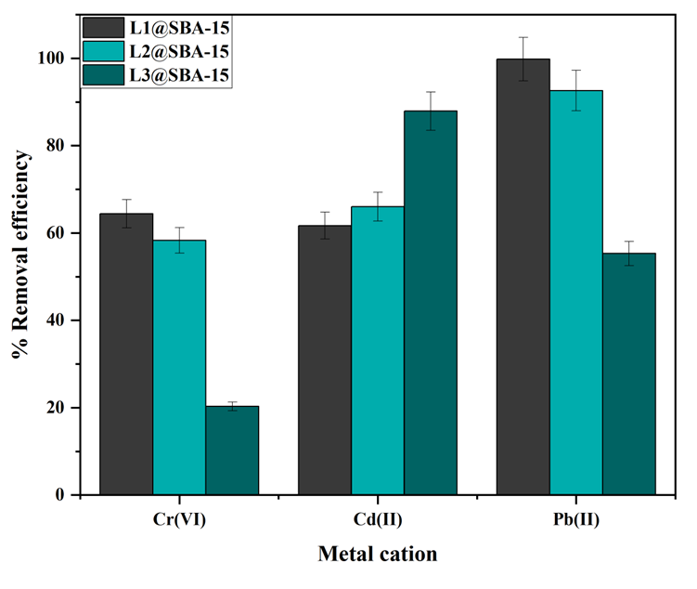
Figure 22: % Removal efficiency for different metal cations using L1@SBA-15 to L3@SBA-15.
These results can be attributed to the Hard Soft Acid Base (HSAB) theory; L1@SBA-15 and L2@SBA-15 possess N^N^O and N^N^N donor atoms, respectively, and thus, they are classified as borderline hard bases while L3@SBA-15 possess N^N^S donor atoms and is classified as a borderline soft base due to the presence of the soft sulphur atom. Adsorbents L1@SBA-15 and L2@SBA-15 yielded high removal efficiencies for the borderline hard acid, Pb(II) cation, of 99% and 93%, respectively, and average removal efficiencies for the hard Cr(VI) acid of 64% and 58%, respectively. Adsorbent L1@SBA-15 possesses a hard oxygen atom as compared to L2@SBA-15 that contains a relatively softer nitrogen atom, and the influence of these donor atoms was evident from the relatively higher removal efficiency of L2@SBA-15 for Cd(II) cations (66%) as compared to 62% of L1@SBA-15 for the same metal cation. Compound L3@SBA-15 recorded the highest removal efficiency of 88% for the soft Cd(II) cation as compared to L1@SBA-15 and L2@SBA-15 (Table 12). A large surface areas of the adsorbents was expected to result in enhanced removal capacity of the adsorbents. However, L3@SBA-15 that had the smallest surface area of all the adsorbents registered the highest removal efficiency for Cd(II) cation as shown in Table 12.
Table 12: Physical properties and removal efficiencies of metal cations using different adsorbents.
Sorbent | Classification | ªS_{BET} (m²/g) | ^{b}PD (nm) | Metal cation/Overall removal efficiency
 |  |  |  | Cr(VI) | Cd(II) | Pb(II)
L1@SBA-15 | Hard | 105 | 8.7 | 64 | 62 | 99
L2@SBA-15 | Borderline soft | 128 | 8.3 | 41 | 66 | 93
L3@SBA-15 | Borderline soft | 58 | 13 | 20 | 88 | 55
ª BET surface area, ^{b} Pore diameter.
Furthermore, adsorbent L2@SBA-15 had the largest surface but did not yield higher removal efficiencies of the metal cations in comparison to L1@SBA-15. These results show that coordination of the chelating ligands enhanced the adsorbent-metal interaction of the adsorbent systems following the HSAB theory, thereby, influencing the removal of the metal cations in comparison to the surface properties of the adsorbents [111].
FT-IR analysis was done to provide insight into the coordination mechanism of the chelating ligands on the adsorbents with the metal cations in solution during removal (Appendices 8-10). Shifts in vibration frequencies of various functional groups and absence of particular peaks in the used adsorbents were observed in comparison to the FT-IR spectra of the fresh adsorbents, as shown in Table 13.
Table 13: Vibration frequencies (cm⁻¹) of various functional groups in L1@SBA-15 to L3@SBA-15
Entry | Adsorbent/Functional group (υcm⁻¹) | L1@SBA-15 |  | L2@SBA-15 |  | L3@SBA-15
Entry | Adsorbent/Functional group (υcm⁻¹) | Fresh | Used | Fresh | Used | Fresh | Used
1 | C=N | 1630 | 1624 | 1649 | 1643 | 1633 | 1629
2 | N-H | 3289 | - | 3290 | - | 3294 | -
3 | O-H | 3256 | - | - | - | - | -
- Not present
For example, for adsorbent L1@SBA-15, the vibrational frequency peaks of the phenolic (Phe-OH) and N-H functional groups were absent in the used adsorbent (Appendix 8). Additionally, the peak resonating to υ_{(C-O)} functional group in L1@SBA-15 was not observed in the used adsorbent which was attributed to the formation of C-O-M analogue upon metal complexation [112]. Other functional groups present in the adsorbents followed similar trends which could be attributed to the deprotonation of the donor atoms during complexation with the metal cations present in solution consistent with literature reports [112, 113]. Thus, adsorbents L1@SBA-15-L3@SBA-15 were proposed to possess tridentate coordination sites which consisted of N^N^O, N^N^N and N^N^S donor atoms respectively, (Figure 23).
Figure 23: Nature of coordination (N^N^O, N^N^N, and N^N^S) of the immobilized Schiff base chelating ligands to the metal cations.

3.3 Conclusion
Adsorbents L1@SBA-15 to L3@SBA-15 were synthesized and characterized utilizing a wide array of techniques such as NMR, FTIR which confirmed the successful condensation of the ligands and BET/BHJ, PXRD, TGA/DSC, TEM-SEM which confirmed the successful immobilization of the chelating ligands onto SBA-15. The adsorbents were used in the removal of Cr(VI), Cd(II) and Pb(II) cations from aqueous solutions while varying several parameters such as pH, adsorbent dosage, contact time and initial metal concentration. The BET analysis revealed the large surface areas of the adsorbents which was instrumental in the removal capacity of the sorbents as high metal removal efficiencies were recorded. Compound L1@SBA-15 recorded the highest removal efficiency for Pb(II) cations of 99% at an optimum pH of 9 as compared to 64% and 62%, respectively, for Cr(VI) and Cd(II) cations at pH 3 where the removal efficiencies were significantly different (p<0.05),. L2@SBA-15 recorded removal efficiencies of 41%, 66% and 93% whereas L3@SBA-15 recorded 20%, 88% and 55% for Cr(VI), Cd(II) and Pb(II) cations, respectively, which were significantly different (p<0.05). Further, the removal capacity of L1@SBA-15 was influenced by pH, contact time, adsorbent dosage and initial metal concentration.
In addition, the HSAB theory was found to influence the removal of the metal cations more as compared to the adsorbents’ surface properties. To further evaluate the adsorption of Cr(VI), Cd(II) and Pb(II) cations onto L1@SBA-15, several adsorption kinetic models such PFO, PSO, Elovich and IPD were employed where the pseudo-second-order kinetic model was observed to perfectly describe the adsorption process in that it recorded the highest correlation coefficient values, R²>0.98. Moreover, Redlich-Peterson, Langmuir, Temkin, and Freundlich isotherms were also used to study the mechanistic nature of adsorption where The Langmuir isotherm was observed to best characterize the adsorption process in that it recorded the highest R² values for all metal cations. In conclusion, the functionalization of the Schiff base ligands onto mesoporous SBA-15 yielded viable extractants with the potential for remediating environmental components polluted with heavy metals.

CHAPTER FOUR

4.1 Experimental section

4.1.1 Materials and chemicals
The materials and chemicals utilized were similar to those described in section 3.2.1. In addition, magnetic susceptibility experiments were evaluated using a Quantum Design MPMS3 Evercool SQUID magnetometer.

4.1.2 Preparation of Fe₃O₄ MNPs
The MNPs were prepared using a co-precipitation method [114]. About 1.50 g of ferrous chloride (Fe²⁺) was dissolved in 100 mL deionized water at 85℃ under nitrogen atmosphere. After dissolving, 3.00 g of ferric chloride (Fe³⁺) was added to the mixture and a red-brown color was observed. Overall, the mole ratio attained of Fe³⁺ to Fe²⁺ was 2:1. After one hour, about 15 mL of 25% ammonium hydroxide (NH₄OH) was rapidly mixed the reaction mixture and stirred vigorously (500 rpm), immediately forming a black precipitate which indicated the nucleation of Fe₃O₄. The mixture was stirred for 1 h (430 rpm) after which it was filtered, and the residue washed four times with deionized water and ethanol. The residue was subsequently vacuum-dried at 65℃ for 8 h.

4.1.3 Immobilization of Schiff base chelating ligands on MNPs

4.1.3.1 Immobilization of L1 on Fe₃O₄ MNPs
(E)-2-(3,3-dimethoxy-2-oxa-7,10-diaza-3-silaundec-10-en-11-yl)phenol (L1) (1.0 g, 5.3 mmol) was added to 0.50 g of Fe₃O₄ MNPs dispersed in dry toluene (20 mL). The solution was then sonicated for 45 min and refluxed for 24 h at 100℃ under nitrogen environment. Thereafter, the product was filtered and washed three times with dichloromethane and vacuum-dried at 65℃ for 8 h to yield a black powder (L1@Fe₃O₄). Yield 0.80 g (53%). IR υ_{max}/cm⁻¹: υ_{(N-H)}= 3394, υ_{(O-H)}= 3290, υ_{(C=N)}= 1666, υ_{(Si-O)}=1020, υ_{(Fe-O)}=522.

4.1.3.2 Immobilization of L2 on Fe₃O₄ MNPs
Compound L2@Fe₃O₄ using the same procedure described for L1@Fe₃O₄ using (E)-N-(2-((pyridine-2ylmethylene)amino)ethyl)-3-(trimethoxysilyl)propan-1-amine (L2) (1.0 g, 5.3 mmol) and Fe₃O₄ (0.5 g). Yield 0.65 g (43%), which was a black powder. IR υ_{max}/cm⁻¹: υ_{(N-H)}=3384, υ_{(C=N)}= 1634, υ_{(Si-O)}=1025, υ_{(Fe-O)}=545.

4.1.3.3 Immobilization of L3 on Fe₃O₄ MNPs
Compound L3@Fe₃O₄ using the same procedure described for L1@Fe₃O₄ using (E)-N-(2-((thiophen-2-ylmethylene)amino)ethyl)-3-(trimethoxysilyl)propan-1-amine (L3) (0.75 g, 5.3 mmol) and Fe₃O₄ (0.5 g). Yield 0.47 g (38%), black powder. IR υ_{max}/cm⁻¹: υ_{(N-H)}=3382, υ_{(C=N)}= 1625, υ_{(Si-O)}=1018, υ_{(Fe-O)}=558.

4.1.4 Adsorption experiments
Removal experiments were carried out with the same procedure described in section 3.1.5 where 0.01 g of L1@Fe₃O₄-L3@Fe₃O₄ was used and L1@Fe₃O₄ was used in the optimization studies. Adsorption isotherm studies were carried out at room temperature where 0.01 g of L1@Fe₃O₄ was added to 15 mL of solutions containing Cr(VI), Cd(II) and Pb(II) cations at various initial concentrations. The adsorption isotherms used in this study and their respective parameters are given in Table 2. Kinetic studies were conducted using 0.01 g of L1@Fe₃O₄ in 15 mL of different metal concentrations at different time intervals. In the present work, the kinetic models utilized to evaluate the nature of adsorption of the studied metal cations are given in Table 3.

4.1.5 Data analysis
Data analysis will be done using two-way Analysis of Variance (ANOVA) to determine any significant differences in the extraction efficiencies of Cr(VI), Cd(II) and Pb(II) by L1@Fe₃O₄, L2@Fe₃O₄ and L3@Fe₃O₄.

4.2 Results and discussion

4.2.1 Synthesis and characterization of immobilized MNPs
Compounds L1 to L3 were immobilized onto Fe₃O₄ MNPs to afford the functionalized materials L1@Fe₃O₄ to L3@Fe₃O₄ (Scheme 3). The immobilized materials were characterized using several techniques which include FT-IR, TEM-SEM, VSM and BET-BHJ.
Scheme 3: Immobilization of Fe₃O₄ MNPs to give, L1@Fe₃O₄ to L3@Fe₃O₄; dry toluene, reflux 24 h under nitrogen atmosphere (i-iii).
The FTIR spectra of L1@Fe₃O₄ to L3@Fe₃O₄ showed very strong adsorption bands which were between 1010-1105cm⁻¹ and 740-790cm⁻¹ for all the sorbents (Figure 24). These vibrational frequencies were conferred to the asymmetric bending and stretching vibrations of the O-Si functional group which were present in the Fe₃O₄ MNPs framework confirming the successful immobilization of the chelating compounds. Additionally, strong stretching vibrational frequencies ranging from 540-560cm⁻¹ were observed for all the compounds which corresponds to the Fe-O vibration frequency of the magnetite phase, confirming the successful formation of Fe₃O₄ core in the synthesized and functionalized nanoparticles [115].
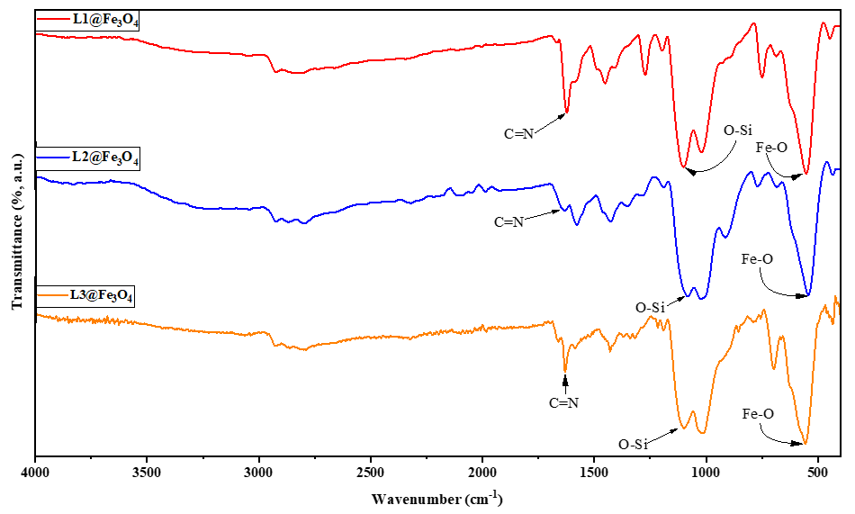
Figure 24: FT-IR spectra of compounds L1@Fe₃O₄, L2@Fe₃O₄ and L3@Fe₃O₄ adsorbent systems showing υ(C=N) resonating between 1620-1670 cm⁻¹ confirming successful immobilization.
The bending vibrational frequency of the secondary amine groups, N-H, was responsible for the bands in the 3382-3394 cm⁻¹ range consistent with previous reports [116, 117]. All the compounds exhibited sharp peaks ranging from 1620-1670 cm⁻¹ which were a result of the azomethine stretching vibration frequency confirming the successful functionalization of the Schiff base ligands onto Fe₃O₄ MNPs matrix. A broad peak at 3290 cm⁻¹ was observed for adsorbent L1@Fe₃O₄ which was a result of the phenolic O-H bending vibrational frequency, validating the successful grafting of salicylaldehyde onto the system [118]. Compound L2@Fe₃O₄ also showed a sharp characteristic peak at 1429cm⁻¹ that confirmed the presence of the pyridine moiety within the sorbent system [90]. Adsorbent L3@Fe₃O₄ on the other hand, exhibited a unique sharp intense peak at 697cm⁻¹, which was assigned to the stretching of C-S bond, thereby, validating the presence of the thiophene moiety in the compound [91]. In addition, the peaks observed between 2850-2930 cm⁻¹ for the adsorbents were a result of the C-H asymmetric stretching vibration in agreement with previous reports [119-121].
Moreover, shifts in υ_{(Si-O)} vibration frequencies were also observed upon the immobilization of the ligands onto the Fe₃O₄ MNPs. For example, the O-Si functional group which had been observed to vibrate at a frequency of 1112 cm⁻¹ in L1 shifted to a lower frequency of 1099 cm⁻¹ in L1@Fe₃O₄ , upon immobilization. Similar trends were observed for the other adsorbents relative to their respective precursor ligands which confirmed the successful immobilization of the Schiff base ligands onto Fe₃O₄ MNPs, which is consistent with literature reports [92, 93].

4.2.1.1 Surface morphology
Normally, under TEM imaging analysis, Fe₃O₄ MNPs usually look like small agglomerated particles [115]. Indeed the MNPs synthesized in this study appearred as particles with narrow sized distributions with some agglomeration, Figure 25a, which is in alignment with literature [115]. The size and regularity of the Fe₃O₄ nanoparticles was further confirmed by SEM imaging as shown in Figure 25e.
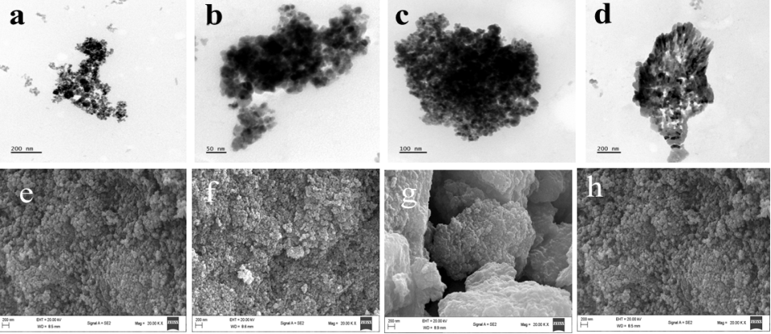
Figure 25: TEM micrographs: pure Fe₃O₄ MNPs (a), L1@Fe₃O₄ (b), L3@Fe₃O₄ (c), L3@Fe₃O₄ (d). SEM micrographs, pure Fe₃O₄ MNPs (e), L1@Fe₃O₄ (f), L2@Fe₃O₄ (g), L3@Fe₃O₄ (h).
The sorbent systems L1@Fe₃O₄ to L3@Fe₃O₄ also showed small agglomerated particles with a similar appearance and narrow distribution as the Fe₃O₄ MNPs, confirming the successful immobilization of AEAPTMS and the Schiff base ligands onto this particular solid support (Figure 25(b-d)). Furthermore, the sorbent materials L1@Fe₃O₄ to L3@Fe₃O₄ showed similar surface morphologies to the MNPs, Figure 25(f-h) respectively, thereby validating the successful functionalization of the chelating ligands on the surface of the solid support.

4.2.1.2 Magnetic properties
The magnetic properties of the sorbent systems were analyzed using a superconducting quantum interference device (SQUID) as illustrated in Figure 26.
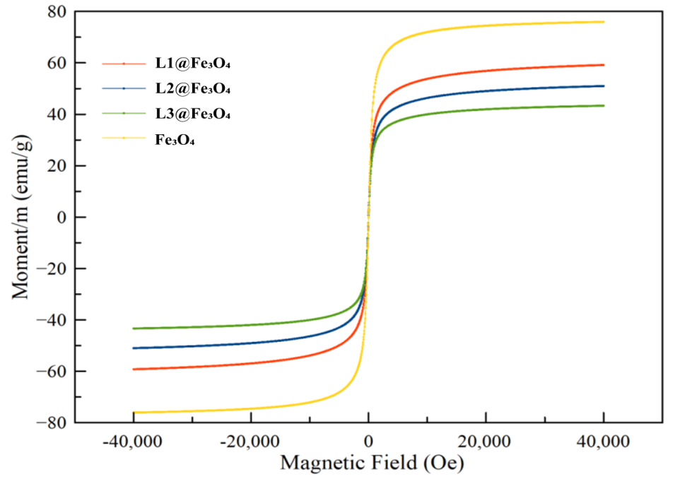
Figure 26: Magnetic properties analysis of MNPs and sorbent L1@Fe₃O₄ to L3@Fe₃O₄.
The magnetization saturation of the purely synthesized Fe₃O₄ MNPs was found to have a magnetic moment of 75.97 emu/g. A drop in the magnetic moment of the immobilized materials was observed in comparison to the MNPs where L1@Fe₃O₄ to L3@Fe₃O₄ recorded values of 60, 50 and 43 emu/g, respectively, as tabulated in Table 14. The drop in the superparamagnetic nature of the compounds could be a result of the functionalization of the adsorbent, where the Schiff base ligands could have diluted the magnetic moment. This is in alignment with a report by Meng et al., who observed that the addition of silicate containing compounds on the surface of Fe₃O₄ MNPs led to a decrease in the magnetic moment of the nanoparticles from 75.2 emu/g to 39.7-42.1 emu/g [115]. In a similar study, it was observed that the immobilization of Fe₃O₄ MNPs core shell caused an alteration of the electronic structure and surface properties of the particles ultimately affecting the magnetic moment of the materials [114, 122]. Thus, the newly formed silicate material/amino interface shell led to the decrease in the coercivity and magnetic saturation. Despite the drop in saturation magnetization, the modified MNPs still displayed significant magnetization, making them ideal for magnetic separation. Furthermore, the absence of hysteresis in the results confirmed the superparamagnetic tendency of the sorbents which affirmed their capability to be used in magnetic separation.

4.2.1.3 Surface properties
Moreover, the specific surface area of the Fe₃O₄-immobilized sorbent systems were assessed by nitrogen adsorption-desorption technique with respect to BET, while the overall porosity of the adsorbents were evaluated using BHJ and results given in Table 14. A H3 form of a hysteresis loop was obtained in the nitrogen physisorption experiments for L1@Fe₃O₄ to L3@Fe₃O₄ which indicates that the materials are mesoporous in nature [123], Appendix 6. The pore size analysis of the materials recorded pore diameters of <20 nm for L1@Fe₃O₄-L3@Fe₃O₄ (Appendix 7) as given in Table 14.
Table 14: The physical and magnetic properties of Fe₃O₄ immobilized systems
Adsorbent | ªS_{BET} (m²/g) | ^{b}PD (nm) | ^{c}Ms (emu/g)
L1@Fe₃O₄ | 21 | 15 | 60
L2@Fe₃O₄ | 21 | 17 | 50
L3@Fe₃O₄ | 7 | 15 | 43
ª-BET surface area (S_{BET}) measured by N₂ physisorption. ^{b}-Pore diameter (PD) calculated according to BHJ. ^{c}-Magnetic moment of non-immobilized Fe₃O₄ MNPs = 75.97 emu/g.

4.2.1.4 Thermal properties
The thermal properties of L1@Fe₃O₄ to L3@Fe₃O₄ were also evaluated using TGA-DSC and the decomposition patterns were acquired in the temperature range 0$-$900 ℃ as shown in Figure 27a.
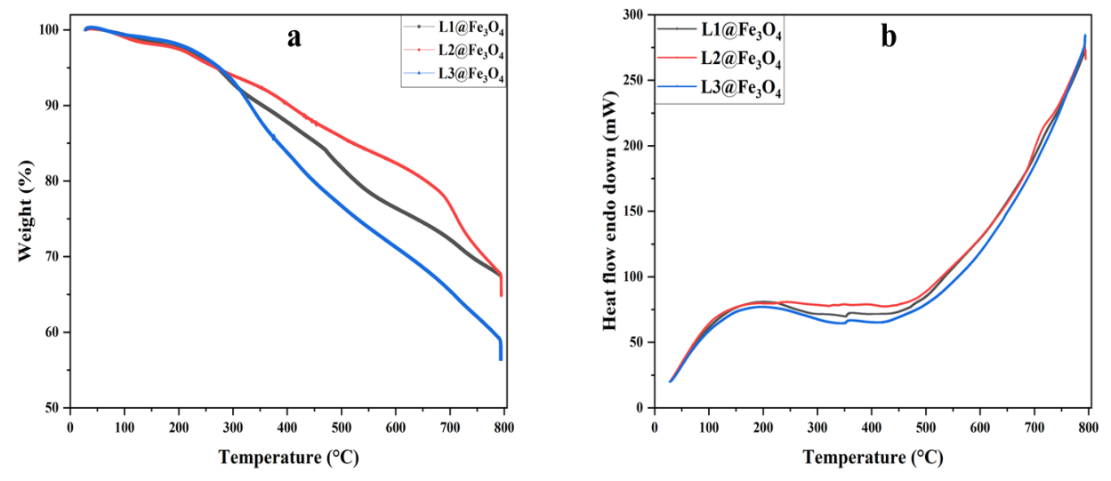
Figure 27: TGA and DSC plots, a and b respectively, showing the decomposition patterns of L1@Fe₃O₄ to L3@Fe₃O₄.
The adsorbents generally showed unique phases of decomposition. For example, between 0 and 200 ℃, it was observed that all adsorbents experienced weight loss which could be attributed to the loss of the moisture content in the compounds. Additionally, between 200 and 600 ℃, the weight loss exhibited by the adsorbents may be attributed to the degradation of the organic core within the compounds. Moreover, from the DSC profiles (Figure 27b) the reactions of the compounds at increased temperatures validated the exothermic nature of the reactions which could be attributed to the melting/decomposition of L1@Fe₃O₄ to L3@Fe₃O₄, consistent with literature reports on TGA analysis [124, 125].

4.2.2 Adsorption studies

4.2.2.1 Effect of pH on adsorption of metal cations
The initial pH of a solution is a particularly essential parameter in the removal of metal cations since it affects not only the surface characteristics of the adsorbent, but also the form of the metal cation prevalent in solution [91]. Thus, in this study, the effect of pH on the removal of Pb(II), Cr(VI), and Cd(II) metal cations using L1@Fe₃O₄ was studied by altering the pH of the solutions from ranges 1.0 to 9.0 as presented in Table 15. As observed in Table 15, the removal efficiencies varied significantly (p<0.05) with lower removal efficiencies of 38%, 19% and 25% for Cr(VI), Pb(II) and Cd(II) cations, respectively, were recorded at pH 1.

Table 15: % Removal efficiencies of metal cations by variation of pH
pH | % Removal efficiency of metal cation
pH | Cr(VI) | Pb(II) | Cd(II)
1 | 38 | 19 | 25
3 | 68 | 47 | 46
5 | 55 | 83 | 45
7 | 45 | 98 | 41
9 | 42 | 99 | 36
Reaction conditions: contact time 24 hrs, adsorbent dose 10 mg, initial metal concentration 20 ppm (Cr(VI), Cd(II), Pb(II)) using L1@Fe₃O₄.
Several studies have shown that at lower pH, protonation of the nitrogen-donor atoms is predominant, thus limiting metal-N interactions [107, 126]. Furthermore, at low pH levels, significant concentrations of H⁺ ions compete with metal cations for active sites on adsorbent surfaces [127]. The optimum pH for Cd(II) and Cr(VI) cations was obtained as 3, giving the maximum removal efficiency of 46% and 68% respectively, (Table 15). Lower removal of Cd(II) and Cr(VI) cations at high pH could be attributed to the possible precipitation of Cd(II)/Cr(VI) (OH)₂ anions at high pH [128]. In contrast, the optimum pH of 9 was recorded for Pb(II) cations displaying removal efficiencies of 99% (Figure 28a)). Furthermore, Pb(II) cation has been shown to be in abundance between pH 1-9 and viable for removal, in good agreement with the trend observed, and consistent with previous findings of Zhu et al., [129].

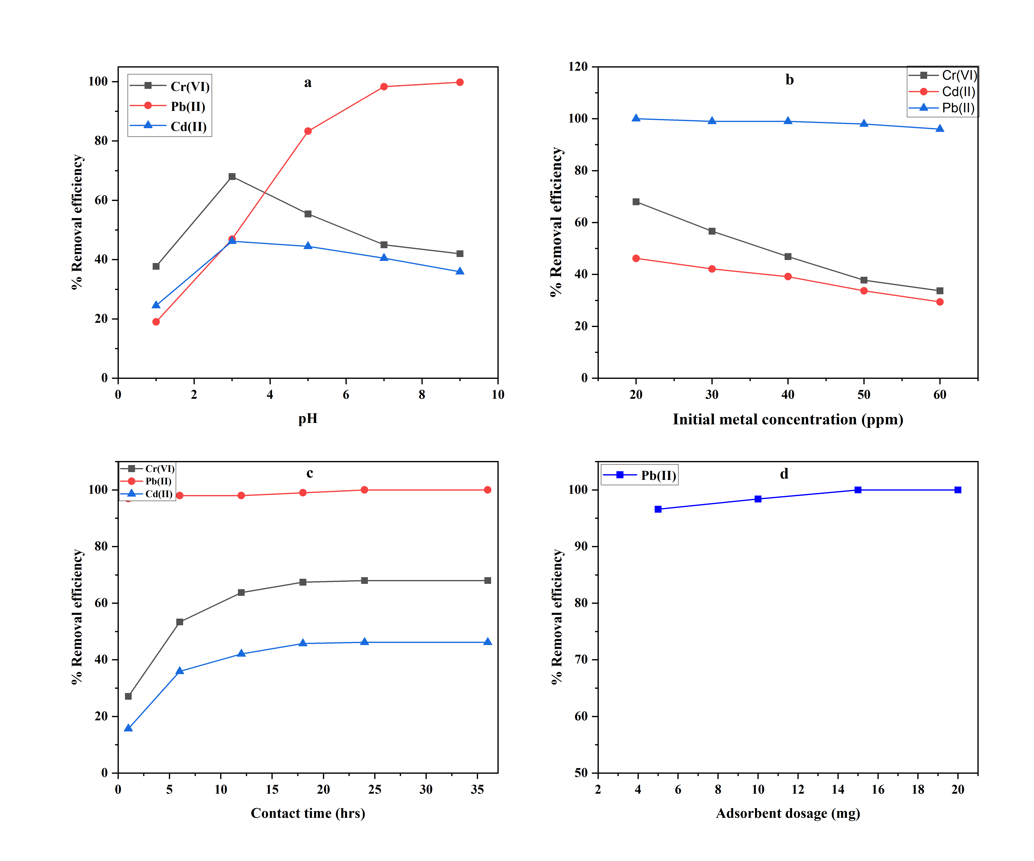
Figure 28: % Removal efficiencies of L1@Fe₃O₄ showing the effect of (a)-pH, (b)- initial metal concentration, (c)-contact time, (d)- adsorbent dosage

4.2.2.2 Effect of initial metal concentration on adsorption
To evaluate the effect of initial concentration on the adsorption process, aqueous solutions of concentrations ranging from 20 ppm to 60 ppm for Cd(II), Cr(VI) and Pb(II) cations were utilized. At lower concentrations of 20 ppm, removal efficiencies of 68%, 46% and 100% for Cr(VI), Cd(II) and Pb(II) cations, respectively, as shown in Table 16.

Table 16: % Removal efficiencies by variation of initial metal concentration
Initial metal concentration (ppm) | % Removal efficiency of different metal cations
Initial metal concentration (ppm) | Cr(VI) | Cd(II) | Pb(II)
20 | 68 | 46 | 100
30 | 57 | 42 | 99
40 | 47 | 39 | 99
50 | 38 | 34 | 98
60 | 34 | 29 | 96
Reaction conditions: contact time 24 hrs, adsorbent dose 10 mg, pH 3 (Cr(VI), Cd(II)) , pH 7 ( Pb(II)) using L1@Fe₃O₄.
It’s also noteworthy to point out that adsorbent L1@Fe₃O₄ maintained very high removal efficiencies for Pb(II) cations even at higher concentrations of 60 ppm, displaying removal efficiencies of 96%. Generally, as is evident from Figure 28(b), the removal efficiency of the adsorbent declined with the increase in concentration of the metal cations. Thus, high metal concentrations would imply lower adsorbent concentrations that translates to an overall decrease in removal efficiency of the adsorbent as metal concentration is increased which is in agreement with previous findings [130, 131]. To evaluate the nature of adsorption of the different metal cations at different initial metal concentrations, several isotherms which include, Freundlich, Temkin, Redlich-Peterson and Langmuir isotherm were utilized in the assessment and clarification of the favorableness of heavy metal cation adsorption on L1@Fe₃O₄. A separation factor R_{L} of 0<R_{L}<1 was obtained (Table 17), which is an indication that the sorption of the cations was favorable [102].
Table 17: Separation factor (RL) values for the adsorption of metal cations based on Langmuir isotherm using L1@Fe₃O₄
Initial conc. (mg L⁻¹) | Cr(VI) | Cd(II) | Pb(II)
20 | 0.162 | 0.516 | 0.0094
30 | 0.114 | 0.415 | 0.0063
40 | 0.088 | 0.347 | 0.0057
50 | 0.072 | 0.299 | 0.0035
60 | 0.061 | 0.262 | 0.0019
It was observed that Langmuir isotherm recorded the highest correlation coefficients (>0.98), (Table 18) which indicated that the adsorption process may be represented by the formation of a monolayer of metal cations on the surface of the adsorbent. Freundlich isotherm model was also used to evaluate the nature of the extraction of Cd(II), Cr(VI) and Pb(II) cations on L1@Fe₃O₄ where it recorded high correlation coefficients and 1/n values for each metal cation (Table 18). This illustrated an avid interaction between the metal cations and the surface of L1@Fe₃O₄ as similar findings were reported by [100]. Redlich-Peterson isotherm, which is an extension of Freundlich and Langmuir kinetic models, was employed and high correlation coefficients and β≈1 values, (Table 18), were recorded indicating that the system best fits the Langmuir adsorption isotherm [100]. This was also confirmed by the high correlation coefficients recorded for Langmuir isotherm, (Table 18). Temkin isotherm model recorded R²>0.90, which was an indication that there was indeed a robust positive interaction between the adsorbing species and the adsorbent (Table 18 and Figure 29).
Figure 29: Linear adsorption isotherm studies for Cr(VI), Cd(II) and Pb(II) cations on L1@Fe3O4. Langmuir isotherm (inset, Pb(II) isotherm) (a), Freundlich isotherm (inset, Pb(II) isotherm) (b), Redlich-Peterson isotherm (inset, Pb(II) isotherm) (c) and Temkin isotherm (inset, Pb(II) isotherm) (d).

Table 18: Isotherm models and other statistical parameters of adsorption using L1@Fe₃O₄
Isotherm Model |  | Cr(VI) ion |  | Cd(II) ion |  | Pb(II) ion
 |  | Parameter | R² | Parameter | R² | Parameter | R²
Langmuir | Linear | q_{m}=32.840  K_{L}=0.2581 | 0.9903 | q_{m}=41.771  K_{L}=0.0469 | 0.9881 | q_{m}=450.450  K_{L}=0.3153 | 0.9911
Langmuir | Non-linear | q_{m}=32.762  K_{L}=0.2619 | 0.9824 | q_{m}=36.619  K_{L}=0.0561 | 0.9775 | q_{m}=472.245  K_{L}=0.2426 | 0.9785
Freundlich | Linear | K_{F}=14.420  n=4.860 | 0.940 | K_{F}=4.672  n=2.0820 | 0.9482 | K_{F}=156.070  n=4.233 | 0.9042
Freundlich | Non-linear | Kfr =14.869  nfr =5.106 | 0.9371 | Kfr =5.372  nfr =2.285 | 0.9389 | Kfr =184.109  nfr =5.181 | 0.9038
Redlich-Peterson | Linear | α_{R}=0.069  β=0.794 | 0.9957 | α_{R}=0.214  β=0.520 | 0.9775 | α_{R}=0.0064  β=0.764 | 0.9899
Redlich-Peterson | Non-linear | K_{R}=8.583  α_{R}=0.087  β=3.021 | 0.9823 | K_{R}=2.166  α_{R}=0.040  β=1.398 | 0.9775 | K_{R}=114.6  α_{R}=0.0018  β=1.384 | 0.9785
Temkin | Linear | A=9.407  B=5.142 | 0.9559 | A=0.426  B=9.478 | 0.9722 | A=7.745  B=68.404 | 0.9594
Temkin | Non-linear | A=9.407  B=5.141 | 0.9552 | A=0.425  B=9.478 | 0.9720 | A=7.744  B=68.403 | 0.9593

4.2.2.3 Effect of contact time on adsorption
To assess the influence of contact time on the metal cation removal, 15 mL of aqueous solutions of 20 ppm Cr(VI), Cd(II), and Pb(II) cations using 0.01 g of adsorbent L1@Fe₃O₄ was evaluated by varying contact time from 1 h to 24 h. As is evident from Figure 28(c), an increase in contact time generally translated to an increase in removal efficiencies of the metal cations. The lowest removal efficiencies were recorded at 1 h of 27%, 16% and 86% for Cr(VI), Cd(II) and Pb(II), respectively. The optimum removal efficiencies recorded were at 18 h of 68%, 98% and 46% for Cr(VI), Pb(II) and Cd(II) cations, respectively, as shown in Table 19. It is also worth noting that after 1 h, the adsorbent displayed an removal efficiency of 86% for Pb(II) cations, pointing to the high sorption capacity and fast kinetics towards Pb(II) cation which could be attributed to high adsorbent-metal interaction, consistent with other previous studies [132, 133].
Table 19: % Removal efficiencies of metal cations by contact time variation
Contact time (hrs) | % Removal efficiency of metal cations
Contact time (hrs) | Cr(VI) | Pb(II) | Cd(II)
1 | 27 | 97 | 16
6 | 53 | 98 | 36
12 | 64 | 98 | 42
18 | 67 | 99 | 46
24 | 68 | 100 | 46
36 | 68 | 100 | 46
Reaction conditions: initial metal concentration 20 ppm (Cr(VI), Cd(II), (Pb(II)), adsorbent dose 10 mg, pH 3 (Cr(VI), Cd(II)) , pH 7 ( Pb(II)) using L1@Fe₃O₄.
Kinetic models given in Table 3, were used to assess the nature of adsorption of Cr(VI), Cd(II) and Pb(II) cations on L1@Fe₃O₄ at different contact times. The pseudo-second-order kinetic model which is founded on the assumption that valence forces are involved in the substitution of electrons between the adsorbate and adsorbent was used to evaluate the nature of adsorption of the studied metal cations on L1@Fe₃O₄. The experimental data (Table 20) are in good agreement with the PSO model characterized by the high R² values (>0.99) for all the metal cations as compared to the other kinetic models utilized in the study. This affirms that the rate determining step is chemisorption and removal of metal cations is controlled by chemical processes [134]. Interestingly, Pb(II) cations showed a higher adsorption rate compared to the other metal cations (Table 20). This is because Pb(II) cation has a greater ionic radius, larger atomic weight, greater electronegativity and smaller Z/R (charge/radius) ratio as compared to Cd(II) and Cr(VI) cations [107, 108]. Furthermore, the good correlations between the calculated and experimental q_{e} values indicated a perfect fit of this model for the use of L1@Fe₃O₄ in the removal of the studied metal cations. The extraction data was also evaluated using Lagergren pseudo-first-order which recorded R²>0.93 and it was also noted that there was a large difference between the equilibrium adsorption capacity (q_{e}) values of the experimental and calculated data while utilizing this model, implying that it’s an improper fit to explain the nature of adsorption of the metal cations on L1@Fe₃O₄. Elovich model which was also utilized recorded R²>0.99 which was attributed to the enhanced adsorbent-metal interaction during extraction (Table 20). Since the kinetic results fitted well to the chemisorption kinetic model, the intraparticle diffusion model was further utilized to evaluate the influence of mass transfer resistance on the binding of metal cations to L1@Fe₃O₄. A linear plot of the various concentrations did not pass through the origin which could be because of the difference in the mass transfer rate at both the initial and final stages of metal cation adsorption which was an indication that there is a degree of boundary layer control [100].

Table 20: Kinetic models and other statistical parameters of adsorption using L1@Fe₃O₄
Kinetic model | Parameters | Metal ions solution
Kinetic model | Parameters | Cr(VI)  (20ppm) | Cd(II)  (20ppm) | Pb(II)  (20ppm)
Pseudo-first-order equation | K₁ (min⁻ ¹) | 0.0118 | 0.0231 | 0.0951
Pseudo-first-order equation | q_{e} exp (mg/g) | 23.565 | 20.685 | 147.705
Pseudo-first-order equation | q_{e} cal (mg/g) | 19.539 | 13.396 | 144.233
Pseudo-first-order equation | R² | 0.9321 | 0.9870 | 0.9969
Pseudo-second-order equation | K₂ (g mg⁻ ¹ min⁻ ¹) | 0.0377 | 0.0351 | 0.0349
Pseudo-second-order equation | q_{e}, exp (mg/g) | 23.565 | 20.685 | 147.705
Pseudo-second-order equation | q_{e}, cal (mg/g) | 21.222 | 14.533 | 148.148
Pseudo-second-order equation | h (mg g⁻ ¹ min⁻ ¹) | 18.853 | 10.560 | 763.358
Pseudo-second-order equation | R² | 0.9950 | 0.9940 | 0.9997
Elovich equation | α (mg/g min) | 28.333 | 12.886 | 1.25E10
Elovich equation | β (g/mg) | 0.240 | 0.317 | 0.1666
Elovich equation | R² | 0.9946 | 0.9937 | 0.9995
Intraparticle diffusion | K_{diff} (mg/g min^{1/2}) | 4.149 | 2.880 | 63.752
Intraparticle diffusion | C | 2.875 | 1.571 | 25.285
Intraparticle diffusion | R² | 0.9126 | 0.9282 | 0.8294

4.2.2.4 Effect of adsorbent dosage on adsorption
The influence of adsorbent dose on the removal efficiencies was investigated using Pb(II) cations by varying the concentrations of L1@Fe₃O₄ from 0.005 g to 0.02 g. The choice of solely using Pb(II) cations was guided by the fact that among the three metal cations under study, it recorded the highest extraction efficiencies, thus propagating the need to establish the influence of dosage variation in its extraction. It was observed that the lowest adsorbent dose, 0.005 g, recorded the least efficiency of 96% while the highest adsorbent dose, 0.02 g, recorded the highest removal efficiency of 100%, as shown in Figure 28(d). It is obvious that the removal effectiveness of the adsorbent rose with an increase in the adsorbent dose quantity, which may be attributed to an increase in the material's active sites (available active binding sites ≥ total number of ions in solution), consistent with previous findings in related studies [132, 135, 136].

4.2.3 Adsorbent-metal interaction
Adsorbent L1@Fe₃O₄ was used to optimize the removal parameters such as pH, time, dosage and metal cation concentration (Figure 30). It was observed that adsorbent L1@Fe₃O₄ recorded the highest removal efficiencies for Pb(II) cations of 99% at optimized conditions of pH 9, initial metal concentration of 20 ppm, contact time 24 h and adsorbent dosage of 20 mg. Similarly, adsorbent L1@Fe₃O₄ recorded optimum removal efficiencies for Cr(VI) and Cd(II) cations, 68% and 46%, respectively, at pH 3, initial metal concentration of 20 ppm, contact time 24 h and adsorbent dosage of 10 mg. These optimum removal conditions were then employed in the subsequent removal of Cr(VI), Cd(II), and Pb(II) cations using adsorbents L2@Fe₃O₄ and L3@Fe₃O₄.
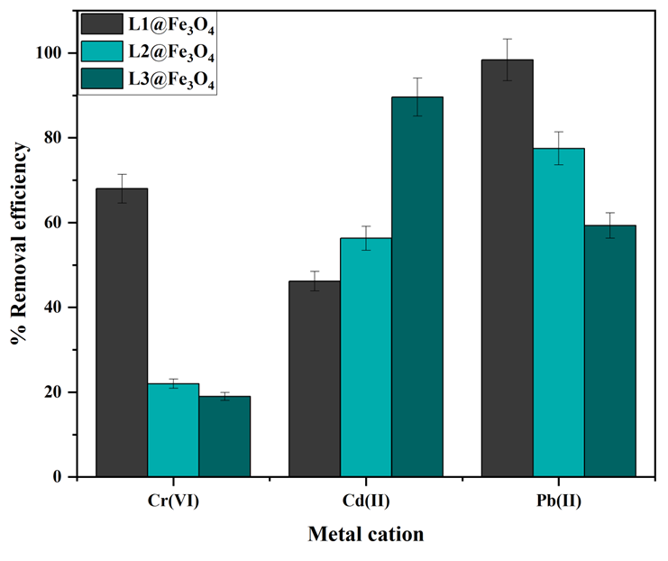
Figure 30: % Removal efficiency for different metal cations using L1@Fe₃O₄ to L3@Fe₃O₄
As shown in Figure 30, compound L2@Fe₃O₄ exhibited relatively high removal efficiency for Pb(II) cations of 78%, compared to the removal capacities of 22% and 56% for Cr(VI) and Cd(II) cations, respectively. On the other hand, adsorbent L3@Fe₃O₄ displayed removal efficiencies of 89%, 59% and 19% for Cd(II), Pb(II) and Cr(VI) cations, respectively. The removal efficiencies of the different adsorbents varied significantly (p<0.05). The varied removal efficiencies of the three adsorbents could be explained by the Hard Soft Acid Base Theory [137]. The metals used in this study vary in terms of their acidity; Pb(II) cation is a borderline hard acid, Cr(VI) cation is a hard acid while Cd(II) cation is a soft acid. The donor atoms N^N^O in L1@Fe₃O₄ qualifies it as a borderline hard base, N^N^N in L2@Fe₃O₄ qualifies it to be classified as a borderline soft base while the N^N^S donor atoms in L3@Fe₃O₄ classifies it as a soft base. This explains why L1@Fe₃O₄ and L2@Fe₃O₄ recorded high removal efficiencies for Pb(II) cations (borderline hard acid), while the N^N^S donor L3@Fe₃O₄ recorded the highest removal efficiency for the soft acid Cd(II) cations, consistent with the expected adsorbent-metal interactions. Moreover, since Pb(II) cations are classified as a borderline hard acid, adsorbent L1@Fe₃O₄ is expected to have an increased interaction with Pb(II) cations as compared to adsorbent L2@Fe₃O₄, as observed in the removal efficiencies recorded in Table 21. This argument is supported by the relatively lower removal efficiencies obtained for the hard Cr(VI) cation by L3@Fe₃O₄ with a soft donor atom, and L2@Fe₃O₄ with a borderline soft donor atom, relative to L1@Fe₃O₄, with a hard donor atom.
The study also sought to establish if the surface properties of the adsorbents such as particle size and surface area influenced the removal abilities of the heavy metal cations (Table 21). Adsorbents with larger surface areas are normally expected to achieve higher removal efficiencies of metal cations [138]. However, no clear dependence of removal efficiencies on the adsorbent surface area was observed. For example, adsorbents L1@Fe₃O₄ and L2@Fe₃O₄ with higher surface areas of 21 m²/g recorded higher removal efficiencies of 99% and 78% for Pb(II) cations, respectively, as compared to 59% displayed by L3@Fe₃O₄, with a surface area of 7 m²/g (Table 21). However, in spite of the smaller surface area of 7 m²/g, adsorbent L3@Fe₃O₄ displayed the highest removal efficiency of 89% while adsorbent L1@Fe₃O₄ showed higher removal efficiency towards Cr(VI) of 68% compared to 22% recorded for adsorbent L2@Fe₃O₄, despite both adsorbents having similar surface areas of 21 m²/g (Table 21). From these trends, it is evident that the Hard Soft Acid Base Theory (HSAB), i.e. nature of metal atom and donor atoms in the adsorbents, largely controlled the observed removal efficiencies with the surface/physical properties of the adsorbents playing minimal roles.
Table 21: Physical properties and removal efficiencies of metal cations using different adsorbents.
Adsorbent | Classification | ªS_{BET} (m²/g) | ^{b}PD (nm) | Metal cation/Overall removal efficiency
 |  |  |  | Cr(VI) | Cd(II) | Pb(II)
L1@Fe₃O₄ | Hard base | 21 | 15 | 68 | 46 | 99
L2@Fe₃O₄ | Borderline soft base | 21 | 17 | 22 | 56 | 78
L3@Fe₃O₄ | Borderline soft base | 7 | 15 | 19 | 89 | 59
ª BET surface area, ^{b} Pore diameter.
In order to gain more insights on the observed varied removal efficiencies of the adsorbents towards Cr(VI), Cd(II) and Pb(II) metal cations, FT-IR analyses of the used adsorbents was performed in order to establish the possible nature of coordination of the chelating agents to the respective metal cations (Appendices 11-13). As an illustration, the υ_{(C=N)} vibration frequencies of the fresh and used adsorbent L1@Fe₃O were observed at 1666 cm⁻¹ and 1624 cm⁻¹, respectively (Table 22). In addition, for adsorbent L1@Fe₃O₄, the observed N-H (3394 cm⁻¹) and phenolic O-H (3290 cm⁻¹) signature peaks were not observed in the used adsorbent (Appendix 11). Similar trends were observed for adsorbents L2@Fe₃O₄ and L3@Fe₃O₄ (Table 22, Appendix 12 and 13). These data point to the possible deprotonation of the N-H and O-H protons during removal of the metal cations to form dianionic ligands and the formation of tridentately bound N^N^O, N^N^N and N^N^S metal chelates as depicted in Figure 31. Similar findings have been reported in literature in the formation of transition metal complexes [139, 140].
Table 22: Vibration frequencies (cm-1) of various functional groups in L1@Fe₃O₄ to L3@Fe₃O₄
Adsorbent/Functional group | L1@Fe₃O₄ |  | L2@Fe₃O₄ |  | L3@Fe₃O₄
Adsorbent/Functional group | Fresh | Used | Fresh | Used | Fresh | Used
C=N | 1666 | 1624 | 1634 | 1643 | 1625 | 1632
N-H | 3394 | - | 3384 | - | 3382 | -
O-H | 3290 | - | - | - | - | -
- Not present
Figure 31: Nature of the varied coordination (N^N^O, N^N^N, and N^N^S) of the chelating agents to the metal cations resulting in different removal efficiencies. The formation of bis(chelates) to give the more preferred octahedral complexes is most likely.

4.3 Conclusion
The Schiff base chelating ligands, L1 to L3 were synthesized and characterized using NMR and FT-IR spectroscopy which confirmed successful condensation. Adsorbents L1@Fe₃O₄ to L3@Fe₃O₄ were synthesized and characterized by several techniques such as BET/BHJ and TEM/SEM which classified them as mesoporous materials and VSM which confirmed that the adsorbents possess a magnetic moment. Additionally, TGA/DTA was also used to assess the thermal stability of the adsorbents, and it was observed that they are significantly stable even at elevated temperatures (200-600 ℃).
The adsorbents were then used to investigate the removal of Cr(VI), Cd(II) and Pb(II) cations from aqueous solutions under varied conditions of pH, initial metal concentration, adsorbent dosage and contact time. It was observed that pH greatly influenced the removal capability of L1@Fe₃O₄, as the optimum pH recorded for both Cr(VI) and Cd(II) cations was pH 3 with removal efficiencies of 68, 46%, respectively, while for Pb(II) was pH 9 (99%) varied significantly (p<0.05). It was also noted that the removal efficiency increased with increase in contact time where L1@Fe₃O₄ recorded removal efficiencies of 68, 46 and 98% at 24 h for Cr(VI), Cd(II) and Pb(II) respectively. Compound L2@Fe₃O₄ and L3@Fe₃O₄ recorded removal efficiencies of 22, 56, 76% and 19, 90, 59% for Cr(VI), Cd(II) and Pb(II) cations (p<0.05), respectively. The removal of the metal cations was observed to mainly be influenced by the HSAB theory.
Equilibrium and kinetic studies of the adsorption of Cr(VI), Cd(II) and Pb(II) cations by L1@Fe₃O₄ revealed excellent fits in the order Langmuir>Redlich-Peterson>Temkin>Freundlich. Furthermore, the kinetics of adsorption was evaluated using PFO, PSO, IPD and Elovich kinetic models with PSO model providing the highest correlation coefficients (R²>0.99) and the smallest margin observed between the experimental and calculated q_{e} values. In conclusion, the Schiff base ligands immobilized Fe₃O₄ MNPs materials proved their potential as adsorbents for the removal of heavy metal cations from aqueous solutions.

CHAPTER FIVE

CONCLUSIONS AND RECOMMENDATIONS

5.1 Conclusions
- The Schiff base ligands (E)-2-(3,3-dimethoxy-2-oxa-7,10-diaza-3-silaundec-10-en-11-yl)phenol (L1), (E)-N-(2-((pyridine-2ylmethylene)amino)ethyl)-3-(trimethoxysilyl)propan-1-amine (L2), (E)-N-(2-((thiophen-2-ylmethylene)amino)ethyl)-3-(trimethoxysilyl)propan-1-amine (L3) were successfully synthesized and fully characterized.
- The chelating ligands (E)-2-(3,3-dimethoxy-2-oxa-7,10-diaza-3-silaundec-10-en-11-yl)phenol (L1), (E)-N-(2-((pyridine-2ylmethylene)amino)ethyl)-3-(trimethoxysilyl)propan-1-amine (L2), (E)-N-(2-((thiophen-2-ylmethylene)amino)ethyl)-3-(trimethoxysilyl)propan-1-amine (L3) were successfully immobilized onto SBA-15 and Fe₃O₄ MNPs support to yield adsorbents L1@SBA-15-L3@SBA-15 and L1@Fe₃O₄-L3@Fe₃O₄ respectively, which were also fully characterized.
- Adsorbents L1@SBA-15-L3@SBA-15 and L1@Fe₃O₄-L3@Fe₃O₄ were used to remove Cr(VI), Cd(II) and Pb(II) ions from aqueous solutions. Compounds L1@SBA-15 and L1@Fe₃O₄ were used in optimization studies where various parameters such as pH, initial metal concentration, contact time and adsorbent dosage were varied. Compounds L1@SBA-15 and L1@Fe₃O₄ recorded the highest removal efficiencies for Pb(II) and L3@SBA-15 and L3@Fe₃O₄ recorded the highest removal efficiency for Cd(II) ions which was attributed to the nature of metal-ligand interactions and the HSAB theory.
- The nature of adsorption was evaluated using various kinetic and isotherm models. The pseudo-second-order kinetic model and the Langmuir adsorption isotherm were found to best explain the nature of adsorption of the metal cations studied using the adsorbents L1@SBA-15 and L1@Fe₃O₄ recording high correlation coefficient values (R²>0.98) as compared to other models studied.

5.2 Recommendations
The Schiff base chelating ligands immobilized onto SBA-15 and Fe₃O₄ magnetic nanoparticles can be synthesized as potential adsorbents for heavy metal removal from aqueous solutions. These chelating adsorbents can be used as potential sequestering agents for heavy metal cations in wastewater.

REFERENCES
[1] P. Morseletto, C. E. Mooren, and S. Munaretto, "Circular economy of water: definition, strategies and challenges," Circular economy and sustainability, vol. 2, pp. 1463-1477, 2022. https://doi.org/10.1007/s43615-022-00165-x
[2] M. E. Sears, "Chelation: harnessing and enhancing heavy metal detoxification—a review," The Scientific World Journal, vol. 2013, 2013. https://doi.org/10.1155/2013/219840
[3] P. Martínez-Santos, "Does 91% of the world’s population really have “sustainable access to safe drinking water”?," International Journal of Water Resources Development, vol. 33, pp. 514-533, 2017.
[4] Renu, M. Agarwal, and K. Singh, "Removal of copper, cadmium, and chromium from wastewater by modified wheat bran using Box–Behnken design: kinetics and isotherm," Separation Science and Technology, vol. 53, pp. 1476-1489, 2018. https://doi.org/10.1080/01496395.2017.1417316
[5] M. J. K. Ahmed and M. Ahmaruzzaman, "A review on potential usage of industrial waste materials for binding heavy metal ions from aqueous solutions," Journal of Water Process Engineering, vol. 10, pp. 39-47, 2016. https://doi.org/10.1016/j.jwpe.2016.01.014
[6] D. Vu, Z. Li, H. Zhang, W. Wang, Z. Wang, X. Xu, et al., "Adsorption of Cu (II) from aqueous solution by anatase mesoporous TiO2 nanofibers prepared via electrospinning," Journal of colloid and interface science, vol. 367, pp. 429-435, 2012. https://doi.org/10.1016/j.jcis.2011.09.088
[7] M. Balali-Mood, K. Naseri, Z. Tahergorabi, M. R. Khazdair, and M. Sadeghi, "Toxic mechanisms of five heavy metals: mercury, lead, chromium, cadmium, and arsenic," Frontiers in pharmacology, p. 227, 2021. https://doi.org/10.3389/fphar.2021.643972
[8] P. B. Tchounwou, C. G. Yedjou, A. K. Patlolla, and D. J. Sutton, "Heavy metal toxicity and the environment," Molecular, clinical and environmental toxicology: volume 3: environmental toxicology, pp. 133-164, 2012. https://doi.org/10.1007/978-3-7643-8340-4_6
[9] K. Kocot, B. Zawisza, and R. Sitko, "Dispersive liquid–liquid microextraction using diethyldithiocarbamate as a chelating agent and the dried-spot technique for the determination of Fe, Co, Ni, Cu, Zn, Se and Pb by energy-dispersive X-ray fluorescence spectrometry," Spectrochimica Acta Part B: Atomic Spectroscopy, vol. 73, pp. 79-83, 2012. https://doi.org/10.1016/j.sab.2012.05.003
[10] N. A. Qasem, R. H. Mohammed, and D. U. Lawal, "Removal of heavy metal ions from wastewater: A comprehensive and critical review," Npj Clean Water, vol. 4, p. 36, 2021. https://doi.org/10.1038/s41545-021-00127-0
[11] H. Ge, T. Hua, and X. Chen, "Selective adsorption of lead on grafted and crosslinked chitosan nanoparticles prepared by using Pb2+ as template," Journal of hazardous materials, vol. 308, pp. 225-232, 2016. https://doi.org/10.1016/j.jhazmat.2016.01.042
[12] P. Wang, M. Du, H. Zhu, S. Bao, T. Yang, and M. Zou, "Structure regulation of silica nanotubes and their adsorption behaviors for heavy metal ions: pH effect, kinetics, isotherms and mechanism," Journal of hazardous materials, vol. 286, pp. 533-544, 2015. https://doi.org/10.1016/j.jhazmat.2014.12.034
[13] K. McBride, E. I. Sanchez Medina, and K. Sundmacher, "Hybrid semi‐parametric modeling in separation processes: a review," Chemie Ingenieur Technik, vol. 92, pp. 842-855, 2020. https://doi.org/10.1002/cite.202000025
[14] W. A. Khan, M. B. Arain, and M. Soylak, "Nanomaterials-based solid phase extraction and solid phase microextraction for heavy metals food toxicity," Food and Chemical Toxicology, vol. 145, p. 111704, 2020. https://doi.org/10.1016/j.fct.2020.111704
[15] L. Brown, K. Seaton, R. Mohseni, and A. Vasiliev, "Immobilization of heavy metals on pillared montmorillonite with a grafted chelate ligand," Journal of hazardous materials, vol. 261, pp. 181-187, 2013. https://doi.org/10.1016/j.jhazmat.2013.07.024
[16] D. Zhao, J. Feng, Q. Huo, N. Melosh, G. H. Fredrickson, B. F. Chmelka, et al., "Triblock copolymer syntheses of mesoporous silica with periodic 50 to 300 angstrom pores," science, vol. 279, pp. 548-552, 1998. https://doi.org/10.1126/science.279.5350.548
[17] P. Verma, Y. Kuwahara, K. Mori, R. Raja, and H. Yamashita, "Functionalized mesoporous SBA-15 silica: recent trends and catalytic applications," Nanoscale, vol. 12, pp. 11333-11363, 2020. https://doi.org/10.1039/D0NR00732C
[18] N. Ajinkya, X. Yu, P. Kaithal, H. Luo, P. Somani, and S. Ramakrishna, "Magnetic iron oxide nanoparticle (IONP) synthesis to applications: present and future," Materials, vol. 13, p. 4644, 2020. https://doi.org/10.3390/ma13204644
[19] E. Hanhauser, M. S. Bono Jr, C. Vaishnav, A. J. Hart, and R. Karnik, "Solid-phase extraction, preservation, storage, transport, and analysis of trace contaminants for water quality monitoring of heavy metals," Environmental Science & Technology, vol. 54, pp. 2646-2657, 2020. https://doi.org/10.1021/acs.est.9b04695
[20] S. Kandhasamy, P. Singh, S. Thurgate, M. Ionescu, D. Appadoo, and M. Minakshi, "Olivine-type cathode for rechargeable batteries: Role of chelating agents," Electrochimica acta, vol. 82, pp. 302-308, 2012. https://doi.org/10.1016/j.electacta.2012.05.129
[21] H. Ali, E. Khan, and I. Ilahi, "Environmental chemistry and ecotoxicology of hazardous heavy metals: environmental persistence, toxicity, and bioaccumulation," Journal of chemistry, vol. 2019, 2019. https://doi.org/10.1155/2019/6730305
[22] N. R. Jyothi, "Heavy metal sources and their effects on human health," Heavy Metals-Their Environmental Impacts and Mitigation, 2020.
[23] G. F. Nordberg, M. Nordberg, and M. Costa, "Toxicology of metals: overview, definitions, concepts, and trends," Handbook on the Toxicology of Metals, pp. 1-14, 2022. https://doi.org/10.1016/B978-0-12-823292-7.00029-2
[24] F. Wang, W. Dong, Z. Zhao, H. Wang, W. Li, G. Chen, et al., "Heavy metal pollution in urban river sediment of different urban functional areas and its influence on microbial community structure," Science of the Total Environment, vol. 778, p. 146383, 2021. https://doi.org/10.1016/j.scitotenv.2021.146383
[25] J. Ahmed, A. Thakur, and A. Goyal, "Industrial wastewater and its toxic effects," 2021. https://doi.org/10.1039/9781839165399-00001
[26] Z. Yuan, T. Luo, X. Liu, H. Hua, Y. Zhuang, X. Zhang, et al., "Tracing anthropogenic cadmium emissions: From sources to pollution," Science of the total environment, vol. 676, pp. 87-96, 2019. https://doi.org/10.1016/j.scitotenv.2019.04.250
[27] P. Tchounwou, C. Yedjou, A. Patlolla, and D. Sutton, "Heavy metal toxicity and the environment. EXS NIH Public Access 101: 133–164," ed, 2012.
[28] R. Singh, N. Gautam, A. Mishra, and R. Gupta, "Heavy metals and living systems: An overview," Indian journal of pharmacology, vol. 43, p. 246, 2011. https://doi.org/10.4103%2F0253-7613.81505
[29] M. Jaishankar, T. Tseten, N. Anbalagan, B. B. Mathew, and K. N. Beeregowda, "Toxicity, mechanism and health effects of some heavy metals," Interdisciplinary toxicology, vol. 7, p. 60, 2014. doi: 10.2478/intox-2014-0009
[30] V. Valdiglesias, G. Kiliç, C. Costa, N. Fernández‐Bertólez, E. Pásaro, J. P. Teixeira, et al., "Effects of iron oxide nanoparticles: cytotoxicity, genotoxicity, developmental toxicity, and neurotoxicity," Environmental and molecular mutagenesis, vol. 56, pp. 125-148, 2015. https://doi.org/10.1002/em.21909
[31] A. Brenner and E. J. Hoekstra, "Drinking water quality standards and regulations," inBest Practice Guide on Metals Removal from Drinking Water by Treatment, p. 1, 2012.
[32] R. E. Ferner, "Disposition of toxic drugs and chemicals in man: Randall C. Baselt. Biomedical Publications Seal Beach, CA. 2020," ed: Taylor & Francis, 2021. https://doi.org/10.1080/15563650.2020.1843661
[33] A. Ara and J. A. Usmani, "Lead toxicity: a review," Interdisciplinary toxicology, vol. 8, p. 55, 2015.
[34] S. A. Bhat, T. Hassan, and S. Majid, "Heavy metal toxicity and their harmful effects on living organisms–a review," International Journal of Medical Science And Diagnosis Research, vol. 3, 2019.
[35] C. R. Tyler and A. M. Allan, "The effects of arsenic exposure on neurological and cognitive dysfunction in human and rodent studies: a review," Current environmental health reports, vol. 1, pp. 132-147, 2014. https://doi.org/10.1007/s40572-014-0012-1
[36] R. Abu-El-Halawa and S. A. Zabin, "Removal efficiency of Pb, Cd, Cu and Zn from polluted water using dithiocarbamate ligands," Journal of Taibah University for Science, vol. 11, pp. 57-65, 2017. https://doi.org/10.1016/j.jtusci.2015.07.002
[37] K. M. A. Al-Qahtani, "Extraction heavy metals from contaminated, water using chelating agents," Oriental Journal of Chemistry, vol. 33, p. 1698, 2017. DOI:10.13005/ojc/330414
[38] M. M. Matlock, K. R. Henke, and D. A. Atwood, "Effectiveness of commercial reagents for heavy metal removal from water with new insights for future chelate designs," Journal of hazardous materials, vol. 92, pp. 129-142, 2002. https://doi.org/10.1016/S0304-3894(01)00389-2
[39] B. Buszewski and M. Szultka, "Past, present, and future of solid phase extraction: a review," Critical Reviews in Analytical Chemistry, vol. 42, pp. 198-213, 2012. https://doi.org/10.1080/07373937.2011.645413
[40] G. S. Shyam Sunder, S. Adhikari, A. Rohanifar, A. Poudel, and J. R. Kirchhoff, "Evolution of environmentally friendly strategies for metal extraction," Separations, vol. 7, p. 4, 2020. https://doi.org/10.3390/separations7010004
[41] S. Ötles and C. Kartal, "Solid-Phase Extraction (SPE): Principles and applications in food samples," Acta Scientiarum Polonorum Technologia Alimentaria, vol. 15, pp. 5-15, 2016. https://doi.org/10.17306/J.AFS.2016.1.1
[42] W. Y. Sang and O. P. Ching, "Tailoring MCM-41 mesoporous silica particles through modified sol-gel process for gas separation," in AIP Conference Proceedings, 2017. https://doi.org/10.1063/1.5005480
[43] R. Hajian and A. Ehsanikhah, "Manganese porphyrin immobilized on magnetic MCM-41 nanoparticles as an efficient and reusable catalyst for alkene oxidations with sodium periodate," Chemical Physics Letters, vol. 691, pp. 146-154, 2018. https://doi.org/10.1016/j.cplett.2017.11.009
[44] L. Klapper, A. Lusardi, and P. Van Oudheusden, "Financial literacy around the world," World Bank. Washington DC: World Bank, vol. 2, pp. 218-237, 2015.
[45] E. Da'na, "Adsorption of heavy metals on functionalized-mesoporous silica: A review," Microporous and Mesoporous Materials, vol. 247, pp. 145-157, 2017.
[46] A. Galarneau, M. Nader, F. Guenneau, F. Di Renzo, and A. Gedeon, "Understanding the stability in water of mesoporous SBA-15 and MCM-41," The Journal of Physical Chemistry C, vol. 111, pp. 8268-8277, 2007.
[47] M. Hami Dindar, M. Yaftian, M. Pilehvari, and S. Rostamnia, "SBA-15 mesoporous materials decorated with organic ligands: use as adsorbents for heavy metal ions," Journal of the Iranian Chemical Society, vol. 12, pp. 561-572, 2015. https://doi.org/10.1007/s13738-014-0513-8
[48] Y. Zhang, G. Wu, Y. Yang, J. Sun, and D. Zhang, "Preparation of SBA-15 mesoporous silica grafted with bis-salicylaldehyde Schiff base for uptake of Pb (II) and Cu (II) from water," Journal of Sol-Gel Science and Technology, vol. 98, pp. 170-182, 2021. https://doi.org/10.1007/s10971-020-05455-0
[49] R. He, Z. Wang, L. Tan, Y. Zhong, W. Li, D. Xing, et al., "Design and fabrication of highly ordered ion imprinted SBA-15 and MCM-41 mesoporous organosilicas for efficient removal of Ni2+ from different properties of wastewaters," Microporous and mesoporous materials, vol. 257, pp. 212-221, 2018. https://doi.org/10.1016/j.micromeso.2017.08.007
[50] N. Wang, X. Yu, Y. Wang, W. Chu, and M. Liu, "A comparison study on methane dry reforming with carbon dioxide over LaNiO3 perovskite catalysts supported on mesoporous SBA-15, MCM-41 and silica carrier," Catalysis today, vol. 212, pp. 98-107, 2013.
[51] S. Radi, S. Tighadouini, M. Bacquet, S. Degoutin, F. Cazier, M. Zaghrioui, et al., "Organically modified silica with pyrazole-3-carbaldehyde as a new sorbent for solid-liquid extraction of heavy metals," Molecules, vol. 19, pp. 247-262, 2013. https://doi.org/10.3390/molecules19010247
[52] S. Radi, Y. Toubi, M. Bacquet, S. Degoutin, Y. N. Mabkhot, and Y. Garcia, "An inorganic–organic hybrid material made of a silica-immobilized Schiff base receptor and its preliminary use in heavy metal removal," RSC advances, vol. 6, pp. 34212-34218, 2016. https://doi.org/10.1039/C6RA05138C
[53] S. Gu, X. Kang, L. Wang, E. Lichtfouse, and C. Wang, "Clay mineral adsorbents for heavy metal removal from wastewater: a review," Environmental Chemistry Letters, vol. 17, pp. 629-654, 2019. https://doi.org/10.1007/s10311-018-0813-9
[54] H. N. Tran, P. Van Viet, and H.-P. Chao, "Surfactant modified zeolite as amphiphilic and dual-electronic adsorbent for removal of cationic and oxyanionic metal ions and organic compounds," Ecotoxicology and Environmental Safety, vol. 147, pp. 55-63, 2018. https://doi.org/10.1016/j.ecoenv.2017.08.027
[55] Z. Wang, K. Tan, J. Cai, S. Hou, Y. Wang, P. Jiang, et al., "Silica oxide encapsulated natural zeolite for high efficiency removal of low concentration heavy metals in water," Colloids and Surfaces A: Physicochemical and Engineering Aspects, vol. 561, pp. 388-394, 2019. https://doi.org/10.1016/j.colsurfa.2018.10.065
[56] S. Kakaei, E. Khameneh, M. Hosseini, and M. Moharreri, "A modified ionic liquid clay to remove heavy metals from water: investigating its catalytic activity," International Journal of Environmental Science and Technology, vol. 17, pp. 2043-2058, 2020. https://doi.org/10.1007/s13762-019-02527-9
[57] M. Cegłowski and G. Schroeder, "Removal of heavy metal ions with the use of chelating polymers obtained by grafting pyridine–pyrazole ligands onto polymethylhydrosiloxane," Chemical Engineering Journal, vol. 259, pp. 885-893, 2015. https://doi.org/10.1016/j.cej.2014.08.058
[58] G. Zhao, X. Huang, Z. Tang, Q. Huang, F. Niu, and X. Wang, "Polymer-based nanocomposites for heavy metal ions removal from aqueous solution: a review," Polymer Chemistry, vol. 9, pp. 3562-3582, 2018. https://doi.org/10.1039/C8PY00484F
[59] D. Ko, J. S. Lee, H. A. Patel, M. H. Jakobsen, Y. Hwang, C. T. Yavuz, et al., "Selective removal of heavy metal ions by disulfide linked polymer networks," Journal of hazardous materials, vol. 332, pp. 140-148, 2017. https://doi.org/10.1016/j.jhazmat.2017.03.007
[60] A. Naeimi, M. Amini, and N. Okati, "Removal of heavy metals from wastewaters using an effective and natural bionanopolymer based on Schiff base chitosan/graphene oxide," International Journal of Environmental Science and Technology, vol. 19, pp. 1301-1312, 2022. https://doi.org/10.1007/s13762-021-03247-9
[61] X. Zhang, J. Ma, B. Zou, L. Ran, L. Zhu, H. Zhang, et al., "Synthesis of a novel bis Schiff base chelating resin for adsorption of heavy metal ions and catalytic reduction of 4-NP," Reactive and Functional Polymers, vol. 180, p. 105409, 2022. https://doi.org/10.1016/j.reactfunctpolym.2022.105409
[62] F. Almomani, R. Bhosale, M. Khraisheh, and T. Almomani, "Heavy metal ions removal from industrial wastewater using magnetic nanoparticles (MNP)," Applied Surface Science, vol. 506, p. 144924, 2020. https://doi.org/10.1016/j.apsusc.2019.144924
[63] V. Phouthavong, R. Yan, S. Nijpanich, T. Hagio, R. Ichino, L. Kong, et al., "Magnetic adsorbents for wastewater treatment: advancements in their synthesis methods," Materials, vol. 15, p. 1053, 2022. https://doi.org/10.3390/ma15031053
[64] S. Shukla, R. Khan, and A. Daverey, "Synthesis and characterization of magnetic nanoparticles, and their applications in wastewater treatment: A review," Environmental Technology & Innovation, vol. 24, p. 101924, 2021. https://doi.org/10.1016/j.eti.2021.101924
[65] J. Zhao, L. Luan, Z. Li, Z. Duan, Y. Li, S. Zheng, et al., "The adsorption property and mechanism for Hg (II) and Ag (I) by Schiff base functionalized magnetic Fe3O4 from aqueous solution," Journal of Alloys and Compounds, vol. 825, p. 154051, 2020. https://doi.org/10.1016/j.jallcom.2020.154051
[66] Q. Bi, C. Zhang, J. Liu, X. Liu, and S. Xu, "Positively charged zwitterion-carbon nitride functionalized nanofiltration membranes with excellent separation performance of Mg2+/Li+ and good antifouling properties," Separation and purification technology, vol. 257, p. 117959, 2021. https://doi.org/10.1016/j.seppur.2020.117959
[67] Y. Zhou, L. Luan, B. Tang, Y. Niu, R. Qu, Y. Liu, et al., "Fabrication of Schiff base decorated PAMAM dendrimer/magnetic Fe3O4 for selective removal of aqueous Hg (II)," Chemical Engineering Journal, vol. 398, p. 125651, 2020. https://doi.org/10.1016/j.cej.2020.125651
[68] S. Liu, B. Yu, S. Wang, Y. Shen, and H. Cong, "Preparation, surface functionalization and application of Fe3O4 magnetic nanoparticles," Advances in colloid and Interface Science, vol. 281, p. 102165, 2020. https://doi.org/10.1016/j.cis.2020.102165
[69] S. Bao, K. Li, P. Ning, J. Peng, X. Jin, and L. Tang, "Highly effective removal of mercury and lead ions from wastewater by mercaptoamine-functionalised silica-coated magnetic nano-adsorbents: Behaviours and mechanisms," Applied Surface Science, vol. 393, pp. 457-466, 2017. https://doi.org/10.1016/j.apsusc.2016.09.098
[70] H. M. A. Sharif, A. Mahmood, H.-Y. Cheng, R. Djellabi, J. Ali, W.-L. Jiang, et al., "Fe3O4 nanoparticles coated with EDTA and Ag nanoparticles for the catalytic reduction of organic dyes from wastewater," ACS Applied Nano Materials, vol. 2, pp. 5310-5319, 2019. https://doi.org/10.1021/acsanm.9b01250
[71] K. Karami, A. Ramezanpour, N. Moradi, and M. Sillanpää, "Adsorption of Pb (II) ions from aqueous solutions by magnetite (Fe3O4) nanoparticles functionalized with two different Schiff base ligands," Journal of Molecular Structure, vol. 1271, p. 134059, 2023. https://doi.org/10.1016/j.molstruc.2022.134059
[72] S. Bakhshi Nejad and A. Mohammadi, "Epoxy-triazinetrione-functionalized magnetic nanoparticles as an efficient magnetic nanoadsorbent for the removal of malachite green and Pb (II) from aqueous solutions," Journal of Chemical & Engineering Data, vol. 65, pp. 2731-2742, 2020. https://doi.org/10.1021/acs.jced.0c00063
[73] P. Rocío-Bautista, I. Taima-Mancera, J. Pasán, and V. Pino, "Metal-organic frameworks in green analytical chemistry," Separations, vol. 6, p. 33, 2019. https://doi.org/10.3390/separations6030033
[74] H.-C. Zhou, J. R. Long, and O. M. Yaghi, "Introduction to metal–organic frameworks," vol. 112, ed: ACS Publications, 2012, pp. 673-674. https://doi.org/10.1021/cr300014x
[75] M. Esmaeilzadeh, "A composite prepared from a metal-organic framework of type MIL-101 (Fe) and morin-modified magnetite nanoparticles for extraction and speciation of vanadium (IV) and vanadium (V)," Microchimica Acta, vol. 186, pp. 1-7, 2019. https://doi.org/10.1007/s00604-018-3093-y
[76] P. Rocio-Bautista, I. Pacheco-Fernández, J. Pasán, and V. Pino, "Are metal-organic frameworks able to provide a new generation of solid-phase microextraction coatings?–A review," Analytica chimica acta, vol. 939, pp. 26-41, 2016. https://doi.org/10.1016/j.aca.2016.07.047
[77] L. Liang, Q. Chen, F. Jiang, D. Yuan, J. Qian, G. Lv, et al., "In situ large-scale construction of sulfur-functionalized metal–organic framework and its efficient removal of Hg (II) from water," Journal of Materials Chemistry A, vol. 4, pp. 15370-15374, 2016. https://doi.org/10.1039/C6TA04927C
[78] G. S. Nyamato, M. G. Alam, S. O. Ojwach, and M. P. Akerman, "Nickel (II) complexes bearing pyrazolylpyridines: synthesis, structures and ethylene oligomerization reactions," Applied Organometallic Chemistry, vol. 30, pp. 89-94, 2016. https://doi.org/10.1002/aoc.3402
[79] S. De Gisi, G. Lofrano, M. Grassi, and M. Notarnicola, "Characteristics and adsorption capacities of low-cost sorbents for wastewater treatment: A review," Sustainable Materials and Technologies, vol. 9, pp. 10-40, 2016. https://doi.org/10.1016/j.susmat.2016.06.002
[80] X. Guo and J. Wang, "Comparison of linearization methods for modeling the Langmuir adsorption isotherm," Journal of Molecular Liquids, vol. 296, p. 111850, 2019. https://doi.org/10.1016/j.molliq.2019.111850
[81] K. Nebaghe, Y. El Boundati, K. Ziat, A. Naji, L. Rghioui, and M. Saidi, "Comparison of linear and non-linear method for determination of optimum equilibrium isotherm for adsorption of copper (II) onto treated Martil sand," Fluid Phase Equilibria, vol. 430, pp. 188-194, 2016. https://doi.org/10.1016/j.fluid.2016.10.003
[82] S. Shahmohammadi-Kalalagh, H. Babazadeh, and A. Nazemi, "Comparison of linear and nonlinear forms of isotherm models for Zn (II) and Cu (II) sorption on a kaolinite," Arabian Journal of Geosciences, vol. 8, pp. 397-402, 2015. https://doi.org/10.1007/s12517-013-1114-z
[83] P. Paluri, K. A. Ahmad, and K. S. Durbha, "Importance of estimation of optimum isotherm model parameters for adsorption of methylene blue onto biomass derived activated carbons: Comparison between linear and non-linear methods," Biomass Conversion and Biorefinery, pp. 1-18, 2020. https://doi.org/10.1007/s13399-020-00867-y
[84] H. I. Inyang, A. Onwawoma, and S. Bae, "The Elovich equation as a predictor of lead and cadmium sorption rates on contaminant barrier minerals," Soil and Tillage Research, vol. 155, pp. 124-132, 2016. https://doi.org/10.1016/j.still.2015.07.013
[85] A. E. Ofomaja, E. B. Naidoo, and A. Pholosi, "Intraparticle diffusion of Cr (VI) through biomass and magnetite coated biomass: A comparative kinetic and diffusion study," South African Journal of Chemical Engineering, vol. 32, pp. 39-55, 2020. https://hdl.handle.net/10520/EJC-1d7a4c6819
[86] S. Radi, Y. Toubi, M. El-Massaoudi, M. Bacquet, S. Degoutin, and Y. N. Mabkhot, "Efficient extraction of heavy metals from aqueous solution by novel hybrid material based on silica particles bearing new Schiff base receptor," Journal of Molecular Liquids, vol. 223, pp. 112-118, 2016. https://doi.org/10.1016/j.molliq.2016.08.024
[87] M. A. Wahab, I. Kim, and C.-S. Ha, "Bridged amine-functionalized mesoporous organosilica materials from 1, 2-bis (triethoxysilyl) ethane and bis [(3-trimethoxysilyl) propyl] amine," Journal of Solid State Chemistry, vol. 177, pp. 3439-3447, 2004. https://doi.org/10.1016/j.jssc.2004.05.062
[88] H. F. G. Barbosa and É. T. G. Cavalheiro, "The influence of reaction parameters on complexation of Zn (II) complexes with biopolymeric Schiff bases prepared from chitosan and salicylaldehyde," International journal of biological macromolecules, vol. 121, pp. 1179-1185, 2019. https://doi.org/10.1016/j.ijbiomac.2018.10.113
[89] E. L. de Araújo, H. F. G. Barbosa, E. R. Dockal, and É. T. G. Cavalheiro, "Synthesis, characterization and biological activity of Cu (II), Ni (II) and Zn (II) complexes of biopolymeric Schiff bases of salicylaldehydes and chitosan," International journal of biological macromolecules, vol. 95, pp. 168-176, 2017. https://doi.org/10.1016/j.ijbiomac.2016.10.109
[90] Y.-l. Yang and Y. Kou, "Determination of the Lewis acidity of ionic liquids by means of an IR spectroscopic probe," Chemical Communications, pp. 226-227, 2004. https://doi.org/10.1039/B311615H
[91] S. Parambadath, A. Mathew, M. J. Barnabas, S. Y. Kim, and C.-S. Ha, "Concentration-dependant selective removal of Cr (III), Pb (II) and Zn (II) from aqueous mixtures using 5-methyl-2-thiophenecarboxaldehyde Schiff base-immobilised SBA-15," Journal of Sol-Gel Science and Technology, vol. 79, pp. 426-439, 2016. https://doi.org/10.1007/s10971-015-3923-x
[92] A. M. Aqeel, L. Zhenling, P. Wan-Xi, and G. Caixia, "New Copper Complex on Fe3O4 Nanoparticles as a Highly Efficient Reusable Nanocatalyst for Synthesis of Polyhydroquinolines in Water," Catalysis Letters, vol. 150, pp. 683-701, 2020. https://doi.org/10.1007/s10562-019-02986-2
[93] L. Z. Fekri and S. Zeinali, "Copper/Schiff‐base complex immobilized on amine functionalized silica mesoporous magnetic nanoparticles under solvent‐free condition: A facile and new avenue for the synthesis of thiazolidin‐4‐ones," Applied Organometallic Chemistry, vol. 34, p. e5629, 2020. https://doi.org/10.1002/aoc.5629
[94] S. M. L. dos Santos, K. A. B. Nogueira, M. de Souza Gama, J. D. F. Lima, I. J. da Silva Júnior, and D. C. S. de Azevedo, "Synthesis and characterization of ordered mesoporous silica (SBA-15 and SBA-16) for adsorption of biomolecules," Microporous and Mesoporous Materials, vol. 180, pp. 284-292, 2013. https://doi.org/10.1016/j.micromeso.2013.06.043
[95] R. Huirache-Acuña, R. Nava, C. L. Peza-Ledesma, J. Lara-Romero, G. Alonso-Núñez, B. Pawelec, et al., "SBA-15 mesoporous silica as catalytic support for hydrodesulfurization catalysts," Materials, vol. 6, pp. 4139-4167, 2013. https://doi.org/10.3390/ma6094139
[96] H. Vojoudi, A. Badiei, S. Bahar, G. M. Ziarani, F. Faridbod, and M. R. Ganjali, "A new nano-sorbent for fast and efficient removal of heavy metals from aqueous solutions based on modification of magnetic mesoporous silica nanospheres," Journal of magnetism and magnetic materials, vol. 441, pp. 193-203, 2017. https://doi.org/10.1016/j.jmmm.2017.05.065
[97] E. Moazzen, N. Daei, S. M. Hosseini, H. Ebrahimzadeh, A. Monfared, M. M. Amini, et al., "Comparison of the performance of pyridine-functionalized nanoporous silica particles for the extraction of gold (III) from natural samples," Microchimica Acta, vol. 178, pp. 367-372, 2012. https://doi.org/10.1007/s00604-012-0851-0
[98] J. Huang, M. Ye, Y. Qu, L. Chu, R. Chen, Q. He, et al., "Pb (II) removal from aqueous media by EDTA-modified mesoporous silica SBA-15," Journal of colloid and interface science, vol. 385, pp. 137-146, 2012. https://doi.org/10.1016/j.jcis.2012.06.054
[99] A. Mathew, S. Parambadath, S. Y. Kim, S. S. Park, and C.-S. Ha, "Adsorption of Cr (III) ions using 2-(ureylenemethyl) pyridine functionalized MCM-41," Journal of Porous Materials, vol. 22, pp. 831-842, 2015. https://doi.org/10.1007/s10934-015-9956-2
[100] A. Murugesan, L. Ravikumar, V. SathyaSelvaBala, P. SenthilKumar, T. Vidhyadevi, S. D. Kirupha, et al., "Removal of Pb (II), Cu (II) and Cd (II) ions from aqueous solution using polyazomethineamides: Equilibrium and kinetic approach," Desalination, vol. 271, pp. 199-208, 2011. https://doi.org/10.1016/j.desal.2010.12.029
[101] S. He, Y. Li, L. Weng, J. Wang, J. He, Y. Liu, et al., "Competitive adsorption of Cd2+, Pb2+ and Ni2+ onto Fe3+-modified argillaceous limestone: Influence of pH, ionic strength and natural organic matters," Science of the Total Environment, vol. 637, pp. 69-78, 2018. https://doi.org/10.1016/j.scitotenv.2018.04.300
[102] X. Yu, S. Tong, M. Ge, L. Wu, J. Zuo, C. Cao, et al., "Adsorption of heavy metal ions from aqueous solution by carboxylated cellulose nanocrystals," Journal of Environmental Sciences, vol. 25, pp. 933-943, 2013. https://doi.org/10.1016/S1001-0742(12)60145-4
[103] P. S. Ghosal and A. K. Gupta, "Determination of thermodynamic parameters from Langmuir isotherm constant-revisited," Journal of Molecular Liquids, vol. 225, pp. 137-146, 2017. https://doi.org/10.1016/j.molliq.2016.11.058
[104] M. Belhachemi and F. Addoun, "Comparative adsorption isotherms and modeling of methylene blue onto activated carbons," Applied water science, vol. 1, pp. 111-117, 2011. https://doi.org/10.1007/s13201-011-0014-1
[105] F. Nworie, F. Nwabue, W. Oti, E. Mbam, and B. Nwali, "Removal of methylene blue from aqueous solution using activated rice husk biochar: Adsorption isotherms, kinetics and error analysis," Journal of the Chilean chemical society, vol. 64, pp. 4365-4376, 2019. http://dx.doi.org/10.4067/s0717-97072019000104365
[106] J. Wang and X. Guo, "Adsorption kinetic models: Physical meanings, applications, and solving methods," Journal of Hazardous materials, vol. 390, p. 122156, 2020. https://doi.org/10.1016/j.jhazmat.2020.122156
[107] A. Heidari, H. Younesi, and Z. Mehraban, "Removal of Ni (II), Cd (II), and Pb (II) from a ternary aqueous solution by amino functionalized mesoporous and nano mesoporous silica," Chemical Engineering Journal, vol. 153, pp. 70-79, 2009. https://doi.org/10.1016/j.cej.2009.06.016
[108] X. Jing, F. Liu, X. Yang, P. Ling, L. Li, C. Long, et al., "Adsorption performances and mechanisms of the newly synthesized N, N′-di (carboxymethyl) dithiocarbamate chelating resin toward divalent heavy metal ions from aqueous media," Journal of hazardous materials, vol. 167, pp. 589-596, 2009. https://doi.org/10.1016/j.jhazmat.2009.01.020
[109] M. R. Awual, I. M. Rahman, T. Yaita, M. A. Khaleque, and M. Ferdows, "pH dependent Cu (II) and Pd (II) ions detection and removal from aqueous media by an efficient mesoporous adsorbent," Chemical Engineering Journal, vol. 236, pp. 100-109, 2014. https://doi.org/10.1016/j.cej.2013.09.083
[110] V. Kumari, M. Sasidharan, and A. Bhaumik, "Mesoporous BaTiO 3@ SBA-15 derived via solid state reaction and its excellent adsorption efficiency for the removal of hexavalent chromium from water," Dalton Transactions, vol. 44, pp. 1924-1932, 2015. https://doi.org/10.1039/C4DT03180F
[111] I. Kabogo, G. Nyamato, J. Ogunah, S. Maqinana, and S. Ojwach, "Extraction of heavy metals from water using chelating agents: a comprehensive review," International Journal of Environmental Science and Technology, pp. 1-44, 2024. https://doi.org/10.1007/s13762-024-05586-9
[112] I. Cano, A. M. Chapman, A. Urakawa, and P. W. van Leeuwen, "Air-stable gold nanoparticles ligated by secondary phosphine oxides for the chemoselective hydrogenation of aldehydes: crucial role of the ligand," Journal of the American Chemical Society, vol. 136, pp. 2520-2528, 2014. https://doi.org/10.1021/ja411202h
[113] M. Pervaiz, I. Ahmad, M. Yousaf, S. Kirn, A. Munawar, Z. Saeed, et al., "Synthesis, spectral and antimicrobial studies of amino acid derivative Schiff base metal (Co, Mn, Cu, and Cd) complexes," Spectrochimica Acta Part A: Molecular and Biomolecular Spectroscopy, vol. 206, pp. 642-649, 2019. https://doi.org/10.1016/j.saa.2018.05.057
[114] R. G. Digigow, J.-F. Dechézelles, H. Dietsch, I. Geissbühler, D. Vanhecke, C. Geers, et al., "Preparation and characterization of functional silica hybrid magnetic nanoparticles," Journal of Magnetism and Magnetic Materials, vol. 362, pp. 72-79, 2014. https://doi.org/10.1016/j.jmmm.2014.03.026
[115] C. Meng, W. Zhikun, L. Qiang, L. Chunling, S. Shuangqing, and H. Songqing, "Preparation of amino-functionalized Fe3O4@ mSiO2 core-shell magnetic nanoparticles and their application for aqueous Fe3+ removal," Journal of hazardous materials, vol. 341, pp. 198-206, 2018. https://doi.org/10.1016/j.jhazmat.2017.07.062
[116] A. Maleki, U. Hamesadeghi, H. Daraei, B. Hayati, F. Najafi, G. McKay, et al., "Amine functionalized multi-walled carbon nanotubes: single and binary systems for high capacity dye removal," Chemical Engineering Journal, vol. 313, pp. 826-835, 2017. https://doi.org/10.1016/j.cej.2016.10.058
[117] A. Shanmugharaj, J. Yoon, W. Yang, and S. H. Ryu, "Synthesis, characterization, and surface wettability properties of amine functionalized graphene oxide films with varying amine chain lengths," Journal of colloid and interface science, vol. 401, pp. 148-154, 2013. https://doi.org/10.1016/j.jcis.2013.02.054
[118] K. I. Aly, M. G. Mohamed, O. Younis, M. H. Mahross, M. Abdel-Hakim, and M. M. Sayed, "Salicylaldehyde azine-functionalized polybenzoxazine: Synthesis, characterization, and its nanocomposites as coatings for inhibiting the mild steel corrosion," Progress in Organic Coatings, vol. 138, p. 105385, 2020. https://doi.org/10.1016/j.porgcoat.2019.105385
[119] Z. Azarkamanzad, F. Farzaneh, M. Maghami, J. Simpson, and M. Azarkish, "Synthesis, characterization and immobilization of a novel mononuclear vanadium (V) complex on modified magnetic nanoparticles as catalyst for epoxidation of allyl alcohols," Applied Organometallic Chemistry, vol. 32, p. e4168, 2018. https://doi.org/10.1002/aoc.4168
[120] K. Karami, N. Jamshidian, M. M. Nikazma, P. Herves, A. R. Shahreza, and A. Karami, "Hiyama cross‐coupling reaction using Pd (II) nanocatalyst immobilized on the surface of Fe3O4@ SiO2," Applied Organometallic Chemistry, vol. 32, p. e3978, 2018. https://doi.org/10.1002/aoc.3978
[121] M. Sharbatdaran, F. Farzaneh, M. M. Larijani, A. Salimi, M. Ghiasi, and M. Ghandi, "Synthesis, characterization, DFT studies, and immobilization of cobalt (II) complex with N, N′, N ″-tris (2-pyrimidinyl) dimethylentriamine on modified iron oxide as oxidation catalyst," Polyhedron, vol. 115, pp. 264-275, 2016. https://doi.org/10.1016/j.poly.2016.05.023
[122] B. Issa, I. M. Obaidat, B. A. Albiss, and Y. Haik, "Magnetic nanoparticles: surface effects and properties related to biomedicine applications," International journal of molecular sciences, vol. 14, pp. 21266-21305, 2013. https://doi.org/10.3390/ijms141121266
[123] S. O. Akiri, M. Schmitz, and S. O. Ojwach, "Controlling the Physical Properties of Fe3O4-Immobilized Palladium Complexes towards Reusable Catalysts in the Methoxycarbonylation of 1-Hexene," Processes, vol. 11, p. 2516, 2023. https://doi.org/10.3390/pr11092516
[124] J. Wang, Z. Zheng, J. Xu, and Y. Wang, "Microstructure and magnetic properties of mechanically alloyed FeSiBAlNi (Nb) high entropy alloys," Journal of Magnetism and Magnetic Materials, vol. 355, pp. 58-64, 2014. https://doi.org/10.1016/j.jmmm.2013.11.049
[125] S. Wöhlert, T. e. Runčevski, R. E. Dinnebier, S. G. Ebbinghaus, and C. Näther, "Synthesis, structures, polymorphism, and magnetic properties of transition metal thiocyanato coordination compounds," Crystal growth & design, vol. 14, pp. 1902-1913, 2014. https://doi.org/10.1021/cg500037d
[126] A. Benhamou, M. Baudu, Z. Derriche, and J.-P. Basly, "Aqueous heavy metals removal on amine-functionalized Si-MCM-41 and Si-MCM-48," Journal of Hazardous Materials, vol. 171, pp. 1001-1008, 2009. https://doi.org/10.1016/j.jhazmat.2009.06.106
[127] Y. Zhang, X. Cao, J. Sun, G. Wu, J. Wang, and D. Zhang, "Synthesis of pyridyl Schiff base functionalized SBA-15 mesoporous silica for the removal of Cu (II) and Pb (II) from aqueous solution," Journal of Sol-Gel Science and Technology, vol. 94, pp. 658-670, 2020. https://doi.org/10.1007/s10971-019-05205-x
[128] A. Shahbazi, H. Younesi, and A. Badiei, "Functionalized SBA-15 mesoporous silica by melamine-based dendrimer amines for adsorptive characteristics of Pb (II), Cu (II) and Cd (II) heavy metal ions in batch and fixed bed column," Chemical Engineering Journal, vol. 168, pp. 505-518, 2011. https://doi.org/10.1016/j.cej.2010.11.053
[129] W. Zhu, J. Wang, D. Wu, X. Li, Y. Luo, C. Han, et al., "Investigating the heavy metal adsorption of mesoporous silica materials prepared by microwave synthesis," Nanoscale research letters, vol. 12, pp. 1-9, 2017. https://doi.org/10.1186/s11671-017-2070-4
[130] G. Kanthimathi, P. Kotteeswaran, P. Thillai Arasu, P. Govindaraj, and M. Kottaisamy, "A comparative study of the adsorption efficiency of the newly synthetic nano iron oxide and commercial activated charcoal towards the removal of the nickel (II) ions," E-Journal of Chemistry, vol. 9, pp. 2384-2393, 2012. https://doi.org/10.1155/2012/567428
[131] L. Panda, B. Das, D. Rao, and B. Mishra, "Application of dolochar in the removal of cadmium and hexavalent chromium ions from aqueous solutions," Journal of Hazardous Materials, vol. 192, pp. 822-831, 2011. https://doi.org/10.1016/j.jhazmat.2011.05.098
[132] R. K. Madri, D. Tiwari, and I. Sinha, "Efficient removal of chromate ions from aqueous solution using a highly cost-effective ferric coordinated [3-(2-aminoethylamino) propyl] trimethoxysilane–MCM-41 adsorbent," RSC advances, vol. 11, pp. 11204-11214, 2021. https://doi.org/10.1039/D0RA07425J
[133] S. Naeimi and H. Faghihian, "Modification and magnetization of MOF (HKUST-1) for the removal of Sr2+ from aqueous solutions. Equilibrium, kinetic and thermodynamic modeling studies," Separation Science and Technology, vol. 52, pp. 2899-2908, 2017. https://doi.org/10.1080/01496395.2017.1375527
[134] S.-F. Lim and A. Y. W. Lee, "Kinetic study on removal of heavy metal ions from aqueous solution by using soil," Environmental Science and Pollution Research, vol. 22, pp. 10144-10158, 2015. https://doi.org/10.1007/s11356-015-4203-6
[135] A. Çimen, M. Torun, and A. Bilgiç, "Immobilization of 4-amino-2-hydroxyacetophenone onto silica gel surface and sorption studies of Cu (II), Ni (II), and Co (II) ions," Desalination and Water Treatment, vol. 53, pp. 2106-2116, 2015. https://doi.org/10.1080/19443994.2013.860881
[136] N. Pourmand, M. M. Sanagi, A. A. Naim, W. A. W. Ibrahim, and U. Baig, "Dispersive micro-solid phase extraction method using newly prepared poly (methyl methacrylate) grafted agarose combined with ICP-MS for the simultaneous determination of Cd, Ni, Cu and Zn in vegetable and natural water samples," Analytical Methods, vol. 7, pp. 3215-3223, 2015. https://doi.org/10.1039/C4AY02889A
[137] M. M. Jones and W. K. Vaughn, "HSAB theory and acute metal ion toxicity and detoxification processes," Journal of Inorganic and Nuclear Chemistry, vol. 40, pp. 2081-2088, 1978. https://doi.org/10.1016/0022-1902(78)80212-7
[138] N. A. Qasem, R. H. Mohammed, and D. U. Lawal, "Removal of heavy metal ions from wastewater: A comprehensive and critical review," Npj Clean Water, vol. 4, pp. 1-15, 2021. https://doi.org/10.1038/s41545-021-00127-0
[139] I. Cano, M. A. Huertos, A. M. Chapman, G. Buntkowsky, T. Gutmann, P. B. Groszewicz, et al., "Air-stable gold nanoparticles ligated by secondary phosphine oxides as catalyst for the chemoselective hydrogenation of substituted aldehydes: a remarkable ligand effect," Journal of the American Chemical Society, vol. 137, pp. 7718-7727, 2015. https://doi.org/10.1021/jacs.5b02802
[140] R. Haddad, E. Yousif, and A. Ahmed, "Synthesis and characterization of transition metal complexes of 4-Amino-5-pyridyl-4H-1, 2, 4-triazole-3-thiol," SpringerPlus, vol. 2, pp. 1-6, 2013. https://doi.org/10.1186/2193-1801-2-510

APPENDICES
Appendix 1: ¹³C-NMR for L1 showing the C=N carbon at 161 ppm
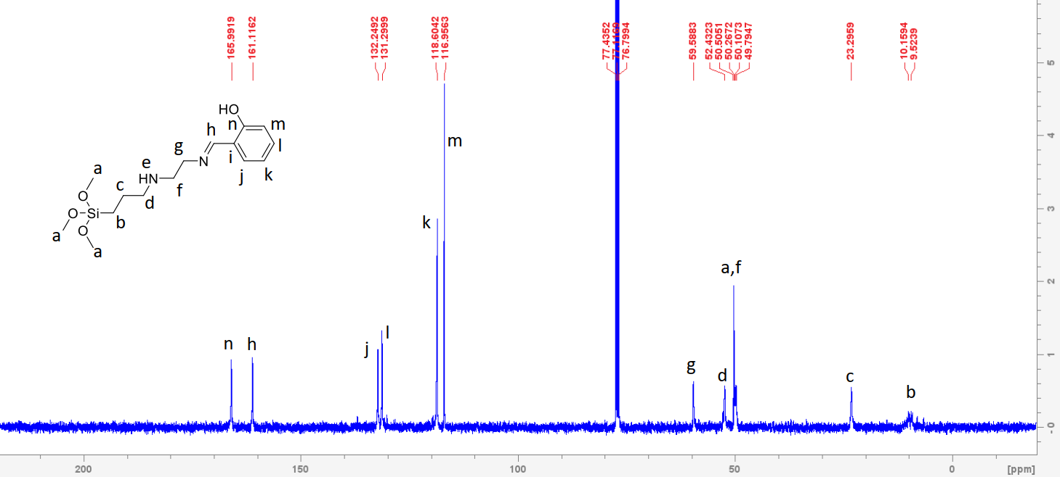

Appendix 2: ¹³C-NMR for L2 showing the C=N carbon at 153 ppm
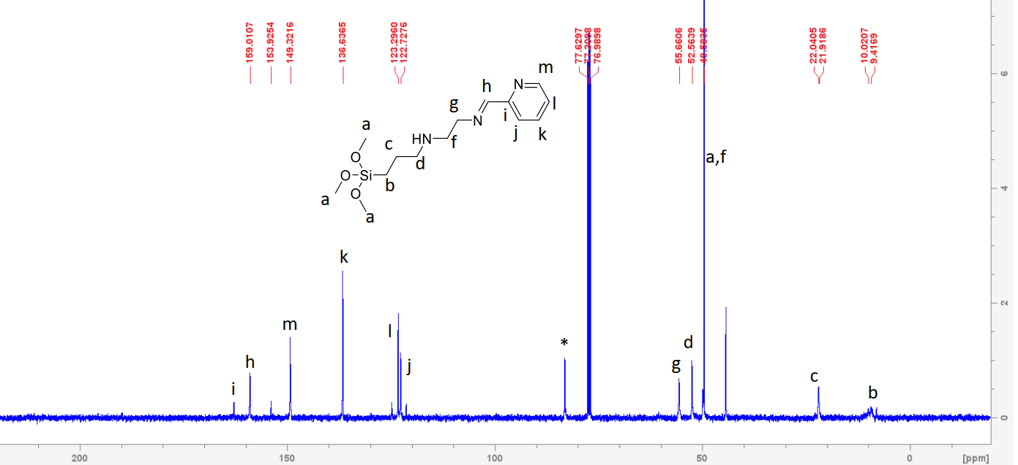

Appendix 3: ¹³C-NMR for L3 showing the C=N carbon at 155 ppm
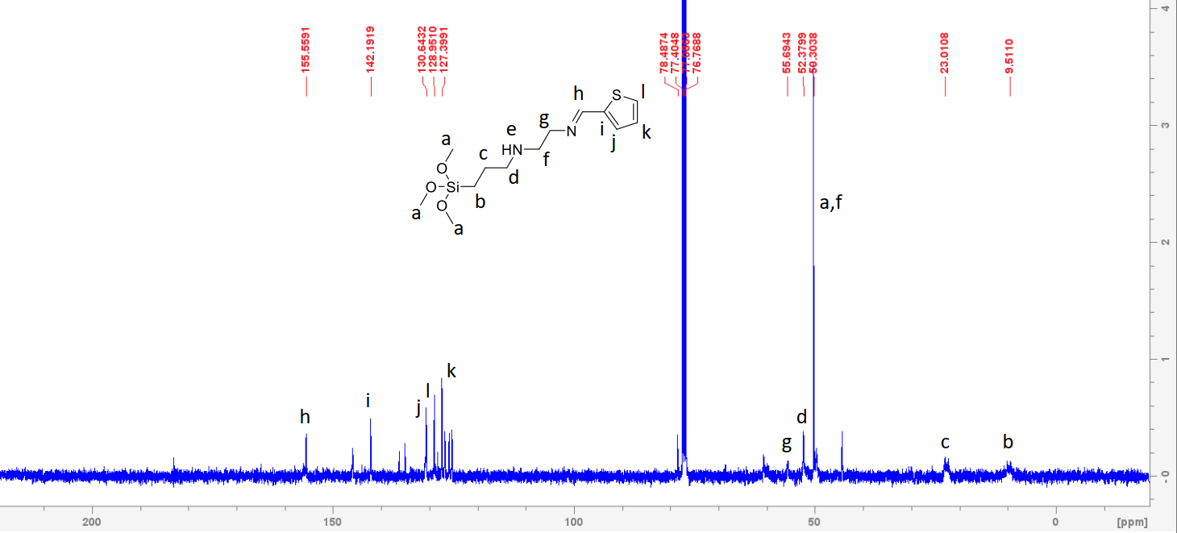

Appendix 4: Pore distribution (according to BHJ) for L1@SBA-15 to L3@SBA-15, a-c respectively.
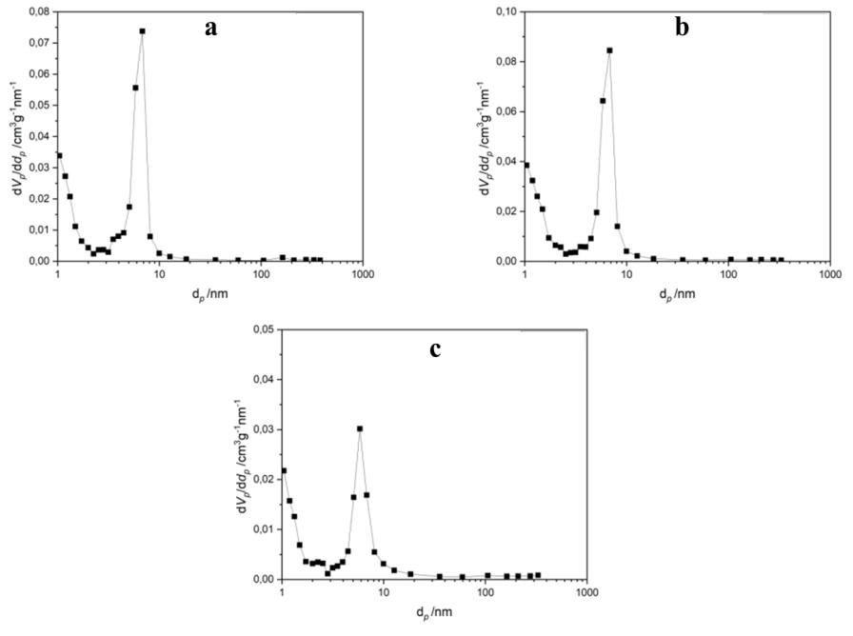

Appendix 5: N₂ adsorption-desorption isotherms for L1@SBA-15-L3@SBA-15, a-c respectively.
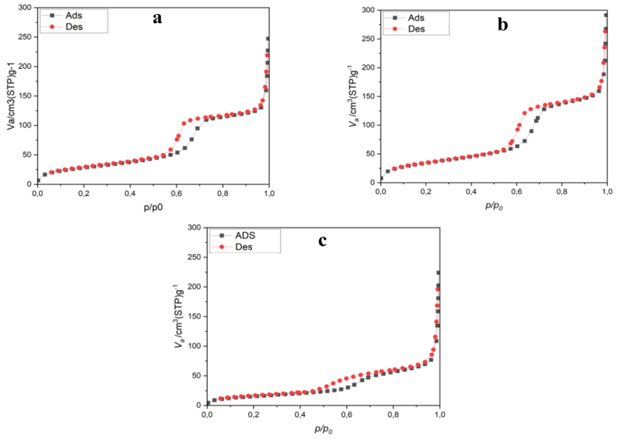

Appendix 6: N₂ adsorption-desorption isotherms for L1@ Fe₃O₄ to L3@Fe₃O₄, a-c respectively.
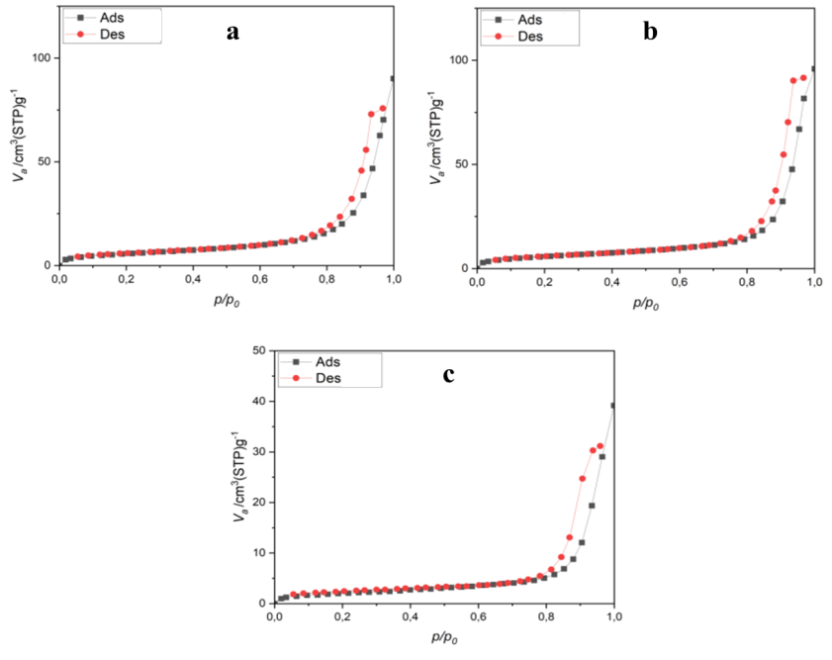
Appendix 7: Pore-size distribution (according to BJH) for L1@Fe₃O₄ to L3@ Fe₃O₄, a-c respectively.
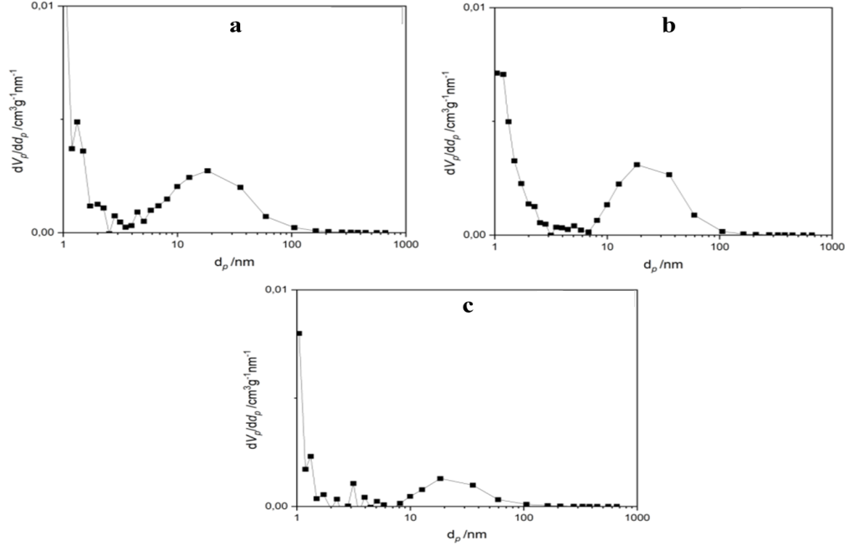

Appendix 8: Stacked FT-IR spectra of fresh and used L1@SBA-15 adsorbent showing the absence of the υ(N-H), υ(O-H) and υ(C-O) peaks in the used adsorbent which is a result of their deprotonation upon metal chelate formation.
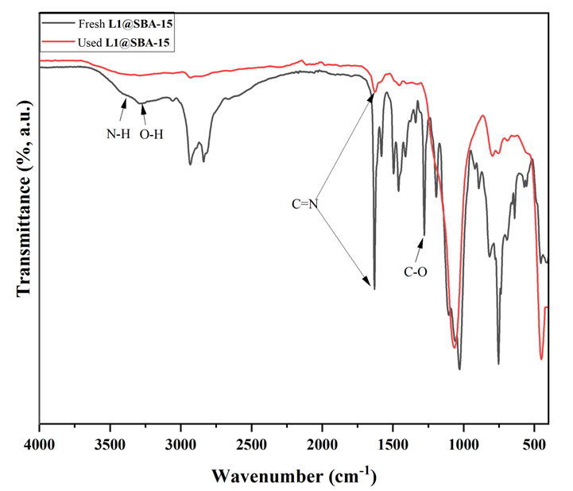

Appendix 9: Stacked FT-IR spectra of fresh and used L2@SBA-15 adsorbent showing the shift in vibration frequency of υ(C=N) and the absence of υ(N-H) peak in the used adsorbent which is a result of deprotonation upon metal chelate formation.
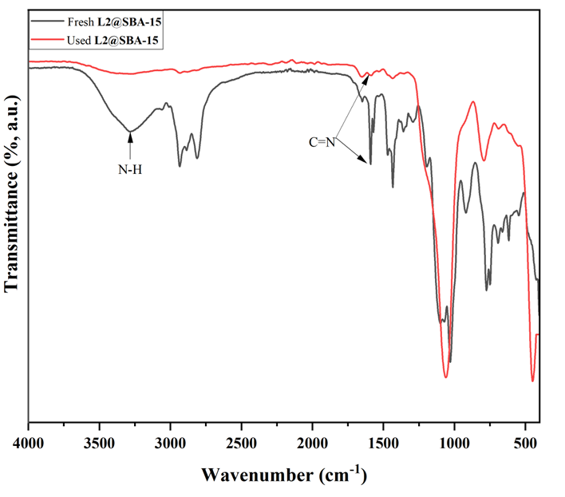
Appendix 10: Stacked FT-IR spectra of fresh and used L3@SBA-15 adsorbent showing the shift in vibration frequency of υ(C=N) and the absence of υ(N-H) and υ(C-S) peaks in the used adsorbent which is a result of deprotonation upon metal chelate formation.
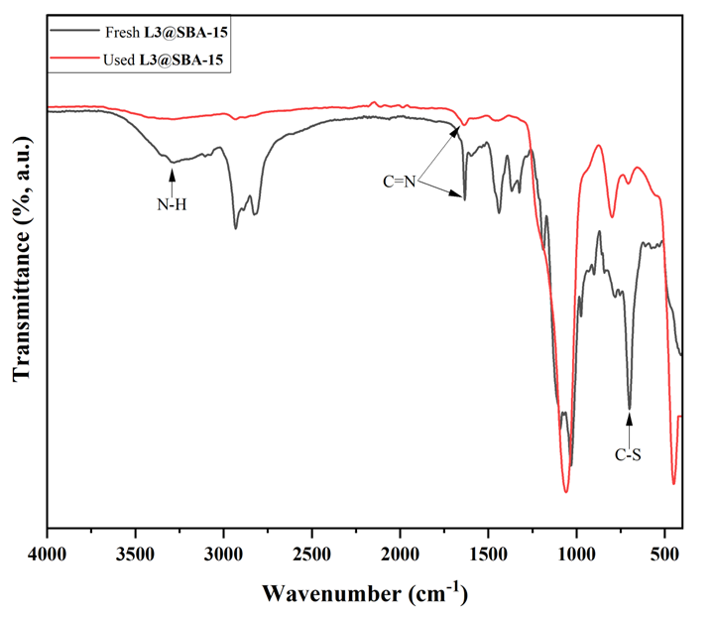

Appendix 11: Stacked FTIR spectra of fresh and used L1@Fe₃O₄ adsorbent showing the υ(C=N) at 1666 and 1624 cm⁻¹, respectively, and disappearance of O-H and N-H peaks at 3290 and 3394 cm⁻¹, respectively, in the used adsorbent due to deprotonation upon complexation.
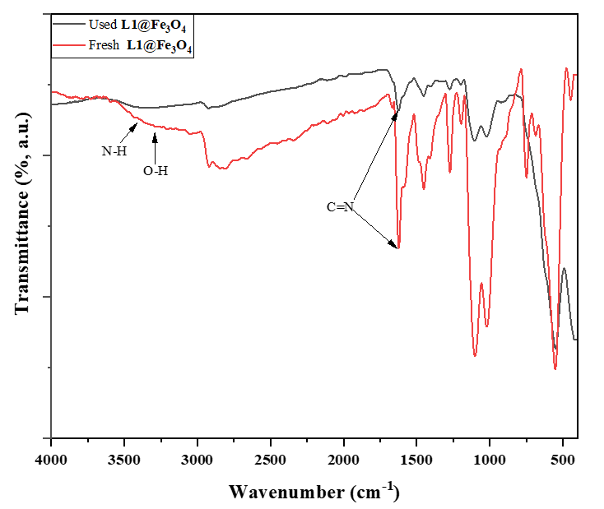
Appendix 12: Stacked FT-IR spectra of fresh and used L2@Fe₃O₄ adsorbent showing the υ(C=N) at 1634 and 1643 cm⁻¹, respectively, and disappearance of N-H peak at 3384 cm⁻¹ in the used adsorbent due to deprotonation upon complexation.
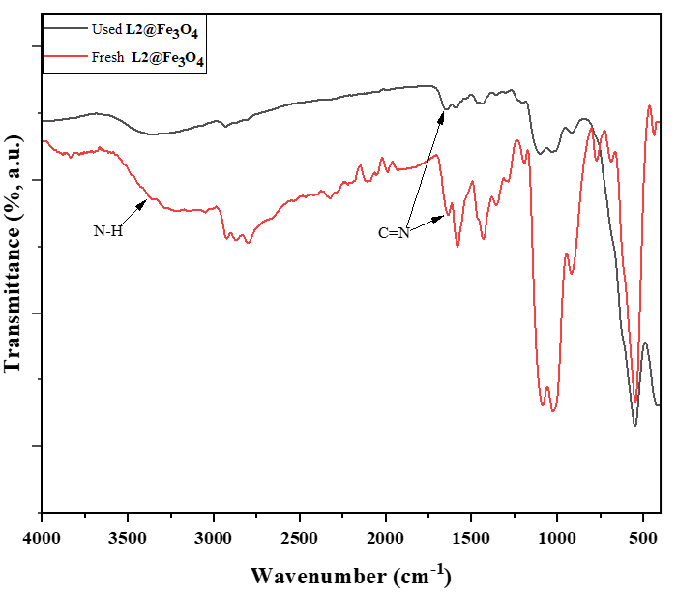

Appendix 13: Stacked FTIR spectra of the fresh and used L3@Fe₃O₄ adsorbent showing υ(C=N) at 1625 and 1632 cm⁻¹, respectively, and disappearance of N-H peak at 3382 cm⁻¹ in the used adsorbent due to deprotonation upon complexation.
