Application of water quality index to assess water quality in river chania, kiambu county, kenya

GEOFREY KASYOKA ROBERT
A509/1149/2017

A THESIS SUBMITTED IN PARTIAL FULFILLMENT OF THE REQUIREMENTS FOR THE AWARD OF A MASTER OF SCIENCE DEGREE IN LAND AND WATER MANAGEMENT IN THE UNIVERSITY OF EMBU, KENYA

OCTOBER 2020

DECLARATION
Declaration by student
This thesis is my original work and has not been presented for the award of a degree in any other University.

Signed…………………………. Date……………………………………
Geofrey Kasyoka Robert
Department of Land and Water Management
A509/1149/2017

Declaration by supervisors
This thesis has been submitted for examination with our approval as University Supervisors.

Signed……………………………… Date…………………………………….
Dr. Charles Nyambane Onyari
Department of Land and Water Management
University of Embu.

Signed………………………………… Date…………………………………………
Dr. John Gichimu Mbaka
Department of Environmental Sciences
Machakos University

DEDICATION
I would like to dedicate this thesis to my loving parents, Mr. and Mrs. Musya, for their unwavering moral and financial support, as well as inspiration.

ACKNOWLEDGEMENT
I take pride and pleasure in thanking my supervisors, Dr. Charles Nyambane Onyari of the Department of Land and Water Management, University of Embu and Dr. John Gichimu Mbaka of Department of Environmental Sciences, Machakos University. Both supervisors were instrumental in shaping this thesis with their wise guidance and contributions for which I am indebted. I also thank Kiambu Water and Sewerage Company (KIWASCO) for providing laboratory working space, equipment and facilities that enabled data collection, and analysis. I would also like to acknowledge the University of Embu for the scholarship award in 2017 to pursue my Master’s degree and for the guidance through the Department of Land and Water Management during the preparation of the project proposal and thesis development. Lastly, I would like to thank Ms. Esther Wairimu Irungu, Erick Otieno and other persons who in one way or the other influenced or made an input towards accomplishment of this research work.

TABLE OF CONTENTS
DECLARATION ii
DEDICATION iii
ACKNOWLEDGEMENT iv
LIST OF TABLES viii
LIST OF FIGURES ix
LIST OF PLATES x
LIST OF APPENDICES xi
ABBREVIATIONS AND ACRONYMS xii
DEFINITION OF TERMS xiv
ABSTRACT xv
CHAPTER ONE 1
INTRODUCTION 1
1.1 Background information 1
1.2 Statement of the problem 3
1.3 Justification of the study 4
1.4 Hypotheses 4
1.5 Objectives 4
1.5.1 General objective 4
1.5.2 Specific objectives 5
1.6 Significance of the study 5
1.7 Conceptual Framework 6
CHAPTER TWO 8
LITERATURE REVIEW 8
2.1 Overview 8
2.2 Spatial and temporal variation of water quality 9
2.2.1 Water quality studies in Kenya 9
2.2.2 Water quality degradation 9
2.2.3 Strategies to combat water quality problems 12
2.2.3.1 Prevention of pollution 12
2.2.3.2 Treatment of polluted water 13
2.2.3.3 Safe use of wastewater 14
2.2.3.4 Restoration and protection of ecosystems 15
2.3 Use of Water Quality Index for water quality evaluation 15
2.3.1 Methods of evaluating water quality of river ecosystems 15
2.3.1.1 Physico-chemical approach 16
2.3.1.2 Water Quality Index 16
2.4 Socio-economic factors affecting water quality 18
2.4.1 Agriculture and other land based activities 18
2.4.2 Industrial activities 19
2.4.3 Domestic and municipal wastewater 19
2.5 Summary and research gap 19
CHAPTER THREE 21
MATERIALS AND METHODS 21
3.1 Description of the study area 21
3.2 Research design 24
3.3 Data collection and analytical procedures 26
3.4 Water Quality Index (WQI) 27
3.5 Data analysis 30
CHAPTER FOUR 31
RESULTS AND DISCUSSION 31
4.0 Results 31
4.1 Physico-chemical parameters 31
4.2 Water Quality Index 35
4.3 River Chania as influenced by anthropogenic activities 35
4.4 Socio-economic characteristics of the respondents 42
4.4.1 Gender and education 42
4.4.2 Household income 42
4.4.3 Economic activities 43
4.4.4 Source of water 43
4.5 Effect of level of education 46
4.6 Effect of gender 46
4.7 Effect of age 47
4.8 Water quality characteristics 48
4.8.1 Source and treatment 48
4.9 Effect of demographic changes on water quality 50
4.10 Multi-nomial analysis 52
4.11 Discussion 53
4.11.1 Physico-chemical parameters 53
4.11.2 Water Quality Index 55
4.11.3 Effect of socio-economic factors on water quality 56
CHAPTER FIVE 61
CONCLUSION AND RECOMMENDATIONS 61
5.1 Conclusion 61
5.2 Recommendations 61
5.3 Limitations of the study and future research 62
REFERENCES 64
APPENDICES 81

LIST OF TABLES
Table 3.1: Description of the sampling sites 255
Table 3.2: The measured parameters and method used in measurement 27
Table 3.3: Water quality parameters and the recommended water quality standards by World Health Organization (WHO) 28
Table 3.4: Physico-chemical parameters, prescribed values by WHO, weights assigned (w_{i}) and corresponding relative weights (W_{i}) 28
Table 3.5: Water Quality Indicator (WQI) classes for drinking purpose 290

Table 4.1: Physico-chemical properties of water in study sites along part of the River Chania Error! Bookmark not defined.3
Table 4.2: Water Quality Index (WQI) values for the wet (WQI_{w}) and dry (WQI_{d}) seasons, combined seasons (WQI_{combined}) and water type categories for the different study sites 335
Table 4.3: Socio-economic characteristics as assessed by the respondents 432
Table 4.4: Effect of the level of education on household income per month (KSh), water usage, identification of water quality changes in River Chania in the last decade and the determination of the causes of water quality degradation in River Chania 43
Table 4.5: Effect of gender on household income per month (KSh), water usage, identification of water quality changes in River Chania in the last decade and the causes of water quality degradation in River Chania 44
Table 4.6: Effect of age on household income per month (KSh), water usage, identification of water quality changes in River Chania in the last decade and the determination of the causes of water quality degradation in River Chania 44
Table 4.7: Water quality characteristics as assessed by the respondents 46
Table 4.8: Effect of demographic change on River Chania as assessed by the respondents 47
Table 4.9:Multinomial analysis of the socio-economic factors influencing identification of water quality changes in River Chania in the last 10 years 48

LIST OF FIGURES
Figure1.1: Conceptual framework 7
Figure 3.1: Map of Kenya highlighting the study area………………………………………….22
Figure 3.2: Map of River Chania water catchment 23

LIST OF PLATES
Plate 4.1: A photograph of Site 1 (Forested area) at Karimenu along River Chania showing dense riparian vegetation on both banks with little human disturbance. 35
Plate 4.2: A photograph of Site 2 (upstream of Chania Estate Bridge) along River Chania showing dense riparian vegetation on both banks with minimal anthropogenic activities. 35
Plate 4.3: A photograph of Site 3 (downstream of Chania Estate Bridge) along River Chania showing agricultural activities on its banks with scarce riparian vegetation. 36
Plate 4.4: A photograph of Site 5 (downstream of Ngoingwa Estate) along River Chania showing river quality degradation due to anthropogenic activities. 36
Plate 4.5: A photograph of Site 4 (upstream of Ngoingwa Estate) along River Chania showing river quality degradation due to anthropogenic activities. A path leading to river and riparian vegetation removal is evident. 37
Plate 4.6: A photograph of Site 5 (downstream of Ngoingwa Estate) along River Chania showing development activities taking place on the banks of the river causing pollution. 37
Plate 4.7: A photograph of Site 3 (downstream of Chania Estate Bridge) along River Chania showing expansive coffee plantations on banks of the river with an adjacent coffee factory. 38
Plate 4.8: A photograph of Site 6 (upstream of Thika town) along River Chania showing high turbidity of river water due to anthropogenic activities. 38
Plate 4.9: A photograph of Site 6 (upstream of Thika town) along River Chania showing a motorcycle operator washing a motorcycle on the banks of the river water. 39
Plate 4.10: A photograph of Kenya Tanning Extracts at Site 7 (downstream of Thika town) located on the banks of River Chania. 39
Plate 4.11: A photograph of Site 7 (downstream of Thika town) along River Chania showing high turbidity of river water due to anthropogenic activities. 410

LIST OF APPENDICES
Appendix 1: Work plan 77
Appendix 2: Budget 78
Appendix 3: Questionnaire 80

ABBREVIATIONS AND ACRONYMS
APHA American Public Health Association
BOD Biological Oxygen Demand
CGK County Government of Kiambu
DO Dissolved Oxygen
DWQI Drinking Water Quality Index
GLOWS Global Water for Sustainability
GPS Geographical Positioning System
HIV Human Immuno deficiency Virus
IWQI Irrigation Water quality Index
KEBS Kenya Bureau of Standards
KNBS Kenya National Bureau of Statistics
KSh Kenya Shillings

LMMs Linear Mixed-effect Models
MCDM Multi Criteria Decision Making
MEA Millenium Ecosystem Assessment
MNLR Multi-nomial Logit Regression
NEMA National Environmental Management Authority
NTU Nephelometric Turbidity Units
PCPB Pest Control Products Board
PCPs Personal Care Products
PhACs Pharmaceutically Active Compounds
PPCPs Pharmaceuticals and Personal Care Products
SPSS Statistical Package for Social Sciences
TDS Total Dissolved Solids
UN United Nations
UNEP United Nations Environmental Programme
WARMA Water Resources Management Authority
WHO World Health Organization
WQI Water Quality Index

DEFINITION OF TERMS
Dissolved Oxygen (DO): Denotes the level of free non-compound oxygen present in water or other liquids
Ecological integrity: Ability of an ecosystem to support and maintain its organization, ecological processes and diverse communities of organisms
Economic water scarcity: Available water resources which require substantial purification and infrastructural investment which makes it unfeasible for countries without significant economic resources
Human activities: These are activities that are caused or influenced by humans
Hydrological cycle: This are the conditions through which water passes as vapour in the atmosphere in form of precipitation upon land or water surfaces and eventually back to the atmosphere as a consequence of evaporation and transpiration
Opine: Hold and state as one’s opinion
Riparian zone/area: It is the interface between land and a stream or river.
Water Quality Index: It is a way of summarizing water quality data to report to the public by integrating the data into one score that falls between 0 – 100. The higher the score, the better the quality of the water concerned
Water quality: The water status that meets the universal standards set for legitimate and vital water use at any scale, that is, local, regional and global levels.

ABSTRACT
Human-related activities are known to have deleterious effects on the water quality of aquatic ecosystems globally. However, there is limited information on the impact of similar perturbations in tropical regions, especially the River Chania in Kiambu County, Kenya, which is an important source of water for humans and animals and also provides habitat for a variety of flora and fauna along its length. The aim of this study was to determine the spatial and temporal variations of selected water quality parameters in seven sampling sites along a section of River Chania, to evaluate water quality of the river using Water Quality Index (WQI) and to assess the effect of socio-economic factors on water quality of the river. The study used a longitudinal study design in water sample collection. The sample collection was done between October 2018 and February 2019 to cater to the dry and wet seasons. A paired t-test (p< 0.05) was used to compare the water quality variables collected in both the wet and dry seasons across sites to see if these differed longitudinally down the river. The data were subjected to analysis of variance (ANOVA) using Statistical Analysis Software (SAS) version 9.2 and means separated using LSD at p< 0.05 confidence level. The mean values of the physico-chemical parameters were compared with the World Health Organization (WHO) water quality guidelines. The parameters used to compute WQI were nitrates, Total Dissolved Solids (TDS), potassium, sulphates, chlorides, copper, manganese, pH and total phosphates. The study revealed a decline in water quality from the most upstream site (Site 1) from excellent (WQI=23.17) to poor (WQI=>50) and very poor (WQI=>76) water quality at the two downstream sites during the wet season. On the other hand, the socio-economic factors were assessed using a survey employing cross-sectional survey design. The study observed that the education level of the respondents was a positive and significant predictor of the ability of an individual to identify water quality changes in River Chania in the last 10 years with an associated significance of 0.014. Age, household size, change in household number, gender and household income had no significant correlation with the identification of water quality changes in River Chania in the last 10 years. The study recommends that the riparian zone of River Chania, especially at downstream sites, should be protected from interference by human activities (e.g., deforestation, farming) and human interactions with the river ecosystem should be regulated for sustainable utilization, hence protect the water quality from further deterioration. Further research can be conducted to develop models for predicting water quality of the river over time.

Keywords: Riparian zone, human activities, longitudinal study design, Water Quality Index, River Chania, Thika town

CHAPTER ONE

INTRODUCTION

1.1 Background information
The water quality of pristine rivers is influenced by geochemical factors and the prevailing climate based on location (Owa, 2014; Gibson et al., 2018). However, human activities such as discharge of industrial effluents, agricultural and urban runoff have affected the quality of river water (Ashiyani and Suryanarayana, 2015; Laaffat et al., 2015). The contaminants released into rivers are of concern because they deteriorate water quality and pose a threat to the supply of water for humans and wildlife and habitat conditions for a range of aquatic and semi-aquatic organisms (Santos et al., 2014). Reduced water quality also reduces ecosystem health and hampers human resource use that hinders sustainable development (Lopez et al., 2013; Kostyla et al., 2015).
Water is a unique chemical medium with the ability to assimilate a wide range of substances, and can easily be contaminated (Jinturkar et al., 2010), posing risks to human health and requiring expensive water treatment to sustain water supply (Karkra et al., 2016). Developing countries, such as Kenya, are increasingly grappling with water quality deterioration as urban and agricultural populations expand and contaminated wastewater volumes increase (WHO, 2014; Besada and Werner, 2015). Therefore, river water quality should be continuously monitored through the regular assessment of selected chemical, biological and physical properties (Jang et al., 2013; Karkra et al., 2017).
This is especially true for Kenya with scarce water resources of sufficient quality (Mumma et al., 2011) to achieve the Sustainable Development Goals (SDGs) for health, water and food security. Consequently, it is of great concern that water pollution has increasingly become an environmental threat to rivers since the 1990s in the country (Githinji et al., 2019). The literature on water quality of the River Chania is limited despite the important and various agricultural activities along its banks and that it supplies water to the increasing population of Thika town and other peri-urban areas around Nairobi city (Kimani et al., 2016). Other studies in Kenya have linked river pollution with surrounding anthropogenic activities (Masese and McClain, 2012). For example, Mbaka et al. (2014) linked water abstraction and grazing to a decline in water and habitat quality in Honi and Naro Moru rivers. Another study by Njuguna et al. (2017) mapped poor water quality in the River Nairobi using a Water Quality Index (WQI). It attributed this to the presence and release of industrial effluents, domestic sewage, agricultural activities and solid wastes.
Water quality may be assessed in different ways (Zahedi et al., 2017). Some water quality determinations are based solely on a comparison of observed parameter values against established water quality guidelines for different uses or purposes. This physico-chemical approach is useful to identify different sources of contamination and checking compliance with set limits. However, it is less helpful in comparing sites that have different water quality impacts (Debels et al., 2005). The use of a water quality index (WQI) is one of several methods that allow sites to be compared by reducing a set of water quality variables into a single dimensionless number that ranks water quality from poor to good and so the results are easy to interpret (Hosseini-Moghari et al., 2015). The first comprehensive WQI was developed by Horton (1965) and was subsequently improved by Brown et al. (1970) and later Cude (2001) and Krishan and Singh (2016). Different versions of WQIs are used depending upon the intended use of water and its suitability for different purposes (Zahedi et al., 2017). The Canadian Council of Ministers of the Environment Water Quality Index (CCMEWQI) (Khan et al., 2003), U.S. National Sanitation Foundation Water Quality Index (NSFWQI) (Brown et al., 1970), British Columbia Water Quality Index (BCWQI) and Oregon Water Quality Index (OWQI) (Abbasi et al., 2012; Debels et al., 2005; Kannel et al., 2007) are some of the numerous water quality indices available.
For this study, the Weighted Arithmetic Mean method described by Tyagi et al. (2013) was used to calculate WQI because the various parameters’ composite influences are reflected, which are essential in water quality management and assessment. Additionally, the method was preferred due to its requirement of fewer parameters relative to the parameters of water quality for a specific use. Water Quality Indices (WQIs) are useful because the simplified results are being easily incorporated into water resource plans to support increasing human use of natural water resources (Nikoonahad et al., 2010; Babaei et al., 2011) and also make descriptions of water quality conditions easier to understand by members of the public during stakeholder engagements (Akoteyon et al., 2011; Bharti, 2011).
Changes in land use and unsustainable farming practices increase water quality degradation in rivers that originate from Chania River catchment, thereby increasing the cost of water treatment and exacerbate the poor health status of downstream water users (Chapman et al., 2011). These effects should inform stringent measures to mitigate the increasing water pollutants and quality deterioration. Numerous studies have demonstrated the importance of WQI in the world but unfortunately there are only a few studies using WQI in the assessment of water quality in the African context and much less in Kenya. Water quality monitoring is mainly based on the determination of physical and chemical parameters and comparing the characteristics of the water sample with water quality guidelines from the World Health Organization (WHO) whereas there is a dearth of information on the utility of WQI in summarizing water quality information and evaluating river health. Since the intended purpose of this study was to assess some physico-chemical parameters of the River Chania water pertinent to human use and consumption, these results will feed into water resource planning discussions and will need to be made public so the use of a WQI in this regard will be helpful.
Several studies in Kenya have investigated the relationships between water quality and factors such as land use, pollution, climate variations, and urbanization (e.g., Budambula and Mwachiro, 2006; Shivoga et al., 2007; Adhikari et al., 2016; Aera et al., 2019). For example, urbanization has been reported to result in contamination of the environment with toxicants such as heavy metals. Meanwhile, land-use practices such as small-scale agriculture have been found to contribute significantly to nutrient loads (e.g., phosphorous) and pesticides in aquatic ecosystems (Shivoga et al., 2007; Ndunda et al., 2018). However, there is a scarcity of information on the relationship between socio-economic factors and water quality conditions of freshwater ecosystems

1.2 Statement of the problem
The quality of water in River Chania, Kiambu County, has been declining over the years as demand surpasses supply (WARMA, 2012). This problem is mainly caused by unsustainable farming practices, in conjunction with vagaries of industrialization and urbanization taking place along the banks (Chislock et al., 2013). This problem could potentially lead to increased human health risks, economic water scarcity and aquatic environment pollution. It is therefore important that declining water quality of River Chania is urgently addressed holistically. The WQI method is capable of holistically addressing water quality concerns in River Chania, however, its utilization has not been prominent in Kenya. Determination of water quality has routinely been done through the comparison of physico-chemical parameters with prescribed regulations to gauge suitability for various uses (Lawson, 2011). There is a burgeoning need to manage water resources through water quality monitoring in order to curtail the declining quality of water. This research study sought to use the WQI method since it summarizes large amounts of water quality data in ways that can be easily interpreted by different levels of stakeholders’ unlike the physico-chemical method.

1.3 Justification of the study
The purpose of the study was to examine the water quality of River Chania through the use of the WQI method. While other methods of water quality analysis, such as the physico-chemical method (Gandaseca et al., 2011), have been identified and studied in previous research, there is a glaring lack of knowledge on water quality issues. In view of this, the study employed the WQI which provides simplified results that can easily be understood by stakeholders across multiple levels. The data collected through this study have the potential to raise awareness of declining water quality in River Chania, Kiambu County and to provide information for water quality agencies, such as Water Resources Management Authority (WARMA), to use in an effort to create or improve mitigation measures. Information on spatial-temporal variations of water quality, predictable variation of the water quality along the river and the effect of socio-economic factors on the water quality will thus inform policy formulation and implementation on sustainable use of riverine ecosystems such as that of River Chania.

1.4 Hypotheses
- There are no significant spatial and temporal variations in selected water quality parameters of River Chania, Kiambu County.
- There is no significant difference in WQI of River Chania in Kiambu County along selected sampling points.
- There is no significant effect of socio-economic factors on the water quality of River Chania, Kiambu County.

1.5 Objectives

1.5.1 General objective
To assess the water quality status of River Chania Kiambu County through development of a Water Quality Index for the river.

1.5.2 Specific objectives
The specific objectives of the study will be:
- To determine the spatial and temporal variation of selected water quality parameters in River Chania, Kiambu County.
- To evaluate water quality using WQI along selected sampling sites of River Chania, Kiambu County.
- To assess the effect of socio-economic factors on water quality of River Chania, Kiambu County.

1.6 Significance of the study
The WQI developed from the study was an integration of the complex water quality data into information that was easily understood and useful to professionals and policy makers as well as the general public, to help better plan, manage and allocate water resources in the catchment and beyond. Additionally, the study informed river management organizations on the utility of WQI in evaluating water quality in rivers impacted by human-related perturbations. The study also described the water quality status and evaluated water quality trends in the long run. The findings of the study and the recommendations will be a basis for policy formulation and decision making for the agencies which deal with the management of water quality in Kenya such as the National Environment Management Authority (NEMA) and the Water Resources Management Authority (WARMA). Reliable information on water quality will help monitor utilization of water along River Chania, steer the efforts to combat water-borne diseases, identify the locations along the river experiencing widespread pollution and the areas which are likely to come under the threat of contamination in the short term. This will help plan for conservation and mitigation strategies for the long-term sustainability of the River and its functionality in the provision of ecosystem services.

1.7 Conceptual Framework
The main factors causing the decline in water quality of River Chania include runoff from adjacent agricultural lands together with industrialization and urbanization in close proximity to the river. Water quality deterioration in River Chania not only poses a human health risk but also causes social and economic water scarcity, poor WQI and increased spatial and temporal water quality variations which affect the ecological integrity and functioning of the river. To address this problem, considerable effort must be made at all stakeholder levels to steer the restoration of ecological balance. This will involve development of appropriate national water quality policies and legislation which will be applied in tandem with regular water quality monitoring and enforcement of water quality legislation. Ultimately, there will be improved water quality as well as improved socio-economic status, improved WQI and reduced spatial and temporal variation in water quality of River Chania.

CHAPTER TWO

LITERATURE REVIEW

2.1 Overview
Water quality is naturally affected by geochemical and climatological location of a body of water. However, human activities such as discharge of waste products, agricultural runoff and urban settlements also heavily affect the quality of surface water bodies (Laaffat et al., 2015). Water quality can take any of the following definitions according to different authors; James (2013) suggests that it is a specific judgement as to how water of a given composition fits the perceived needs of the individual, group or ecosystem using it. However, human judgements of water quality are inherently dynamic. On the other hand, Arcipowski et al. (2017) defines water quality as the water status that meets the universal standards set for legitimate and vital water use at any scale, that is, local, regional and global levels and assessment based on the physical, chemical and biological variables of water. Abbasi et al. (2012) opines that it is a measure of the status of the water with regards to the necessities of human needs or purposes
River Chania Catchment is located in the upper Tana Catchment in Kiambu County. The catchment supplies water to Kenya’s capital, Nairobi. River Chania drains the Chania catchment at Ragia location in Nyandarua County flowing downstream to the confluence of River Thika. River Chania has three tributaries namely; Kariminu, Kimakia and Nyakibai all forming a dendrite drainage pattern (Jaeztold et al., 2007). The catchment capacity does not adequately meet the demand placed on it due to the increasing population coupled with declining water quality and quantity especially during dry periods (WARMA, 2012). Due to the unchecked population growth and rapid urbanization experienced around the Chania catchment, there has been numerous land cover and land use changes. These activities have led to encroachment into riparian land and deforestation in the water towers and along River Chania. A number of studies have been conducted on River Chania and its catchment. Mwangi et al. (2015) investigated the effects of water and soil conservation practices on ecosystem services on the upstream part of River Chania.

2.2 Spatial and temporal variation of water quality

2.2.1 Water quality studies in Kenya
Kenya is one of the countries in the world experiencing chronic water-scarcity in terms of quantity and quality (Mumma et al., 2011). The water crisis is exacerbated by inadequate management of water supply, pollution, droughts and degradation of forest cover (Samantha, 2011). Studies done on African rivers have shown pollution occurring as a result of anthropogenic activities pose profound effects on water bodies (Masese and McClain, 2012). In Kenya, mineralization of geologic materials is one of the many factors causing water quality decline, thereby making the water unfit for human consumption especially in regions experiencing a higher concentrations of Manganese and Fluoride (Mohapatra et al., 2009) leading to economic water scarcity.
Pharmaceuticals and personal care products (PPCPs) have garnered a lot of attention in terms of the number of publications due to their high consumption rate (Tsutsui et al., 2018) and their frequent detection in the environment (Tran et al., 2018). Only a few publications in Kenya are accessible in open literature on pharmaceuticals active compounds (PhACs) in water bodies (Madikizela et al., 2017), while there are even fewer publications on personal care products (PCPs). Pesticide consumption in the world stands at ca. 2*10⁶ tonnes per year (De et al., 2014). In 2007, Kenya imported ca. 8750 tonnes of pesticides into the country not including locally produced pesticide products. Organo-chlorine and organophosphate pesticides have been detected in surface waters in Kenya in variable concentrations (Otieno et al., 2012).
Global Water for Sustainability (GLOWS) conducted a water quality study in May-2005, May-2006 and June-2007 and investigated the quality of surface in the Mara river basin in Kenya with a view of identifying water quality issues and coming up with action plans (GLOWS, 2007). The study found out that there was little or no systematic monitoring of water quality in the basin. The assessment concluded that although the parameter characteristics determined were not in excess of accepted guideline limits, there were detectable amounts of mercury, pesticides, high nutrient load and PCPs.

2.2.2 Water quality degradation
The significant amounts and diverse contaminants released each day are a source of concern because they deteriorate water quality and pose a threat to the well-being of aquatic ecosystems (Santos et al., 2014). Quality of running systems is a result of mineralization, ionic concentration, dissolved organic matter composition and the total and permanent hardness. The quality status of a river at a particular site reflects several main catalysts including climatic conditions, atmospheric contributions and human activities (Kostyla et al., 2015) . Diminished water quality impoverishes the society and hampers sustainable development (Lopez et al., 2013).
Pollutants that commonly contaminate water bodies include soil particles in suspension from erosion that result in turbidity and sediments in water systems, nutrient loading that cause eutrophication, over-fertilization of algae and exhaustion of dissolved oxygen (DO); toxic elements that include pesticides, industrial effluents, heavy metals and increase in temperature as a result of cooling of industrial processes (Liputa et al., 2008). These may lead to odor, clogging of filters by algae, expensive water treatments, increase in chlorine demand, bacterial growth in distribution system, metal remnants in reservoirs and distribution channels and enhanced corrosion (Liputa et al., 2008).
There are various factors that can lead to degradation of water. The type and intensity of the process occurring in water bodies influence the type of contamination (suspended, colloidal or dissolved) (Huang et al., 2015). Moreover, the concentration of pollutants that enter water bodies depend on the quantity and composition of chemical deposits in water systems. In addition, it can be affected by the amount and nature of microorganisms living biofilms, microbial metabolic pathways, stability of flowing water and biological and chemical processes (Jachimowski, 2017). Globally, the manufacture and use of synthetic chemicals for crop production and animal husbandry has resulted in the increase in food security (Kibaroglu and Gürsoy, 2015). Many of these activities have polluted water bodies due to runoff containing insecticides and herbicides from farmlands and industrial effluents into surface water bodies (Stehle and Schulz, 2015). Chawira et al. ( 2013) asserted that in sub-Saharan Africa, the quality of water is one of the several problems currently and is poised in the future to scourge the region hence determination of the quality of surface waters is paramount for environmental monitoring and management. Water quality degradation is fast becoming a major problem in Kenya. This is due to the prioritization of attainment of industrialization status and diversification of national development goals (Kithiia and Mutua, 2006).
A good water quality source for drinking and domestic use is of utmost importance to human health (Morris et al., 2003). In most nations, 70% to 85% of the population heavily relies on surface water as the main source of drinking water (Morris et al., 2003). Discomfort and death are some of the risks associated with the ingestion of water containing pathogens or toxic elements (WHO, 2012). It is estimated that 3.4 million people die each year as a result of diseases associated with pathogens in water including cholera, typhoid, infectious hepatitis, cryptosporidiosis, polio, diarrhoeal diseases and ascariasis (WHO, 2014). Traditional techniques of water quality assessments are costly, time and labour intensive and they are inadequate in spatial and temporal scales (Glasgow et al., 2004). Recent studies by Kilonzo et al. (2014) and Waithaka et al. (2015) revealed deterioration patterns in water quality within river systems as a result of changes and intensity of land use activities. Moreover, a study by Kithiia and Mutua (2006) within rivers Nzoia, Nyando and Kerio reported an increase in water pollutants and eventual contamination downstream.
The people who are most at risk as a result of water quality decline are those who live near contaminated water bodies and those who have no options with regards to access to safe water or to improved sanitation (Rahman et al., 2012). As of 2008, about 42 percent of the world’s population then or 2.6 billion people, still had no access to improved sanitation (Isunju et al., 2011). Fish and other organisms consumed by humans can bio-accumulate chemicals and toxins hence affecting human health or humans can ingest these compounds directly, causing developmental and neurological damage (Ehiagbonare and Ogunrinde, 2010). Each year, 1.8 million people die from diarrhea disease, directly linked to unsafe water or poor sanitation and hygiene (Yongsi, 2010). Over 1.5 million of these are children under five years, who are more vulnerable to diarrhea than Malaria and Human Immuno deficiency Virus (HIV) combined (Kouadio et al., 2012). Other grim statistics include roughly 200 million people around the globe are infected with Schistosomiasis, which is a debilitating, water-borne parasitic disease and that in 2009, over 50 countries in the world still reported cholera to the World Health Organization (WHO) (Rinaldo et al., 2017).
Abysmal water quality is directly correlated to the availability of water in a number of ways. A polluted source of water that cannot be utilized by people in a number of different ways which include but are not limited to bathing, drinking, industrial and agricultural production effectively reduces the amount of useable water within a given area (Zeng et al., 2013). Regardless, the use of poor quality water (e.g. saline and brackish waters) may have direct and profound impacts on productive use, such as irrigated agriculture, with substantial effects on land degradation, crop production and consequently on rural income and food security (Pang et al., 2010). Roughly 700 million people in 43 countries globally today suffer from water scarcity, a situation whereby the water has been degraded to an extent where treatment is utterly expensive due to the infrastructural investment required and where there are insufficient water resources to satisfy long-term average requirements (Munia et al., 2016). By 2025, 1.8 billion people across the universe will be living in countries or regions with out-and-out water scarcity and two thirds of the world’s population could be living under water-stressed conditions (Wada et al., 2011). All of this coupled with the climate change phenomenon means that half of the world’s population will be living in conditions of water stress by 2030, including between 75 million and 250 million people in the African continent (Shiferaw et al., 2014).
In light of the above situation, water quality issues deserve greater attention alongside water quantity in water resources management. Nevertheless, given the complexity and magnitude of the challenges discussed above, an effective response to water quality problems will involve a collaborative effort by all stakeholders including the public sector, the private sector and the civil society. The water quality of River Chania has not been sufficiently documented hence the need to determine and document.

2.2.3 Strategies to combat water quality problems
The four basic strategies to combat water quality degradation and which can form the basis of policy formulation and solutions for improving water quality include: (1) prevention of pollution, (2) safe use of wastewater, (3) treatment of polluted water and, (4) restoration and protection of ecosystems (Palaniappan et al., 2010).

2.2.3.1 Prevention of pollution
This strategy involves the reduction or elimination of waste at the source. Prevention is prominently regarded as the most cost-friendly, easiest and most effective way to protect water quality. Moreover, not only are there environmental benefits accrued from prevention or reduction of water pollution but there are also financial benefits as well, as generation of waste especially from industrial and agricultural processes, is a demonstration of inefficient use of materials and resources (Belayutham et al., 2016).
Industrial solutions for prevention of pollution include reformulating products so that they produce less pollution levels and so that the same products require fewer resources (including water) during their manufacture. In agriculture, nutrient input reduction and generally water usage can reduce pollution. Appropriate agricultural practices include cover cropping, crop rotation, improved irrigation management, conservation agriculture and integrated pest management methods (Olayide et al., 2016). Domestically, improved sanitation coverage, considerations of settlement design (such as the types of materials used for construction), the handling of storm water and reducing wastewater production are the most obvious solutions to water quality decline prevention (Larsen et al., 2016).

2.2.3.2 Treatment of polluted water
In an event where pollutants are attributed to domestic, agricultural and industrial activities, wastewater ought to be treated before being discharged into waterways (De Gisi et al., 2016). Treatment techniques for polluted waters range from high-technology, energy-intensive approaches to low technology, low energy, biologically and ecologically focused approaches (Rajasulochana and Preethy, 2016) In situations where there is existence of good water distribution and treatment systems, it is imperative that there is constant effort to ensure the system undergoes periodic maintenance in order to expand their effective operation (Adeleye et al., 2016). Nonetheless, many wastewater treatment facilities are not working due to unskilled, semi-skilled or deficient human, technical and financial resources for operation and maintenance. Systems which are poorly maintained and operated can result in the degradation of even high quality water before it reaches at its point of utilization (Trendewicz and Braun, 2013).
The appropriate treatment option for polluted water is a function of the intended after use. For instance, a modern multi-stage water treatment plant is typically required to supply drinking water for large settlements. Solar stills and smaller-scale filtration or disinfection plants are solutions at the community level. At the household level, solutions include boiling, simple water filter, solar pasteurization, chlorine treatment and solar water disinfection (Gupta et al., 2012). Several of the techniques mentioned above may be applicable for treatment of water for industrial use, however, water meant for agricultural use in some cases can be of much lower quality especially where harmful contaminants that can build up in soils and crops are non-existent (Bauder et al., 2011).

2.2.3.3 Safe use of wastewater
To render wastewater environmentally safe, it is ideally treated before being disposed of into waterways. However, it can be safely used, sometimes even untreated, in situations where impacts on human health and the environment are clear and all possible action is taken to get rid of risks (Sato et al., 2013). If well monitored and regulated, safe use of wastewater, for example in agriculture, can reduce the pressure exerted by anthropogenic activities on existing freshwater resources and increase water supply in water-scarce and semi-arid zones and in rapidly growing peri-urban areas (Pedrero et al., 2010). Moreover, wastewater can be an important source of nutrients and if well regulated, it can potentially be valuable for certain agricultural uses, reducing expenses associated with expensive chemical fertilizers (Sahu et al., 2013). Furthermore, agriculture may play a role in biological treatment, thus removing unwanted nutrients that may otherwise pollute water bodies.
To reduce the pressure exerted on water bodies for water supply, peri-urban and rural areas can reuse treated human wastewater as a viable source of water (Grant et al., 2012). Ecological sanitation, for example, is a low-cost method of dealing with human waste promoted by many development agencies (Haq and Cambridge, 2012). It calls for the separation of urine and faecal matter with sterile urine potentially being applied directly to plants, while faecal matter being composted until it is safe for application on land. This approach has been in use in some countries and regions including Burkina Faso, Niger, Kenya, China, Sweden, India and parts of Eastern Europe (Simha and Ganesapillai, 2017). By recycling water and using dry pre-stored human wastes, livelihoods are created for the local people as well as market opportunities for the provision of local fertilizers that suit the soils and soil conditioners for agriculture (Andersson et al., 2011).
Safe reuse of wastewater can also be achieved in industries, for example those that are involved in food processing and utilize large amounts of water, and therefore discharge large quantities of wastewater (Qu et al., 2012). In such an event, safe reuse of wastewater, as a component of cleaner production application, can improve water and energy efficiency and bring about environmental benefits (Yi et al., 2011). For instance, industry can reuse wastewater from certain processes in other applications that do not demand high quality water, or apply appropriate technologies to process wastewater for procedures requiring water of higher quality (Salgot and Folch, 2018). Namibia and Singapore are good examples of where freshwater resources for both human consumption and industrial use are augmented with treated wastewater (Bahri and Asano, 2011).

2.2.3.4 Restoration and protection of ecosystems
Ecosystem services accrue as a result of healthy ecosystems in the form of water purification, many a time at far lower cost than subsequent engineered efforts to remedy polluted waters (Gordon et al., 2010). When water systems, including watersheds, are adversely impacted by substandard water quality, strategies to counter pollution and restore systemic health and functions are paramount (Keeler et al., 2012). Ecological restoration involves assisting the recovery of an ecosystem that has for long been destroyed, degraded or damaged (Suding et al., 2015). Restoration of rivers and wetlands and the removal of upstream dams are straightforward strategies for freshwater restoration. Ecohydrology on the other hand is one of the most well established approaches that can be used to arrest pollution from both point and non-point sources (Zalewski, 2011).
An ecohydrological approach hinges on the understanding of the interrelationships between the ecological processes and the water cycle in a given catchment and supports the role of ecosystem processes in water quality improvement (Izydorczyk et al., 2013). Ecohydrology can address water-related threats, such as reducing flood risk by increasing the retention capacity of the landscape, or by creating wetlands that avert contaminants from entering water bodies (Burt et al., 2010). Examples of ecohydrological approaches worldwide can be derived from Japan, Poland and Iraq (Li, 2012).

2.3 Use of Water Quality Index for water quality evaluation

2.3.1 Methods of evaluating water quality of river ecosystems
River ecosystems are among the most vital ecosystems the in the world where water is abstracted for fundamental purposes such as industry, agriculture and drinking (Chitsaz and Azarnivand, 2017). However, they are among the most threatened ecosystems in the planet due to reckless human activities, rapid population growth and accelerated industrialization (Krishan et al., 2016). This trend expedites descends of surface water resources and degrades water quality (Pophare et al., 2014). Several methods of evaluation have been put into practice in an effort to come up with accuracy in the determination of water quality (Zahedi et al., 2017).

2.3.1.1 Physico-chemical approach
Water quality is influenced by numerous physico-chemical and biological variables which are introduced naturally or by human activities into river ecosystems (Bald et al., 2005). Physico-chemical approach is based on the qualitative determination of parameters derived from the aquatic environment. These parameters include Dissolved Oxygen (DO), Biological Oxygen Demand (BOD), temperature, pH, electrical conductivity, salinity, nitrates, total phosphates, sulphates and transparency (Chung et al., 2016). This approach is founded on the concept of comparison of the parameter measurements with water quality standards derived from national standards of different countries on water, sewage and other effluents (Bhandari and Nayal, 2008).
However, the physico-chemical approach is an expensive venture in the assessment of water quality in all the water bodies in the world because of the use of so many water quality parameters. This is because numerous water samples would be required to determine the health status to permissible limits (Prasanna and Ranjan, 2010). Increasing complexity and irregularity of agro-chemicals and domestic discharges underlines the challenge in the assessment of water quality since it becomes difficult to be monitored or detected (Dabrowski et al., 2009). Physico-chemical measurements cannot stand alone effectively in the assessment of water quality in rivers because their ecological influence is too complex (Pablos et al., 2018) hence the need for WQI method. This problem will be addressed by the study in River Chania with the incorporation of WQI method which aggregates large quantities of data into simple values which are easily understood even by lay people

2.3.1.2 Water Quality Index
Ground-breaking and pioneering work of developing WQI was by Horton in 1965 and subsequently developed by Brown et al. (1970). It was subsequently improved by Krishan and Singh (2016). Water Quality Index (WQI) is a method used for rating which involves evaluating the composite effect of each variable as well as clarification of all qualitative variables on drinking water (WHO, 2003). In the calculation of WQI, each parameter is weighed in relation to its effect on human health (Goher et al., 2014). One of the major merits of using WQI is the ease of interpretation of water quality trends in different times and places in an appropriate way (Nasirian, 2007). Therefore, the index has occupied a special niche in water resources planning and management especially for drinking purpose (Nikoonahad et al., 2010). Other merits of the index include the flexibility in its use since it gives the researcher the freedom to select from various polluted ecosystems based on generic or specific levels (Lumb et al., 2011) and can be applied universally because it is not affected by the geographic locality of a water body (Reza and Singh, 2010).
WQI is regarded as the most effective tool for determination of water quality (Zahedi, 2017). This technique is recommended for application in the assessment of both ground and surface water quality (Naubi et al., 2016; Bora and Goswami, 2017). A pre-determined number of variables are taken into account in the calculation of WQI to rate water quality and determine the adequacy of water for drinking (Ochuko et al., 2014).
Some of the demerits of WQI are that firstly, it might not hold sufficient information about the real quality status of the water (Sidek et al., 2016). In addition the water quality variables are aggregated into WQI values (0-100) based on a specific formula (see formulae 1 – 4 in page 33-34) and the periodic reports only show the aggregated value with classified pollution level (i.e. poor, marginally polluted, fair, good and excellent quality) (Saleh et al., 2014). However, the advantages of applying WQI outweigh the disadvantages. In terms of complexity, it is not a complex predictive tool for scientific and technical use and also communicates water quality issues to the general public and also policy makers (Vasanthavigar et al., 2010).
Mosaferi et al. (2015) applied WQI using seven qualitative parameters to assess the quality of drinking water in Sabalan aquifer. While Sadat-Noori et al. (2014) outlined Saven-Arak plane to determine adequate regions where water for drinking can be exploited. Lermontov et al. (2009) expressed their reservations that despite the positive effect of WQI in qualitative assessment of water resources it has its limitations. These would include the classifications generated from this index which would lead to inflexible and definite results. In addition, Dahiya et al. (2007) stated that this analysis in some instances provided unreliable consequences. Zahedi et al. (2017) and Hosseini-Moghari et al. (2015) observed that Drinking Water Quality Index (DWQI) and Irrigation Water Quality Index (IWQI) aroused contradicting results of water quality ranking; such that water quality reported to be appropriate for drinking purposes is unfit for agriculture. Amiri et al. (2014) invented novel techniques of computing WQI. They modified WHO based results of WQI by taking advantage of Multi Criteria Decision Making (MCDM) methods.
Shokuhi et al. (2012) used WQI to establish the water quality of Agdughmush dam in Mianeh, Iran. They observed that a significant proportion of measured samples had good water quality according to WQI standards by WHO. The result of the study revealed that the lake had good water quality for drinking. Baghapour and Shooshtarian (2017) used WQI to evaluate water quality in Khorram Abad, Iran in 6 stations for a period of 6 months. The study showed that the best and the worst quality status were classified in quality designations of good and bad respectively. Abba et al. (2015) evaluated the water quality patterns in Yamuna Rover in India using WQI for 3 years including 2000, 2005 and 2010. Their research revealed declining trend of water quality due to incautious increase in human activities.

2.4 Socio-economic factors affecting water quality

2.4.1 Agriculture and other land based activities
Unsustainable agricultural practices meant to meet growing demand for food leads to increased pressure on water resources and degrades water quality from runoff-carrying fertilizers and pesticides (Cañedo-Argüelles et al., 2013). In other cases, abstraction of water for irrigation significantly affects the availability of surface water thereby contributing to water quality degradation by addition of salts, fertilizers and pesticides by the returning water (Adeoye et al., 2013).
Increase in nutrients due to land-based activities causing eutrophication and other undesirable changes in aquatic ecosystems is one of the most studied phenomenon on water bodies (Smith et al., 2006; Bricker et al., 2014; Glibert et al., 2018). Nitrogen and phosphorous are at low levels in pristine water bodies, However, they can be typically high in rivers due to the influence of human activities, particularly due to runoff from agricultural lands (Schindler, 2006). Consequently, rivers transport these pollutants including sediments and nutrients to coastal ecosystems and as a result eutrophication has increasingly become a major problem in coastal waters. Eutrophication is a major water quality issue currently due to the increased demand for food production thus intensification of agricultural activities (Borysova et al., 2005).

2.4.2 Industrial activities
Social and economic prosperity is a subject of adequate amount of good quality water for manufacturing and production processes as well as for the treatment and assimilation of waste products (UNEP, 2016). Production of pharmaceutical products demands high quality water while other industrial processes such as paper production require large volumes of water. To meet these needs will be a challenge if the current water use and pollution continue (Bhaduri et al., 2016). In practice, only the most toxic and persistent pollutants are measured on a regular basis in rivers because the number of possible compounds is high, their concentration is low and the measurement expensive (Petrovic, 2014). This data is scarce at a global scale though it is easily available in some countries (Hughes et al., 2012). Currently, new toxins are being investigated due to their likelihood of reaching aquatic ecosystems and lead to contamination of aquatic systems and harm human health through ingestion (Corcoran et al., 2010).

2.4.3 Domestic and municipal wastewater
Sewage from homes and other establishments contain organic matter, pathogens and chemicals used by man such as personal care products (Klein et al., 2010). Human and animal waste contains pathogens such as viruses, bacteria, worms and protozoa whose occurrence is a subject of geographical location and occurrence of the disease in the local population (Murray and Drechsel, 2011). The effect of socio-economic activities on the water quality of River Chania has not been documented hence the need to evaluate the effects and document them.

2.5 Summary and research gap
Socio-economic factors such as the density of human population, education attainment, and gross domestic product are typically utilized as indicators of the impact of human-related stressors in freshwater ecosystems (e.g., Farzin and Grogan, 2013). Chen and Lu (2014) reported that socio-economic factors such as human population density explained a more significant percentage (45%) of the overall river water quality variance than natural elements such as topography and some factors related to land use. The study also found that human population density was a significant predictor for phosphorous concentration, while gross domestic product mostly explained variability in electrical conductivity. Another study also reported that the human population was a significant source of disturbance to coastal wetlands and that it had a considerable influence on phosphorous and chloride concentrations (Morrice et al., 2008).
One of the simplest methods to assess water quality conditions is by using water quality indices (Citation). It is a tool that provides meaningful summaries of water quality data that are useful to both technical and non-technical individuals interested in water quality results. It is important to note that the WQI is not a substitute for detailed analysis of water quality data and should not be used as a sole tool for management of water bodies. It was simply developed to provide a broad overview of environmental performance (Citation). Any number of water quality measurements can serve and have already been used as indicators of water quality. However, there is no single measure that can describe overall water quality for any one body of water, let alone at a global level. As such, a composite index that quantifies the extent to which a number of water measures deviate normal, expected or ‘ideal’ concentrations may be more appropriate for summarizing water quality conditions across a range of inland water types and over time. Although there is no globally accepted composite index of water quality, some countries and regions have used, or are using aggregated water quality data in the development of water quality indices (Citation). Indices simplify and reduce the required raw and primary data for describing water quality. The spatial variation of the indices can show the particular water quality issues within a river body, thereby allowing managerial decisions to be made. In simple terms, indices are proper tools to determine conditions of water quality and like any other tool; it requires knowledge about principles and basic concepts of water and related issues. This study draws upon the lack of expert study and inspection of the water quality of River Chania in Kiambu County, Kenya.

CHAPTER THREE

MATERIALS AND METHODS

3.1 Description of the study area

The study was carried out in along River Chania in Kiambu County. River Chania along with its tributaries, Thika and Kariminu, originate from the slopes of Mt. Kinangop in the Aberdare ranges which is the second largest water tower in Kenya (Figure 3.1) (CGK, 2016). Aberdare ranges are located in the central province of Kenya which comprises of 160 kilometers long mountain range of upland north of Kenya’s capital city Nairobi, with 3500 meters elevation above sea level (Lambrechts et al., 2003). River Chania’s catchment, located within the Upper Tana catchment, covers an area of 840 km² and covers three counties in Kenya; namely Kiambu, Murang’a and Nyandarua. This catchment lies between latitude 0.753 ºN and 1.04 ºN and longitudes 36.58 ºE and 37.07 ºE (Ng’ang’a et al., 2017). The river has a confluence with River Thika at the catchment’s outlet and drains into the Masinga reservoir (Kumari and Gunarathna, 2016). The human population that depends on the water supply from River Chania according to the 2019 Kenya Population and Housing Census is 2,417,735 with 1,187,146 males and 1,230,454 females. Population growth rate can be explained by the influx of people working in the city who prefer to stay in the area and its environs where there is less congestion and well developed infrastructure. In terms of gender, the sex ratio of male to female was roughly 1:1.02 (KNBS, 2019).
Distribution of rainfall in the study area is bimodal. The long rains are experienced between mid-March to May and the short rains between mid-October to November. The average annual rainfall is a function of altitude where higher regions receive 2000 mm and lower areas of Thika town receive as low as 600 mm and the overall average for the county is 1200 m. Temperature ranges between 7 ºC in the upper highlands and 34 ºC in the lower midland zones with an average temperature of 26 ºC (CGK, 2016). The study area is also characterized by Acrisols, Alisols, Lixisols and Luvisols (Jaetzold et al., 2007). These soils oocur in the coffee zones in the sub-humid areas on undulating to hilly topography. These soils show an increase in the clay content in the sub-soil (B-horizon), in which the sub-soil is often not very porous, impeding root spreading. These soils in wet areas are characterized by low pH, aluminum and manganese toxicities and low levels of nutrients and nutrient reserves (Jaetzold et al., 2007). Soils found in high level uplands are very fertile due to volcanic activity and are suitable for livestock keeping and growing of crops such as coffee, tea, pyrethrum, maize, beans, peas and potatoes. Soils in the middle zone and the eastern part are inferior in quality and form the semi-arid areas. They have sandy and clay soils which are limited in functionality and support drought resistant crops such as soya beans and sunflower, in addition to ranching operations. Parts of Thika town where a section of the River flows is characterized by shallow soils which have poor drainage as well as experience scanty rainfall which hamper agricultural activities (Jaetzold et al., 2007).
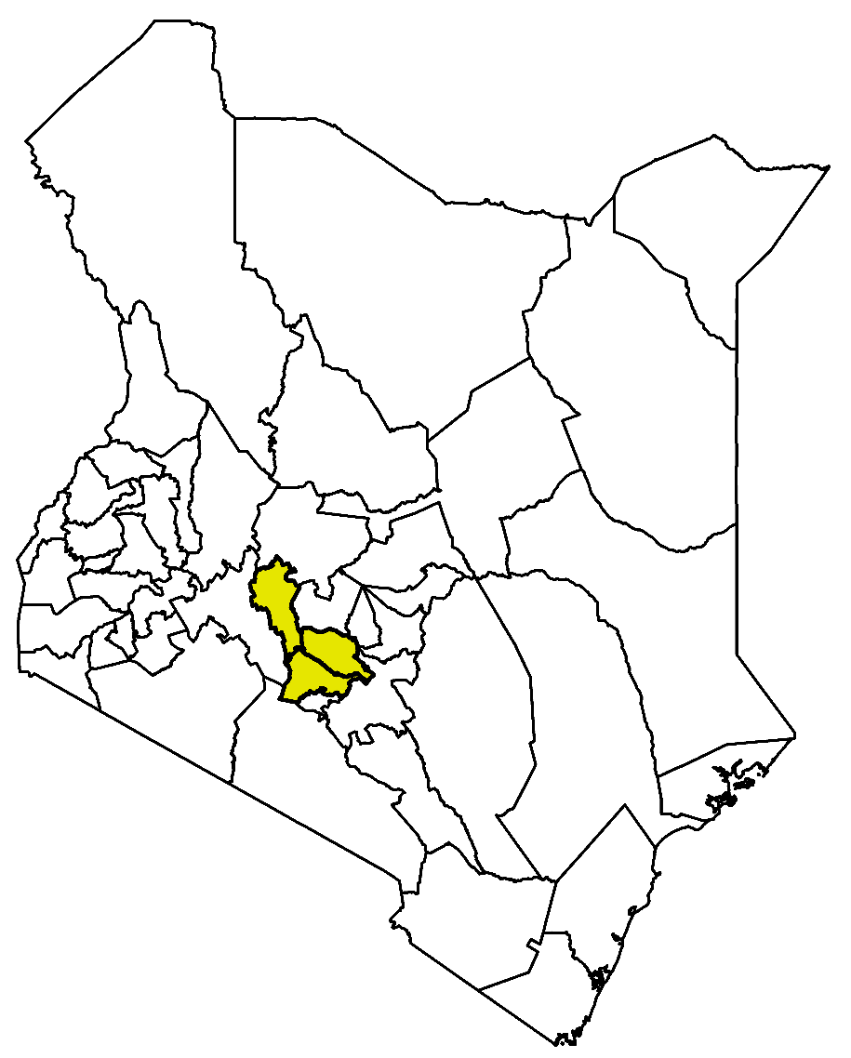
Figure 3.1: Map of Kenya highlighting the study area

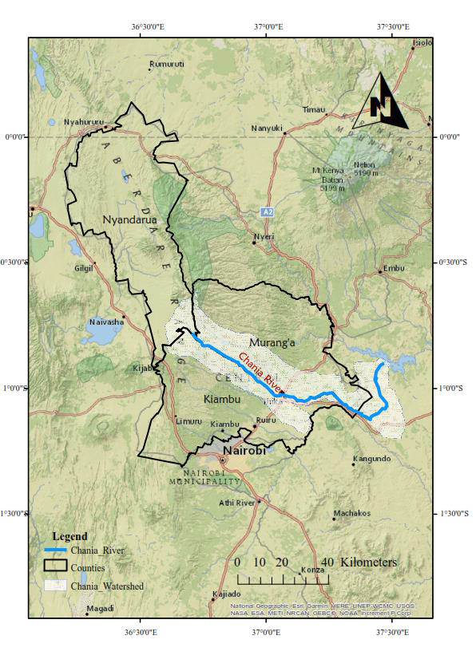
Figure 3.2: Map of River Chania water catchment

3.2 Research design
The experiment employed a longitudinal study design along the river profile. Seven sites were selected along the River Chania based on the prevailing anthropogenic activities and ease of access. The distances between the sites varied between 1 km and 2.5 km and the total length of river studied was 10 km. All the sites on the River Chania had different surrounding land uses. Site 1 had an indigenous forest and dense vegetation cover and served as the control site. In contrast, Sites 2 and 3 have numerous coffee and flower plantations on either side of the River as well as horticultural fields on both banks. Sites 4 and 5 have farmed fields, coffee plantations on the left bank and residential houses on the right bank of the river, while Sites 6 and 7 are dotted with residential houses, industries and other commercial activities on both banks. The descriptions and geographical locations of the study sites are presented in Table 1 and Table 2. (Plate 4.1-Plate 4.11). The descriptions of the study sites are presented in Table 3.1.

The cross-sectional survey design enabled the researcher to collect socio-economic data at a single site at a time. The data collected assessed the human activities that affect water quality in River Chania. Finally, sixty (60) individuals were randomly selected from each site. The number of individuals selected as respondents was in line with Mugenda and Mugenda (2009) study that asserted that 30 and above respondents are representative enough of a population.

Table 3.1: Description of the sampling sites
Site codes | Description
Site 1  Site 2  Site 3  Site 4  Site 5  Site 6  Site 7 | - River Chania at Karimenu, forested zone. This site is located in a forested area. There were trees and shrubs on both banks and there were no human settlements near the river.  - River Chania just before Chania Estate Bridge and located next to Penta flowers factory. There were trees and shrubs near the river, people washed clothes and abstracted water but no domestic animals were observed. Residential homes are present within 150 metres from the river. Agricultural activities were observed near river.  - River Chania after Chania Estate Bridge at Chania Coffee factory. Residential homes released domestic water into river; the coffee factory also released effluents; people washed clothes, bathed and swam in the river; motorbikes were washed in the river; there are agricultural activities and associated fertilizer and pesticides being applied.  - River Chania just before the onset of Ngoingwa Estate is a residential area that releases domestic effluents into the river; there are agricultural activities; people wash clothes and bathe in the river and water is abstracted.  - River Chania after Ngoingwa Estate but just before Thika town. Mainly a residential area that releases effluents into the river; there is  Subsistence farming and raising of livestock; people wash clothes in the river and have removed some of the riparian vegetation.  - River Chania just before the intake weir of Thika town and the intake weir of Kiambu Water and Sewerage Company (KIWASCO). The  riparian plants have been removed on both banks, garbage washes into the river from the adjacent road leading to Nairobi and people wash their motorbikes into the river.  - River Chania just after Thika town at Biafra. Industrial and domestic effluents are released into river; a Hindu crematorium disposes of ashes into the river; Delamare pineapple farm is situated here and much of the riparian vegetation has been removed.

3.3 Data collection and analytical procedures
Four water quality samples were collected at each site in the wet (October and November 2018) and the dry season months (January and February 2019). The water samples were collected in triplicate at a depth of about 20 cm, so there were 21 samples collected per month and 84 samples over the entire period. The samples were collected in pre-cleaned polypropylene bottles washed with distilled water. Temperature, electrical conductivity pH and total dissolved solids (TDS) were measured in-situ using a thermometer, conductivity, pH and TDS meters, respectively. Nitrites were analysed using the sulphanilic acid method (Dobrinas et al., 2013), nitrates and sulphates using the spectrophotometric method (Beaton et al., 2012) and total phosphates using the ascorbic acid method (Jońca et al., 2011). The atomic absorption spectroscopy method was used for both manganese and copper measurements (Ahmed et al., 2017). In contrast, the atomic emission spectroscopy method (Albert et al., 2011) and the argentometric method (Rahbar et al., 2019) were employed in the determination of potassium and chloride, respectively. The methods of chemical analysis are described by APHA (2002) and summarised in Table 3.2.

Primary survey data for this study was collected using a semi-structured interview schedule (Appendix 3). The interview schedule was administered with the help of enumerators who were selected and trained for this exercise. A total of 60 sampled respondents were interviewed. Prior to data collection, the data collection instruments were tested both for validity and reliability using a sample of 10 interview schedules administered to 10 randomly selected individuals. The information collected centred on demographics such as gender, age, education level, household size, average monthly income, change in households’ number, residence period, water meter connection, sources of households’ drinking water, water quality satisfaction and water quality issues.

Table 3.2: The measured parameters and method used in measurement
Parameter | Units | Analytical procedures and equipment
Temperature  TDS  Turbidity  Conductivity  pH  Nitrite  Nitrate  Sulphate  Total phosphate  Potassium  Manganese  Copper  Chloride | ºC  mg/L  NTU  µs/cm  ̲  mg/L  mg/L  mg/L  mg/L  mg/L  mg/L  mg/L  mg/L | Thermometer  TDS meter  Turbidity meter  Conductivity meter  pH meter  Sulphanilic acid method  Spectrophotometric  Spectrophotometric  Ascorbic acid method  Atomic emission spectroscopy  Atomic absorption spectroscopy  Atomic absorption spectroscopy  Argentometric

3.4 Water Quality Index (WQI)
A Water Quality Index was calculated using the Weighted Arithmetic Mean method (Chowdhury et al., 2012; Balan et al., 2012). The method follows three steps (Alobaidy et al., 2010). The first involves assigning a weight (w_{i}) to each parameter according to its perceived importance to water quality and human health (Avvannavar and Shrihari, 2008; Saeedi et al., 2010). Nine water quality parameters were used in the calculation of water quality index: nitrates, total dissolved solids (TDS), potassium, sulphate, chloride, copper, manganese, pH and Total phosphate.
Table 3.3 and Table 3.4 show the assigned weights and the World Health Organization (WHO) recommended standards for drinking water quality (WHO, 2011). The assigned weights range from one to five, with the most influential parameter on water quality and human health being assigned five and the least influential being assigned one (Srinivasamoorthy et al., 2008). Nitrates and manganese were assigned the highest weight; Total phosphate, sulphate, chloride, TDS, copper, and pH were assigned intermediate weights and potassium the lowest due to their perceived effects on water quality and human health (Varol and Davraz, 2015). If the values of these parameters are beyond the acceptable threshold, they could limit water use for domestic and drinking purposes (Yidana and Yidana, 2010).
Table 3.3: Water quality parameters and the recommended water quality standards by World Health Organization (WHO)
Parameter | Unit | WHO
Temperature | ºC | -
pH | - | 6.5-8.5
TDS | mg/L | 1000
Conductivity | µs/cm | 500-5000
Turbidity | NTU | 5
Chloride | mg/L | 250
Sulphate | mg/L | 250
Phosphate | mg/L | 5
Nitrate | mg/L | 50
Nitrite | mg/L | 0.2-3
Manganese | mg/L | 0.4
Copper | mg/L | 1-2
Potassium | mg/L | 30

Table 3.4: Physico-chemical parameters, prescribed values by WHO, weights assigned (w_{i}) and corresponding relative weights (W_{i})
Parameter | w_{i} | WHO standard | W_{i}
Nitrates  TDS  Potassium  Sulphates  Chlorides  Copper  Manganese  pH  Total Phosphates | 5  3  2  4  3  4  5  4  3 | 50  1000  30  250  250  1  0.4  7.5  5 | 0.152  0.091  0.061  0.121  0 .091  0.121  0.152  0.121  0.091
 | ∑=33
Source: WHO, 2011
The second step involves the computation of the relative weight (W_{i}) by the use of equation 1;
W_{i} = ………………………………….………………………………………(1)
Where W_{i} is the relative weight, w_{i} is the assigned weight of each parameter and n is the number of parameters.
The third step involves calculating a quality rating scale (q_{i}) for each parameter using equation (2) below. This is done by dividing the concentration of each parameter (C_{i}) in each water sample by its respective set standard (S_{i}) and the result multiplied by 100. The standard (S_{i}) used was WHO (2011).
q_{i} = ( ) ×100 …………………………………………………………………….(2)
Where q_{i} is the quality rating, C_{i} is the concentration of each parameter in each water sample and S_{i} is the WHO set drinking water standard for each parameter. In the calculation of WQI, sub-index (SI_{i}) is determined first for each parameter (Equation 3) and the WQI is derived from the summation of the different sub-indices as indicated in equation 4.
SI_{i} = w_{i} × q_{i} ………………………….……………………………………………….. (3)
WQI = …………………………………………..………………………………(4)
The WQI values obtained were classified into five water quality classes; 0-25 indicates excellent water quality, 26-50 indicates good water quality, 51-75 indicates poor water quality, 76-100 indicates very poor quality of water and >100 indicates water that is unsuitable for drinking purposes (Tyagi et al., 2013) (Table 3.5).

Table 3.5: Water Quality Indicator (WQI) classes for drinking purpose
Class number | WQI Range | Water type
1  2  3  4  5 | 0-25  26-50  51-75  76-100  >100 | Excellent  Good  Poor  Very poor  Unsuitable for drinking purpose
Source: Tyagi et al., 2013.

3.5 Data analysis
The mean values of the replicate samples collected were calculated in Microsoft Excel. A paired t-test (p< 0.05) was used to compare the water quality variables collected in both the wet and dry seasons across sites to see if these differed longitudinally down the river. The data were subjected to analysis of variance (ANOVA) using Statistical Analysis Software (SAS) version 9.2 (Ferreira 2011) and means separated using LSD at p< 0.05 confidence level.
The socio-economic characteristics data of the respondents was entered and managed in Microsoft excel and later coded. Consequently, the data was analyzed using descriptive statistics such as frequencies and percentages. In order to express the degree of correspondence between two variables, Pearson Chi-Square was used. Multinomial Logit Regression (MNLR) model was used with the objective of determining how the different socio-economic factors affect water quality at a statistical significance of 5% probability level in concurrence with Hassan and Nhemachena (2008). To conduct these analyses, Statistical Package for Social Sciences (SPSS) version 21 (Bryman and Cramer, 2002) was used.

CHAPTER FOUR

RESULTS AND DISCUSSION

4.0 Results

4.1 Physico-chemical parameters
The physico-chemical parameters measured in the River Chania are presented in Table 4.1. Temperature varied significantly among the sites in both seasons (Table 4.1). Site 7 had the highest temperature compared to the other sites in both seasons; 20.43 ± 0.15ºC for the wet season and 23.43 ± 0.33ºC for the dry season (p< 0.05). However, in the dry season, only Sites 1 (20.43 ± 0.27ºC) and 3 (20.15 ± 0.50ºC) were significantly cooler. Temperature increased with reducing altitude in both seasons at all sites except for Site 3. The temperature across all sites ranged from 16.60 ± 0.17ºC to 20.43 ± 0.15ºC and 20.15 ± 0.50ºC to 23.43 ± 0.33ºC in the wet and dry seasons, respectively (Table 4.1).
Total dissolved solids (TDS) mean values were higher during the dry season and especially high at Site 7 (53.61 ± 1.10 mg/L), while Site 3 (16.37 ± 0.28 mg/L) recorded the lowest in the same season. During the wet season, the highest mean value was recorded at Site 7 (51.90 ± 0.58 mg/L), whereas the lowest mean value was recorded at Site 2 (10.96 ± 0.39 mg/L) (Table 4.1). On the other hand, mean turbidity values were highest during the wet season and especially high at Site 7 (278.48 ± 1.84 NTU). The highest turbidity value during the dry season was also recorded at Site 7 (76.22 ± 1.16 NTU) and the lowest at Site 3 (17.54 ± 0.70 NTU). During the dry season, the results revealed that turbidity values were significantly different between Site 1 to Site 5 (p< 0.05), but there were no differences between Sites 6 and 7 (Table 4.1).
With regard to heavy metals (manganese and copper), higher mean values were recorded during the wet season at downstream sites (Sites 5 to 7) (Table 4.1). Manganese levels in the wet season increased downstream, however, this trend was not observed in the dry season. The highest values for manganese were recorded at Site 7 (1.78 ± 0.07 mg/L) in the wet season and at the same site (0.26 ± 0.02 mg/L) in the dry season. Manganese concentration ranged from 0.21 ± 0.02 mg/L to 1.78 ± 0.07mg/L and 0.11 ± 0.01mg/L to 0.26 ± 0.02mg/L in the wet and dry seasons respectively. The manganese value for the wet season was four times (0.72 mg/L) higher than the manganese during the dry season (Table 4.1). The mean Copper values significantly varied among the sites in both seasons (Table 4.1). Sites 6 (0.22 ± 0.03 mg/L) and 7 (0.22 ± 0.01 mg/L) had the highest copper levels during the wet season compared to the other sites in both seasons but these differences were not significant. Copper levels ranged from 0.11 ± 0.01 mg/L to 0.22 ± 0.01 mg/L and 0.04 ± 0.01 mg/L to 0.16 ± 0.02 mg/L in the wet and dry seasons, respectively (Table 4.1).
Sulphate levels ranged from 21.97 ± 0.49 mg/L to 62.48 ± 0.87 mg/L and 26.39 ± 0.93 mg/L to 82.00 ± 1.15 mg/L in the wet and dry seasons respectively. Sulphate values did not significantly vary among sites in both seasons. Phosphate concentration ranged from 0.08 ± 0.02 mg/L to 2.43 ± 0.11 mg/L and 0.08 ± 0.01 mg/L to 1.34 ± 0.46 mg/L in the wet and dry seasons respectively. Phosphate values, too, did not significantly vary among sites in the wet season, but conversely, they were different in the dry season. Nitrate concentrations were higher during the wet season (0.61 ± 0.24 mg/L to 2.60 ± 0.05 mg/L) than in the dry season (0.66 ± 0.03 mg/L to 1.30 ± 0.07 mg/L) especially at upstream sites (Sites 1 to 4), but there was no clear seasonal variation across the study sites. Nitrite levels were higher during the dry season (0.24 ± 0.02 mg/L to 0.47 ± 0.02 mg/L) than the wet season especially at Site 7 (0.47 ± 0.02) and potassium (0.90 ± 0.04 mg/L to 2.75 ± 0.08 mg/L) showed the same trend at the downstream sites (Site 4 to 7) (Table 4.1).

Table 4.1: Physico-chemical properties of water in study sites along part of the River Chania.
Factor | Site 1 | Site 2 | Site 3 | Site 4 | Site 5 | Site 6 | Site 7
Temp Wet (ºC) | 17.54±0.20^{d} | 17.46±0.18^{d} | 16.60±0.17e | 19.83±0.18^{bc} | 20.33±0.19^{ab} | 19.50±0.18^{c} | 20.43±0.15ª
Temp Dry (ºC) | 20.43±0.27^{b} | 23.45±0.42ª | 20.15±0.50^{b} | 23.82±0.52ª | 23.13±0.18ª | 23.24±0.33ª | 23.43±0.33ª
TDS Wet (mg/L) | 30.80±0.49^{b} | 10.96±0.39^{f} | 19.30±0.29e | 23.91±0.57^{d} | 27.80±0.58^{c} | 24.86±0.23^{d} | 51.90±0.58ª
TDS Dry (mg/L) | 25.75±0.35^{c} | 17.96±0.48^{d} | 16.37±0.28e | 26.03±0.26^{c} | 36.86±0.52^{b} | 36.41±0.68^{b} | 53.61±1.10ª
Turb Wet (NTU) | 69.03±0.92e | 108.73±1.01^{d} | 67.43±1.35e | 225.25±3.27^{b} | 217.97±1.26^{c} | 222.97±1.24^{b} | 278.48±1.84ª
Turb Dry (NTU) | 44.62±0.88^{d} | 32.10±1.91e | 17.54±0.70^{f} | 55.96±2.15^{c} | 67.42±1.15^{b} | 75.87±1.22ª | 76.22±1.16ª
Cond Wet (μS/cm) | 54.60±0.22^{b} | 19.19±0.66^{g} | 34.04±0.45^{f} | 40.85±0.35e | 51.36±0.57^{c} | 45.21±0.40^{d} | 92.54±1.45ª
Cond Dry (μS/cm) | 46.65±0.42e | 39.45±0.29^{f} | 31.81±0.47^{g} | 51.64±3.18^{d} | 62.51±1.86^{c} | 67.22±0.52^{b} | 96.79±1.14ª
pH Wet | 6.83±0.19ª | 6.60±0.18ª | 5.98±0.20^{c} | 5.88±0.17^{c} | 6.26±0.16^{bc} | 6.32±0.16^{abc} | 6.20±0.14^{bc}
pH Dry | 7.37±0.15^{ab} | 6.53±0.17^{c} | 7.06±0.06^{b} | 7.43±0.14ª | 7.67±0.09ª | 7.37±0.03^{ab} | 7.46±0.17ª
Chloride Wet (mg/L) | 4.84±0.13^{bc} | 2.88±0.16e | 4.21±0.03^{d} | 5.05±0.08^{b} | 4.64±0.09^{c} | 4.38±0.03^{d} | 6.04±0.05ª
Chloride Dry (mg/L) | 3.27±0.07^{d} | 2.62±0.04e | 1.91±0.03^{f} | 2.15±0.03^{f} | 4.45±0.14^{c} | 4.83±0.03^{b} | 5.61±0.15ª
Sulphate Wet (mg/L) | 21.97±0.49^{f} | 24.80±0.65e | 37.46±0.83^{d} | 36.68±2.57^{d} | 49.24±0.29^{b} | 45.67±0.23^{c} | 62.48±0.87ª
Sulphate Dry (mg/L) | 26.39±0.93^{f} | 28.85±0.60^{f} | 36.62±0.71e | 72.42±1.29^{b} | 41.02±0.75^{d} | 50.47±0.22^{c} | 82.00±1.15ª
Total Phosphate Wet (mg/L) | 0.08±0.02^{c} | 0.19±0.01^{c} | 0.29±0.02^{c} | 1.57±0.04^{b} | 2.26±0.17ª | 1.35±0.02^{b} | 2.43±0.11ª
Total Phosphate Dry (mg/L) | 0.38±0.02^{c} | 0.20±0.01e | 0.08±0.01^{f} | 0.12±0.02^{f} | 0.26±0.01^{d} | 1.34±0.46ª | 0.83±0.05^{b}
Nitrate Wet (mg/L) | 2.60±0.05ª | 1.58±0.07^{c} | 2.04±0.05^{b} | 1.37±0.04^{c} | 0.81±0.20de | 0.61±0.24e | 0.91±0.21^{d}
Nitrate Dry (mg/L) | 0.78±0.04^{c} | 0.66±0.03^{d} | 0.77±0.04^{c} | 0.82±0.02^{c} | 0.82±0.03^{c} | 1.05±0.04^{b} | 1.30±0.07ª
Nitrite Wet (mg/L) | 0.15±0.02^{d} | 0.19±0.01^{c} | 0.23±0.01^{b} | 0.29±0.01ª | 0.25±0.01^{b} | 0.23±0.01^{b} | 0.25±0.01^{b}
Nitrite Dry (mg/L) | 0.31±0.02^{b} | 0.24±0.02^{c} | 0.31±0.02^{b} | 0.30±0.01^{b} | 0.33±0.02^{b} | 0.28±0.01^{bc} | 0.47±0.02ª
Manganese Wet (mg/L) | 0.21±0.02e | 0.30±0.01^{d} | 0.33±0.01^{d} | 0.63±0.02^{c} | 0.90±0.03^{b} | 0.86±0.03^{b} | 1.78±0.07ª
Manganese Dry (mg/L) | 0.11±0.01^{c} | 0.21±0.01^{ab} | 0.15±0.02^{bc} | 0.22±0.02ª | 0.15±0.02^{c} | 0.14±0.02^{c} | 0.26±0.02ª
Copper Wet (mg/L) | 0.11±0.01^{d} | 0.16±0.01^{c} | 0.12±0.01^{d} | 0.18±0.01^{bc} | 0.21±0.01^{ab} | 0.22±0.03ª | 0.22±0.01ª
Copper Dry (mg/L) | 0.05±0.01^{c} | 0.06±0.01^{c} | 0.04±0.01^{c} | 0.11±0.01^{b} | 0.16±0.02ª | 0.10±0.01^{b} | 0.11±0.01^{b}
Potassium Wet (mg/L) | 1.88±0.11^{b} | 0.48±0.05^{f} | 1.32±0.02e | 1.42±0.06^{d} | 1.69±0.04^{c} | 1.83±0.03^{b} | 2.09±0.03ª
Potassium Dry (mg/L) | 2.13±0.02^{b} | 0.90±0.04e | 1.68±0.03^{c} | 1.66±0.02^{c} | 1.74±0.03^{c} | 2.75±0.08ª | 1.40±0.05^{d}
* Bolded values are values that were outside the recommended threshold limits by WHO; means with the same letter (i.e. a, b, c etc.) are not significantly different between sites.

4.2 Water Quality Index
The mean of the Water Quality Index values showed that the water quality deteriorated (44.67) during the wet season when compared to the dry season (23.75), particularly at downstream sites (Sites 4 to 7) (Table 4.2). During the wet season, water quality was excellent (23.17) at Site 1 and declined to poor (> 50) and very poor (> 76) water quality at the most downstream sites (Sites 5 to 7). During the dry season, water quality varied between excellent water quality (19.67 to 24.69) at Sites 1 to 3, 5 to 6, and good water quality (26.30 to 30.10) at Sites 4 and Site 7 respectively but gave no specific trend with respect to the study sites. Generally, the water quality in the River Chania was classified as good (34.22) (Table 4.2) when considering both seasons at all sites sampled along the river.
Table 4.2: Water Quality Index (WQI) values for the wet (WQI_{w}) and dry (WQI_{d}) seasons, combined seasons (WQI_{combined}) and water type categories for the different study sites
Sampling site | WQI_{w} | Water type | WQI_{d} | Water type | WQI_{combined} | Water type
Site 1  Site 2  Site 3  Site 4  Site 5  Site 6  Site 7  Entire river | 23.17  26.31  27.20  41.34  54.35  51.15  89.15  44.67 | Excellent  Good  Good  Good  Poor  Poor  Very poor  Good | 19.67  21.64  20.29  26.30  23.57  24.69  30.10  23.75 | Excellent  Excellent  Excellent  Good  Excellent  Excellent  Good  Excellent | 21.41  23.79  23.71  33.94  39.09  37.92  59.68  34.22 | Excellent  Excellent  Excellent  Good  Good  Good  Poor  Good

4.3 River Chania as influenced by anthropogenic activities

High level of pollution were observed in the downstream of River Chania as evidenced by Plate 4.2-Plate 4.11. The discoloration of the water is as a result of sediment and silt deposition of organic and inorganic materials from the open agricultural farmlands and the river watershed that end up in the river as well as effects of urbanization and industrialization in the study area. The situation has recentlty been aggravated by increased human activities as seen in the photographs below with people washing and conducting other activities in the stream area and the natural forces along the watercourse of River Chania especially during the rainy season (Plates 4.2-4.11).

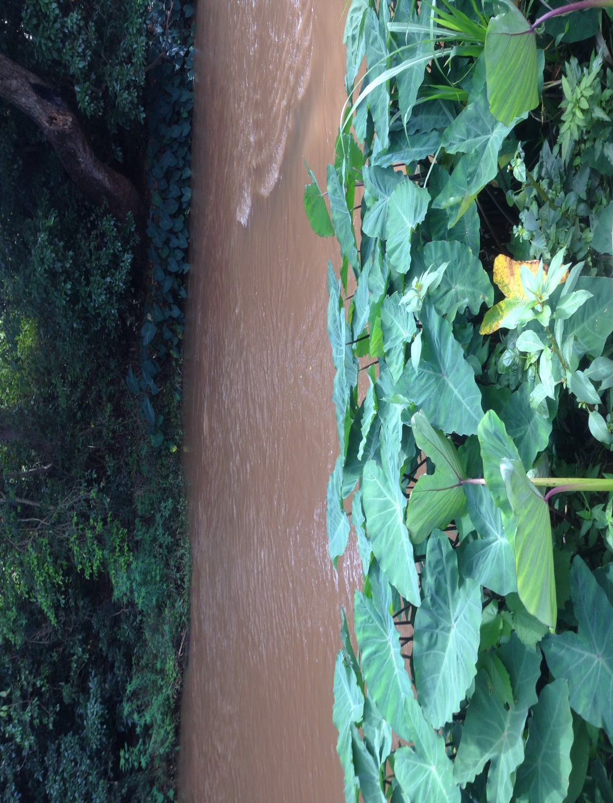
Plate 4.1: Site 1 (Forested area) at Karimenu along River Chania showing dense riparian vegetation on both banks with little human disturbance

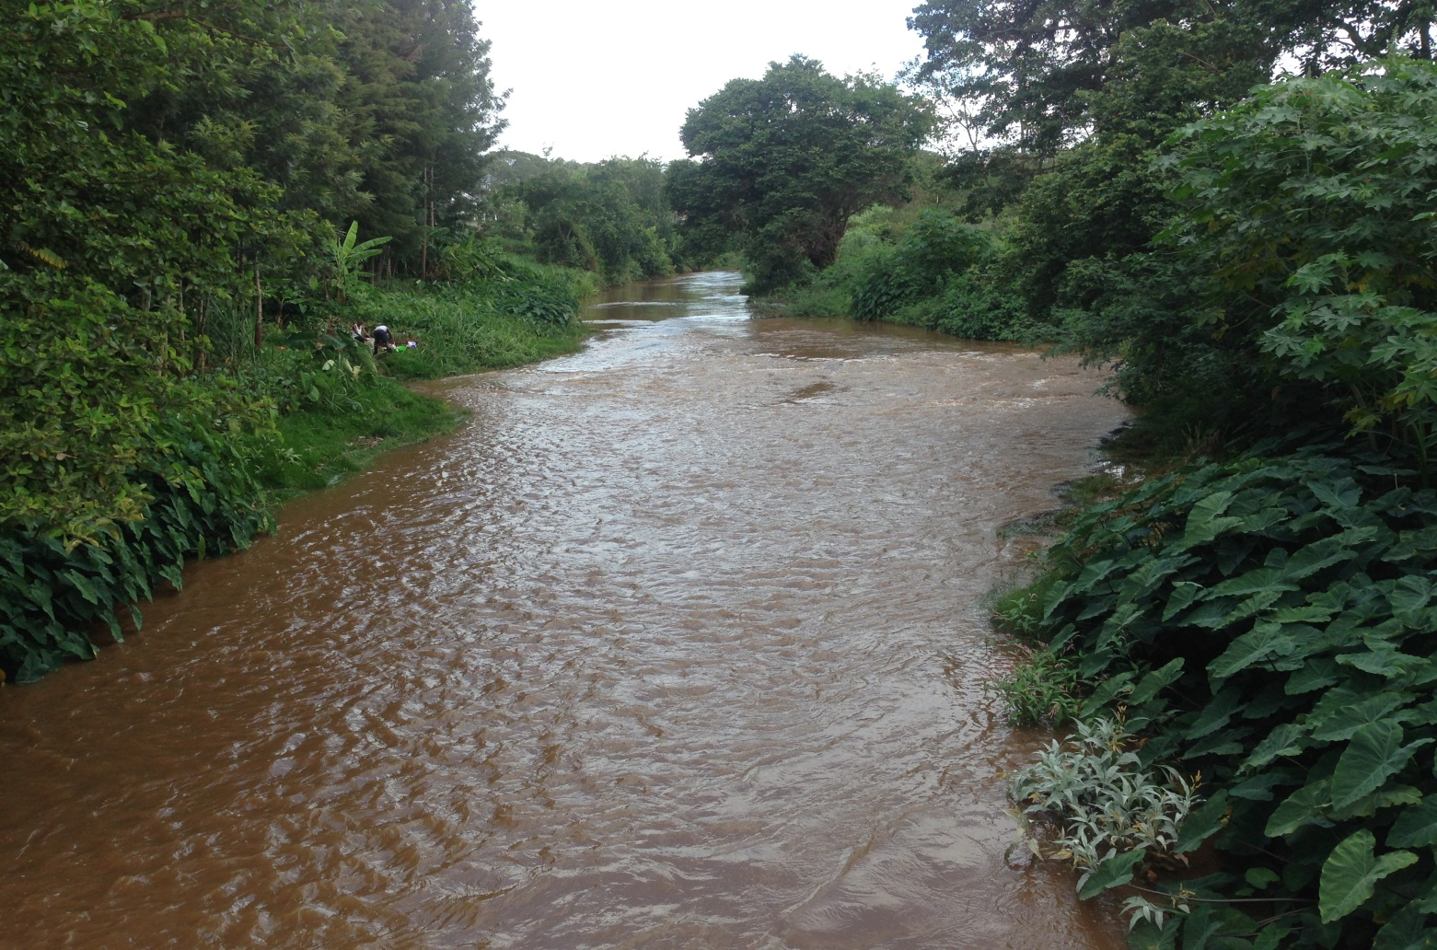
Plate 4.2: Site 2 (upstream of Chania Estate Bridge) along River Chania showing dense riparian vegetation on both banks with minimal anthropogenic activities

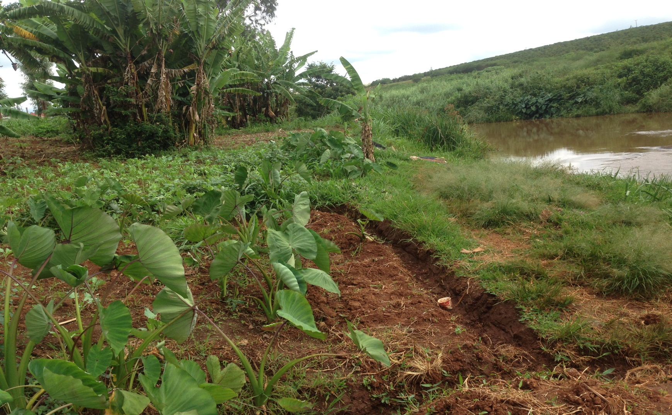
Plate 4.3: Site 3 (downstream of Chania Estate Bridge) along River Chania showing agricultural activities on its banks with scarce riparian vegetation

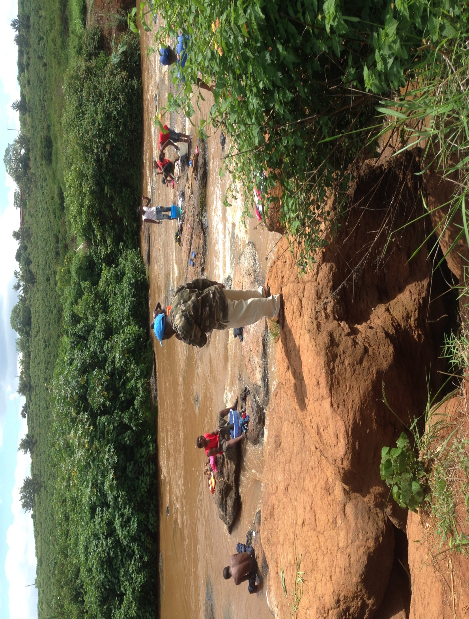
Plate 4.4: Site 5 (downstream of Ngoingwa Estate) along River Chania showing river quality degradation due to anthropogenic activities (bathing and washing clothes-laundry)

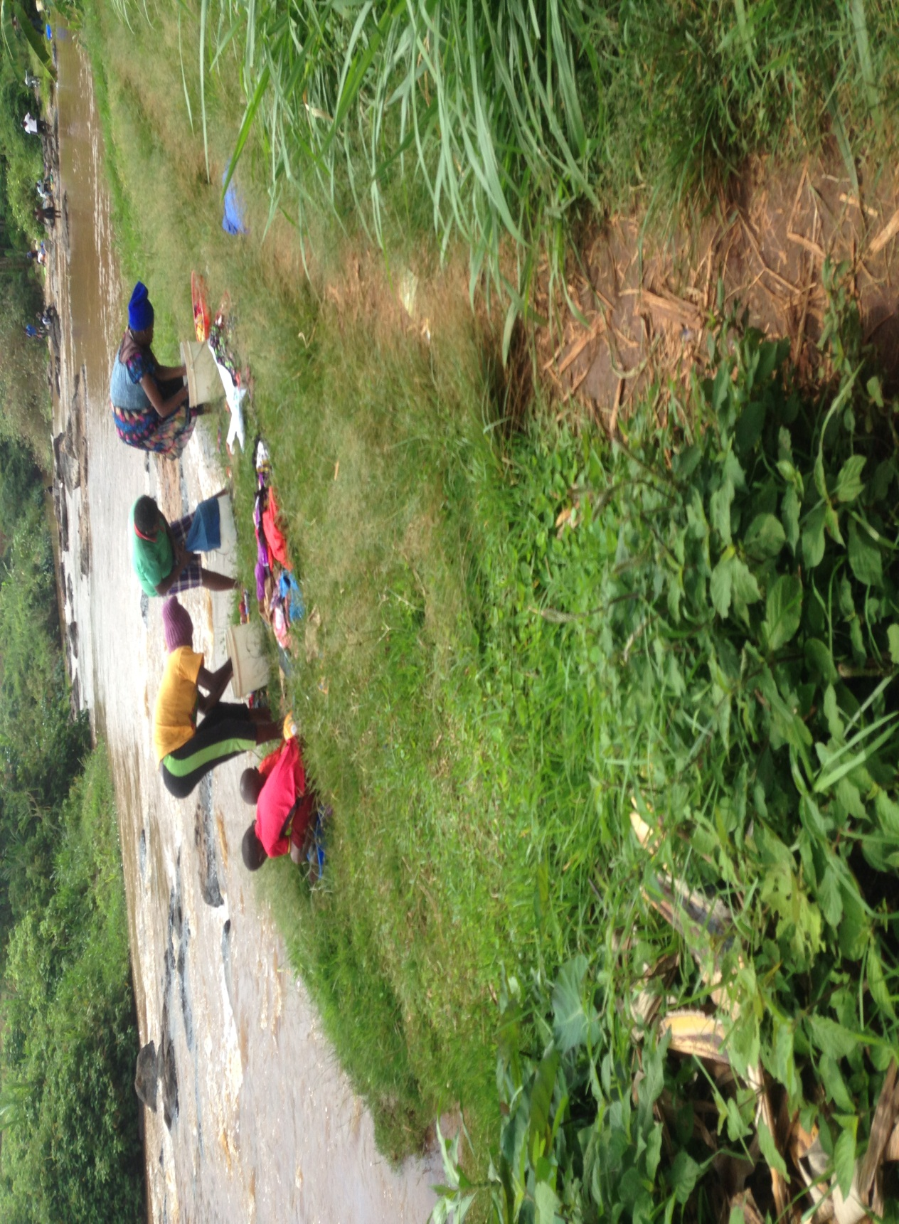
Plate 4.5: Site 4 (upstream of Ngoingwa Estate) along River Chania showing river quality degradation due to human activities such as washing of clothes, bathing and water abstraction. A path leading to river and riparian vegetation removal is evident

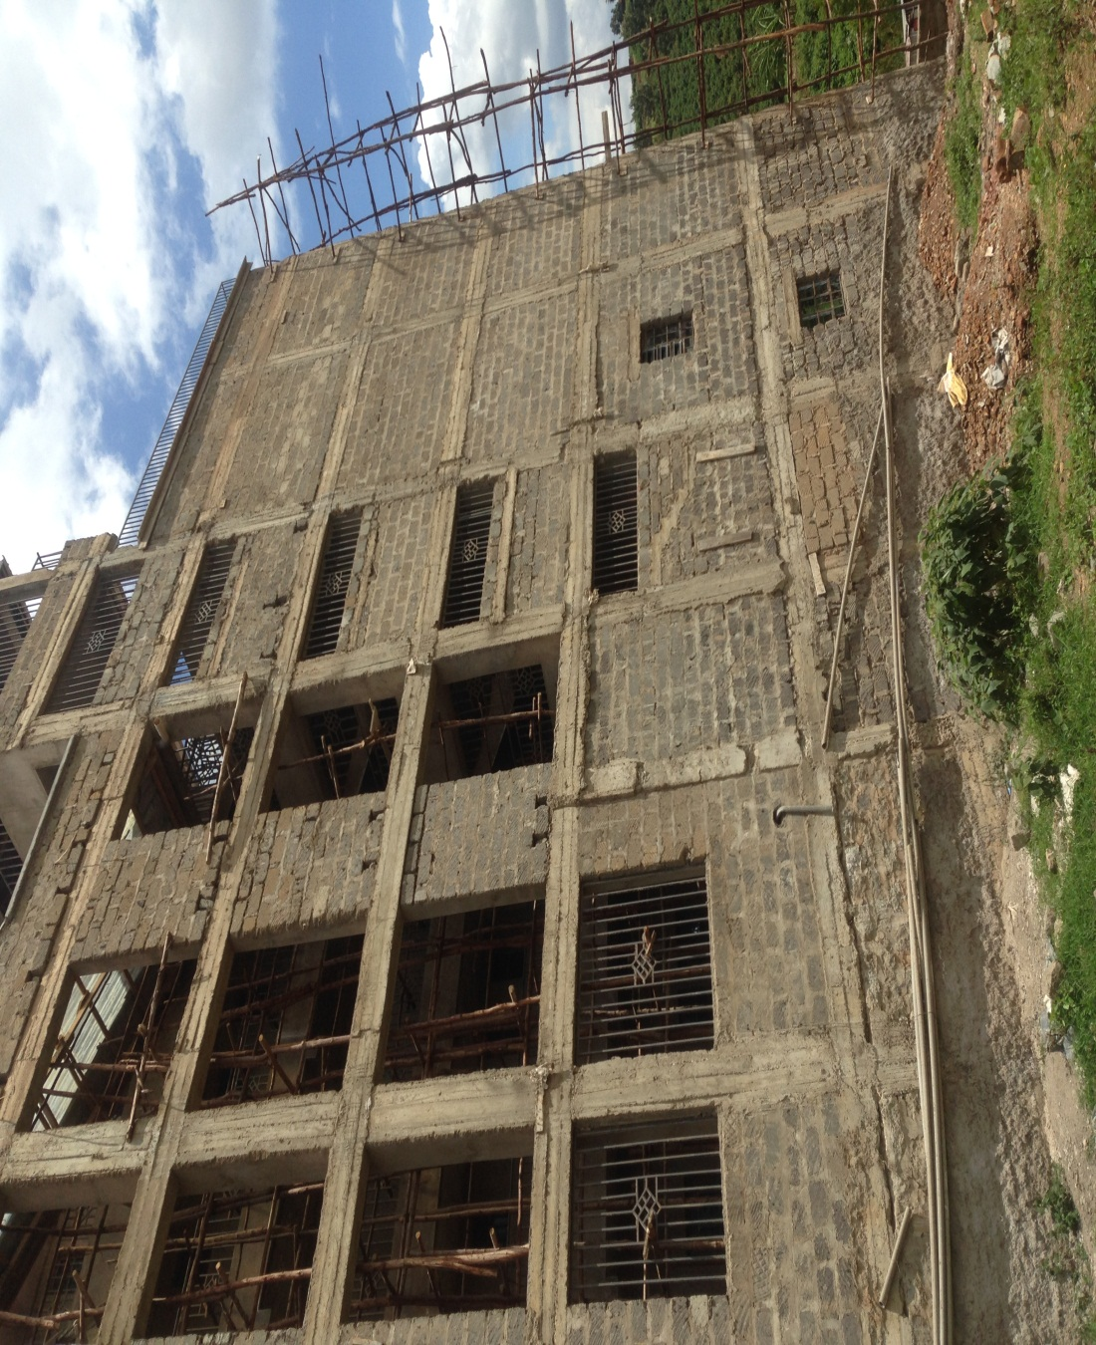
Plate 4.6: Site 5 (downstream of Ngoingwa Estate) along River Chania showing development activities taking place on the banks of the river causing pollution

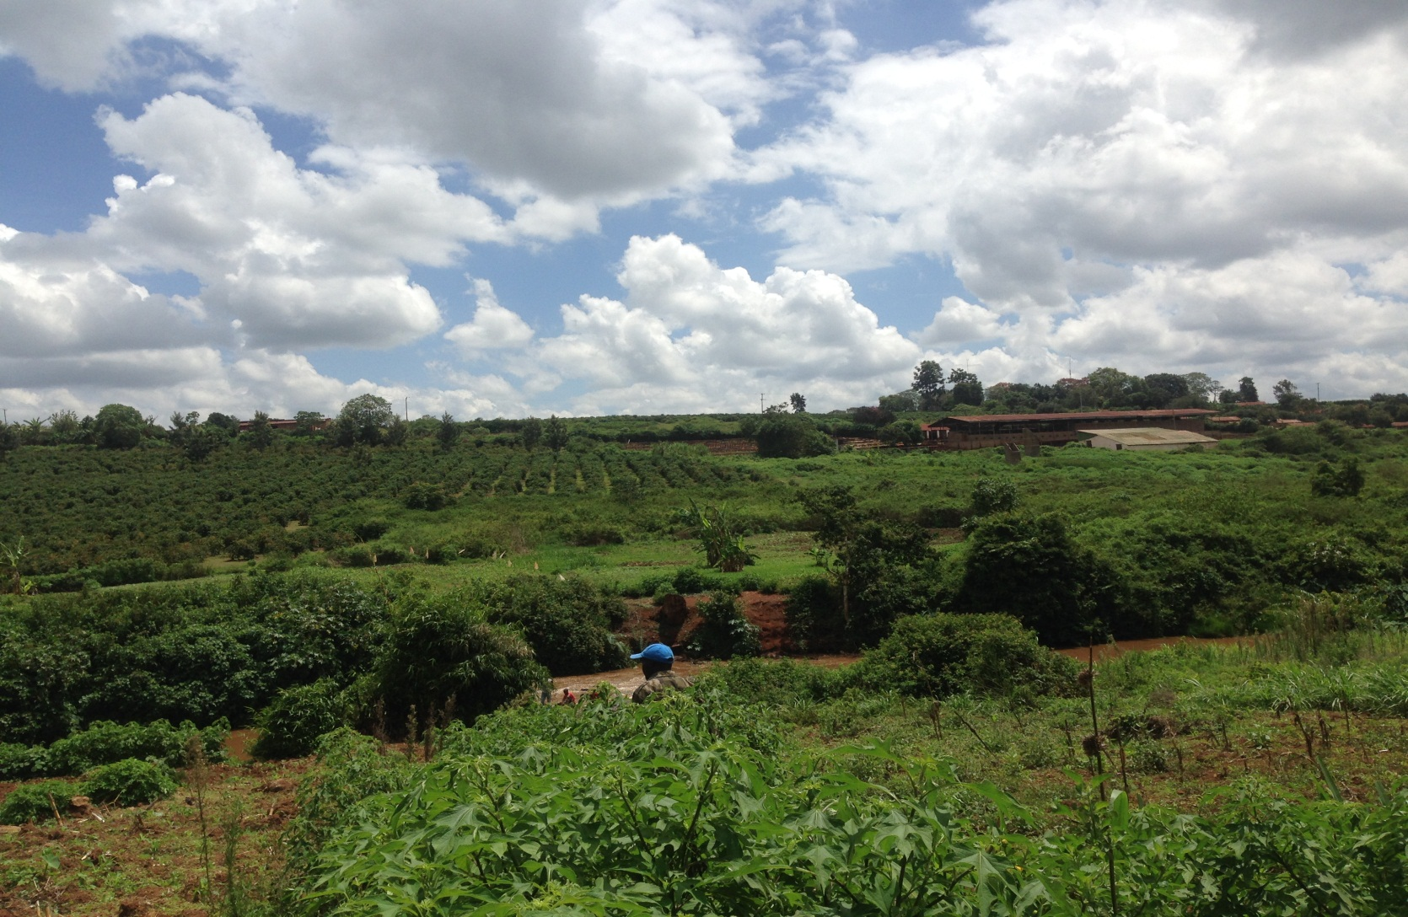
Plate 4.7: Site 3 (downstream of Chania Estate Bridge) along River Chania showing expansive coffee plantations on banks of the river with an adjacent coffee factory which potentially contribute to pollutants to River Chania

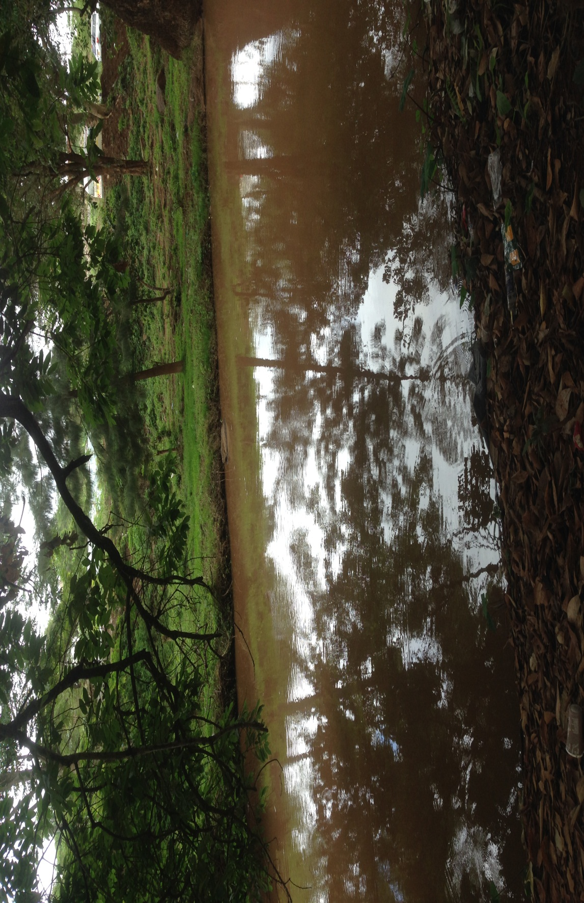
Plate 4.8: Site 6 (upstream of Thika town) along River Chania showing high turbidity of river water due to anthropogenic activities such as washing of cars and motorcycles

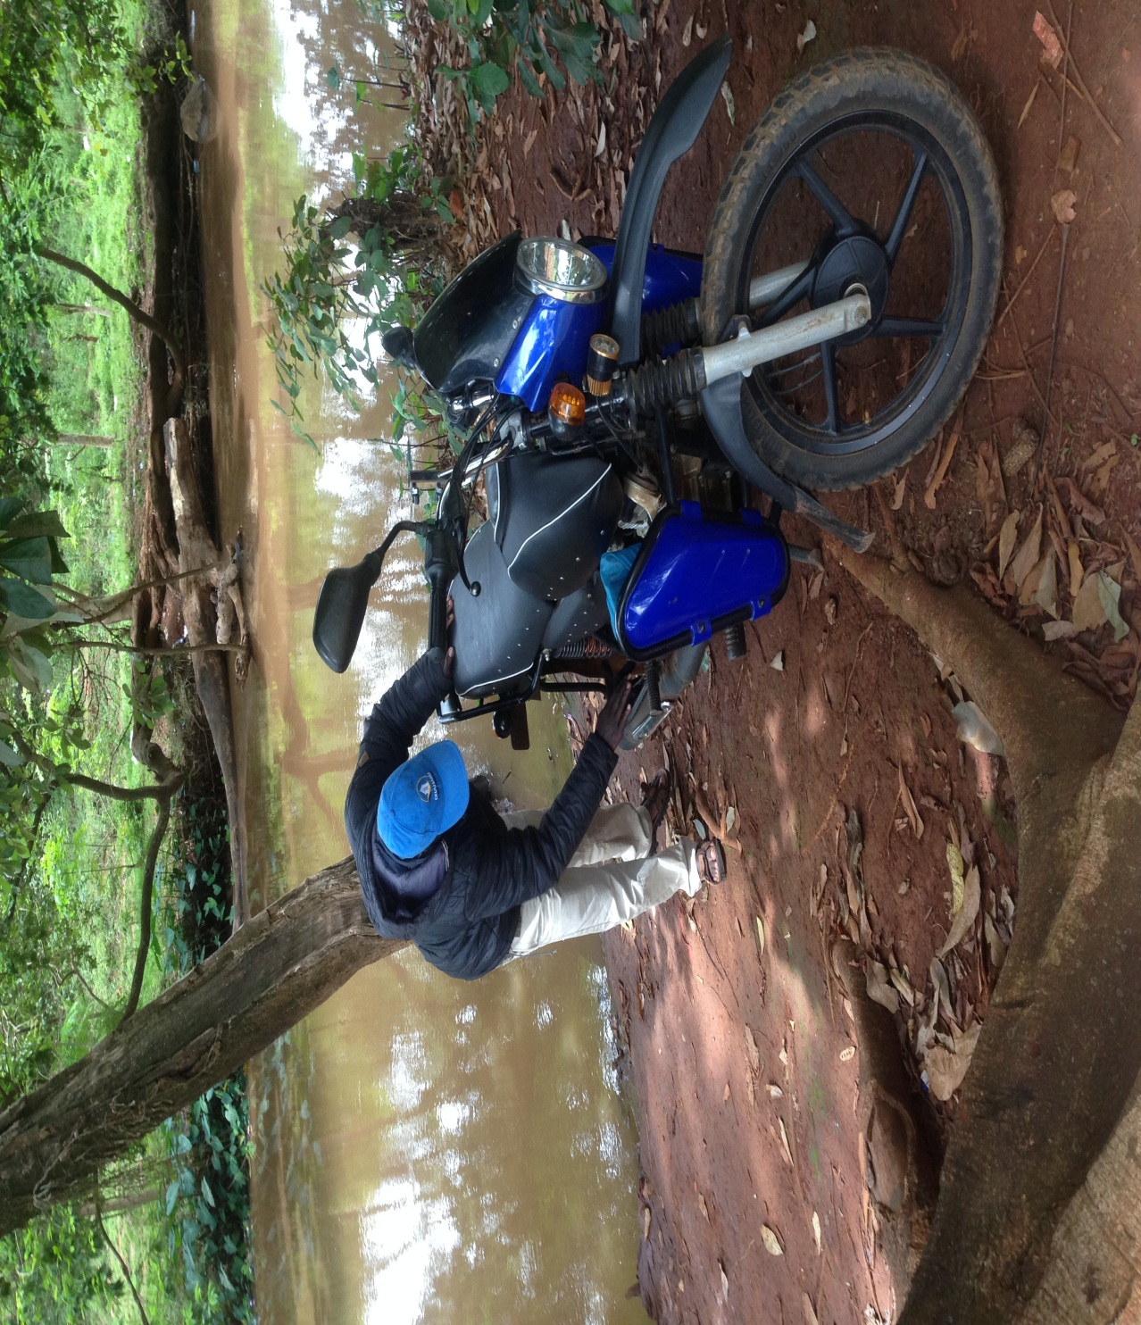
Plate 4.9: Site 6 (upstream of Thika town) along River Chania showing a motorcycle operator washing a motorcycle on the banks of the river water causing pollution in the river

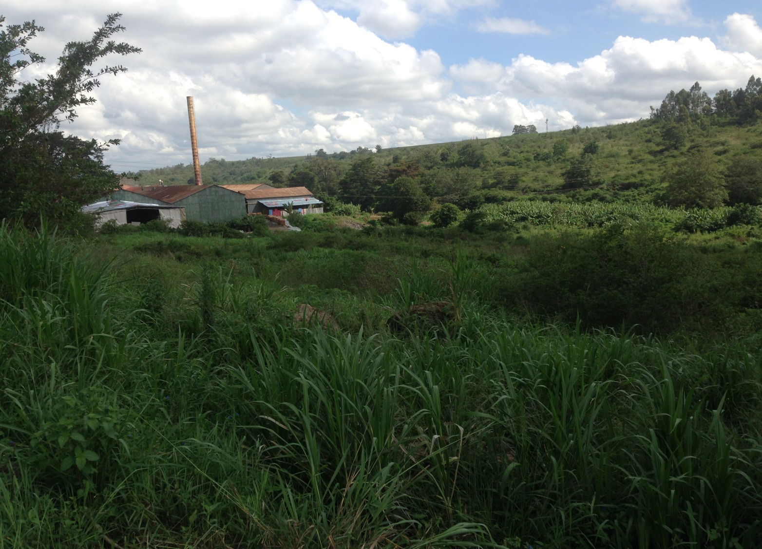
Plate 4.10: Kenya Tanning Extracts at Site 7 (downstream of Thika town) located on the banks of River Chania which potentially discharges wastes into the river

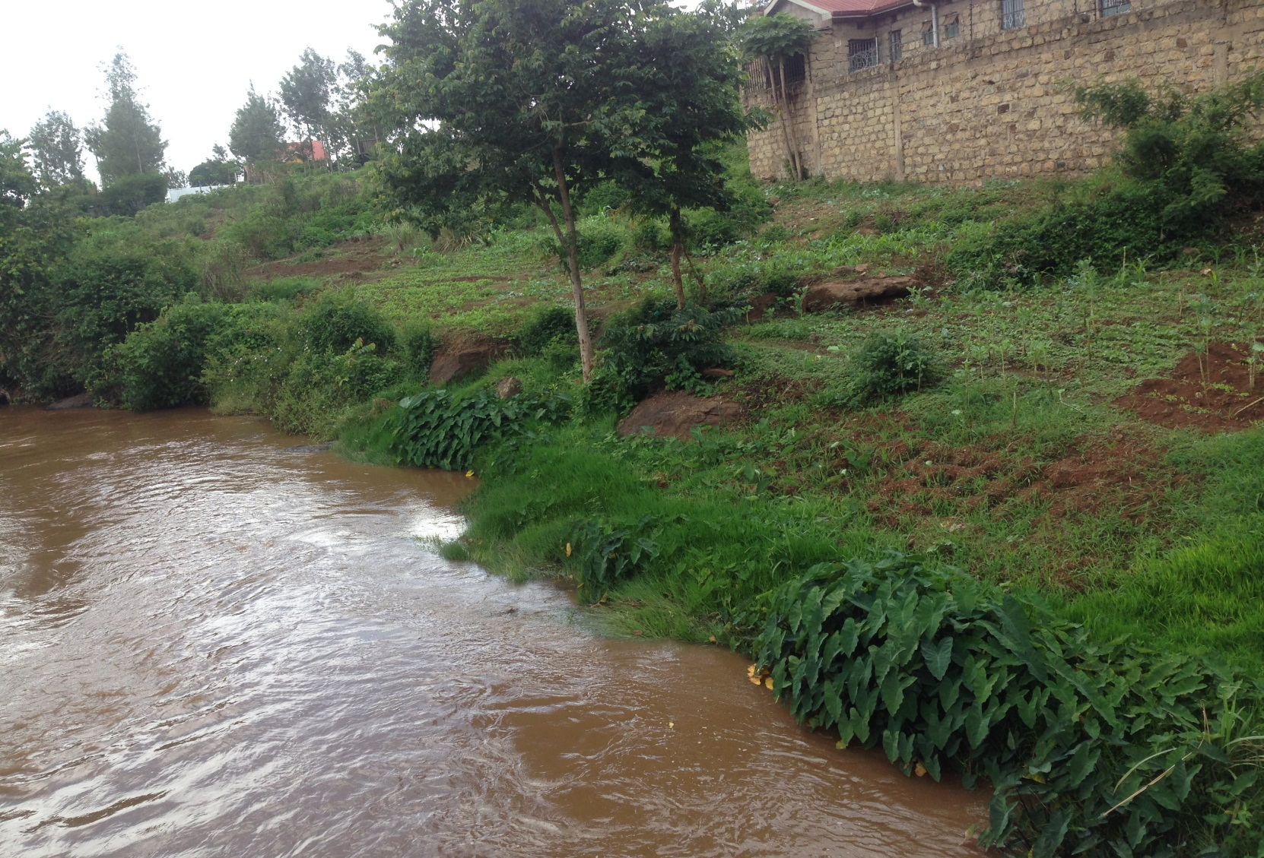
Plate 4.11: Site 7 (downstream of Thika town) along River Chania showing high turbidity of river water due to anthropogenic activities including construction and farming on riparian zone

4.4 Socio-economic characteristics of the respondents

The socio-economic characteristics of the respondents are summarized in Table 4.3.

4.4.1 Gender and education

Two-thirds (65%) of the individuals interviewed were male while the rest were female (35%). Of this, 65% were youth aged between 18-35 years of age, 12% were middle-aged (36-50 years) and the rest were aged over 51 years. All of the sampled respondents had acquired formal education and 53% of the sampled individuals had acquired tertiary education of either college or university level.

4.4.2 Household income

The majority (57%) of the respondents earned between KSh. 10000 and 20000 per month. It was also observed that a about two thirds (67%) of the respondents had meter connection while a third (33%) were not connected to metered water by local water provider, Kiambu Water and Sewerage Company (KIWASCO). Out of the total number of the respondents, 85% had a family size of 1-5 while the rest had more than 5 family members. Thirty two percent of those interviewed have resided in the study area for between 0-5 years while the rest have stayed in the area for over 6 years.

4.4.3 Economic activities

Half of the respondents (50%) perceived farming to be the main economic activity while other respondents identified entrepreneurship and employment in local industries (28% and 22% respectively) as the main economic activity in the area.

4.4.4 Source of water

It was noted that 23% of the respondents used raw water directly from River Chania to meet their daily water requirements while 15% used borehole water, 3% bought water from licensed water vendors and 58% were connected to water by KIWASCO (private piped).

Table 4.3: Socio-economic characteristics as assessed by the respondents
Factor | Frequency |  | Percentage
Gender
Male | 39 |  | 65
Female | 21 |  | 35
Age (years)
18-35 | 39 |  | 65
36-50 | 12 |  | 20
51-60 | 8 |  | 13
Over 60 | 1 |  | 2
Level of education
Primary | 11 |  | 18
Secondary | 17 |  | 28
College | 20 |  | 33
University | 12 |  | 20
Residence period(years)
0-5 | 19 |  | 32
6-10 | 12 |  | 20
11-20 | 17 |  | 28
Over 20 | 12 |  | 20
Household size
1-5 | 51 |  | 85
Over 6 | 9 |  | 15
Household income per month (Kenya shillings)
1000-10000 | 13 |  | 22
10000-20000 | 34 |  | 57
20000-30000 | 8 |  | 13
Over 30000 | 5 |  | 8
Meter connection
No | 20 | 33
Yes | 40 | 67
Major economic activity
Farming | 30 | 50
Entrepreneurship | 17 | 28
Employment in local industries | 13 | 22
Main household source of drinking water
Private piped | 35 | 58
Public piped | 2 | 3
River Chania | 14 | 23
Borehole | 9 | 15

4.5 Effect of level of education
The results of the Pearson’s Chi-Squared test show that the level of education had no significant impact on income per month, water usage and determination of causes of water quality degradation in River Chania (Table 4.4). However, Pearson’s Chi-Squared test revealed that there was a significant correlation between the level of education and the ability to identify water quality changes in River Chania in the last 10 years with a reported Chi-Square value of 9.534 and an associated significance of 0.023 (Table 4.4).
Table 4.4: Effect of the level of education on household income per month (KSh), water usage, identification of water quality changes in River Chania in the last decade and the determination of the causes of water quality degradation in River Chania
Factor | Pearson Chi-Square | p-value
Income per month (Shillings) | 9.873 | 0.361
Water usage | 1.339 | 0.969
Identification of water quality changes in River Chania in the last decade | 9.534 | 0.023*
Determination of causes of water quality degradation in River Chania | 5.806 | 0.759

4.6 Effect of gender
The Pearson’s Chi-Squared test explored whether or not the gender of an individual was significantly related to the household income per month (KSh), water usage, identification of water quality changes in River Chania in the last decade and the determination of the causes of water quality degradation in River Chania. The results showed that there was no significant relationship between gender and household income per month, water usage, identification of water quality changes in River Chania in the last decade and the determination of causes of water quality degradation in River Chania (Table 4.5).

Table 4.5: Effect of gender on household income per month (KSh), water usage, identification of water quality changes in River Chania in the last decade and the causes of water quality degradation in River Chania
Factor | Pearson Chi-Square | p-value
Income per month (Shillings) | 1.898 | 0.594
Water usage | 0.509 | 0.775
Identification of water quality changes in River Chania in the last decade | 0.398 | 0.528
Determination of causes of water quality degradation in River Chania | 1.123 | 0.771

4.7 Effect of age
The Pearson’s Chi-Squared test explored whether or not the age of an individual was significantly related to the household income per month (KSh), water usage, identification of water quality changes in River Chania in the last decade and the determination of the causes of water quality degradation in River Chania. Consequently, the test showed that there was no significant relationship between age and household income per month, water usage, identification of water quality changes in River Chania in the last decade and the determination of causes of water quality degradation in River Chania (P<0.05) (Table 4.6).
Table 4.6: Effect of age on household income per month (KSh), water usage, identification of water quality changes in River Chania in the last decade and the determination of the causes of water quality degradation in River Chania
Factor | Pearson Chi-Square | p-value
Income per month (Shillings) | 14.726 | 0.257
Water usage | 5.290 | 0.726
Identification of water quality changes in River Chania in the last decade | 9.017 | 0.061
Determination of causes of water quality degradation in River Chania | 5.174 | 0.522

4.8 Water quality characteristics

4.8.1 Source and treatment
It was found out that a more than half the sampled respondents (53%) identified that their main source of drinking water had no smell while the rest pointed out that their main source had at least a mild smell. The findings showed that two thirds (67%) of sampled individuals confirmed their main source of water had no taste while the rest perceived a taste in the water. Most respondents (63%) were at least fairly satisfied by the quality of water of their main source while the rest were not with 48% citing poor quality, 48% citing health concerns and the rest dissatisfied due to turbid water. Majority of sampled individuals (47%) identified treating or boiling water before use as their main strategy of dealing with decline in water quality in the main source, 27% buy bottled water, 23% buy treated water from other sources and 2% demand that the water provider provides treated water (Table 4.7).

Table 4.7: Water quality characteristics as assessed by the respondents
Factor | Frequency | Percentage
Water smell
No smell | 32 | 53
Mild smell | 21 | 35
Foul smell | 7 | 12
Taste
Tasteless | 40 | 67
Has a taste | 20 | 33
Water quality satisfaction
Dissatisfied | 22 | 37
Fairly satisfied | 18 | 30
Satisfied | 20 | 33
Reason for dissatisfaction
Poor quality | 19 | 48
Health concerns | 19 | 48
Turbid water | 2 | 5
Degradation solution by households
Treating or boiling the water before use | 28 | 47
Buying bottled water | 16 | 27
Buying treated water from other sources | 14 | 23
Demand that the service provider provides treated water | 2 | 3
Potential outcome of water quality decline in River Chania
Increase in water borne diseases | 38 | 63
Reduced use of the river for water users | 8 | 13
Change in micro-climate in riparian land | 7 | 12
Change in biodiversity | 7 | 12
Expectation of water quality of River Chania to improve
Yes | 39 | 65
No | 21 | 35

4.9 Effect of demographic changes on water quality
An overwhelming majority of the respondents (90%) identified an increase in the number of households in the study area while the rest could not tell (2%) and identified a decrease in the number of households (8%). A significant amount of respondents (73%) reported that an increase in the number of households negatively affects the water quality of River Chania, with 22% observing no changes in water quality and 5% cannot tell any changes. A bulk of the interviewed individuals (57%) pointed out that there was an improvement in water quality in River Chania in the event the household numbers decreased. Thirty percent observed no change in water quality while 13% could not confirm whether or not there were any changes in water quality in River Chania (Table 4.8).
Table 4.8: Effect of demographic change on River Chania as assessed by the respondents
Factor | Frequency | Percentage
Change in household number in the study area
Decrease | 5 | 8
Cannot tell | 1 | 2
Increase | 54 | 90
How does increase in the number of households affect water quality in River Chania
Reduction of water quality | 44 | 73
No change | 22 | 22
Cannot tell | 5 | 5
How does decrease in the number of households affect water quality in River Chania
No change | 18 | 30
Cannot tell | 8 | 13
Improved water quality | 34 | 57

4.10 Multi-nomial analysis
Multinomial logit regression (MNLR) model showed that two socio-economic factors; education level and residence time were significant in explaining identification of water quality changes in River Chania in the last 10 years (Table 4.9). Education level of the respondent was found to be a positive and significant predictor of the ability of an individual to identify water quality changes in River Chania in the last 10 years with an associated significance of 0.014. (Table 4.9). Residence time was found to have a positive effect on identification of water quality changes in River Chania in the last 10 years with an associated significance of 0.074 (Table 4.9). Age, household size, change in household number, gender and household income had no significant correlation with the identification of water quality changes in River Chania in the last 10 years with associated significance of 0.555, 0.218, 0.348, 0.803 and 0.449, respectively.
Table 4.9: Multinomial analysis of socio-economic factors
 | B | Std. Error | Wald | Significance | Exp(B) | Lower Bound | Upper Bound
Intercept | 1.870 | 2.437 | 0.633 | 0.083
Age | 0.239 | 0.426 | 0.449 | 0.555 | 0.763 | 0.346 | 1.683
Education Level | 1.046 | 0.172 | 7.625 | 0.014* | 0.312 | 0.136 | 0.713
Household size | 0.193 | 0.336 | 1.256 | 0.218 | 1.213 | 0.866 | 1.699
Residency Period | 0.600 | 0.553 | 3.528 | 0.074 | 0.541 | 0.285 | 1.027
Monthly Income | 0.393 | 0.683 | 0.851 | 0.449 | 1.481 | 0.643 | 3.412
Change in Households | 0.406 | 0.430 | 0.185 | 0.348 | 1.500 | 0.236 | 9.534

4.11 Discussion

4.11.1 Physico-chemical parameters

The most upstream site (Karimenu) had lower mean water temperatures when compared to the other sites downstream. This agreed with the fact that temperatures reduce with altitude, a concept referred to as lapse rate (Kattel et al., 2013) and matched the nature of vegetation whose cover that was observed to increase with altitude. More vegetation reduces the amount of light, thus lowering the water temperature at the vegetated sites (Garman and Moring, 1991; Steedman et al., 1998; Bowler et al., 2012). The higher mean water temperature recorded during the dry season, particularly at Sites 4, Site 6 and Site 7 was also due to higher mean ambient temperatures (Kalny et al., 2017) and the clearing of riparian plants. Higher temperatures may also result from the release of warm or hot industrial and domestic effluents (e.g., wastewater, cooling water) (Bogan et al., 2003; Verones et al., 2010).

The high level of total dissolved solids at Site 7 suggests the input of wastes from anthropogenic sources (Anhwange et al., 2012). Additionally, turbidity in natural systems is expected to increase downstream. This is because agricultural activities increase downstream and more tributaries coalesce (Greathouse and Pringle, 2006; Daphne et al., 2011). This site received industrial and domestic effluents from the surrounding area and ashes from a Hindu crematorium at the frequency of twice per month. Such human activities increase the suspended and dissolved matter in lotic systems and modify other chemical factors such as trace metals and nutrients, reducing water quality (Arnold, 2016; Maurya and Sharma, 2016). This is also illustrated by the fact that there were higher total dissolved solid values downstream during the dry season than during the wet season when runoff is expected to transport more suspended and dissolved substances from surrounding areas. These factors also probably were responsible for the higher conductivity values at Sites 4 to 7.

Turbidity mean values were relatively higher during the wet season than the dry season in all the sites; especially in the downstream sites (Sites 4 to 7). Similar results were observed by Feng et al. (2012), Yang et al. (2014) and Ogamba et al. (2015) that showed that overland flow during the wet season, transport suspended matter (e.g., soil, organic matter) into rivers thus contributing to the decline in water transparency and quality. Riparian zones along river banks (e.g., at Site 1) slow runoff carrying suspended matter from entering rivers and this drops sediments and pollutants into the fringing riparian zone, thereby reducing sedimentation and pollution in the river (Tabacchi et al., 2000; Xiang et al., 2017). Sites 6 and 7 where clearing of riparian vegetation has taken place are also those with a greater number of anthropogenic disturbance (washing clothes, animals trampling, etc.) that together contribute to increased turbidity levels.

The high mean values for heavy metals such as manganese and copper during the wet season suggest that these chemicals are transported from the surrounding areas by runoff. These chemical substances were also at higher concentrations at downstream areas (Sites 5 to 7), where removal of riparian vegetation compromised chemical water quality (Dosskey et al., 2010; Valera et al., 2019). Njue et al. (2016) and Chua et al. (2019) evaluated the effect of riparian vegetation on river water quality and found that rivers with less riparian vegetation had high concentrations of dissolved organic carbon, total phosphorous, dissolved manganese, potassium, sulphate, sulphur, cadmium, lead, copper and total nitrogen concentrations when compared with less disturbed riparian areas. The authors further suggested that protecting riparian vegetation and restoring degraded riparian zones would assist in improving stream water quality. Conversely, Guo et al. (2015) discovered that riparian grassland had the highest nutrient concentrations showing that maintenance of vegetation (e.g., grassland) near riparian areas intercept and infiltrates runoff, trapping nutrients and reducing river pollution. Lack of a clear seasonal pattern for sulphate, phosphate and nitrate suggests that runoff is not the only important pathway for their presence in rivers, human activities (effluent input), natural sources, or transformation of the nutrients are also important (Rapport, 1999; Baldwin, 2013; Bouwman et al., 2013).

Mean values for physico-chemical variables such as total dissolved solids, conductivity, chloride, sulphate, phosphate, nitrate, nitrite and potassium were lower than the recommended water quality standards by World Health Organization (WHO) but turbidity (>15 NTU), manganese (> 0.1 mg/L) and copper (> 0.1 mg/L) were not. High turbidity may reduce the utility of water by humans due to the high amounts of suspended organic and inorganic matter. Additionally, turbidity may increase water treatment cost due to the increased amount of chemicals required for the coagulation process (Beyene et al., 2016). Turbidity in the current study is particularly important within the water treatment context because some of the highest turbidity values (> 200 NTU) were recorded just upstream of the intake weirs of Kiambu Water and Sewerage Company. Manganese and copper should also be maintained within the recommended threshold limits by WHO; manganese has been reported to affect the central nervous system in children, impair cognitive abilities and adaptive behaviours among other effects (Ljung and Vahter, 2007; Rahman et al., 2017; Dion et al., 2018).

4.11.2 Water Quality Index

The water quality of the River Chania during the wet season was in the "excellent" to "very poor" range across all sites, mainly due to runoff from agricultural lands and municipal, domestic and industrial wastewaters discharged into the river (Halder and Islam, 2015). This was especially evident at Sites 4 to 7 downstream, where water quality deteriorated from good to very poor. However, the index showed that the river water was "excellent" and "good" during the dry season at all sites. The main reasons for the declined water quality during the wet season were inputs of suspended and dissolved substances in the overland runoff, which impacted the water quality (Uusitalo et al., 2001; Wei et al., 2013).

The main contaminant sources of the River Chania were wastewater discharged from Thika town (Site 7); fertilizers, pesticides and other agrochemicals from coffee plantations as well as effluent from coffee processing factory (Site 3); and agricultural activities along its banks (Site 5). In particular, river water quality may be significantly reduced in areas where there is high runoff per unit area, in disturbed watershed areas in which there is reduced capacity for retention of solid particles and by the presence of toxins in the riparian areas and where infiltration of runoff is low (Zhang et al., 2010). Indeed, the presence of a healthy riparian zone and fewer human-related activities contributed to better water quality at the upstream site (Site 1) in both seasons. The WQI method has been used to identify polluted river sites (Cude, 2001; Boyacioglu, 2007; Ramakrishnaiah et al., 2009). Fathi et al. (2018) used the Water Quality Index to assess water quality in Iran and found that water quality deteriorated from good to poor as the pollution increased from upstream to downstream.

4.11.3 Effect of socio-economic factors on water quality

The results of the Pearson’s Chi-Squared test in Table 4.4 show that the level of education had no significant impact on income per month, water usage and determination of causes of water quality degradation in River Chania. This could be attributed to perhaps all the respondents having formal education and being involved in almost the same tasks and their monthly incomes being almost at par. Water usage per capita per day could be the same despite the level of education due to the respondents leaving in the morning for their daily engagements and coming back in the evening from their different occupations. This means then the water used by the different individuals will not be significantly different. Despite the level of education, determination of the causes of water quality decline in River Chania was difficult perhaps due to the diffuse sources of pollution into the River and therefore difficult to pinpoint an actual source of pollution in the study area. Likewise, Ellis and Mitchell (2006) assert that diffuse sources of pollution are in nature difficult to define and are associated with overland flow from rainfall that carries away anthropogenic and natural contaminants and pollutants and finally depositing them into water bodies, atmospheric deposition of pollutants and habitat alteration such as riparian vegetation removal and hydrologic modification.

However, the Pearson’s Chi-Squared test revealed that there was a significant correlation between the level of education and the ability to identify water quality changes in River Chania in the last 10 years. This implies that the more educated an individual is, the more likely to be knowledgeable about water quality issues and the easier to comprehend and identify any water quality issues in the past decade in River Chania. The literacy rate was high (Table 4.3) and hence this means that more than half of interviewed individuals were capable of identifying the changes in water quality in River Chania that had taken place in the last 10 years.

The Pearson’s Chi-Squared test in Table 4.5 showed that there was no significant relationship between gender and household income per month, water usage, identification of water quality changes in River Chania in the last decade and the determination of causes of water quality degradation in River Chania. This can be attributed to the fact that both men and women have access to similar opportunities in terms of education and employment and therefore have no big disparities in income per month and therefore water usage, identification of water quality changes in River Chania and determination of the causes of water quality in River Chania are almost similar. Similar results were observed by Gillborn and Mirza (2000) that equality and expansion of education opportunities for both men and women not only stimulates productivity but also extensively grows participation in income generating activities for both genders and also spur environmental awareness.

The Pearson’s Chi-Squared test in Table 4.6 showed that there was no significant relationship between age and household income per month, water usage, identification of water quality changes in River Chania in the last decade and the determination of causes of water quality degradation in River Chania. These results could be occasioned by the fact that all the respondents were above the age of consent and therefore had access to opportunities of education and employment and hence few to no disparities in income per month (KSh), water usage, identification of water quality changes in River Chania in the last decade and the determination of the causes of water quality decline in River Chania. This is supported by Ziervogel et al. (2008) and Ziervogel and Zermoglio (2009), who stressed that those same age groups that have access to almost similar opportunities in life end up with disparities, which are few and far between even in terms of income generation.

Education level of the respondent was found to be a positive and significant predictor of the ability of an individual to identify water quality changes in River Chania in the last 10 years by the MNLR model. This means that the higher the education level, the higher the likelihood to perceive changes in water quality in River Chania. This concurs with Hite et al. (2002) and Hu et al. (2007) that individuals with a higher education level are more likely to perceive changes in their physical environment including changes in water quality of water bodies. Similar results were observed by (Turgeon et al., 2004) in Quebec City region, Canada where individuals with high levels of education showed a high probability of perceiving changes in their physical environment.

Residence time was found to have a positive effect on identification of water quality changes in River Chania in the last 10 years. This implies that the more the residency time of an individual, the more likelihood the individual will perceive changes in water quality in River Chania and likewise the least the amount time spend in particular location, the least likelihood an individual will identify changes in water quality. This is in line with Tremblay and Dunlap (1978) who observed a positive influence on the residency time of an individual to have the ability to affect the identification of changes in the physical environment. In addition, Hoekstra and Chapagain (2006) stress similar results by stating that residency time of an individual increases his ability to perceive changes and actively engage in conservation and rehabilitation of the physical environment.

From the findings, the majority of the respondents identified farming as the main economic activity of the study area. Farming played a major role in water quality decline in River Chania. (Shortle et al., 2001) asserts that farms discharge significant quantities of agrochemicals, organic matter, drug residues and sediments into water bodies. According to Abhilash et al. (2019) in most developed countries and many developing nations, agricultural pollution has surpassed contamination from industries and human settlements as the prime factor in water quality decline of inland and coastal waters. Globally, nitrate from agricultural practices is currently the most rampant chemical contaminant in surface waters (Beutel et al., 2016). Eutrophication as a result of accumulation of nutrients such as nitrates and phosphates in rivers weighs heavily on biodiversity and high concentrations of nitrates in water can lead to “blue baby syndrome”, a potentially fatal disease in babies (Kawagoshi et al., 2019).

According to the findings, the majority of the respondents were male who were the main participants in farming activities. This could explain the influence of male farmers on the degradation of River Chania. This is in line with Zimmerman et al. (2019) who argues that approximately 70 to 90 percent of formal farmland owners are men in many Latin American countries and similar trends are observed in sub-Saharan Africa including Kenya (Quisumbing et al., 2004). This implies that males have a major role to play in farming activities and hence contribute significant pollutants in River Chania.

The larger part of the respondents were youths who could be the primary users of River Chania. Youths are involved in several activities within and around the river that negatively affects the quality of its water. The youths wash utensils and carry out laundry washing in the stream as well as washing of cars and motorcycles. The washing of cars and motorcycles could result in oil and grease spillage which has adverse effects on the river ecosystem (Chronopoulou et al., 2015). The most immediate effects of these compounds are toxic and mass mortality and contamination of fish and other aquatic species (Bayat et al., 2005)). Long term ecological effects of these compounds include interruption of the food chain in the ecosystems, such that species populations may change or disappear entirely (Osuji and Onojake, 2004). Detergents discharged into the river during washing have severe effects on aquatic life (Kundu et al., 2015). If detergents are in sufficient quantities, they may cause breeding ability of aquatic organisms to decrease, lowering of the surface tension of water thus fish absorb pesticides and phenols more easily and algal blooms that discharge toxins and reduce oxygen levels in waterways due to the phosphate content (Adesuyi et al., 2015).

Despite the greater part of the respondents of the study area being educated, they could still be contributing to declining water quality in River Chania, possibly because they are not environmentalists. This agrees with Sun et al. (2017) who argue that a population that is not aware of and concerned about the total environment and its associated problems and which has limited knowledge, poor attitudes, low motivation, non-commitment and poor skills to work individually and collectively toward solutions of current pollution problems and the prevention of new ones is at risk of exacerbating global warming, climate change, air pollution, water scarcity and water pollution.

The majority of the respondents were poor thus creating foot pathways as they obtained water directly from River Chania. The abstraction of water from River Chania along with other anthropogenic activities such as washing clothes, animals trampling within the stream area cause the removal of riparian vegetation which protect the water bodies from sedimentation and pollution by slowing down runoff and thereby allowing sediments and pollutants to deposit in the fringing zone (Swanson et al., 2017). The degradation or removal of riparian vegetation through activities such as grazing, human settlements, abstraction of water, weed invasion and land clearing for agriculture has led to the degradation of numerous waterways (Connolly et al., 2015).

A big number of the respondents identified that there was an increase in the number of households in the study area. This implies an increase in the population occasioned by immigration, reduced mortality rate and rural to urban migration into the cosmopolitan Thika town. The increase in the number of individuals could be a huge player in the decline of water quality in River Chania. This corroborates Halder and Islam (2015) that population growth and economic advancement are contributing to significant environmental calamities. These include water quality deterioration, land degradation, ecosystem interference, loss of biodiversity and heavy pressure on land (Panayotou, 2016). Migration into cities and towns causes physical disturbance of land due to construction of human settlements, industries, roads etc. ; inadequate sewage treatment, increases in the amount of pesticides, fertilizers and other agro-chemicals to grow food, all which lead to a negative impact on river ecosystems in the long run (Wen et al., 2017).

CHAPTER FIVE

CONCLUSION AND RECOMMENDATIONS

5.1 Conclusion
- Seasons and sampling sites had significant and dependent effects on water quality variables. Physical water parameters such as TDS and turbidity were observed to be higher in the wet season and in the downstream sites (Site 5, Site 6 and Site 7). Thus the downstream sites especially during the wet season manifested relatively abysmal water quality state. The presence of heavy metals such as copper and manganese were prevalent in the lower downstream sites (Sites 5, Site 6 and Site 7) in both seasons due to waste disposal and increased pollution levels from surrounding areas.
- Water Quality Index (WQI) method is a useful tool in the determination and assessment of water quality in river ecosystems. Water Quality Index (WQI) was observed to be excellent in the dry season especially for upstream sites due to reduced runoff input common in the wet season. The findings of the determination of water quality of River Chania by the use of WQI method were in corroboration with other similar studies carried out in other parts of the world. Continuous degradation through anthropogenic activities has always adversely affected the quality of water in rivers and streams as well as the availability of useable water.
- Education level was found out to be a positive and significant predictor of the ability of an individual to identify water quality changes in River Chania in the last ten years. Thus the more educated a respondent was, the higher the likelihood to identify the changes in water quality and re-adjust accordingly. Other socio-economic factors (e.g. Age, household size, change in household number, gender and household income) had no significant correlation with the identification of water quality changes in River Chania in the last 10 years

5.2 Recommendations
- Strategies should be formulated and implemented by water management stakeholders to maintain or better the current water quality status in the upstream of River Chania, while putting more effort to minimize or eradicate raw waste disposal to the river. Local residents should also plant indigenous trees and vegetation especially in the river watershed to re-establish and build-up more riparian vegetation to reduce overland flow and subsequently improve the water quality state and ecological integrity of River Chania. The vegetation cover should be protected, conserved and sustained for the improvement of water quality and biodiversity conservation.
- The use of WQI in water quality monitoring and assessment can be a useful tool in policy formulation and implementation regarding monitoring and managing of the water quality status of River Chania for the benefit of its’ users and biodiversity conservation. Continuous water quality assessment based on WQI method of River Chania should be conducted as often as possible in order to establish a long-term profile of the water quality status, trends and ecological integrity of the river.
- More emphasis should be put on education and awareness creation of the adverse effects of pollution of river ecosystems by the relevant agencies to halt the current runaway pollution on rivers and streams. Information on water quality decline and the strategies to cope and combat the menace should be mainstreamed and made more available to the local population.

5.3 Limitations of the study and future research

The study was affected by time constraint. Water quality analysis was not carried out for a long period so as to reveal a long-term trend of physico-chemical parameters of River Chania, Kiambu County. Additionally, there was little to no prior research in the Kenyan context on Water Quality Index (WQI) and this proved challenging to provide evidence to support the study’s conclusions. Moreover, the sample size of the respondents was limited and the opinions of the sampled respondents may not have adequately represented the opinions of the entire population. These limitations, however, do not in any way invalidate the study’s findings and conclusion.

For detailed analysis of water quality in River Chania, Kiambu County, monitoring and analysis by the relevant agencies (e.g. WARMA) should be carried out for a longer period of time. The minimum time for such monitoring should be one year in order to have a series of data trends to confirm the study reliability. Standardization of the sampling locations would also help in making the obtained data more comparable with scientific findings. Studies can be carried out in assessing the concentration of heavy metals (copper and manganese) in the human body through analysis of urine or blood paired with health impact assessment to a population in certain locations, which may have been affected by high concentrations of heavy metals in drinking water. The analysis of water parameters should be analyzed using advanced analytical techniques such as Inductively Coupled Plasma-Mass Spectrometer (ICP-MS) (Dubascoux et al., 2010) due to their high detection limits. Also, the elevated mean concentrations of copper and manganese in the current study should be examined further to determine whether the human-related agricultural and industrial activities in the upstream areas of the river could be responsible for their concentrations and potential methods for their reduction.

REFERENCES
Abba, S. I., Said, Y. S. and Bashir, A. (2015). Assessment of Water Quality Changes at Two Location of Yamuna River Using the National Sanitation Foundation of Water Quality (NSFWQI). Journal of Civil Engineering and Environmental Technology, 2, 730–733.
Abbasi, T., Tauseef, S. M. and Abbasi, S. A. (2012). Anaerobic digestion for global warming control and energy generation-an overview. Renewable and Sustainable Energy Reviews, 16, 3228–3242.
Abhilash, K. R., Sankar, R., Purvaja, R., Deepak, S. V., Sreeraj, C. R., Krishnan, P. and Ramesh, R. (2019). Impact of long-term seaweed farming on water quality: a case study from Palk Bay, India. Journal of Coastal Conservation, 23, 485-499.
Adeleye, A. S., Conway, J. R., Garner, K., Huang, Y., Su, Y., and Keller, A. A. (2016). Engineered nanomaterials for water treatment and remediation: costs, benefits, and applicability. Chemical Engineering Journal, 286, 640-662.
Adeoye, P. A., Adeolu, A. R. and Ibrahim, H. M. (2013). Appraisal of rural water supply: case study of Kwara state, north central Nigeria. International Journal of Basic and Applied Science, 1, 816–826.
Adesuyi, A. A., Nnodu, V. C., Njoku, K. L. and Jolaoso, A. (2015). Nitrate and Phosphate Pollution in Surface Water of Nwaja Creek, Port Harcourt, Niger Delta, Nigeria. International Journal of Geology, Agriculture and Environmental Sciences, 3, 14-20.
Ahmed, A. A. H., Mohammed, E. E. P., Yahia, D., and Faried, A. S. M. (2017). Lead, Cadmium and Copper Levels in Table Eggs. Journal of Advanced Veterinary Research, 7, 66-70.
Akoteyon, I. S., Omotayo, A. O., Soladoye, O. and Olaoye, H. O. (2011). Determination of Water Quality Index and Suitability of UrbanRiver for Municipal Water Supply in Lagos-Nigeria. European Journal of Scientific Research, 54, 263–271.
Albert, V., Subramanian, A., Rangarajan, K., and Pandey, R. M. (2011). Agreement of two different laboratory methods used to measure electrolytes. Journal of laboratory physicians, 3, 104-106.
Albuquerque, A. F., Ribeiro, J. S., Kummrow, F., Nogueira, A. J. A., Montagner, C. C. and Umbuzeiro, G.A. (2016). Pesticides in Brazilian freshwaters: a critical review. Environmental Science: Processes and Impacts, 18, 779-787.
Alobaidy, A. H. M. J., Abid, H. S. and Maulood, B. K. (2010). Application of water quality index for assessment of Dokan lake ecosystem, Kurdistan region, Iraq. Journal of Water Resource and Protection, 2, 792.
American Public Health Association (APHA). (2002). WPCF, Standard Methods for the Examination of Water and Wastewater. American Public Health Association., Washington, DC. USA, 19, 123-129.
Amiri, V., Rezaei, M. and Sohrabi, N. (2014). Groundwater quality assessment using entropy weighted water quality index (EWQI) in Lenjanat, Iran. Environmental Earth Sciences, 72, 3479–3490.
Andersson, J. C., Zehnder, A. J., Rockström, J. and Yang, H. (2011). Potential impacts of water harvesting and ecological sanitation on crop yield, evaporation and river flow regimes in the Thukela River basin, South Africa. Agricultural water management, 98, 1113-1124.
Arcipowski, E., Schwartz, J., Davenport, L., Hayes, M. and Nolan, T. (2017). Clean Water, Clean Life: Promoting Healthier, Accessible Water in Rural Appalachia. Journal of Contemporary Water Research and Education, 161, 1–18.
Arnold, D. (2016). Burning issues: cremation and incineration in modern India. NTM Zeitshrift für Geschichte der Wissenschaften, Technik und Medizin 24, 393-419.
Ashiyani, N. and Suryanarayana, T. M. V. (2015). Assessment of groundwater quality using GWQI method. A case study of nadiad taluka, Gujarat, India. In 20th International Conference on Hydraulics, Water Resources and River Engineering. Hudro.
Avvannavar, S. M. and Shrihari, S. (2008). Evaluation of water quality index for drinking purposes for river Netravathi, Mangalore, South India. Environmental Monitoring and Assessment, 143, 279-290.
Babaei, S., F, Hassani, A. H and Torabian, A., F. (2011). Water quality index development using fuzzy logic: A case study of the Karoon River of Iran. African Journal of Biotechnology, 10, 10125–10133.
Baghapour, M. A. and Shooshtarian, M. R. (2017). Assessment of Groundwater Quality for Drinking Purposes Using Water Quality Index (WQI ) in Shiraz , Iran ( 2011 to 2015 ) WQI : Water Quality Index, 5, 888–893.
Bahri, A. and Asano, T. (2011). Global challenges to wastewater reclamation and reuse. On the Water Front, 7, 65-66.
Balan, I. N., Shivakumar, M. and Kumar, P. M. (2012). An assessment of groundwater quality using water quality index in Chennai, Tamil Nadu, India. Chronicles of Young Scientists, 3, 146.
Bald, J., Borja, A., Muxika, I., Franco, J. and Valencia, V. (2005). Assessing reference conditions and physico-chemical status according to the European Water Framework Directive: a case-study from the Basque Country (Northern Spain). Marine Pollution Bulletin, 50, 1508–1522.
Baldwin, D. S. (2013). Organic phosphorous in the aquatic environment. Environmental Chemistry, 10, 439-454.
Bauder, T. A., Waskom, R. M., Sutherland, P. L., Davis, J. G., Follett, R. H. and Soltanpour, P. N. (2011). Irrigation water quality criteria. Environmental science and technology, 46, 954-955.
Bayat, A., Aghamiri, S. F., Moheb, A. and Vakili‐Nezhaad, G. R. (2005). Oil spill cleanup from sea water by sorbent materials. Chemical Engineering and Technology: Industrial Chemistry‐Plant Equipment‐Process Engineering‐Biotechnology, 28, 1525-1528.
Beaton, A. D., Cardwell, C. L., Thomas, R. S., Sieben, V. J., Legiret, F. E., Waugh, E. M., and Morgan, H. (2012). Lab-on-chip measurement of nitrate and nitrite for in situ analysis of natural waters. Environmental science and technology, 46, 9548-9556.
Belayutham, S., Gonzalez, V. A. and Yiu, T. W. (2016). A cleaner production-pollution prevention based framework for construction site induced water pollution. Journal of Cleaner Production, 135, 1363-1378.
Beutel, M. W., Duvil, R., Cubas, F. J., Matthews, D. A., Wilhelm, F. M., Grizzard, T. J. and Gebremariam, S. (2016). A review of managed nitrate addition to enhance surface water quality. Critical reviews in environmental science and technology, 46, 673-700.
Bhaduri, A., Bogardi, J., Siddiqi, A., Voigt, H., Vörösmarty, C., Pahl-Wostl, C. and Foster, S. (2016). Achieving sustainable development goals from a water perspective. Frontiers in Environmental Science, 4, 64-66.
Bhandari, N. S. and Nayal, K. (2008). Correlation study on physico-chemical parameters and quality assessment of Kosi river water, Uttarakhand. Journal of Chemistry, 5, 342–346.
Bharti, N. (2011). Water quality indices used for surface water vulnerability assessment. International Journal of Environmental Sciences, 2, 154–173.
Bora, M. and Goswami, D. C. (2017). Water quality assessment in terms of water quality index (WQI): case study of the Kolong River, Assam, India. Applied Water Science, 7, 3125–3135.
Borysova, O., Kondakov, A., Paleari, S., Rautalahti-Miettinen, E., Stolberg, F. and Daler, D. (2005). Eutrophication in the Black Sea region; Impact assessment and Causal chain analysis. University of Kalmar, Sweden. 62, 205-208.
Bricker, S. B., Rice, K. C., and Bricker, O. P. (2014). From headwaters to coast: influence of human activities on water quality of the Potomac River Estuary. Aquatic Geochemistry, 20, 291-323.
Brown, R. M, McClelland, N. I., Deininger, R. A. and Tozer, R. G. (1970). A water quality index - do we dare? Water Sew. Works 117, 339–343.
Bryman, A. and Cramer, D. (2002). Quantitative data analysis with SPSS release 10 for Windows: A guide for social scientists. Routledge, London.
Budambula, N. L. M., and Mwachiro, E. C. (2006). Metal status of Nairobi river waters and their bioaccumulation in Labeo cylindricus. Water, air, and soil pollution, 169, 275-291.
Burt, T., Pinay, G. and Sabater, S. (2010). What do we still need to know about the ecohydrology of riparian zones?. Ecohydrology, 3, 373-377.
Cañedo-Argüelles, M., Kefford, B. J., Piscart, C., Prat, N., Schäfer, R. B. and Schulz, C.-J. (2013). Salinisation of rivers: an urgent ecological issue. Environmental Pollution, 173, 157-167.
CCME. (2005). Canadian Environmental Sustainability Indicators. Freshwater Quality Indicator: Data Sources and Methods, 8, 16-256
CGK. (2016). County Government of Kiambu: Economic Annual Planning, Report. Government Printers, Nairobi, Kenya.
Chapman, G., Marshall, S., Morgan, E. and Beard, M. (2011). Poverty in Central Asia: Kazakhstan versus Tajikistan The Water Crisis in Kenya: Causes, Effects and Solutions Poverty in Bolivia: Dimensions, Political Conflict and Strategies The Children of Northern Uganda: The Effects of Civil War. Global Majority E-Journal, 2, 4–18.
Chawira, M., Dube, T. and Gumindoga, W. (2013). Remote sensing based water quality monitoring in Chivero and Manyame lakes of Zimbabwe. Physics and Chemistry of the Earth, Parts A/B/C, 66, 38–44.
Chislock, M. F., Doster, E., Zitomer, R. A., and Wilson, A. E. (2013). Eutrophication: causes, consequences, and controls in aquatic ecosystems. Nature Education Knowledge, 4, 10-11.
Chitsaz, N. and Azarnivand, A. (2017). Water scarcity management in arid regions based on an extended multiple criteria technique. Water Resources Management, 31, 233–250.
Chowdhury, R. M., Muntasir, S. Y. and Hossain, M. M. (2012). Water quality index of water bodies along Faridpur-Barisal road in Bangladesh. Glob Eng Tech Rev, 2, 1–8.
Chronopoulou, P. M., Sanni, G. O., Silas‐Olu, D. I., van der Meer, J. R., Timmis, K. N., Brussaard, C. P. and McGenity, T. J. (2015). Generalist hydrocarbon‐degrading bacterial communities in the oil‐polluted water column of the North Sea. Microbial biotechnology, 8, 434-447.
Chung, S. Y., Venkatramanan, S., Park, N., Ramkumar, T., Sujitha, S. B. and Jonathan, M. P. (2016). Evaluation of physico-chemical parameters in water and total heavy metals in sediments at Nakdong River Basin, Korea. Environmental Earth Sciences, 75, 50-55.
Connolly, N. M., Pearson, R. G., Loong, D., Maughan, M. and Brodie, J. (2015). Water quality variation along streams with similar agricultural development but contrasting riparian vegetation. Agriculture, ecosystems and environment, 213, 11-20.
Corcoran, J., Winter, M. J. and Tyler, C. R. (2010). Pharmaceuticals in the aquatic environment: a critical review of the evidence for health effects in fish. Critical Reviews in Toxicology, 40, 287–304.
Cude, C. G. (2001). Oregon water quality index a tool for evaluating water quality management effectiveness 1. JAWRA Journal of the American Water Resources Association, 37, 125-137.
Dabrowski, J. M., Murray, K., Ashton, P. J. and Leaner, J. J. (2009). Agricultural impacts on water quality and implications for virtual water trading decisions. Ecological economics, 68, 1074-1082.
Dahiya, S., Singh, B., Gaur, S., Garg, V. K. and Kushwaha, H. S. (2007). Analysis of groundwater quality using fuzzy synthetic evaluation. Journal of Hazardous Materials, 147, 938–946.
De Gerónimo, E., Aparicio, V. C., Bárbaro, S., Portocarrero, R., Jaime, S. and Costa, J. L. (2014). Presence of pesticides in surface water from four sub-basins in Argentina. Chemosphere, 107, 423-431.
De Gisi, S., Lofrano, G., Grassi, M. and Notarnicola, M. (2016). Characteristics and adsorption capacities of low-cost sorbents for wastewater treatment: a review. Sustainable Materials and Technologies, 9, 10-40.
Debels, P., Figueroa, R., Urrutia, R., Barra, R. and Niell, X. (2005). Evaluation of water quality in the Chillán River (Central Chile) using physicochemical parameters and a modified Water Quality Index. Environmental Monitoring and Assessment, 110, 301–322.
Dobrinas, S., Soceanu, A., Popescu, V., and Stanciu, G. (2013). Nitrite determination in spices. Ovidius University Annals of Chemistry, 24, 21-23.
Dubascoux, S., Le Hecho, I., Hassellöv, M., Von Der Kammer, F., Gautier, M. P., and Lespes, G. (2010). Field-flow fractionation and inductively coupled plasma mass spectrometer coupling: History, development and applications. Journal of Analytical Atomic Spectrometry, 25, 613-623.
Ehiagbonare, J. E. and Ogunrinde, Y. O. (2010). Physico-chemical analysis of fish pond water in Okada and its environs, Nigeria. African Journal of Biotechnology, 9.
Ellis, J. B. and Mitchell, G. (2006). Urban diffuse pollution: key data information approaches for the Water Framework Directive. Water and Environment Journal, 20, 19-26.
Fathi, E., Zamani-Ahmadmahmoodi, R. and Zare-Bidaki, R. (2018). Water quality evaluation using water quality index and multivariate methods, Beheshtabad River, Iran. Applied Water Science, 8, 210.
Gandaseca, S., Rosli, N., Ngayop, J., and Arianto, C. I. (2011). Status of water quality based on the physico-chemical assessment on river water at Wildlife Sanctuary Sibuti Mangrove Forest, Miri Sarawak. American Journal of Environmental Sciences, 7, 269.
Gibson, J. J., Birks, S. J., Yi, Y., Shaw, P., and Moncur, M. C. (2018). Isotopic and geochemical surveys of lakes in coastal BC: Insights into regional water balance and water quality controls. Journal of Hydrology: Regional Studies, 17, 47-63.
Githinji, M. W., Mwaura, F., and Wamalwa, J. (2019). Land Use and Water Pollution along the Altitudinal Gradient of the Likii River, Laikipia County, Kenya. Journal of Environment Pollution and Human Health, 7, 39-52.
Glasgow, H. B., Burkholder, J. M., Reed, R. E., Lewitus, A. J. and Kleinman, J. E. (2004). Real-time remote monitoring of water quality: a review of current applications, and advancements in sensor, telemetry, and computing technologies. Journal of Experimental Marine Biology and Ecology, 300, 409–448.
Glibert, P. M., Al-Azri, A., Allen, J. I., Bouwman, A. F., Beusen, A. H., Burford, M. A., and Zhou, M. (2018). Key questions and recent research advances on harmful algal blooms in relation to nutrients and eutrophication. In Global Ecology and Oceanography of Harmful Algal Blooms 9, 229-259.
Global Water for Sustainability Program (GLOWS), 2007. Water Quality Baseline Assessment Report: Mara River Basin. Florida International University, Kenya-Tanzania, 4, 61.
Goher, M. E., Hassan, A. M., Abdel-Moniem, I. A., Fahmy, A. H. and El-sayed, S. M. (2014). Evaluation of surface water quality and heavy metal indices of Ismailia Canal, Nile River, Egypt. The Egyptian Journal of Aquatic Research, 40, 225–233.
Gordon, L. J., Finlayson, C. M. and Falkenmark, M. (2010). Managing water in agriculture for food production and other ecosystem services. Agricultural Water Management, 97, 512-519.
Grant, S. B., Saphores, J. D., Feldman, D. L., Hamilton, A. J., Fletcher, T. D., Cook, P. L. and Deletic, A. (2012). Taking the “waste” out of “wastewater” for human water security and ecosystem sustainability. science, 337, 681-686.
Gupta, V. K., Ali, I., Saleh, T. A., Nayak, A. and Agarwal, S. (2012). Chemical treatment technologies for waste-water recycling-an overview. Rsc Advances, 2, 6380-6388.
Halder, J. N. and Islam, M. N. (2015). Water pollution and its impact on the human health. Journal of environment and human, 2, 36-46.
Haq, G. and Cambridge, H. (2012). Exploiting the co-benefits of ecological sanitation. Current Opinion in Environmental Sustainability, 4, 431-435.
Hassan, R. M. and Nhemachena, C. (2008). Determinants of African farmers’ strategies for adapting to climate change: Multinomial choice analysis. African Journal of Agricultural and Resource Economics, 2, 83.
Hite, D., Hudson, D. and Intarapapong, W. (2002). Willingness to pay for water quality improvements: The case of precision application technology. Journal of Agricultural and Resource Economics, 27, 433.
Hoekstra, A. Y. and Chapagain, A. K. (2006). Water footprints of nations: water use by people as a function of their consumption pattern. In Integrated assessment of water resources and global change, 3, 35-48.
Horton, R. K. (1965). An index number system for rating water quality. Journal of Water Pollution Control Federation, 37, 300-306.
Hosseini-Moghari, S. M., Ebrahimi, K. and Azarnivand, A. (2015). Groundwater quality assessment with respect to fuzzy water quality index (FWQI): an application of expert systems in environmental monitoring. Environmental Earth Sciences, 74, 7229–7238.
Hu, Z., Morton, L. W. and Mahler, R. (2011). Bottled water: United States consumers and their perceptions of water quality. International Journal of Environmental Research and Public Health, 8, 565-578.
Huang, C., Ishikawa, S., Kabasawa, K., Morimoto, M., Motoshima, N. and Ogata, S., Haraguchi, K. (2015). Effluent water and river water purification by the installation of decentralized water treatment facilities in Surabaya City, Indonesia. Sustainable Environment Research, 25, 16-19.
Hughes, S. R., Kay, P. and Brown, L. E. (2012). Global synthesis and critical evaluation of pharmaceutical data sets collected from river systems. Environmental Science and Technology, 47, 661–677.
Isunju, J. B., Schwartz, K., Schouten, M. A., Johnson, W. P. and Van Dijk, M. P. (2011). Socio-economic aspects of improved sanitation in slums: a review. Public health, 125, 368-376.
Izydorczyk, K., Frątczak, W., Drobniewska, A., Cichowicz, E., Michalska-Hejduk, D., Gross, R. and Zalewski, M. (2013). A biogeochemical barrier to enhance a buffer zone for reducing diffuse phosphorus pollution-preliminary results. Ecohydrology and Hydrobiology, 13, 104-112.
Jachimowski, A. (2017). Factors Affecting Water Quality in a Water Supply Network. Journal of Ecological Engineering, 5, 15-18.
Jaetzold, R., Schmidt, H., Hornetz, B. and Shisanya, C. (2007). Farm Management Handbook of Kenya: Volume II: Natural Conditions and Farm Management Information; Part B: Central Kenya; Subpart B1a Southern Rift Valley Province.
James, L. A. (2013). Legacy sediment: definitions and processes of episodically produced anthropogenic sediment. Anthropocene, 2, 16–26.
Jang, C.S., Chen, S.K. and Kuo, Y.M. (2013). Applying indicator-based geostatistical approaches to determine potential zones of groundwater recharge based on borehole data. Catena, 101, 178–187.
Jinturkar, A. M., Deshmukh, S. S., Agarkar, S. V. and Chavhan, G. R. (2010). Determination of water quality index by fuzzy logic approach: a case of ground water in an Indian town. Water Science and Technology, 61, 1987–1994.
Jońca, J., Fernández, V. L., Thouron, D., Paulmier, A., Graco, M., and Garçon, V. (2011). Phosphate determination in seawater: Toward an autonomous electrochemical method. Talanta, 87, 161-167.
Kannel, P. R., Lee, S., Lee, Y.S., Kanel, S. R. and Khan, S. P. (2007). Application of Water Quality Indices and Dissolved Oxygen as Indicators for River Water Classification and Urban Impact Assessment. Environmental Monitoring and Assessment, 132, 93–110.
Karkra, R., Kumar, P., Bansod, B. K. S. and Krishna, C. R. (2016). Analysis of heavy metal ions in potable water using soft computing technique. Procedia Computer Science, 93, 988–994.
Karkra, R., Kumar, P., Bansod, B. K. S., Bagchi, S., Sharma, P. and Krishna, C. R. (2017). Classification of heavy metal ions present in multi-frequency multi-electrode potable water data using evolutionary algorithm. Applied Water Science, 7, 3679–3689.
Karuri, A. W., Wamicha, W., Maina, D., and Bartilol, S. K. (2003). Studies on the influences of landuse on soil and water resources in Thika district, Kenya. In Sustainable use of land resources to alleviate poverty in the new millennium, 18, Mombasa (Kenya), 4th-8th December 2000. Soil Science Society of East Africa.
Kawagoshi, Y., Suenaga, Y., Chi, N. L., Hama, T., Ito, H. and Van Duc, L. (2019). Understanding nitrate contamination based on the relationship between changes in groundwater levels and changes in water quality with precipitation fluctuations. Science of the Total Environment, 657, 146-153.
Keeler, B. L., Polasky, S., Brauman, K. A., Johnson, K. A., Finlay, J. C., O’Neill, A. and Dalzell, B. (2012). Linking water quality and well-being for improved assessment and valuation of ecosystem services. Proceedings of the National Academy of Sciences, 109, 186-189.
Kenya National Bureau of Statistics (KNBS) (2019). Statistical Abstract; 2019. Government Printers, 26, 35-44.
Khan, A. A., Paterson, R., and Khan, H. (2003, February). Modification and application of the CCME WQI for the communication of drinking water quality data in Newfoundland and Labrador. In 38th, Central Symposium on Water Quality Research, Canadian Association on Water Quality, 8, 10-11.
Kibaroglu, A. and Gürsoy, S. I. (2015). Water–energy–food nexus in a transboundary context: the Euphrates–Tigris river basin as a case study. Water International, 40, 824–838.
Kilonzo, F., Masese, F. O., Van Griensven, A., Bauwens, W., Obando, J., and Lens, P. N. (2014). Spatial–temporal variability in water quality and macro-invertebrate assemblages in the Upper Mara River basin, Kenya. Physics and Chemistry of the Earth, Parts A/B/C, 67, 93-104.
Kimani, P. K., Thiong’o, G. T., and Mwangi, J. K. (2016). Spatial and seasonal variation of selected water quality parameters in Chania River catchment, Kenya. Current Journal of Applied Science and Technology, 89, 1-16.
Kithiia, S. M. and Mutua, F. M. (2006). Impacts of land-use changes on sediment yields and water quality within the Nairobi River sub-basins, Kenya. Iahs publication, 306, 582.
Klein G. K., Beusen, A. and Janssen, P. (2010). Long-term dynamic modeling of global population and built-up area in a spatially explicit way: HYDE 3.1. The Holocene, 20, 565–573.
Kolpin, D. W. and Meyer, M. T. (2002). Pharmaceuticals , Hormones , and Other Organic Wastewater Contaminants in U . S . Streams , 1999 - 2000 : A National Reconnaissance, 36, 1202–1211.
Kostyla, C., Bain, R., Cronk, R., and Bartram, J. (2015). Seasonal variation of fecal contamination in drinking water sources in developing countries: a systematic review. Science of The Total Environment, 514, 333-343.
Kouadio, I. K., Aljunid, S., Kamigaki, T., Hammad, K. and Oshitani, H. (2012). Infectious diseases following natural disasters: prevention and control measures. Expert review of anti-infective therapy, 10, 95-104.
Krishan, G. and Singh, S. (2016). Assessment of Water Quality Index (WQI) of Groundwater in Rajkot District, Gujarat, India. Journal of Earth Science and Climatic Change, 7, 5–8.
Kumari M.N. and Gunarathna M.H. (2016). Spatial and Seasonal Variation of Water Quality in Chania River Catchment, Kenya. International Journal of Applied and Natural Sciences 5, 45–56.
Kumari, B., Mukherjee, S. and Singh, N. (2015). Groundwater Quality Assessment in hard rock terrain of part of Ranchi district, Jharkhand, India: An integrated approach. International Journal of Environmental Sciences, 5, 754.
Kundu, S., Coumar, M. V., Rajendiran, S., Rao, A. and Rao, A. S. (2015). Phosphates from detergents and eutrophication of surface water ecosystem in India. Current science, 67, 1320-1325.
Laaffat, J., Ouazzani, N. and Mandi, L. (2015). The evaluation of potential purification of a horizontal subsurface flow constructed wetland treating greywater in semi-arid environment. Process Safety and Environmental Protection, 95, 86–92.
Lambrechts, C., Woodley, B., Church, C. and Gachanja, M. (2003). Aerial survey of the destruction of the Aberdare Range forests. Division of Early Warning and Assessment, UNEP.
Larsen, T. A., Hoffmann, S., Lüthi, C., Truffer, B. and Maurer, M. (2016). Emerging solutions to the water challenges of an urbanizing world. Science, 352, 928-933.
Lawson, E. O. (2011). Physico-chemical parameters and heavy metal contents of water from the Mangrove Swamps of Lagos Lagoon, Lagos, Nigeria. Advances in biological research, 5, 8-21.
Lermontov, A., Yokoyama, L., Lermontov, M. and Machado, M. A. S. (2009). River quality analysis using fuzzy water quality index: Ribeira do Iguape river watershed, Brazil. Ecological Indicators, 9, 1188–1197.
Li, C. (2012). Ecohydrology and good urban design for urban storm water-logging in Beijing, China. Ecohydrology and Hydrobiology, 12, 287-300.
Liputa, G. I., Nikodemus, K. and Menge, J. (2008). Strategic drinking water quality monitoring for drinking water safety in Windhoek. Proceedings of the Water Institute of Southern Africa (WISA).
Lopez Alvarez, B., Ramos Leal, J. A., Santa Cruz, G., Moran Ramirez, J., Carranco Lozada, S. E., Noyola Medrano, M. C. and Pineda Martinez, L. F. (2013). Water proverty index assessment in semi-arid regions: the case of San Luis Potosi Valley (Mexico). Revista Internacional de Contaminacion Ambiental, 29, 249–260.
Lumb, A., Sharma, T. C. and Bibeault, J.F. (2011). A review of genesis and evolution of water quality index (WQI) and some future directions. Water Quality, Exposure and Health, 3, 11–24.
Madikizela, L. M., Tavengwa, N. T. and Chimuka, L. (2017). Status of pharmaceuticals in African water bodies: Occurrence, removal and analytical methods. Journal of environmental management, 193, 211-220.
Masese, F. O. and McClain, M. E. (2012). Trophic resources and emergent food web attributes in rivers of the Lake Victoria Basin: a review with reference to anthropogenic influences. Ecohydrology, 5, 685-707.
Maurya, U. S. and Sharma, A. (2016). Impact of cremation centers in river pollution: a case study from Gomti River, Lucknow, Uttar Pradesh, India. International Journal of Geology, Earth and Environmental Sciences 6, 8-15.
Mbaka, J. G., M'Erimba, C. M., Thiongo, H. K., and Mathooko, J. M. (2014). Water and habitat quality assessment in the Honi and Naro Moru rivers, Kenya, using benthic macroinvertebrate assemblages and qualitative habitat scores. African Journal of Aquatic Science, 39, 361-368.
Mohapatra, M., Anand, S., Mishra, B. K., Giles, D. E., and Singh, P. (2009). Review of fluoride removal from drinking water. Journal of environmental management, 91, 67-77.
Morris, B. L., Lawrence, A. R. L., Chilton, P. J. C., Adams, B., Calow, R. C. and Klinck, B. A. (2003). Groundwater and its susceptibility to degradation: a global assessment of the problem and options for management (Vol. 3). United Nations Environment Programme (UNEP).
Mosaferi, M., Mahmoudi, M., Pourakbar, M. and Sheykholeslami, S. (2015). Groundwater quality assessment in a volcanic region, Iran. In Proceedings of the 14th International Conference on Environmental Science and Technology.
Mugenda, O. M. and Mugenda, G. A., (2009). Research Methods. Quantitative and Qualitative Approaches, 5, 15-26.
Mumma, A., Lane, M., Kairu, E., Tuinhof, A. and Hirji, R. (2011). Kenya groundwater Governance Case study. Water Unit, Transport, Water and ICT Department. Sustainable Development Vice Presidency. sl: World Bank, Washington, DC.
Munia, H., Guillaume, J. H. A., Mirumachi, N., Porkka, M., Wada, Y. and Kummu, M. (2016). Water stress in global transboundary river basins: significance of upstream water use on downstream stress. Environmental Research Letters, 11, 14-22.
Murray, A. and Drechsel, P. (2011). Why do some wastewater treatment facilities work when the majority fail? Case study from the sanitation sector in Ghana. Waterlines, 30, 135–149.
Mwangi, J. K., Shisanya, C. A., Gathenya, J. M., Namirembe, S. and Moriasi, D. N. (2015). A modeling approach to evaluate the impact of conservation practices on water and sediment yield in Sasumua Watershed, Kenya. Journal of Soil and Water Conservation, 70, 75-90.
Nasirian, M. (2007). A new water quality index for environmental contamination contributed by mineral processing: a case study of Amang (Tin Tailing) processing activity. Journal of Applied Sciences, 7, 2977–2987.
Naubi, I., Zardari, N. H., Shirazi, S. M., Ibrahim, N. F. B. and Baloo, L. (2016). Effectiveness of Water Quality Index for Monitoring Malaysian River Water Quality. Polish Journal of Environmental Studies, 25, 45-67.
Ndunda, E. N., Madadi, V. O., and Wandiga, S. O. (2018). Organochlorine pesticide residues in sediment and water from Nairobi River, Kenya: levels, distribution, and ecological risk assessment. Environmental Science and Pollution Research, 25, 345-348.
Ng’ang’a, G. J., Omondi, O. B. and Mourad, K. (2017). Soil and Water Conservation in Thika-Chania catchment, Kenya. International Journal of Sustainable Water and Environmental Systems-IASKS, 9, 59-65.
Nikoonahad, A., Moazed, H. and Kazembeigi, F. (2010). Comparing Inices for Selecting the Best Index for Karkheh Dam. Journal of Water Resourses Research, 3, 69-73.
Njuguna, S. M., Yan, X., Gituru, R. W., Wang, Q., and Wang, J. (2017). Assessment of macrophyte, heavy metal, and nutrient concentrations in the water of the Nairobi River, Kenya. Environmental monitoring and assessment, 189, 454.
Ochuko, U., Thaddeus, O., Oghenero, O. A. and John, E. E. (2014). A comparative assessment of water quality index (WQI) and suitability of river use for domestic water supply in urban and rural communities in Southern Nigeria. International Journal Human Social Sciences, 4, 234–245.
Olayide, O. E., Tetteh, I. K. and Popoola, L. (2016). Differential impacts of rainfall and irrigation on agricultural production in Nigeria: Any lessons for climate-smart agriculture?. Agricultural water management, 178, 30-36.
Osuji, L. C. and Onojake, C. M. (2004). Trace heavy metals associated with crude oil: A case study of Ebocha‐8 Oil‐spill‐polluted site in Niger Delta, Nigeria. Chemistry and biodiversity, 1, 1708-1715.
Otieno, P. O., Schramm, K. W., Pfister, G., Lalah, J. O., Ojwach, S. O. and Virani, M. (2012). Spatial distribution and temporal trend in concentration of carbofuran, diazinon and chlorpyrifos ethyl residues in sediment and water in Lake Naivasha, Kenya. Bulletin of environmental contamination and toxicology, 88, 526-532.
Owa, F. W. (2014). Water pollution: sources, effects, control and management. International Letters of Natural Sciences, 3, 46-89.
Pablos, M. V, Rodríguez, J. A., García-Hortigüela, P., Fernández, A., Beltrán, E. M., Torrijos, M. and Fernández, C. (2018). Sublethal and chronic effects of reclaimed water on aquatic organisms. Looking for relationships between physico-chemical characterisation and toxic effects. Science of The Total Environment, 640, 1537–1547.
Panayotou, T. (2016). Economic growth and the environment. The environment in anthropology, 140-148.
Pang, H. C., Li, Y. Y., Yang, J. S. and Liang, Y. S. (2010). Effect of brackish water irrigation and straw mulching on soil salinity and crop yields under monsoonal climatic conditions. Agricultural Water Management, 97, 1971-1977.
Pedrero, F., Kalavrouziotis, I., Alarcón, J. J., Koukoulakis, P. and Asano, T. (2010). Use of treated municipal wastewater in irrigated agriculture—Review of some practices in Spain and Greece. Agricultural Water Management, 97, 1233-1241.
Petrovic, M. (2014). Methodological challenges of multi-residue analysis of pharmaceuticals in environmental samples. Trends in Environmental Analytical Chemistry, 1, 25–33.
Pophare, A. M., Lamsoge, B. R., Katpatal, Y. B. and Nawale, V. P. (2014). Impact of over-exploitation on groundwater quality: a case study from WR-2 Watershed, India. Journal of Earth System Science, 123, 1541–1566.
Prasanna, M. B. and Ranjan, P. C. (2010). Physico chemical properties of water collected from Dhamra estuary. International Journal of Environmental Sciences, 1, 334.
Qu, X., Brame, J., Li, Q. and Alvarez, P. J. (2012). Nanotechnology for a safe and sustainable water supply: enabling integrated water treatment and reuse. Accounts of chemical research, 46, 834-843.
Quisumbing, A. R., Payongayong, E. M. and Otsuka, K. (2004). Are Wealth Transfers Biased Against Girls? Gender Differences in Land Inheritance and Schooling Investment in Ghana's Western Region. 5, 201-396.
Rahbar, M., Paull, B., and Macka, M. (2019). Instrument-free argentometric determination of chloride via trapezoidal distance-based microfluidic paper devices. Analytica chimica acta, 1063, 1-8.
Rahman, A. L., Islam, M., Hossain, M. Z. and Ahsan, M. A. (2012). Study of the seasonal variations in Turag river water quality parameters. African Journal of Pure and Applied Chemistry, 6, 144-148.
Rajasulochana, P. and Preethy, V. (2016). Comparison on efficiency of various techniques in treatment of waste and sewage water–A comprehensive review. Resource-Efficient Technologies, 2, 175-184.
Rapport, D. J. (1999). On the transformation from healthy to degraded aquatic ecosystems. Aquatic Ecosystem Health & Management, 2, 97-103.
Reza, R. and Singh, G. (2010). Assessment of ground water quality status by using water quality index method in Orissa, India. World Applied Sciences Journal, 9, 1392–1397.
Rinaldo, A., Bertuzzo, E., Blokesch, M., Mari, L. and Gatto, M. (2017). Modeling key drivers of cholera transmission dynamics provides new perspectives for parasitology. Trends in Parasitology, 33, 587-599.
Sadat-Noori, S. M., Ebrahimi, K. and Liaghat, A. M. (2014). Groundwater quality assessment using the Water Quality Index and GIS in Saveh-Nobaran aquifer, Iran. Environmental Earth Sciences, 71, 382–384.
Saeedi, M., Abessi, O., Sharifi, F. and Meraji, H. (2010). Development of groundwater quality index, 327-335.
Saeedi, M., Abessi, O., Sharifi, F. and Meraji, H. (2010). Development of groundwater quality index. Environmental monitoring and assessment, 163, 327-335.
Sahu, A. K., Siljudalen, J., Trydal, T. and Rusten, B. (2013). Utilisation of wastewater nutrients for microalgae growth for anaerobic co-digestion. Journal of environmental management, 122, 113-120.
Saleh, M. A., Ramli, A. T., Alajerami, Y., Mhareb, M. H. A., Aliyu, A. S., Gabdo, H. T. and Garba, N. N. (2014). Assessment of radiological health implicat from ambient environment in the Muar district, Johor, Malaysia. Radiation Physics and Chemistry, 103, 243–252.
Salgot, M. and Folch, M. (2018). Wastewater treatment and water reuse. Current Opinion in Environmental Science & Health, 2, 64-74.
Santos, J. C. N. dos, Andrade, E. M. de, Araújo Neto, J. R. de, Meireles, A. C. M. and Palácio, H. A. de Q. (2014). Land use and trophic state dynamics in a tropical semi-arid reservoir. Revista Ciência Agronômica, 45, 35–44.
Sato, T., Qadir, M., Yamamoto, S., Endo, T. and Zahoor, A. (2013). Global, regional, and country level need for data on wastewater generation, treatment, and use. Agricultural Water Management, 130, 1-13.
Schindler, D. W. (2006). Recent advances in the understanding and management of eutrophication. Limnology and Oceanography, 51, 356–363.
Shiferaw, B., Tesfaye, K., Kassie, M., Abate, T., Prasanna, B. M. and Menkir, A. (2014). Managing vulnerability to drought and enhancing livelihood resilience in sub-Saharan Africa: Technological, institutional and policy options. Weather and Climate Extremes, 3, 67-79.
Shivoga, W. A., Muchiri, M., Kibichi, S., Odanga, J., Miller, S. N., Baldyga, T. J., and Gichaba, M. C. (2007). Influences of land use/cover on water quality in the upper and middle reaches of River Njoro, Kenya. Lakes & Reservoirs: Research and Management, 12, 97-105.
Shokuhi, R., Hosinzadeh, E., Roshanaei, G., Alipour, M. and Hoseinzadeh, S. (2012). Evaluation of Aydughmush dam reservoir water quality by National Sanitation Foundation Water Quality Index (NSF-WQI) and water quality parameter changes. Iranian Journal of Health and Environment, 4, 439–450.
Shortle, J. S., Abler, D. G. and Ribaudo, M. A. R. K. (2001). Agriculture and water quality: the issues. Environmental policies for agricultural pollution control, 6, 1-18.
Sidek, L., Basri, H., Lee, L. K. and Foo, K. Y. (2016). The performance of gross pollutant trap for water quality preservation: a real practical application at the Klang Valley, Malaysia. Desalination and Water Treatment, 57, 247–249.
Simha, P. and Ganesapillai, M. (2017). Ecological Sanitation and nutrient recovery from human urine: How far have we come? A review. Sustainable Environment Research, 27, 107-116.
Smith, V. H., Joye, S. B. and Howarth, R. W. (2006). Eutrophication of freshwater and marine ecosystems. Limnology and Oceanography, 51, 351–355.
Srinivasamoorthy, K., Chidambaram, S., Prasanna, M. V., Vasanthavihar, M., Peter, J. and Anandhan, P. (2008). Identification of major sources controlling groundwater chemistry from a hard rock terrain-a case study from Mettur taluk, Salem district, Tamil Nadu, India. Journal of Earth System Science, 117, 49.
Stehle, S. and Schulz, R. (2015). Agricultural insecticides threaten surface waters at the global scale. Proceedings of the National Academy of Sciences, 112, 5750-5755.
Suding, K., Higgs, E., Palmer, M., Callicott, J. B., Anderson, C. B., Baker, M. and Randall, A. (2015). Committing to ecological restoration. Science, 348, 638-640.
Sun, Y., Liu, N., Shang, J. and Zhang, J. (2017). Sustainable utilization of water resources in China: A system dynamics model. Journal of cleaner production, 142, 613-625.
Swanson, S., Kozlowski, D., Hall, R., Heggem, D. and Lin, J. (2017). Riparian proper functioning condition assessment to improve watershed management for water quality. Journal of soil and water conservation, 72, 168-182.
Tabacchi, E., Lambs, L., Guilloy, H., Planty‐Tabacchi, A. M., Muller, E. and Decamps, H. (2000). Impacts of riparian vegetation on hydrological processes. Hydrological processes, 14, 2959-2976.
Tran, N. H., Reinhard, M. and Gin, K. Y. H. (2018). Occurrence and fate of emerging contaminants in municipal wastewater treatment plants from different geographical regions-a review. Water research, 133, 182-207.
Tremblay, K. R. and Dunlap, R. E. (1978). Rural-urban residence and concern with environmental quality: A replication and extension. Rural sociology, 43, 474.
Trendewicz, A. A., and Braun, R. J. (2013). Techno-economic analysis of solid oxide fuel cell-based combined heat and power systems for biogas utilization at wastewater treatment facilities. Journal of Power Sources, 233, 380-393.
Tsutsui, A., Yahara, K. and Shibayama, K. (2018). Trends and patterns of national antimicrobial consumption in Japan from 2004 to 2016. Journal of infection and chemotherapy, 24, 414-421.
Turgeon, S., Rodriguez, M. J., Thériault, M. and Levallois, P. (2004). Perception of drinking water in the Quebec City region (Canada): the influence of water quality and consumer location in the distribution system. Journal of environmental management, 70, 363-373.
Tyagi, S., Sharma, B., Singh, P. and Dobhal, R. (2013). Water quality assessment in terms of water quality index. American Journal of Water Resources, 1, 34–38.
Valera, C. A., Pissarra, T. C. T., Valle Júnior, R. F. D., Oliveira, C. F., Moura, J. P., Sanches Fernandes, L. F. and Pacheco, F. A. L. (2019). The buffer capacity of riparian vegetation to control water quality in anthropogenic catchments from a legally protected area: a critical view over the Brazilian new forest code. Water, 11, 549.
Varol, S. and Davraz, A. (2015). Evaluation of the groundwater quality with WQI (Water Quality Index) and multivariate analysis: a case study of the Tefenni plain (Burdur/Turkey). Environmental Earth Sciences. 73, 1725-1744.
Vasanthavigar, M., Srinivasamoorthy, K., Vijayaragavan, K., Ganthi, R. R., Chidambaram, S., Anandhan, P. and Vasudevan, S. (2010). Application of water quality index for groundwater quality assessment: Thirumanimuttar sub-basin, Tamilnadu, India. Environmental Monitoring and Assessment, 171, 595–609.
Wada, Y., Van Beek, L. P. H., and Bierkens, M. F. (2011). Modelling global water stress of the recent past: on the relative importance of trends in water demand and climate variability. Hydrology and Earth System Sciences, 15, 3785-3805.
Waithaka, P. N., Maingi, J. M., and Nyamache, A. K. (2015). Physico-chemical analysis, microbial isolation, sensitivity test of the isolates and solar disinfection of water running in community taps and River Kandutura in Nakuru North Sub-county, Kenya. The Open Microbiology Journal, 9, 117.
WARMA, (2012) Sub catchment Management Plan, Report. Water Resources Management Authority. Government Printers, Nairobi, Kenya.
Watelet, A. and Johnson, P. G. (1999). Overview of Impacts of Recent Land and Channel Changes in Eastern Ontario. Water Quality Research Journal, 34, 361-390.
Wen, Y., Schoups, G. and Van De Giesen, N. (2017). Organic pollution of rivers: Combined threats of urbanization, livestock farming and global climate change. Scientific reports, 7, 43-89.
World Health Organization (WHO) 2011. Guidelines for drinking-water quality. Fourth edition. WHO chronicle, 38, 104-8.
World Health Organization (WHO). (2003). Guidelines for safe recreational water environments: Coastal and fresh waters (Vol. 1). World Health Organization. Rome, Italy.
World Health Organization (WHO). (2012). Preventing diarrhoea through better water, sanitation and hygiene: exposures and impacts in low-and middle-income countries. World Health Organization. Rome, Italy.
World Health Organization (WHO). (2014). The health of the people: what works-the african regional health report 2014: health statistics. Rome, Italy.
World Health Organization (WHO). (2015). Guidelines for Drinking-water Quality: Surveillance and control of community supplies. World Health Organization (Vol. 1). Rome, Italy.
Yi, L., Jiao, W., Chen, X. and Chen, W. (2011). An overview of reclaimed water reuse in China. Journal of Environmental Sciences, 23, 1585-1593.
Yidana, S. M. and Yidana, A. (2010). Assessing water quality using water quality index and multivariate analysis. Environmental Earth Sciences, 59, 1461-1473.
Ying, O. (2005). Evaluation of river water quality monitoring stations by principal component analysis. Water Research, 39, 2621–2635.
Yongsi, H. B. N. (2010). Suffering for water, suffering from water: access to drinking-water and associated health risks in Cameroon. Journal of health, population, and nutrition, 28, 424.
Zahedi, S. (2017). Modification of expected conflicts between drinking water quality index and irrigation water quality index in water quality ranking of shared extraction wells using multi criteria decision making techniques. Ecological Indicators, 83, 368–379.
Zahedi, S., Azarnivand, A. and Chitsaz, N. (2017). Groundwater quality classification derivation using Multi-Criteria-Decision-Making techniques. Ecological Indicators, 78, 243–252.
Zalewski, M. (2011). Ecohydrology for implementation of the EU water framework directive. Proceedings of the Institution of Civil Engineers, 164, 375.
Zeng, Z., Liu, J. and Savenije, H. H. (2013). A simple approach to assess water scarcity integrating water quantity and quality. Ecological indicators, 34, 441-449.
Ziervogel, G. and Zermoglio, F. (2009). Climate change scenarios and the development of adaptation strategies in Africa: challenges and opportunities. Climate Research, 40, 133-146.
Ziervogel, G., Cartwright, A., Tas, A., Adejuwon, J., Zermoglio, F., Shale, M and Smith, B. (2008). Climate change and adaptation in African agriculture. Stockholm environment institute, 17-19.
Zimmerman, E. K., Tyndall, J. C., Schulte, L. A. and Larsen, G. L. D. (2019). Farmer and Farmland Owner Views on Spatial Targeting for Soil Conservation and Water Quality. Water Resources Research, 4, 25-38.

APPENDICES

Appendix 1: Work plan
Activities |  | JAN | FEB | MAR | APR | MAY | JUN | JUL | AUG | SEP | OCT | NOV | DEC
Proposal development
Proposal defense
Proposal submission
 | Season 1 (2018)
Collection of survey data
Site preparations
Data collection
Laboratory analyses
 | Season 2 (2019)
Site preparation
Data collection
Laboratory analyses
 | 2019
Publishing
Data management and thesis write up
Thesis presentation
Thesis correction and submission

Appendix 2: Budget
Activity | Item | Units | Unit cost | Total cost
Sample collection and surveying | Glass bottles | 12×1L | 500 | 6000
Sample collection and surveying | Glass bottles | 120×200ml | 250 | 30000
Sample collection and surveying | Cooler box | 1 | 6000 | 6000
Sample collection and surveying | Travel expenses | 5 | 4000 | 20000
Sample collection and surveying | Research assistant (RA) | 1 RA | 1000 | 5000
Laboratory analyses | NTU standards | 200mls (100mls each) | 4500 | 9000
Laboratory analyses | Phosphate reagent | 1 | 8000 | 8000
Laboratory analyses | Nitrate reagent | 1 | 8000 | 8000
Laboratory analyses | COD reagent | 1 | 2000 | 2000
Laboratory analyses | BOD reagent | 1 | 4000 | 4000
Laboratory analyses | PH meter standards | 1 | 2000 | 2000
Laboratory analyses | Conductivity  Standards | 1 | 2000 | 2000
Laboratory analyses | TDS standards | 1 | 2000 | 2000
Laboratory analyses | Temperature standards | 1 | 2000 | 2000
Laboratory analyses | Laboratory charges | 4 | 5000 | 20000
Statistical analysis | Statistical Analysis Software (SAS) | 1 | 25000 | 25000
Statistical analysis | Statistical Package for Social Sciences (SPSS) | 1 | 20000 | 20000
Documentation | Printing and binding | 6 | 1390 | 8340
Stationery | Field note books | 2 | 100 | 200
Stationery | Ball pens | 2 | 25 | 50
Stationery | Pencils | 2 | 25 | 50
Stationery | Mark pens | 100 | 4 | 400
Total |  |  |  | 180,040

Appendix 3: Questionnaire
My name is Mr. Robert G. Kasyoka pursuing a Master’s degree in Land and Water Management at the University of Embu. I am collecting data on water quality of River Chania for my Master’s Thesis as a basic fulfillment for the award of the Degree. The proposed research work will collect data on socio-economic factors and water quality of River Chania. To enable me achieve the intended purpose, I am kindly requesting you to fill the questionnaire by giving sincere and objective responses to the questions. The researcher promises to use the information provided in confidence and purely for research purposes.

Section A: Social data
- Name: ………………………………………….. (Optional)
- Gender; Male [ ] Female [ ]
- Age bracket: Below 18 [ ] 18 – 35 [ ] 36 – 50 [ ] 51 – 60 [ ] Over 60 [ ]
- What is the highest education level achieved;
Primary [ ] Secondary [ ] College [ ] University [ ]
- How many members are there in your household? ………………………………
- How long have you lived in this location? 0 – 5 [ ] 6 – 10 [ ] 10 – 20 [ ] Over 20 [ ]
- In your opinion, has the area experienced an increase or a decrease in the number of households?
- Increase in population [ ]
- Decrease in population [ ]
- Cannot tell [ ]
- In your opinion, how does increase in the number of households affect water quality in River Chania?
- Improved water quality [ ]
- Reduction of water quality [ ]
- No change [ ]
- Cannot tell [ ]
- In your opinion, how does decrease in the number of households affect water quality in River Chania?
- Improved water quality [ ]
- Reduction of water quality [ ]
- No change [ ]
- Cannot tell [ ]

Section B: Economic data
- What is the main economic activity of the area?
……………………………………………..
- What is the average monthly household income? (Optional)
1000 –10000 [ ] 10000 – 20000 [ ] 20000 – 30000 [ ] over 30000 [ ]

- Do you have metered water? (If No go to question 17)
- Yes [ ]
- No [ ]

- On average what do you pay per month? ………………………

- In your opinion, how does metering affect your usage?
- Reduction in usage [ ]
- No change in usage [ ]
- Cannot tell
- On average, what is the cost of repairing or maintaining your metered water system per year?
………………………………………..
- What is the proportion of your income spent on water bills and repairs? ......................................

- Does payment of water help in the maintenance of water quality in River Chania?
- Yes [ ]
- No [ ]
- Which of the following drinking sources of drinking water are available in your area?
- Borehole [ ]
- Public piped water [ ]
- Private Piped [ ]
- Roof catchment [ ]
- Vendors [ ]
- Others (Specify) [ ]
- What is your main source of water in your household?
- Borehole [ ]
- Public piped water [ ]
- Private Piped [ ]
- Roof catchment [ ]
- vendors [ ]
- Others (Specify) ………………………………………………
- Does the water that you draw from your main source meet your demand?
- Yes [ ]
- No [ ]
- Do you generate any income from the use of water from your main source?
- Yes [ ]
- No [ ]
- Identify the economic activity

………………………………..

Section C: Water quality
- Have you observed any changes in water quality of River Chania in the past 0 to 10 years? (If No go to question 26)
- Yes [ ]
- No [ ]
- If yes, what changes have you observed?
- Improvement in quality [ ]
- Reduction in quality [ ]
- No change [ ]
- Cannot tell [ ]
- What do you suppose are the reasons behind this change identified above?
- Runoff from agricultural activities
- Discharge from industries
- Effluents as a result of urbanization
- Disposal of domestic wastes
- Others (Specify) …………………………………………………………….
- In general, how does the water from your main source smell?
- Foul smell [ ]
- Mild smell [ ]
- No smell [ ]
- In general, how does the water from your main source taste?
- Tasteless [ ]
- Has a taste [ ]
- In general, are you satisfied with the quality of drinking water from your main source? (If Satisfied go to question 30)
- Satisfied [ ]
- Fairly satisfied [ ]
- Dissatisfied [ ]
- What are the reasons for your dissatisfaction?
- Poor quality [ ]
- Foul smell [ ]
- Turbid water [ ]
- Health concerns [ ]
- Other (Specify)………………………………………………………
- In your opinion, how are you dealing with the decline of water quality in River Chania and your main source of drinking water as a result of changes brought about by socio-economic factors?
- Buying bottled water [ ]
- Buying treated water from other sources [ ]
- Treating or boiling the water before use [ ]
- Demanding that the service provider provides treated water [ ]
- Involving community to treat the water [ ]
- Other (Specify)…………………………………………………
- What methods and techniques have been put in place by your community to mitigate or combat the degradation of water quality in River Chania?
……………………………………………………………………………………………
……………………………………………………………………………………………
……………………………………………………………………………………………
- In your opinion, what are the potential outcomes if water quality of River Chania is allowed to degrade further?
- Increase in water borne diseases [ ]
- Decline in biodiversity [ ]
- Reduced use of the river for water users [ ]
- Change in micro-climate in riparian area [ ]
- Other (Specify)………………………………………………………………………..
- Do you expect any positive change of water quality in River Chania in the near future?
- Yes [ ]
- No [ ]

