UNIVERSITY OF EMBU

DAISY CHEBET

MASTERS THESIS

AUGUST, 2024

GENETIC DIVERSITY OF SELECTED KENYAN EUCALYPTUS SPECIES AND THEIR SUITABILITY AS POWER TRANSMISSION POLES

DAISY CHEBET (Bsc.)

A THESIS SUBMITTED IN PARTIAL FULFILMENT FOR THE DEGREE OF MASTER OF SCIENCE IN GENETICS IN THE UNIVERSITY OF EMBU

August, 2024

DECLARATION
This thesis is my original work and has not been presented for a degree in any other university.

Signature……………………… Date………………………….
Daisy Chebet
B520/1222/2018

This thesis has been submitted for examination with our approval as the University
Supervisors

Signature………………………. Date……………………….
Dr. Sarah Naulikha Kituyi
Department of Biological Sciences, University of Embu

Signature………………………… Date………………………….
Dr. Fredrick Mutie Musila
Department of Applied & Technical Biology, Technical University of Kenya

Signature………………………… Date…………………………
Dr. George Mbeva Muthike
National Forest Products Research Programme, Kenya Forestry Research Institute

DEDICATION
I dedicate this work to my family and dear friends for the support and encouragement that made this research possible.

ACKNOWLEDGEMENT
I wish to thank the Almighty God, in whom I have found the strength, will, health and guidance to make this research a success. I appreciate the University of Embu for offering me a scholarship to take this study. Secondly, I want to acknowledge my supervisors, Dr. Sarah Naulikha Kituyi, Dr. Fredrick Musila and Dr. George Muthike, who have provided me with technical insights, critic and much needed guidance. This work would not have been possible without the support of Dr. Margret Kaigongi who took me through data collection and identification of Eucalyptus species. I am much grateful to KEFRI for funding this research. I greatly appreciate Charles Mongare-KEFRI for guiding me every step of the way in my lab work and largely influencing the success of this work. I am greatly indebted to you all and may the good Lord bless you and give you prosperity in your future endeavors. I also wish to acknowledge my fellow students from the University of Embu for their needed suggestions and comments.

TABLE OF CONTENTS
DECLARATION ii
DEDICATION iii
ACKNOWLEDGEMENT iv
TABLE OF CONTENTS v
LIST OF FIGURES vii
LIST OF TABLES viii
List of Appendices ix
LIST OF ABBREVIATIONS x
ABSTRACT xi
CHAPTER ONE: INTRODUCTION 1
1.1 Background Information 1
1.2 Problem statement 3
1.3 Justification 4
1.4 Research Questions 4
1.5 Objectives 5
1.5.1 General objective 5
1.5.2 Specific objectives 5
CHAPTER TWO: LITERATURE REVIEW 6
2.1 Origin and distribution of Eucalyptus species 6
2.2 Phenotypic diversity in Eucalyptus 6
2.2 Genetic diversity in Eucalyptus 7
2.4. Breeding strategies in Eucalyptus 7
2.5 Hydrological cycle 8
2.6 Allelopathy, pharmacological and therapeutic importance of the Eucalyptus Species 8
2.7 Pests and diseases 9
2.8 The use of Eucalyptus as power transmission poles 9
2.9 Methods of evaluation of genetic diversity 10
2.10 The Roles of Mat K, RbcL and Trnl-F genes 11
CHAPTER THREE: MATERIALS AND METHODS 12
3.1 Study area and sampling 12
3.2 Study design 12
3.3. Sampling procedure 12
3.4. Data collection 12
3.4 DNA extraction 13
3.5. DNA amplification by polymerase chain reaction (PCR) 13
3.6 Sequencing of amplified genes 14
3.7 Phylogenetic analysis 14
3.8 Comparison of Kenyan Eucalyptus species with Eucalyptus species in the 15
NCBI Gene bank 15
3.9 Assessment of the suitability of Kenyan Eucalyptus species for use as 16
power transmission poles 16
3.9.1 Determination of phenotypic traits 16
3.9.2. Analysis of phenotypic traits 19
CHAPTER FOUR: RESULTS 20
4.1 Molecular phylogeny of Eucalyptus species 20
4.2. Suitability of Kenyan Eucalyptus Species for use as power transmission poles 32
4.2.1. Phenotypic traits of Eucalyptus species 32
CHAPTER FIVE: DISCUSSIONS,CONCLUSIONS AND RECOMMENDATIONS 35
5.1 Genetic variation and level of polymorphism 35
5.2 Phenotypic traits of Eucalyptus species 37
5. 3 Conclusions and recommendations 38
REFERENCES 40
List of Appendices 46
Appendix 1: Turkey Test Results 46

LIST OF FIGURES
Figure 1: E. paniculata, E. paniculata, E.urophylla and E. grandis 17
Figure 2: E. dunnii, E. glaucina, E.robusta and E. camaldulensis 18
Figure 3: E. citriodora and E. tereticornis 19
Figure 4: Nucleotide substitution rates 21
Figure 5 :Base composition disparity index of Matk sequence 22
Figure 6: Base composition disparity index of RbcL sequence 23
Figure 7 : Base composition disparity index of TrnL-F sequence 24
Figure 8: Evolutionary divergence between sequences for the Matk gene 25
Figure 9 : Evolutionary divergence between sequences for the RbcL gene 26
Figure 10: Evolutionary divergence between sequences for the Trnl-F gene 27
Figure 11: Phylogenetic trees based on A: RbcL sequences, B: MatK sequences and C:TrnL-F sequences 28
Figure 12 : Rbcl – NCBI based tree 29
Figure 13: Mat k -NCBI based tree 30
Figure 14: TrnL-F – NCBI based tree 31
Figure 15: Mean and standard errors of DBH and height of Eucalyptus species 33

LIST OF TABLES
Table 1: Classification of wood poles 10
Table 2: PCR primers used for amplification of genes 14
Table 3: Gene bank accession numbers for the study sample sequences 20
Table 4: ANOVA results depicting the differences in the mean DBH and height among species 32

List of Appendices
Appendix 1: Turkey test results……………………………………………………59

LIST OF ABBREVIATIONS
ANOVA | Analysis of Variance
CCR | Cinnamoyl-CoA Reductase
CTAB  DNA | Cetyl Trimethylammonium Bromide  Deoxy-ribonucleic acid
EST | Expressed Sequence Tag
GBS | Genome by Sequencing
GS | Genomic Selection
IRR | Internal Rate Return
ISSR | Inter Simple Sequence Repeat
LRR | Leucine Rich Repeat Domains
Mat k | Maturase k
NGS | Next Generation Sequencing
PCR | Polymerase Chain Reaction
RAPDs | Random Amplified Polymorphic DNAs
Rbcl | Ribulose-1,5-bisphosphate carboxylase large subunit
RFLPs | Restriction Fragment Length
SAS | Statistical Analysis Software
SCARs | Sequence Characterized Amplified Region
MEGA | Molecular Evolutionary Genetic Analysis

ABSTRACT
Eucalyptus is a genus in the Myrtaceae family that has many varieties of species. Among these species, Eucalyptus grandis, E. globulus, E. saligna and E. camaldulensis are majorly found in Kenya. E. grandis is the only species that is preferred for use as a source of power transmission poles. This species is known to mostly depend on high rainfall but due to global warming, there is insufficient rainfall making E. grandis to be unavailable hence the demand for this particular species is not met in electrification. There are other Eucalyptus species that occur naturally such as E. camaldulensis and E. globulus, and therefore it was important to carry out molecular phylogenetics and analyze the phenotypic traits of these other species to inform their use as power transmission poles in order to avoid the over exploitation of E. grandis. In this study, the phenotypic traits investigated included measuring tree height and diameter at breast height (DBH), while molecular data was obtained from sequences of MatK, RbcL and TrnL-F genes from the selected species. Evolutionary analyses such as nucleotide substitution rates, base composition disparity index, evolutionary divergence, nucleotide diversity indices and phylogeny construction were conducted in MEGA 11. Significant differences in DBH and height among Eucalyptus species were noted when the phenotypic data was analyzed using ANOVA (p≤0.05). The results obtained suggested that E.robusta, E.paniculata, E.maculata, E.dunnii, E. camaldulensis and E.citriodora might be used as power transmission poles but they are limited due to their shorter height (<30 meters). However, E. tereticornis and E. glaucina have the prefered DBH (18.3–28.3 cm) and height (>30 meters) and hence can be used as substitutes for E.grandis. Generally, the molecular phylogeny study suggested that most of the studied Eucalyptus species have a common ancestor because of the short genetic distances between them, low substitution rates and low nucleotide bias disparity index. The resulting phylogenetic trees will enhance knowledge on genetic relatedness of Kenyan Eucalyptus species as well as enhancing the efforts towards improvement and identification of known species with standard DBH and height for use as power transmission poles. Further studies involving more Eucalyptus species from various regions are needed to better understand the genetic diversity of the genus Eucalyptus and identify more species for use as alternative power transmission poles.

CHAPTER ONE

INTRODUCTION

1.1 Background Information
There are numerous Eucalyptus species and hybrids distributed world -wide (Kluthe, 2018). The genus was introduced into Kenya to provide materials for construction of the Kenya-Uganda railway (Langat & Muchiri, 2018). The numerous species of Eucalyptus have been shown to thrive fairly well in different soil types and in different eco-climatic regions (Liang et al., 2016).

The sub genus symphyomyrtus of Eucalyptus is majorly found in Kenya (Brooker, 2000) and the Eucalyptus plantation is approximately 20 million hectares (Langat & Muchiri, 2018). The species are used in joinery, paper industries, as firewood, and have medicinal value. For instance, medicinal oils from Eucalyptus are used as antiseptics, as inhalants due to their scent, in healing ulcers especially E. camaldulensis, as anti- inflammatory and as antioxidant agents (Al-Snafi, 2017). In addition, they are also used in electrification, construction, and removal of carbon from the atmosphere (Oballa et al., 2010). Commercially, they are important hardwood trees for use in paper and wood industries (Girijashankar, 2011).

The most cultivated species in Kenya are; Eucalyptus grandis, E. saligna, E. camaldulensis and E. globulus alongside E. regnans, E. paniculata, E. maculata and E. citriodora which are grown on small scale (Oballa et al., 2010). Eucalyptus grandis trees grow into tall and straight stems and this makes E.grandis to be used as plywood, sawn timber for furniture in industries, and as power transmission poles (Girijashankar, 2011). Additionally, E. grandis is highly preferred because it can tolerate low soil fertility and has a high growth rate (Sivananthawerl & Mitl, 2011). The trees in this species are equally straight have a wide trunk that grows up to a height of approximately 45–65 m (Luna et al., 2009) and can also be managed easily in the nursery (Turnbull & Booth, 2009). Growing E. grandis has been shown to be profitable in Kenya and this has been necessitated by the high demand of poles for use in power transmission (Langat &\ Muchiri, 2018).

The Kenyan government has made an effort to provide electricity across regions and among households hence increasing demand for treated poles. Over the years, the Kenya Forest Service (KFS) plantations and various private farms have increased the growing of Eucalyptus species and their hybrids. Currently, wooden electricity transmission poles in Kenya are entirely from Eucalyptus species. The main consumers of poles include the Kenya Power and Lightning Company (KPLC) and the Rural Electrification and Renewable Energy Corporation (REREC) requiring approximately 400,000 – 500,000 poles per year. The annual supply of power poles produced in Kenya from Eucalyptus species has not been enough to cater for the projected demand in electrification and this has made companies to import other poles to cater for the deficit (Cheboiwo, 2014). This demand has called for diversification in terms of where Eucalyptus is grown, further calling for enhancement of species identification and matching with different sites. There is a need, therefore, to understand variations in Eucalyptus species in the country and their suitability for poles in order to help farmers to grow and adequately supply the right quality wood for poles.

The demand for power transmission poles has risen over the last years (Muthike & Ali , 2021). Therefore, farmers and many companies have invested in the production and processing of power transmission poles to support distribution of electricity and take advantage of the associated high returns (Cheboiwo ,2014). Although there is an introduction of concrete poles, the production of concrete poles stands at less than 10% of the current annual demand of electric poles (Muthike & Ali, 2021). In Kenya, there has been a deficit of 200,000 transmission poles that has necessitated importation from various countries since 2006 (Cheboiwo, 2014). There is a need, therefore, to venture into low-cost production of E. grandis and other alternative Eucalyptus species to increase the local supply of poles and reduce their importation.

Eucalyptus are best transformed by use of transgenic technology due to long breeding cycle, high level of heterozygosity and incompatible barriers (Girijashankar, 2011). A conventional breeding approach utilizing the ccr gene single nucleotide polymorphism markers is used to determine the reduced microfibril angle in E. nitens and there is limited information on genomic approaches that can be adopted for the improvement of germplasm in Eucalyptus species (Thumma et al., 2005). However, food crops have been transformed successfully using transgenic technology but transformation of forest trees is a challenge (Girijashankar, 2011). Eucalyptus are naturally protandrous hence promote outcrossing (House, 1997). Consequently, when Eucalyptus species are crossed, the off-springs will have characteristics that are almost the same as parents and in the second generation, the off-springs are different from the parents (De Assis, 2005) and identification of the species with similar characteristics as parents is difficult and this could be addressed by molecular phylogeny studies.

Chloroplast DNA such as Maturase k (Mat k), Ribulose biphosphate carboxylase large subunit (RbcL) and TrnL-f are important in studies of population genetics in Eucalyptus (Steane et al., 2005). Mat k basically has effects on chloroplast functions. Barthet & Hilu (2019) demonstrated that mat k RNA and protein exists in most of plant species and the expression of this gene is affected by light and the stage of development hence the importance of this gene has implications in plant phylogenetics and plant molecular biology. The RbcL gene has been exploited to understand plant systemics beyond the family level while the TrnL-F genes function in the first step of photosynthesis and photorespiration in plants and are found in the stomata (Suzuki & Makino, 2012).

Eucalyptus species and their hybrids are phenotypically very similar and hence difficult to identify and classify. E. grandis is preferred for use in provision of electricity power transmission poles hence there is need to determine other Eucalyptus species closely related to E. grandis which could substitute it in provision of transmission poles. In addition, various Eucalyptus species prefer specific ecological zones. Hence, studying the current status of morphological and genetic diversity of Eucalyptus species and obtaining genetic data will provide a guide for their management, assessment and identification of economically and environmentally beneficial species (Ogwu et al., 2016). Molecular phylogeny studies have been widely used to understand genetic diversity within species but the information on the genetic diversity of most of the Kenyan Eucalyptus species that exist among different geographical range is limited (McCallum, 2015) which informed the current study.

1.2 Problem statement
The supply of Eucalyptus poles to be used for power transmission in Kenya has not been enough since Eucalyptus grandis is the only preferred species and this has necessitated importation from other countries (Muthike and Ali, 2021). This demand has called for diversification in terms of where Eucalyptus is grown, further calling for enhancement of species identification and matching with different sites. There is need therefore to know the diversity of the Eucalyptus species in the country and their suitability for poles in order to help farmers adequately supply the right quality wood for poles (Cheboiwo, 2014). In addition, there is insignificant molecular information on germplasm transformation of Eucalyptus species using the genomic approach and identifying the implicated relatedness in the Kenyan species as depicted in this study can pave way for future breeding approaches (Payn et al., 2008). Phenotypic traits such as DBH and height are affected by the environment and it is important to additionally determine if the differences in phenotypic traits among species are equally affected by the genetic factors (Musila et al., 2017).

1.3 Justification
Genetic diversity studies help to know how different species respond to changes in the environment. Trees that are genetically diverse respond to environmental changes differently and studying genetic diversity helps to know the variation in species and population structure of species. Eucalyptus species are majorly found in Kenya and their usage is increasing in rural electrification, construction, fuelwood and in carbon sequestration. E. grandis is the main species used for provision of power transmission poles and the current supply doesn’t meet the projected demand. To avoid the over exploitation of E. grandis, a genetic diversity and analysis of phenotypic traits of various Eucalyptus species was done in order to inform their suitability for use as alternative power transmission poles. In addition, studying the current status of genetic diversity of Kenyan Eucalyptus species will enhance knowledge in identification of useful Eucalyptus in ecology in order to match economic benefits and environmental conservation. The phylogenetic trees in this study yield insight into the genetic relationship of Kenyan Eucalyptus species and can guide the efforts towards improvement and identification of known species with standard DBH and height for use as power transmission poles. This study successfully identified species that have DBH and height that meets the requirements for use in electrification and these findings would guide especially local suppliers on how best to overcome the overdependence on E. grandis. In addition, these findings can equally guide future efforts geared at improved breeding for Eucalyptus species.

1.4 Research Questions
- What are the genetic variations of Kenyan Eucalyptus species based on their Maturase K, Rbcl and TrnL-F genes?
- What are the phenotypic traits of Kenyan Eucalyptus species?

1.5 Objectives

1.5.1 General objective
To evaluate the genetic and phenotypic diversity of Kenyan Eucalyptus species, and assess their suitability for use as power transmission poles

1.5.2 Specific objectives
- To determine the genetic variation of Eucalyptus species in Kenya
- To analyze phenotypic traits and assess the suitability of Eucalyptus species for use as power transmission poles

CHAPTER TWO

LITERATURE REVIEW

2.1 Origin and distribution of Eucalyptus species
Eucalyptus is a large genus original to Australia, Tasmania, New Guinea and the adjacent Islands (Kluthe et al., 2018). Eucalyptus species are mostly planted in south America, India and Australia and the largest population of Eucalyptus in Africa are in Ethiopia. Eucalyptus was introduced into Ethiopia in 1895 and from there, they were distributed to the nearby centers by humans (Kasaye et al., 2020). E. grandis, E. camaldulensis and E. urophylla are found in tropical regions (Grattapaglia et al., 2012).

They were introduced into Kenya as wood fuel during the construction of the Kenya – Uganda railway (Oballa et al., 2010). At the moment, the Eucalyptus genus is found in sub-tropical and warm temperate regime due to human introduction. In Kenya, Eucalyptus species are grown in different parts of the country and the growth of the various species happens at different altitude and rainfall regime (Kluthe et al., 2018).

2.2 Phenotypic diversity in Eucalyptus
Mature Eucalyptus species appear similar phenotypically and differentiating them using phenotyping is difficult (Shepherd & Raymond, 2010). This problem of identification becomes even more pronounced when we have hybrids. Eucalyptus experience heterophylly where the leaf morphology of young plants is different from the leaf morphology of mature plants (Steinbauer, 2002). Since the phenotype is determined by the genotype, molecular studies can help explain or solve phenotypic problems. Phenotypically, the genus Eucalyptus has tall trees with some trees reaching over 50 m in height. In addition, the diameter at breast height (DBH) of Eucalyptus may sometimes reach over 50 cm. In terms of provision of electricity power transmission poles, these two phenotypic traits (height and DBH) are usually considered, and the right poles are cut and cured for power transmission. The preferred range of DBH according to the Kenya Power and Lightning Company (KPLC), for wooden power transmission poles is 18.3–28.3 cm (Cheboiwo, 2014) while according to Muthike and Ali, (2021), the preferred height for power transmission poles according to the Kenya Power and Lightning company (KPLC) is 30–55 m.

2.2 Genetic diversity in Eucalyptus
Eucalyptus is characterized by great diversity and more than 900 species have been grouped under this genus. Over 30 different Eucalyptus species are known to grow in Kenya. Some have specific growth requirements and are known to do well in specific ecological zones (Kluthe, 2016). For instance, E. camandulensis will do and survive in drier areas unlike E. grandis which prefers wet ecological regions (Gibson et al., 1994; Liang et al., 2016). Adaptation to different eco-climates can be attributed to genetic diversity in Eucalyptus. Hence it is crucial to employ various methods of studying genetic diversity to understand phylogeny and adaptation of Eucalyptus (Jones et al., 2006). Eucalyptus species have been studied a lot in terms of how they breed. Indeed, we have several commercial plantations in Kenya focusing on breeding Eucalyptus species. As a result, we have clones and varieties which have emanated as a result of Eucalyptus breeding which are fast growing, with preferable phenotypic traits and adaptable to different eco-climates.

2.4. Breeding strategies in Eucalyptus
Eucalyptus hybrids are crosses that are made from two different Eucalyptus species (Kluthe et al., 2018). Crosses between Eucalyptus grandis and with E. camaldulensis are found in most plantations (Oballa et al., 2010). The crosses of these two species grow fast and they can tolerate drought and are found in areas that receive 750 mm rainfall. These crosses are; GC 581, GC 14 and GC 15 (Kluthe, 2016).

Hybridization between species in the genus Eucalyptus has potential to occur naturally leading new variants and contributing a lot to genetic diversity (Ladiges & Udovicic, 2000). However, distantly related species are furthermost likely to fail pre-fertilization (De Assis et al., 2005). Due to heterosis, hybrids show increased fitness and when the crosses are too distant, the fitness is decreased (Eldridge et al., 1994) and this affects species variation and hybridization (Delaporte et al., 2001). Controlled pollination has been widely explored especially for improvement of Eucalyptus for forestry (Wirthensohn et al., 1999).

When controlling pollination, it is important to make sure that the pollen that is not targeted is not contaminated (Ashour, 2008). Harbard et al. (2000) found that the one stop pollination method of E. globulus and E. grandis seeds are 4% and 12% less effective respectively. Ashour et al. (2015), concluded that there is no reason why E. grandis is more prone to contamination as compared to E. globulus but he presumed that the contamination is due to differences in self-incompatibility and flower morphology.

2.5 Hydrological cycle
Eucalyptus species affect evaporation, run off and infiltration and as compared to rotational crops and they also use more water (Oballa et al., 2010). Plants with ground covers have low run off since they have high infiltration rate. High infiltration rates may cause higher soil and ground recharge which may lead to high river flow in dry seasons and this can be reduced by avoiding weeding and overgrazing (Oballa et al., 2010). However, due to the nature of Eucalyptus species being deep rooted, there is always good shielding of the soil mantle from the intensity of heavy raindrops and this enhance adequate infiltration and subsequently influence recharge of ground water (Oballa et al., 2010).

2.6 Allelopathy, pharmacological and therapeutic importance of the Eucalyptus species
The allelochemicals from the Eucalyptus species affects the growth and development of species (Whittaker & Feeny, 1971). These allelochemicals comes from leaves, roots, fruits, flowers and the stem (Kluthe et al., 2018). A study at California by Del Moral & Muller, (1970) found out that Eucalyptus contain allelopathic chemicals that undesirably affect the growth of other crops and this was confirmed by Espinosa-Garcia et al (2008). In Kenya, the effects of Eucalyptus caused by allelochemicals on corn are minimal and the effects on amaranth are considerably great and this is attributed to the fact that corns were introduced to Kenya while amaranths are native species (Kluthe et al., 2018). Eucalyptus hinders the growth of other plants by producing foliar and root exudates that hinders their growth (Oballa et al., 2010). In lands where Eucalyptus has been harvested, agricultural crops do not grow well but tea yields increases on land previously under Eucalyptus (Kluthe et al., 2018).

Eucalyptus tree leaves are herbal medicines in many countries. Secondary metabolites of these trees are exploited in pharmaceutical industries, agricultural industries, food industries, and in cosmetic industries. Eucalyptus contains volatile oils found in the leaves (Al-Snafi, 2017). The volatile oil is composed of 1,8-cineole which varies between 54 to 95% (Al-Snafi, 2017). This oil from Eucalyptus is used as an anti-inflammatory, antiviral, antifungal, antiseptic, antitumor and as antimicrobial agent (Dhakad et al., 2018). Traditionally, volatile oils derived from Eucalyptus species were used to heal wounds and infections caused by fungus (Taylor & Booth, 2008).

2.7 Pests and diseases
Eucalyptus species in Kenya are not majorly attacked by pests and diseases. Snout beetle (Gonipterus scutellatus) and termites are original known pests in the country (Oballa et al., 2010). In 2002, Leptocybe invasa (Blue gum chalcid) pest attacked Eucalyptus in the country and the snout beetle mostly affected E. globulus (Al-Snafi, 2017). The pest has also affected E. saligna, E. grandis, E. camaldulensis and some of the Eucalyptus hybrids. However ,the pests and diseases of Eucalyptus hybrids are minimal (Kluthe et al., 2018). Tortoise beetle is a pest that attack Eucalyptus species and was first discovered in Southern California. The mature tortoise beetle feed on leaves and immature stems (Gill et al., 1997). Chrysomelid beetle damage the production of foliage and C. excrementarius attack the leaves of E. globulus and cause damage to its leaves (Lawson et al., 2003).

Eucalyptus have an ability to produce different types of leaves and the insects that are specific to certain leaves may not survive for a long time in the same species (Lawson, et al., 2003). In essence, insects that feed on young leaves cannot benefit on the species when the tree has matured (Brennan et al., 2001). In addition, due to the dense nature of Eucalyptus leaves, it is hard for insects to penetrate into them and this equally limits the Eucalyptus leaf damage (Lawson et al., 2003).

In Kenya, mostly in dry areas, Eucalyptus species are attacked by termites and this is controlled using termiticides (Otieno et al., 2009). In other regions of Kenya, L. invasa (Blue gum chalcid) is the pest that severely attack Eucalyptus species (Oballa et al., 2010). Most infections in the country among the Eucalyptus species are equally caused by Botryosphaeria which causes cankers in trees therefore causing retardation (Kluthe, 2016). However, Christie et al,. (2016) found out that Eucalyptus grandis is less susceptible to pests and diseases because they have resistance R genes.

2.8 The use of Eucalyptus as power transmission poles
Wood poles are used for telecommunication and electric power transmission. The poles are treated with preservatives to increase their durability (Mrema, 2007). Growing E. grandis for medium poles and as fire wood is profitable in Kenya (Langat & Muchiri, 2018) and the species is resistant to pests and pathogens (Christie et al., 2016). Langat & Muchiri (2018), found that the growing of E. grandis for medium power transmission pole production has higher discounts for the gross revenue in Kenya. In their study, they also found out that the revenue for E. grandis is Kenya shillings 2.0 million per hectare and concluded that the medium power transmission poles production has an internal rate return (IRR) of 27.8% and this is higher than other investments including bank saving accounts, government securities, and corporate bonds (Langat & Muchiri, 2018). Eucalyptus tree species are preferred to other forest trees species because they have shorter growing periods and have coppicing capacity allowing investors to get returns on their investments in a shorter period and costless regrowth (Kluthe et al., 2018). The classification and specification of wood poles according to American National Standards 1992 is indicated in Table 1.

Table 1: Classification of wood poles
Pole class | Length (Fts) | Tip circumference (Inch)
H | 45- 125 | 37
H | 40- 125 | 35
H | 40- 125 | 33
H | 35- 125 | 31
H | 35- 125 | 29
1 | 35- 125 | 27
2 | 20- 125 | 25
3 | 20- 90 | 23
4 | 20- 70 | 21
5 | 20- 50 | 19
6 | 20- 45 | 17
7 | 20- 35 | 15
9 | 20- 30 | 15
10 | 20-25 | 12

2.9 Methods of evaluation of genetic diversity
Genetic diversity in plants can be investigated by studying the variations in universal molecular markers of chloroplast DNA (cpDNA) used to shade light on genetic diversity in plants (Soltis et al., 1999). Introns and intergenic spacer markers can also be used to expound genetic diversity studies. Mini- and microsatellite sequences show high levels of variation and therefore studying them will provide important information for genotyping and population genetic analysis. Other markers such as single nucleotide polymorphisms (SNPs) are also equally important in plant diversity studies. (Hajibabaei et al., 2007; Abdulla and Gamal, 2010).

2.10 The Roles of Mat K, RbcL and Trnl-F genes
Sequence variation and evolutionary trend at the genus level and chloroplast genes are used in genetic studies (Udensi et al., 2017). The RbcL gene has been exploited to understand plant systemics beyond the family level and maturase k (Mat k) gene also called orf k is an important gene in genetic diversity in plants and evolution since the gene evolved rapidly at some levels (Udensi et al., 2017). Maturase k gene is required for intron excision in the transcript of trn K, trn A, trn l and the products of these genes are important during the process of photosynthesis and as a post transcriptional splicing factors and are found between the 3rd and 5th exons of trn K and in the large genome of chloroplasts (Udensi et al., 2017). According to Udensi et al., (2017), Mat K contributes more phylogenetic information than Rubisco (rbcl) gene which is highly conserved in the chloroplast. Rubisco is made up of two sub units, a large and a smaller sub unit. The larger unit is found in the chloroplast while the small unit is found in the nuclear (Udensi et al., 2017). Rbcl gene is found in the leaves of plants and it functions in the first step of photosynthesis and photorespiration in plants (Suzuki & Makino, 2012). This study employed the use of the Mat K, TrnL-F, Rbc L genes for phylogenetic analysis.

CHAPTER THREE

MATERIALS AND METHODS

3.1 Study area and sampling
The study focused on Eucalyptus species plantations in Nairobi, Kakuzi (80 km from Nairobi), Molo (200 km from Nairobi) and Londiani (220 km from Nairobi). GPS coordinates for each of the study areas are Nairobi (-1.21549, 36.54576), Kakuzi (-0. 75869, 35.22006), Molo (-0.24709, 35.73915) and Londiani (-0.15968, 39.59056). Leaf samples used for analysis were purposively collected from these regions and validated by a botanist at Kenya Forestry Research Institute (KEFRI) in Nairobi.

3.2 Study design
A quasi-randomized blocked design was employed in the study. Various Euclayptus plantations in Kenya were randomly selected then in each region/block, convenience sampling was done. Ten species of Eucalyptus aged between 8 and 12 years were sampled from various Kenya Forest Service plantations and farms in Kakuzi in Nairobi, Molo and Londiani in Rift Valley in February 2021. Eucalyptus species are assumed to have grown to maturity when they attain 8-12 years of age (Marco de Lima et al., 2019), hence the study strictly focused on mature trees. Information on the age of the Eucalyptus trees was provided by the plantation owners.

3.3. Sampling procedure
Convenience sampling was employed by selecting study areas with Eucalyptus plantations where it was likely to get various species of Eucalyptus in them. It was impossible to find all the ten species in one particular study site as some species could only be found in one particular study area and not in the other study sites. Species were positively identified in the field by a botanist at Kenya Forestry Research Institute (KEFRI) then selected for phenotypic study and as source samples for molecular analysis.

3.4. Data collection
For each Eucalyptus species, five leaf samples were obtained and five different measures of DBH and height were made. The leaf samples were then placed in plastic bags containing silica gel and sealed and transported in a cooler box to maintain viability of the cells, and stored in the laboratory at −20°C until extraction of DNA was done. The specimen voucher numbers of the specimens collected are as follows: E. grandis (MK2021/01), E. paniculata (MK2021/02), E. maculate (MK2021/03), E. robusta (MK2021/04), E. camaldulensis (MK2021/05), E. citriodora (MK2021/06), E. urophylla (MK2021/07), E. dunnii (MK2021/08), E.glaucina (MK2021/09) and E. tereticornis (MK2021/10). From the sampled species, two phenotypic traits were measured: tree height (m) and diameter at breast height (DBH) (cm). Assessment of stem straightness were done, and the stem diameter was determined using a diameter tape, and the total height of the tree measured by the Suunto hypsometer (Andersen et al., 2006) .

3.4 DNA extraction
The Cetyl trimethylammonium bromide (CTAB) method developed by Doyle, (1991) was used to extract DNA. Eucalyptus leaf samples were prepared by cryogenically grinding using a Qiagen Tissue II (Hilden, Germany) apparatus while chilling in liquid nitrogen or freeze drying the leaves and grinding them at room temperature. During the grinding process, a pinch of polyvinylpyrrolidone (PVP) was added. 100 mg homogenized tissue, 500 µl extraction buffer was used, mixed and vortexed then transferred to a 60°C water bath for 30 minutes. After the incubation period, the content was centrifuged using an Eppendorf 5415D (Hamburg, Germany) apparatus for 5 minutes. After the settlement of the content, the upper phase was put in a different tube. This was followed by addition of 5ml RNase solution and the content was incubated at 32°C for 20 minutes. 5ml of a mixture of chloroform and alcohol was added at a ratio of (24: 1). The contents were then mixed and centrifuged for 1 minute at 14,000 x g. The clear phase was then transferred to a new tube. DNA was then precipitated by cold isopropanol and incubation was done at -20°C for 15 minutes. Centrifugation was then done to the sample at 14,000 x g for 10 minutes and the content decanted and washed with 500 µl ice cold 70% v/v ethanol. The DNA was then partially dried to remove the alcoholic content using a Speed Vac. 20 µl Tris -EDTA buffer (10 mM Tris, pH 8, 1 mM EDTA) was then added to the DNA to dissolve it and this was done by pipetting up and down to speed up the dissolution.

3.5. DNA amplification by polymerase chain reaction (PCR)
Amplification of genes; Mat K, TrnL-F, Rbc L which have been recommended for phylogenetic analysis was performed using universal primers (Gudeta, 2018) as shown in Table 2.

Table 2: PCR primers used for amplification of genes
Gene | Function | Sequence | Author
Mat K | Forward | 5’-CCTATCCATCTGGAAATCTTA-3’ | (Heckenhauer et al., 2016)
Mat K | Reverse | 3’-GTTCTAGCACAAGAAAGTCG -5’ | (Heckenhauer et al., 2016)
Rbc L | Forward | 5’-ATGTCACCACAAACAGAGACTAAAGC-3’ | (Chiang et al., 1998)
Rbc L | Reverse | 3’-GTAAAATCAAGTCCACCCG-5’ | (Chiang et al., 1998)
TrnL-F | Forward | 5’-ATCATGTTAATTAATGTCTAGAA-3’ | (McCouch et al., 2002)
TrnL-F | Reverse | 3’-TGCTAAAAGGTTATTTTTAC-5’ | (McCouch et al., 2002)

DNA amplification was carried using universal primers and synthetic oligonucleotides that were from Inqaba Biotec East Africa (IBEA). PCR reagents were made by addition of 8ul of milli Q water, 0.5 ul of 5pmole/ul primer and 1ul of 5ng/ul of genomic DNA. This was prepared for each of the 10 Eucalyptus species studied and placed in the PCR machine. After this was done, the PCR machine was then set. Then DNA was first denatured for 2 minutes at 94 ℃, then denatured for the second time for a minute at 94℃. The DNA was then annealed and this was done for 45 seconds at a temperature of 57℃. The sequences of DNA were then extended for 30 seconds at 72℃. A final extension was done at 31 cycles for 7 minutes at 72℃. The PCR reaction was set for 40 cycles. After many copies of DNA had been formed, a gel electrophoresis was done to confirm the amplification. The amplified PCR products were then purified and sequenced.

3.6 Sequencing of amplified genes
Three chloroplast genes were targeted. The chloroplast genes were: MatK gene, rbcL, and TrnL-F. The primers designed for the targeted genes are illustrated in Table 2. After successful confirmation of DNA amplification, sequencing was done at Inqaba Biotec East Africa (IBEA), South Africa.

3.7 Phylogenetic analysis
The sequences obtained from the three genes of the ten species of Eucalyptus were then phylogenetically analyzed using MEGA11 software (Molecular Evolutionary Genetics Analysis Version 11) (kumura et al., 2008). DNA sequences were subjected to basic evolutionary analyses such as evolutionary distances and phylogenetic reconstructions recommended by Tamura et al. (2021) and Kumar et al., (2008). All the MatK, rbcL, and TrnL-F sequences from Eucalyptus species were then transferred and grouped in MEGA 11 and the wrong bases found at the end of the sequence were removed manually, and this was done to maintain the high quality of the DNA sequences. The DNA sequences were then aligned using Muscle-codon alignment method (Edgar, 2004). Evolutionary analyses such as measures of nucleotide substitution rates, base composition bias disparity index, evolutionary divergence and nucleotide diversity indices were carried out. 1st+2nd+3rd+Noncoding regions were codon positions included. During phylogenetic analysis of the three genes, Kimura 3 parameter and Jukes–Cantor evolutionary models were followed (Michałek et al., 2019). The method of tree construction was maximum likelihood (ML), where the heuristic approach was the nearest neighbor interchange, and phylogeny was tested using bootstrap method whereby for each tree constructed, the replication of the tree was set at 2000 replications. The trees were routed by including Stockwellia quadrifida, Callistemon viminalis, and Psidium cattleyanum as outgroups to show the hypothetical last common ancestor of the Eucalyptus species under study. Stockwellia, Callistemon, and Psidium are genera within the Myrtaceae family, just like the Eucalyptus genus. Sequences for the outgroups were obtained from the NCBI GenBank, which included S. quadrifida rbcL (KF496584.1), C. viminalis MatK (JX970912.1), and P. cattleyanum TrnL-F (KC428589.1) then aggregated with the Eucalyptus sequences of the species under study during generation of ML phylogenetic trees. The trees with the highest log likelihood were selected as the best trees to depict the phylogenetic relationships of Eucalyptus species under study.

3.8 Comparison of Kenyan Eucalyptus species with Eucalyptus species in the

NCBI Gene bank
The DNA sequences obtained were subjected to BLAST at NCBI to identify other Eucalyptus species already deposited in the GenBank and also show how they are related to the species under study based on the similarity index, bit score and E value. Sequences for the already deposited Eucalyptus species were extracted and combined with sequences obtained from this study. This was followed by reconstruction of phylogenetic trees for the second analysis of genetic diversity of the sequences.

3.9 Assessment of the suitability of Kenyan Eucalyptus species for use as

power transmission poles

3.9.1 Determination of phenotypic traits
In this experiment, ten different species of Eucalyptus were used; E. grandis, E. dunnii, E. robusta, E. glaucina, E. paniculata, E. maculate, E. camaldulensis, E. citriodora, E. urophylla, and E. terreticornis. These species were purposively selected from each selected study region in Kenya. Two phenotypic traits were measured: the height of a tree (H) and subsequently the stem diameter that was obtained at the breast height (DBH). Stem diameter was determined using a diameter tape and the total height of the tree was measured by the Suunto hypsometer. The species studied are listed below (Figures 1-3).

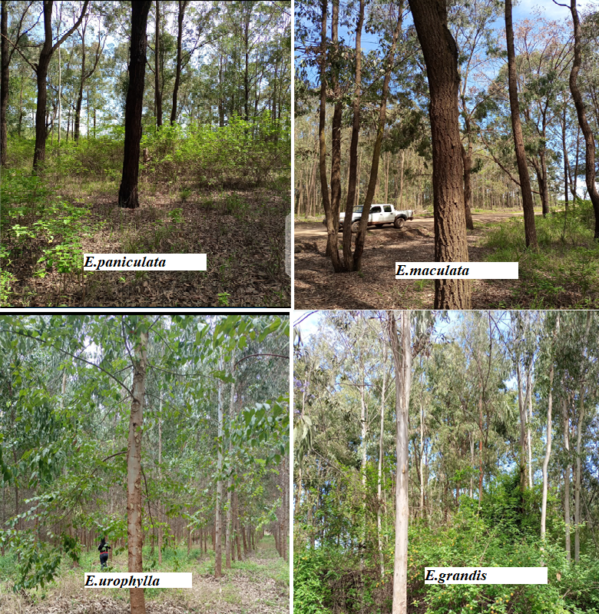
Figure 1: E. paniculata, E. paniculata, E.urophylla and E. grandis
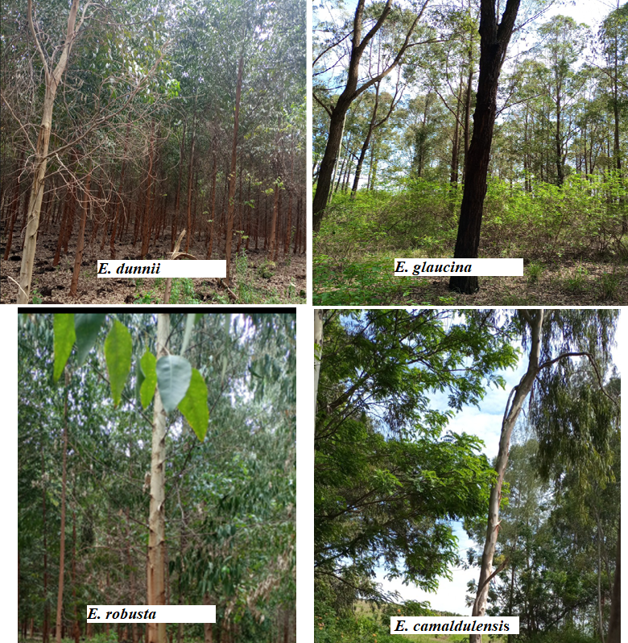
Figure 2: E. dunnii, E. glaucina, E.robusta and E. camaldulensis
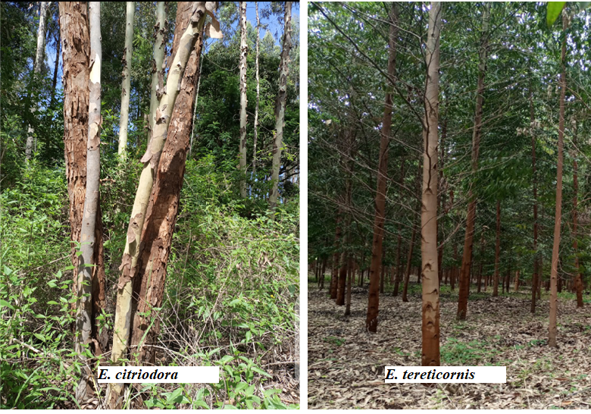

Figure 3: E. citriodora and E. tereticornis

3.9.2. Analysis of phenotypic traits
Data on phenotypic traits (DBH and height sampled from mature trees aged 8-12 years) was analyzed using SPSS. Using this software; descriptive statistics were done and the results were recorded in a table. The analyses done included means of DBH and height of the 10 Eucalyptus species. From the mean result, standard errors analysis was also done and in addition, variance, range, confidence interval of the mean of DBH and height were also carried out. Further, one- way Anova was performed in order to determine if there was any difference in DBH and mean that was significant among the ten Eucalyptus species. Turkey’s test was also done for the comparison of DBH/Height between any two species in comparison with the standard DBH and height to determine whether there was any significant difference and the P value was ≤ 0.05.

CHAPTER FOUR

RESULTS

4.1 Molecular phylogeny of Eucalyptus species
Twenty-four sequences (10 rbcL, 7 MatK, and 7 TrnL-F DNA sequences) from the three genes of the ten Eucalyptus species were amplified and sequenced, then deposited in the NCBI Genbank and their accession numbers are tabulated below (Table 3). Eucalyptus Species without accession numbers are the species that did not successfully generate usable sequences.

Table 3: Gene bank accession numbers for the study sample sequences
Eucalyptus species | Gene | Genbank Accession Number | Gene | Genbank Accession Number | Gene | Genbank Accession Number
E.urophylla | RbcL | OM949975 | MatK | OM949969 | TrnL-F | OM949984
E.paniculata | RbcL | OM949976 | MatK | OM949970 | TrnL-F | OM949985
E. citriodora | RbcL | OM949977 | MatK | OM949971 | TrnL-F | OM949986
E. robusta | RbcL | OM949978 | MatK | OM949972 | TrnL-F | -
E. maculate | RbcL | OM949979 | MatK | - | TrnL-F | -
E. camaldulensis | RbcL | OM949980 | MatK | - | TrnL-F | -
E. dunnii | RbcL | OM949981 | MatK | OM949973 | TrnL-F | OM949987
E.grandis | RbcL | OM949982 | MatK | - | TrnL-F | OM949988
E. tereticornis | RbcL | OM949983 | MatK | OM949974 | TrnL-F | OM949989
E.glaucina | RbcL | OM985042 | MatK | OM985041 | TrnL-F | OM985043

Evolutionary statistics were done using MEGA 11 and this was mainly to establish the model that determines the divergence and phylogeny based on the three genes under study. Models with the lowest Bayesian Information Criterion (BIC) scores are preferred in describing nucleotide substitution pattern in the course of evolution and thought to be the best according to Tamura et al., (2021). From the analyses, the best nucleotide evolutionary model for analysis of MatK sequences was Tamura 3 parameter (Tamura, 1994) with the lowest BIC value of 3062.8906. For analysis of rbcL sequences, the best model with lowest BIC score of 2703.96 was Jukes-Cantor (Erickson, 2010) while for the TrnL-F, the model for phylogeny analysis and construction of trees with the lowest BIC score of 1749.10 selected was Tamura 3 parameter model. According to Tamura 3 parameter model and taking into account the Mat K sequences, the frequency of each nucleotide of adenine (A), cytosine (C), guanine (G), and thymine (T), was 0.33, 0.33, 0.16, and 0.16, respectively and the rate of nucleotide substitution in the Mat K sequences ranged from 0.05 (CG) to 0.15 (CT and GA). While according to the Jukes-Cantor model, the frequency of nucleotides in the rbc L sequences was the same for four nucleotides with a value of 0.25 and the nucleotide substitution rate of 0.08 for all transversions and transitions. Based on Tamura 3 parameter model, the frequency of adenine (A), cytosine (C), guanine (G), and thymine (T) in the TrnL-F sequences was 0.32, 0.32, 0.17, and 0.17, respectively and the substitution rate changed from 0.06 to 0.11 (Figure 4).

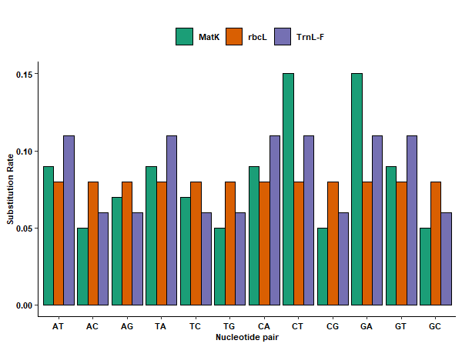
Figure 4: Nucleotide substitution rates

Base pattern disparity index was also determined, the index measures homogeneity of substitution pattern between molecular sequences. Figure 5, 6 and 7 show the values of the base composition bias disparity per site between sequence pairs in the species studied. When the differences in base composition biases are observed, the values are more than zero and by chance alone (Al-Atiyat & Aljumaah, 2014). Therefore, when the values of nucleotide disparity index are lower, it shows that the species are closely related. Based on the RbcL sequences, the highest value was observed between E. paniculata and E. grandis which indicated larger differences between them. Generally, E. paniculata when compared to the other species showed higher disparity scores. Base composition disparity index for the Matk sequences was higher between E. citriodora and E. glaucina, E. robusta and E. urophylla implying larger genetic differences between E. citriodora and these three species. Based on the TrnL-F sequences, high disparity indices were observed between E.grandis and E.tereticornis (0.14) and also between E.grandis and E.dunnii (0.88)

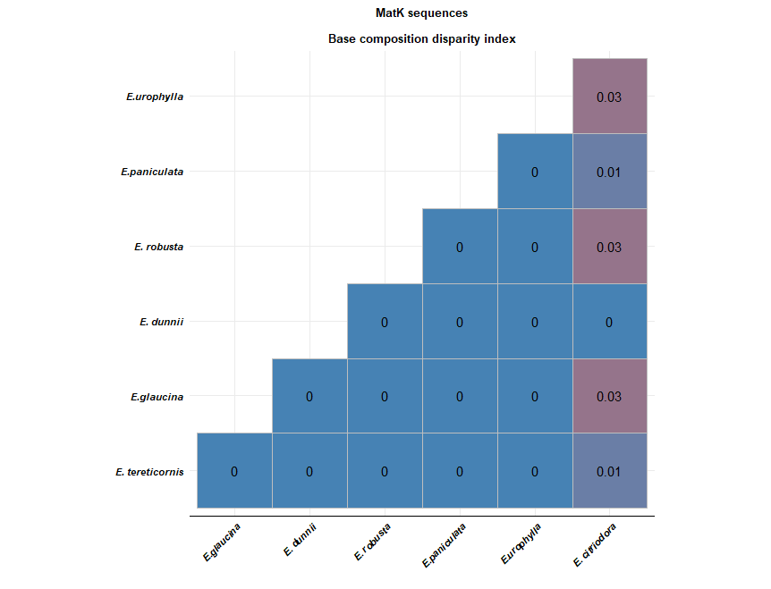

Figure 5 :Base composition disparity index of Matk sequence
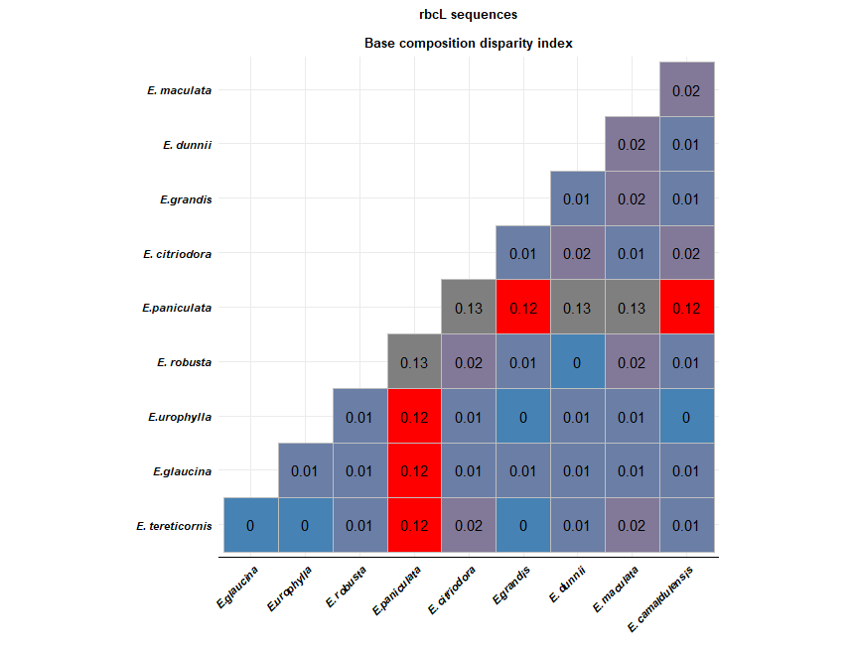
Figure 6: Base composition disparity index of rbcL sequence

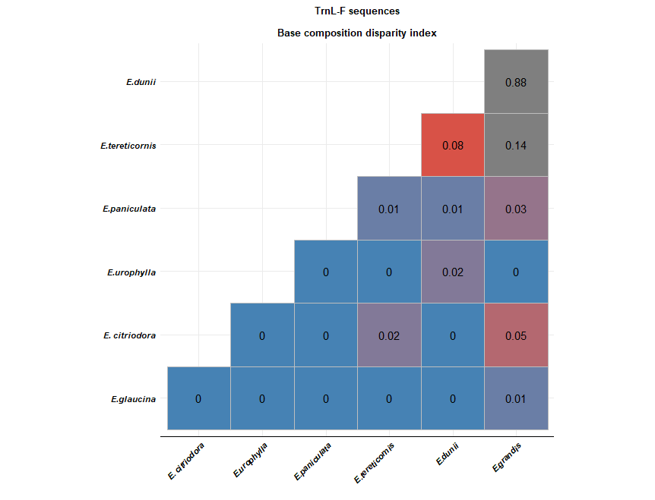
Figure 7 : Base composition disparity index of TrnL-F sequence

Based on the rbcL sequences, transition/transversion rate ratios were; k₁ was 1.806 (purines) and k₂ was 1.36 (pyrimidines) and generally, transition/transversion bias (R) was 0.777. Results from the selection test of the rbcL sequences based on Tajima’s neutrality test suggested that the number of segregation sites were 78 with nucleotide diversity of 0.029. With regard to Mat K sequences, transition/transversion rate ratios were: k₁ was 0.861 (purines) and k₂ was 1.51 (pyrimidines) and the overall transition/transversion bias (R) was 0.562 and the results of selection test based on Tajima’s neutrality test reported that the number of segregation sites were 46 with nucleotide diversity of 0.022. For the TrnL-F genes, the transition/transversion rate ratios were: k₁ was 2.732 (purines) and k₂ was 1.334 (pyrimidines), the overall transition/transversion bias (R) was 0.96 while Tajima’s neutrality test reported that the number of segregation sites were 84 with nucleotide diversity of 0.0256.

Evolutionary distances are best determined by genetic variation studies (Page & Holmes, 2009). Nucleotide substitution occurring between the sequences is used to measure distance between pairs of sequences. Figures 8, 9 and 10 show evolutionary divergence between Eucalyptus species based on the three genes. The higher divergence implies larger differences between sequences. Determination of evolutionary distances was carried out using the Maximum Likelihood method (Tamura et al., 2021) and the number of base substitutions per site between sequences shows differences between the Eucalyptus species under study.

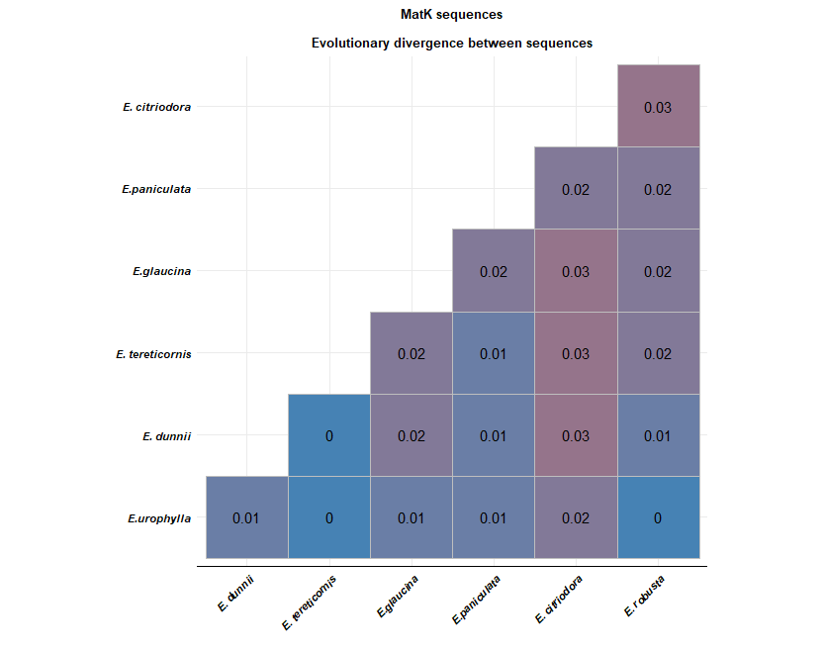
Figure 8: Evolutionary divergence between sequences for the Matk gene

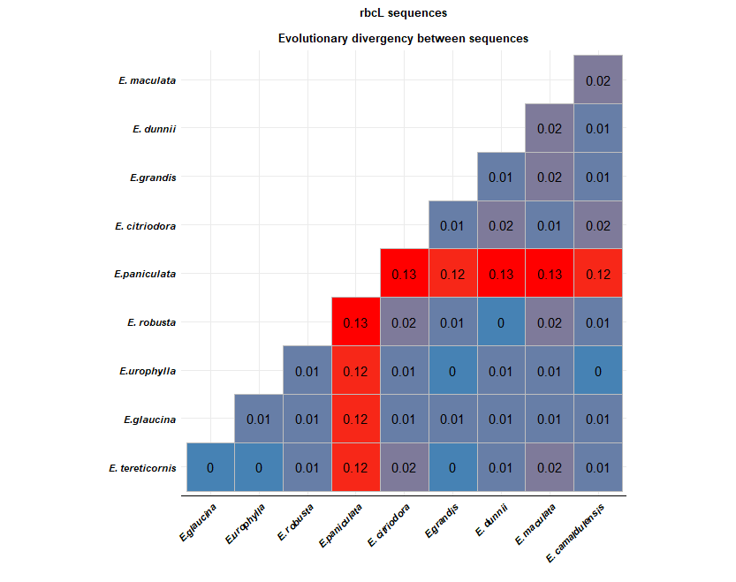
Figure 9 : Evolutionary divergence between sequences for the rbcL gene

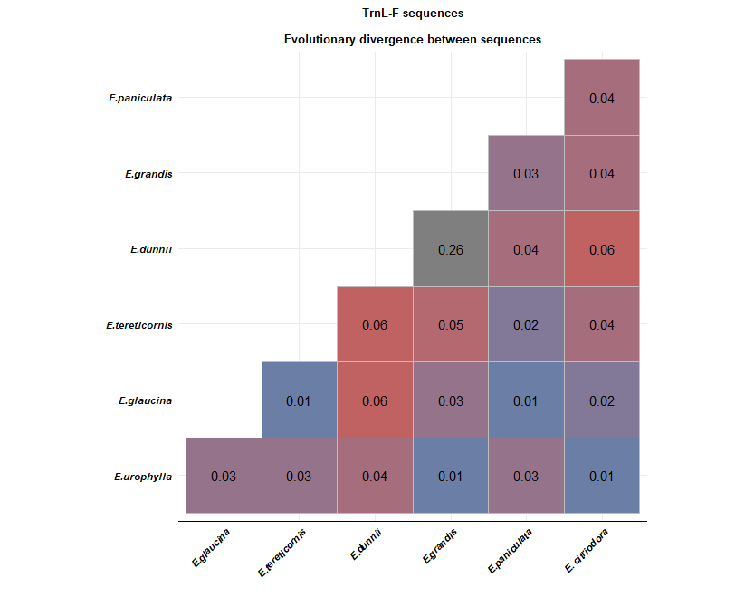
Figure 10: Evolutionary divergence between sequences for the Trnl-F gene

In the rbc L sequences, the longest genetic distance was between E. paniculata and other Eucalyptus species ranging from 0.12 to 0.13. This implied that E.paniculata was distantly related to the other species which had shorter divergence between any two of them suggesting close genetic relations. On the other hand, comparison between most species suggested lower divergence based on the Mat K sequences ranging from 0.00 to 0.03, implying close relationship. For the TrnL-F sequences, largest genetic distance of 0.26 was seen in the comparison of E. dunnii and E. grandis implying that these two species are distantly related. This finding was not surprising since the phenotypic trait analysis did also show that unlike E.grandis whose height and DBH were significantly high, E. Dunnii had the smallest height and DBH. Phylogenetic trees constructed based on the three genes are shown below (Figures 11-14), ancestral states were inferred using the Maximum Likelihood method, Tamura 3-parameter model and Jukes-Cantor evolutionary models.

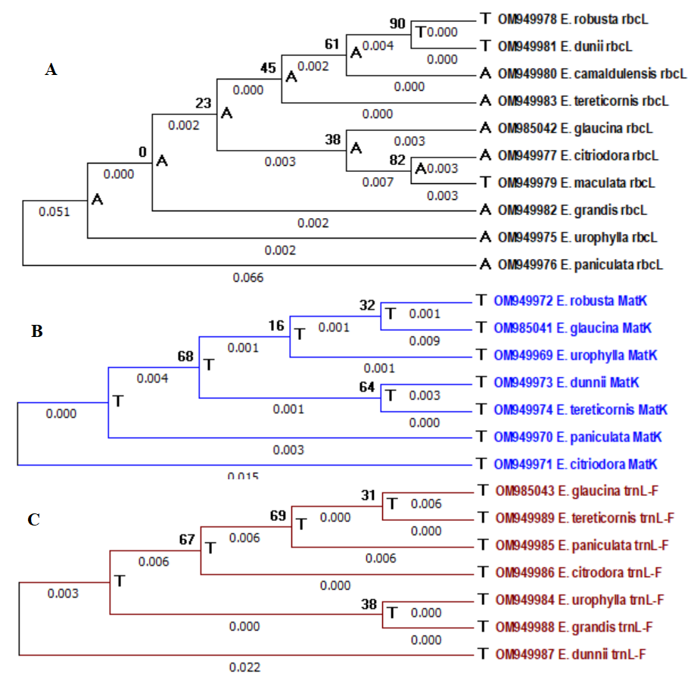
Figure 11: Phylogenetic trees based on A: rbcL sequences, B: MatK sequences and C: TrnL-F sequences
The three trees show branch lengths, bootstrap values, and possible nucleotides at each ancestral node, the ancestral states at each node were arranged in an order that is from high probability to the lowest probability and probability of less than 5% were not included. Initial trees for the ML heuristic search were attained through the application of Neighbor-Join and BioNeighbor-Join algorithms to pairwise distances matrix generated from all the sequences from the three genes based on the two selected models of evolution. The tree with the highest probability was selected as the best tree topology and bootstrap method was the best in tree reconstruction (Musila et al., 2017). Species close to each other based on the trees suggest a close genetic relationship, and those emanating from the same node show that they form a monophyletic clade. The values that are found at the node shows how the species are closely or distantly related. Bootstrap values of over 70 imply strong support, values of around 50 indicate that the tree topology/monophyletic clade is moderately supported, while values below 50 indicate that the tree topology/monophyletic clade is poorly supported (Musila et al., 2017).

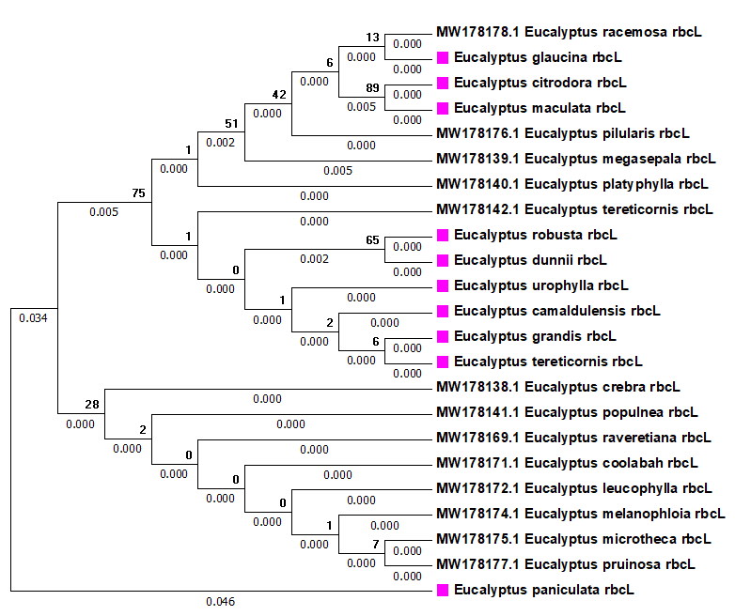
Figure 12 : Rbcl – NCBI based tree
The species colored are the species that were studied in this current study while those without color are the species numbers from the NCBI global database, the tree shows that E. racemosa are distantly related to E. glaucina with a bootstrap support of 13.
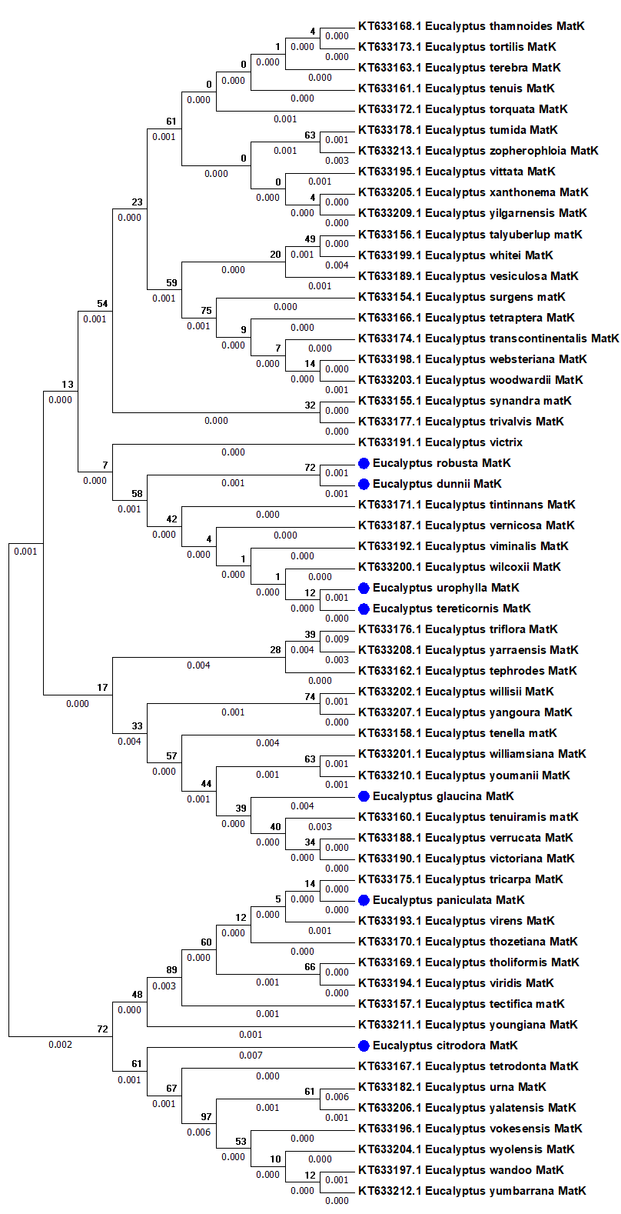
Figure 13: Mat k -NCBI based tree
In figure 13, E. paniculata and E. tricarpa are grouped together hence they show some evolutionary relationship with a bootstrap support value of 14.

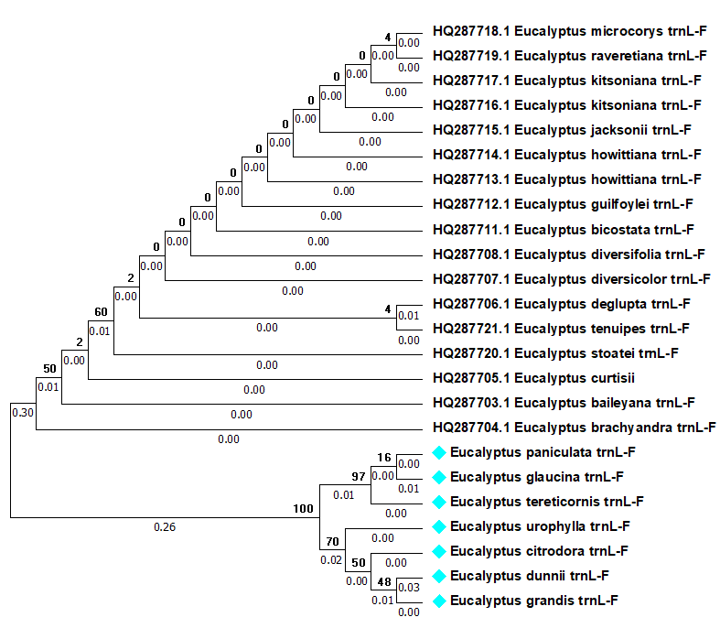
Figure 14: TrnL-F – NCBI based tree
In Figure 14, the Kenyan species show a unique relationship where they are not grouped with the species outside Kenya. This suggest that the species studied have no evolutionary relationship with the species outside Kenya based on the Trn L-F gene but further supports the earlier indication in Figure 13 that E.glaucina and E. tereticornis are related. In our phenotypic data analysis, E.glaucina and E.tereticornis both had substantial height and DBH and were found to be suitable alternatives for use as power transmission poles.

4.2. Suitability of Kenyan Eucalyptus species for use as power transmission poles

4.2.1. Phenotypic traits of Eucalyptus species
Means of DBH and height for the Eucalyptus species under study aged between 8 and 12 years are shown in Figure 15. The mean DBH of E. camaldulensis (90.33 ± 2.31 cm) is higher than the mean DBH of other species, which is followed by the mean DBH of E. grandis (71.0 ± 3.24 cm), while the others have a mean DBH of around 25 cm. The high mean DBH of E. camaldulensis could be because the height of E.camaldulensis is smaller compared to the other species, and it can be assumed that it increases in girth more than height. E. dunnii has the smallest mean DBH (18.0 + 1.2 cm). The preferred range of DBH for wooden power transmission poles is 18.3–28.3 cm (Cheboiwo et al., 2014). Hence E. glaucina (27.0 ± 1.81 cm), E. robusta (22.0 ± 1.73 cm), E. paniculata (30.67 ± 2.41 cm), E. tereticornis (26.0±1.59 cm), E.urophylla (22.0 ± 2.81 cm), E. maculata (24.67 ± 1.57 cm), E. dunnii (18.0 + 1.2 cm) and E. citriodora (27.0 ± 1.22 cm) have prefered average DBH for power transmission poles. However, DBH mainly will depend on the age of the tree, and the climatic condition of the region where the trees are grown, and species such as E. grandis can attain high DBH. In areas that receive high amount of rainfall, the Eucalyptus species will mature fast as compared to areas that experiences drought (Muthike et al., 2021). The phenotypic data was analysed using SPSS version 23. A one-way ANOVA revealed that there was statistically significant difference in DBH (F (9, 28) = 33.356, p = 0.004) and height (F (9, 28) = 7.364, p = 0.007) among the 10 Eucalyptus species as seen in Table 4 and Figure 15 below.

Table 4: ANOVA results depicting the differences in the mean DBH and height among species
ANOVA
 |  | Sum of Squares | Df | Mean Square | F | Sig.
DBH | Between Groups | 22712.942 | 9 | 1765.210 | 46.611 | .000
DBH | Within Groups | 1211.867 | 28 | 37.871
DBH | Total | 25924.809 | 39
HEIGHT | Between Groups | 2105.901 | 9 | 148.421 | 15.265 | .000
HEIGHT | Within Groups | 305.333 | 28 | 9.854
 | Total | 802.102 | 39

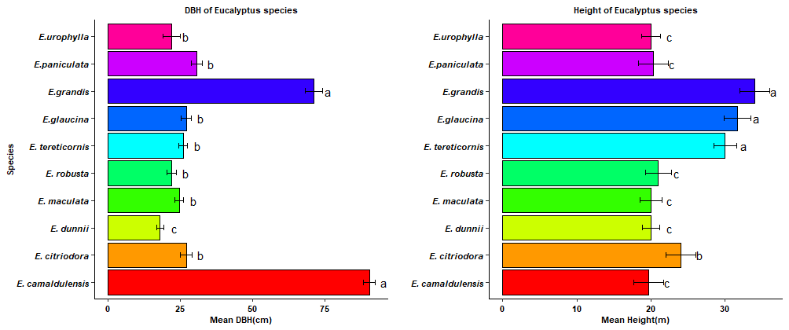
Figure 15: Mean and standard errors of DBH and height of Eucalyptus species
According to Figure15, the mean height of E. grandis (34.0 ± 3.11 m) is slightly higher than the mean height of other species, followed by E. glaucina (31.67 ± 1.17 m) and E. territicornis (30 ± 1.52 m) while E. camaldulensis (19.67 ± 2.34 m), E. maculata (20 ± 1.43 m) and E.dunii (20 ± 1.26 m) are among the species with the shortest height. E. grandis has a higher mean DBH and height, and it is suitable for use as a pole in power transmission since the preferred height according to KPLC is 30-55 m (Muthike et al., 2021). The height of E.grandis was compared with the height of other Eucalyptus species using Turkeys HSD test (Appendix 1). The results suggest that the mean height of E.grandis was the same statistically with E. tereticornis (p = 0.977, 95% C.I. = −6.55, 14.56) as shown in appendix 1. Similarly, the mean height was also statistically similar between E. grandis and E. glaucina (p = 0.931, 95% C.I. = [−7.22, 13.89]. Moreover, Tukey’s test confidence intervals (CIs) included zero, corroborating the fact that there are no differences between groups. Therefore, E. tereticornis and E. glaucina, whose DBHs fall within the preferred KPLC size, can be used to support the high demand for power transmission poles because their DBH and height meet the KPLC pole specifications as gazetted in Kenya Standard 516 of 2008 (KS 516: 2008).

CHAPTER FIVE

DISCUSSIONS, CONCLUSIONS AND RECOMMENDATIONS

5.1 Genetic variation and level of polymorphism
Genetic diversity is important in studying survival of any plant population since it shows how the plants have evolved and adapted to that particular area (Taylor et al., 2015). Genetic variations among species is attributed to the fact that the genes of a population undergo mutation (Nogueira et al., 2019). To conserve the population species, it is therefore important to study genetic diversity of a population (Wiehle et al., 2014). This study involved 10 Eucalyptus species in which three genes; Mat K, rbcL and TrnL-F were targeted to elucidate the extent of relatedness among the studied species. Based on the rbcL phylogenetic tree (Figure 11A), a bootstrap value of 82 was observed suggesting a close relationship between E. citrodora, and E. maculata. This finding is supported by the studies by De Araújo et al. and Bayly who placed the same species in one category (De Araújo et al., 2002; Bayly, 2016). E. glaucina forms a monophyletic clade with both E. citrodora and E. maculate. However, the topology is poorly supported with a bootstrap value of 38. E. tereticornis, E. robusta, E. dunnii and E. camaldulensis have been grouped together and this agrees again with the results of De Araújo et al. (Jump et al., 2009). E. urophylla, E. grandis and E. paniculata are the only species which were shown to be distantly related from the other species from the RbcL tree. In the Mat K gene sequences (Figure 11B), E. urophylla, E. robusta and E.glaucina are grouped together, while E. dunnii has been placed close to E. tereticornis with a moderate bootstrap branch support value of 64. In general, the monophyletic clade which comprises E. urophylla, E. robusta, E.glaucina, E. dunnii and E. tereticornis has a branch support value of 68, implying a close phylogenetic relationship among these five species as shown in the MatK phylogenetic tree and this can also be supported by the low base disparity index and shorter genetic distances among the species within the clade. The results from this study are in agreement with the findings of De Araújo et al., (2002) who studied phylogeny of Eucalyptus species based on rnDNA (De Araújo et al., 2002). Its only E. paniculata and E. citrodora which are distantly related from the other five species based on the MatK sequences. Based on the TrnL-F phylogenetic tree (Figure 11C), E. glaucina, E. tereticoris, E. paniculata, E. citriodora were shown to be closely related with a strong branch support value of 69 and distantly related to E. urophylla, E.grandis and E. dunnii. The three trees show some consensus of the species under study, for instance the MatK and the RbcL trees show E. paniculata and E. grandis to be distantly related to the other species. E. tereticornis and subsequently E. dunii have been shown to be closely related based on both MatK and rbcL phylogenetic trees while based on both rbcL and TrnL-F phylogenetic trees, E. grandis and E. urophylla are distantly related to the other species under study. Generally, based on the three trees, all the species have a common ancestor. These findings correlates with other studies of Eucalyptus species based on biochemical studies (Rozefelds et al., 1995).

The global phylogenetic tree based on RbcL-NCBI, suggests that E.glaucina and E.racemosa forms a monophyletic clade (Figure 12). However, the topology is poorly supported with a bootstrap value of 14. E. paculata and E. tricarpa are grouped together with a moderate bootstrap support of 34 (Figure 13), while from the TrnL-F NCBI tree, species show unique relationship where they are not grouped with the species outside Kenya. This suggests that the species studied have no evolutionary relationship with the species outside Kenya based on Trn L-F gene but further supports the earlier indication that E.glaucina and E. tereticornis are related (Figure 15). These findings are supported by findings by Bayly (2016). The E.racemosa and E.tricarpa species are not found in Kenya but according to the global NCBI-phylogenetic analysis, they might be related to the aforementioned study species. Eucalyptus racemosa is found in southern Queensland and grows to a height of 25m. The trunk and larger branches are covered with ironbark. The bark on the smaller branches is soft and corky (Hill & Hurtado, 2009). The cotyledons are reniform and the seedling leaves produce 3 to 4 nodes and grow to 8cm long and 1cm wide (Hill & Hurtado, 2009). Eucalyptus tricarpa is distinguished by its smooth stem, dull, bluish green leaves, buds in threes, and campanulate seeds. It is related to E. tereticornis (Brooker ,2000) and it is found in south-eastern Queensland.

Eucalyptus species occurring in different geographical areas diverge differently (Butcher et al., 2009) and this explains why there are differences in the genetic diversity among the ten Eucalyptus populations. Genetic diversity within a population may also be caused by drought, diseases and rain (Dutkowski & Potts, 2012). However, according to Dawson (2012), genetic diversity is impacted directly by differences in flowering times within and among the populations (Dawson & Goldringer, 2012) hence flowering periods can cause gene flow from one population to another leading to emergence of new varieties. Extensive gene flow causes low genetic differentiation among the population (Acosta et al., 2007). This could explain why there is low genetic variation among the ten Eucalyptus species studied due to alleles that are shared among the Eucalyptus species (Munthali et al., 2013). A comparison between the species showed low substitution rates, low base disparity index, low genetic distances and the resulting phylogenetic trees suggested that most species were closely related implying low genetic diversity among the species under study.

5.2 Phenotypic traits of Eucalyptus species
Studying the phenotypic traits of Eucalyptus is important for effective tree breeding and in elucidating the genetic progress of parental generation and the generation of offspring (Marco de Lima et al., 2019). In addition, the study of physical traits of plants is becoming important to replace the use of fossil hydrocarbons in industries (Alper et al., 2020). Studying the wood phenotypic traits is costly and time consuming. However, studying the phenotyping traits using calibration model saves times and it is not costly (Sandzak et al., 2016). This model has been employed successfully in predicting physical traits in other Eucalyptus species (Hamilton et al., 2009).

In this study, two phenotypic traits were analyzed among ten different species of Eucalyptus for suitability for use as power transmission poles. The assessment was performed on mature Eucalyptus trees aged between 8 and 12 years that could easily be measured, as suggested by Marco de Lima et al., (2019). The traits analyzed were diameter that was measured at the height of breast using a calibrated measuring tape and total tree height using a suunto hypsometer.

The requirement for a tree species to be used as a power transmission pole are reasonable strength, DBH ranging from 18- 28 cm and a total height of 34 m, straightness, ability to withstand splitting and twisting and should be amendable to preservatives use for treatment (Scott, 1946). From the phenotypic results, E.glaucina, E.robusta, E.paniculata, E.tereticornis, E.maculate, E.dunnii and E.citriodora have standard DBH which suits the requirement to be used as power transmission poles. However, in terms of height, only E. tereticornis and E. glaucina heights are not significantly different from the height of E. grandis. E. grandis is majorly used because it can tolerate low soil fertility and has high growth rate (Sivananthawerl & Mitl, 2011). E. grandis also has a wide trunk which grows up to approximately 45-65 m tall (Luna, 2009). In addition, E. grandis can also be managed easily in the nursery (Turnbull & Booth, 2002).

E.robusta, E.paniculata, E.maculate, E.dunnii, E. camaldulensis and E.citriodora from the study might be categorized as electric poles because they have the required DBH but they are limited due to their shorter height. Equally, the DBH and height of E. tereticornis and E. galucina meets the standards for use as electric poles and subsequently can be used as power transmission poles. To combat pole shortage, one should compromise ecological effects on the environment since species that mature fast need more water (Sivananthawerl & Mitl, 2011). In other countries especially in Europe, the use wooden poles for power transmission is equally common and this gives complete satisfaction except in urban areas where steel poles are used (Taylor & Scott, 2010). E.saligna is alternatively used for poles in other countries because the species is sufficiently available and the trees in this species are preferred because of the ease with which they take up preservatives despite that they are naturally weak (Nogueira et al., 2019). The species and its hybrids are majorly grown in Brazil and South Africa (De Assis, 2000). E. resinifera and E. globulus suits to be used as power transmission poles but they cannot be found easily. E. paniculata on the other hand is one of the strongest pole timbers but it cannot be used as a pole since it does not absorb preservatives easily hence its poles may not be durable (Sivananthawerl & Mitl, 2011).

5. 3 Conclusions and recommendations
The results obtained in this study suggest that the Eucalyptus species in Kenya are closely related to each other and subsentially divergent from species outside Kenya. Additionally, the results suggest that E. robusta, E.paniculata, E.maculata, E.dunnii, E. camaldulensis and E.citriodora might be used as power transmission poles but they have short height and therefore are not preferred. The DBH and height of E. tereticornis and E. galucina are desirable and can be used as substitutes for E.grandis to meet the demand for power transmission poles. Environmental factors and the ecological zone where the species is found affect the phenotypic traits such as the DBH and the height of the species. Therefore, it is important to know if the differences in phenotypic traits among the species is due to the environment or the genetic make up of the species and since it was not possible to obtain a uniform distribution of the ten species in our study sites, future studies can aim at getting similar species from different sites and comparing them to help establish if the phenotypic traits vary by geographical distribution. There is need to venture in low-cost production of E. grandis alternatives as depicted in this study to increase local supply of poles and reduce their importation and the over exploitation of E. grandis.

Generally, most of the studies on Eucalyptus species suggest that Eucalyptus species are closely related. Since the current study examined only ten Eucalyptus species, further research involving many species drawn from different regions are required to exhaustively comprehend the genetic diversity of species in this genus. Roughly, over hundred Eucalypts have been identified in East Africa comprising of indigenous species, clones, hybrids and exotic species (Nakabonge et al., 2006). Some of these species have specific growth requirements and will only grow in specific ecological zones. More studies on the genetic diversity of Eucalyptus species will pave way into the identification of more species that are closely related to E.grandis in an effort to provide more alternatives for use as power transmission poles. These future studies can employ other molecular markers such as ndh-F, atpB, trnT–trnL, trnL–trnF and atpB-Rbcl and utilize methods which have been used to successfully study phylogenetics and gene expression in angiosperms that were beyond the scope of the current study. A comparison of phylogenetic trees based on numerous gene sequences can prove valuable in molecular phylogeny and diversity of Eucalyptus species.

REFERENCES

Abdulla, M., and Gamal, O. (2010). Investigation on molecular phylogeny of some date palm (Phoenix dactylifra L.) cultivars by protein, RAPD and ISSR markers in Saudi Arabia. Australian Journal of Crop Science, 4(1), 23-28.

Acosta‐Gallegos, J. A., Kelly, J. D., & Gepts, P. (2007). Prebreeding in common bean and use of diversity from wild germplasm. Crop Science, 47, S-44.

Al-Atiyat, R. M., & Aljumaah, R. S. (2014). Genetic distances and phylogenetic trees of different Awassi sheep populations based on DNA sequencing. Genetics and Molecular Research, 13(3), 6557–6568.

Al-Snafi, P. D. A. E. (2017). The pharmacological and therapeutic importance of Eucalyptus species grown in Iraq. IOSR Journal of Pharmacy (IOSRPHR), 07(03), 72–91.

Alper, K., Tekin, K., Karagöz, S., & Ragauskas, A. J. (2020). Sustainable energy and fuels from biomass: a review focusing on hydrothermal biomass processing. Sustainable Energy & Fuels, 4(9), 4390–4414.

Andersen, H.-E.; Reutebuch, S.E.; McGaughey, R.J. A rigorous assessment of tree height measurements obtained using airborne lidar and conventional field methods. Can. J. Remote Sens. 2006, 32, 355–366.

Ashour, H. M. (2008). Antibacterial, antifungal, and anticancer activities of volatile oils and extracts from stems, leaves, and flowers of Eucalyptus sideroxylon and Eucalyptus torquata. Cancer biology & therapy, 7(3), 399-403.

Barthet, M. M., & Hilu, K. W. (2007). Expression of matK: functional and evolutionary implications. American Journal of Botany, 94(8), 1402-1412.

Bayly, M. J. (2016). Phylogenetic studies of Eucalypts: fossils, morphology and genomes. Proceedings of the Royal Society of Victoria, 128(1), 12.

Brennan, E. B., Weinbaum, S. A., Rosenheim, J. A., & Karban, R. (2001). Heteroblasty in Eucalyptus globulus (Myricales: Myricaceae) affects ovipositonal and settling preferences of Ctenarytaina eucalypti and C. spatulata (Homoptera: Psyllidae). Environmental Entomology, 30(6), 1144-1149.

Brooker, M. I. H. (2000). A new classification of the genus Eucalyptus L’Her.(Myrtaceae). Australian Systematic Botany, 13(1), 79–148.

Butcher, P. A., McDonald, M. W., & Bell, J. C. (2009). Congruence between environmental parameters, morphology and genetic structure in Australia’s most widely distributed Eucalypt, Eucalyptus camaldulensis. Tree Genetics & Genomes, 5(1), 189–210.

Cheboiwo, J. K. (2014a). Modelling future production. processing and trade in transmission poles in Kenya and east africa.

Cheboiwo, J. K. (2014b). The status of the poles sector; Production, processing and trade in transmission posts in East Africa.

Chiang, T.-Y., Schaal, B. A., & Peng, C.-I. (1998). Universal primers for amplification and sequencing a noncoding spacer between the atpB and RbcL genes of chloroplast DNA. Botanical Bulletin of Academia Sinica, 39.

Christie, N., Tobias, P. A., Naidoo, S., Külheim, C., & Germain, H. (2016). Gene Family : Physical Clustering and Expression Hotspots, 6(January), 1–16.

Dawson, J. C., & Goldringer, I. (2012). Breeding for genetically diverse populations: variety mixtures and evolutionary populations. Organic Crop Breeding, 77–98.

De Araújo, E. S. N. N., Gimenes, M. A., & Lopes, C. R. (2002). Phylogenetic relationships among genera Eucalyptus and Corymbia species based on rnDNA internal transcribed spacers sequences. Scientia Forestalis/Forest Sciences, 75–85.

De Assis, T. F. (2000). Production and use of Eucalyptus hybrids for industrial purposes. In Hybrid breeding and genetics of forest trees. Proceedings of QFRI/CRC-SPF Symposium (pp. 63–74).

Del Moral, R., & Muller, C. H. (1970). The allelopathic effects of Eucalyptus camaldulensis. American Midland Naturalist, 254–282.

Delaporte, K. L., Conran, J. G., & Sedgley, M. (2001). Interspecific hybridization within Eucalyptus (myrtaceae): subgenus symphyomyrtus, sections Bisectae and Adnataria. International Journal of Plant Sciences, 162(6), 1317-1326.

Dhakad, A. K., Pandey, V. V., Beg, S., Rawat, J. M., & Singh, A. (2018). Biological, medicinal and toxicological significance of Eucalyptus leaf essential oil: a review. Journal of the Science of Food and Agriculture, 98(3), 833-848.

Doyle, J. (1991). DNA protocols for plants. In Molecular techniques in taxonomy (pp. 283-293). Springer, Berlin, Heidelberg.

Dutkowski, G. W., & Potts, B. M. (2012). Genetic variation in the susceptibility of Eucalyptus globulus to drought damage. Tree Genetics & Genomes, 8(4), 757–773.

Edgar, R. C. (2004). Muscle: multiple sequence alignment with high accuracy and high throughput. Nucleic Acids Research, 32(5), 1792–1797.

Eldridge, K., Davidson, J., Harwood, C., & Wyk, G. van. (1994). Eucalypt domestication and breeding. Clarendon Press.

Erickson, K. (2010). The jukes-cantor model of molecular evolution. Primus, 20(5), 438–445.

Espinosa-Garcia, F. J., Martínez-Hernández, E., & Quiroz-Flores, A. (2008). Allelopathic potential of Eucalyptus spp plantations on germination and early growth of annual crops. Allelopathy Journal, 21(1), 25.

Gibson, A., Bachelard, E. P., & Brown, A. G. (1994). Relationships between site characteristic and survival strategies of Eucalyptus camaldulensis seedlings. Australian Tree Species Research in China, 91-95.

Girijashankar, V. (2011). Genetic transformation of Eucalyptus. Physiology and Molecular Biology of Plants, 17(1), 9-23.

Gill, H. S., Abrol, I. P., & Samra, J. S. (1998). Nutrient recycling through litter production in young plantations of Acacia nilotica and Eucalyptus tereticornis in a highly alkaline soil. Forest ecology and management, 22(1-2), 57-69.

Grattapaglia, D., Vaillancourt, R. E., Shepherd, M., Thumma, B. R., Foley, W., Külheim, C., ... & Myburg, A. A. (2012). Progress in Myrtaceae genetics and genomics: Eucalyptus as the pivotal genus. Tree Genetics & Genomes, 8(3), 463-508.

Gudeta, T. B. (2018). Molecular marker based genetic diversity in forest tree populations. Forestry Research and Engineering: International Journal, 2(4)

Hajibabaei, M., Singer, G. A., Hebert, P. D. and Hickey, D. A. (2007). DNA barcoding: how it complements taxonomy, molecular phylogenetics and population genetics. Trends in Genetics, 23(4), 167-172.

Hamilton, M. G., Raymond, C. A., Harwood, C. E., & Potts, B. M. (2009). Genetic variation in Eucalyptus nitens pulpwood and wood shrinkage traits. Tree Genetics & Genomes, 5(2), 307–316.

Harbard, J. L., Griffin, R., & Centurion, C. (2000). Reciprocal hybrid crossing between E. dunnii (Maiden)× E. grandis (Hill ex Maiden). In Hybrid Breeding and Genetics of Forest Trees. Proceedings of QFRI/CRC-SPF Symposium (pp. 435–439).

Heckenhauer, J., Barfuss, M. H., & Samuel, R. (2016). Universal multiplexable matK primers for DNA barcoding of angiosperms. Applications in Plant Sciences, 4(6), 1500137.

Hill, K., & Hurtado, A. M. (2009). Cooperative breeding in South American hunter–gatherers. Proceedings of the Royal Society B: Biological Sciences, 276(1674), 3863-3870.

House, R. J., Wright, N. S., & Aditya, R. N. (1997). Cross-cultural research on organizational leadership: A critical analysis and a proposed theory.

Jnanesha, A., Kumar, A., & Vanitha, T. (2019). Variation in the yield and chemical composition of Eucalyptus species ( Nilagiri ) under different agro climatic condition of India. Int J Herbal Med, 7(1), 4–7.

Jones, T. H., Steane, D. A., Jones, R. C., Pilbeam, D., Vaillancourt, R. E., & Potts, B. M. (2006). Effects of domestication on genetic diversity in Eucalyptus globulus. Forest Ecology and Management, 234(1-3), 78-84.

Jump, A. S., Marchant, R., & Peñuelas, J. (2009). Environmental change and the option value of genetic diversity. Trends in Plant Science, 14(1), 51–58.

Kasaye, M., Abebe, G., Nigusie, G., & Eshte, M. (2020). Adaptability of Different Eucalyptus Species in Lasta-Lalibela District Northeastern Highland of Ethiopia. Fores Res, 9, 233.

Kluthe, B. G., Ali, M. B. H., & Stephenson, S. L. (2018). Allelopathic Influence of Eucalyptus on Common Kenyan Agricultural Crops. Journal of Agronomy and Agricultural Science, 1(002).

Kumar, S., Nei, M., Dudley, J., & Tamura, K. (2008). MEGA: a biologist-centric software for evolutionary analysis of DNA and protein sequences. Briefings in Bioinformatics, 9(4), 299–306.

Ladiges, P. Y., & Udovicic, F. (2000). Comment on a new classification of the Eucalypts. Australian Systematic Botany, 13(1), 149–152.

Langat, D., & Muchiri, M. N. (2018). power transmission poles and firewood in Kenya Financial analysis of growing Eucalyptus grandis for production of medium size power transmission poles and firewood in Kenya.

Lawson, S. A., Elek, J., & Lawson, S. A. (2003). Native and Exotic Pests of Eucalyptus : A Worldwide Perspective Related papers Native and Exotic. Annual review of entomology, 56(1), 181-201.

Liang, J., Crowther, T. W., Picard, N., Wiser, S., Zhou, M., Alberti, G., ... & Reich, P. B. (2016). Positive biodiversity-productivity relationship predominant in global forests. Science, 354(6309).

Luna, R. K. (2009). Eucalypts in agroforestry. Eucalypts in India, 209.

Marco de Lima, B., Cappa, E. P., Silva-Junior, O. B., Garcia, C., Mansfield, S. D., & Grattapaglia, D. (2019). Quantitative genetic parameters for growth and wood properties in Eucalyptus “urograndis” hybrid using near-infrared phenotyping and genome-wide SNP-based relationships. PloS one, 14(6), e0218747.

McCallum, L., Lip, S., & Padmanabhan, S. (2015). The hidden hand of chloride in hypertension. Pflügers Archiv-European Journal of Physiology, 467(3), 595-603.

McCouch, S. R., Teytelman, L., Xu, Y., Lobos, K. B., Clare, K., Walton, M., ... & Stein, L. (2002). Development and mapping of 2240 new SSR markers for rice (Oryza sativa L.). DNA research, 9(6), 199-207.

Mrema, A. L. (2007). Assessment of strength compliance with standards for Tanzania Eucalyptus wood poles treated with copper-chromium-arsenic compounds. Tanzania Journal of Engineering and Technology, 1(3), 109-117.

Munthali, C. R. Y., Chirwa, P. W., Changadeya, W. J., & Akinnifesi, F. K. (2013). Genetic differentiation and diversity of Adansonia digitata L (baobab) in Malawi using microsatellite markers. Agroforestry systems, 87(1), 117-130.

Musila, F. M., Lukhoba, C. W., Nguta, J. M., & Dossaji, S. F. (2017). Phylogeny of Ten Kenyan Plectranthus Species in the Coleus Clade Inferred from Leaf Micromorphology, Rbcl and MatK Genes. Journal of Botany, 2017.

Muthike, G., & Ali, G. (2021). Concrete vs. wooden poles: Effects of the Shift to Concrete Poles on Tree Growers. Agroforestry systems, 25(3), 121-130.

Nakabonge, G., Roux, J., Gryzenhout, M., & Wingfield, M. J. (2006). Distribution of Chrysoporthe canker pathogens on Eucalyptus and Syzygium spp. in eastern and southern Africa. Plant Disease, 90(6), 734–740.

Nogueira, M. C. de J. A., Almeida, D. H. de, Araujo, V. A. de, Vasconcelos, J. S., Christoforo, A. L., Almeida, T. H. de, & Lahr, F. A. R. (2019). Physical and mechanical properties of Eucalyptus saligna wood for timber structures. Ambiente Construído, 19, 233–239.

Oballa, P. O., Konuche, P. K., Muchiri, M. N., & Kigomo, B. N. (2010). Facts on growing and use of Eucalyptus in Kenya. Agroforestry systems, 55(3), 125-130.

Ogwu, M.C., Osawaru, M. E., & and Obayuwana, O. . (2016). Diversity and Abundance of Tree Species in the University of Benin , Benin. Applied Tropical Agriculture, 21(3), 46–54.

Otieno, B., Mutitu, K. E., Mwangi, L., & Minjire, M. (2009). Insect pests and diseases associated with Eucalyptus hybrid clones in Kenya. Journal of East African Natural Resources Management, 3(1), 252-256.

Page, R. D. M., & Holmes, E. C. (2009). Molecular evolution: a phylogenetic approach. John Wiley & Sons, 3(1), 202-206.

Rozefelds, A. C. (1996). Eucalyptus phylogeny and history: a brief summary. Tasforests-Hobart-, 8, 15–26.

Schimleck, L. R., Raymond, C. A., Beadle, C. L., Downes, G. M., Kube, P. D., & French, J. (2000). Applications of NIR spectroscopy to forest research. Appita Journal, 53(6), 458–464.

Scott, M. H. (1946). The use of chemically treated wooden poles for telephone and power transmission lines in South Africa. Journal of the South African Forestry Association, 13(1), 21-34.

Shepherd, M., & Raymond, C. (2010). Species differentiation and gene flow in the Blackbutts (genus Eucalyptus subgenus Eucalyptus section Pseudophloius). Conservation Genetics, 11, 1965-1978.

Sivananthawerl, T., & Mitl, R. (2011). Eucalyptus grandis and Other Important Eucalyptus Species : A Case Study from Sri Lanka.

Soltis, P. S., Soltis, D. E. and Chase, M. W. (1999). Angiosperm phylogeny inferred from multiple genes as a tool for comparative biology. Nature, 402(6760), 402-404.

Sreekumar, V. B., & Renuka, C. (2006). Assessment of genetic diversity in Calamus thwaitesii BECC.(Arecaceae) using RAPD markers. Biochemical Systematics and Ecology, 34(5), 397–405.

Steane, D. A. (2005). Complete nucleotide sequence of the chloroplast genome from the Tasmanian blue gum, Eucalyptus globulus (Myrtaceae). DNA Research, 12(3), 215-220.

Steinbauer, M. J. (2002). Oviposition preference and neonate performance of Mnesampela privata in relation to heterophylly in Eucalyptus dunnii and E. globulus. Agricultural and Forest Entomology, 4(4), 245-253.

Suzuki, Y., & Makino, A. (2012). Availability of Rubisco small subunit up-regulates the transcript levels of large subunit for stoichiometric assembly of its holoenzyme in rice. Plant physiology, 160(1), 533-540.

Tamura, K. (1994). Model selection in the estimation of the number of nucleotide substitutions. Molecular Biology and Evolution, 11(1), 154–157.

Tamura, K., Stecher, G., & Kumar, S. (2021). MEGA11: molecular evolutionary genetics analysis version 11. Molecular Biology and Evolution, 38(7), 3022–3027.

Thumma, B.R.; Nolan, M.F.; Evans, R.; Moran, G.F. Polymorphisms in cinnamoyl CoA reductase (CCR) are associated with variation in microfibril angle in Eucalyptus spp. Genetics 2005, 171, 1257–1265.

Turnbull, J. W., & Booth, T. H. (2002). Eucalypts in cultivation: an overview. Eucalyptus: The Genus Eucalyptus. London: Taylor & Francis, 52–74.

Udensi, O. U., Ita, E. E., Ikpeme, E. V., Ubi, G., & Emeagi, L. I. (2017). Sequence analysis of maturase K (Matk): a chloroplast-encoding gene in some selected pulses. Global Journal of Pure and Applied Sciences, 23(2), 213-230.

Whittaker, R. H., & Feeny, P. P. (1971). Allelochemics: Chemical Interactions between species: Chemical agents are of major significance in the adaptation of species and organization of communities. Science, 171(3973), 757-770.

Wiehle, M., Prinz, K., Kehlenbeck, K., Goenster, S., Mohamed, S. A., Finkeldey, R., ... & Gebauer, J. (2014). The African baobab (Adansonia digitata, Malvaceae): Genetic resources in neglected populations of the Nuba Mountains, Sudan. American Journal of Botany, 101(9), 1498-1507.

Wirthensohn, M. G., Collins, G., Jones, G. P., & Sedgley, M. (1999). Variability in waxiness of Eucalyptus gunnii foliage for floriculture. Scientia Horticulturae, 82(3–4), 279–288.

List of Appendices

Appendix 1: Turkey Test Results
Dependent Variable | (I) species | (j) species | Mean Difference (I-J) | Sig.
DBH | E. camaldulensis | E.maculata  E.paculata  E.urophylla  E.grandis  E.robusta  E.glaucina  E.tereticornis  E.dunnii  E. citrodora | 65.667  59.667  68.333  19.333  68.333  63.333  64.333  72.333  62.333 | .000  .000  .000  .054  .000  .000  .000  .000  0.00
 | E.maculate | E.robusta  E.paculata  E.urophylla  E.grandis  E.glaucina  E.tereticornis  E.dunii  E. citrodora | -65.667  2.667  -46.333  -53.333  -2.333  -1.333  6.667  -45.23 | .246  .996  1.000  .246  1.000  1.000  .990  .321
 | E.paculata | E.robusta  E.urophylla  E.grandis  E.glaucina  E.tereticornis  E.dunnii | 3.667  -40.333  -47.333  3.667  4.667  12.667 | .996  .924  .000  1.000  1.000  .520
 | E.urophylla | E.grandis  E.glaucina  E.tereticornis  E.dunnii | -56.000  -5.000  -4.000  4.000 | .000  .999  1.000  1.000
 | E.grandis | E.robusta  E.glaucina  E.tereticornis  E.dunnii | -19.333  44.000  45.000  53.000 | .000  .000  .000  .000
 | E. robusta | E.glaucina  E.tereticornis  E.dunnii | -5.000  -4.000  4.000 | .999  1.000  1.000
 | E.glaucina | E.tereticornis  E.dunnii | 1.000  9.000 | 1.000  .904
 | E. tereticornis | E.dunnii | 8.000 | .956
Height
 | E.camaldulensis | E.maculata  E.paniculata  E.urophylla  E.grandis  E. robusta  E.glaucina  E.territicornis | -6.333  -.667  -.333  -14.333  -1.333  -11.000  -10.333 | .536  1.000  1.000  .001  1.000  .019  .034
 | E. maculate | E.robusta  E.paniculata  E.urophylla  E.grandis  E.glaucina  E.tereticornis  E.dunnii | 6.333  6.000  -8.000  7.000  -4.667  -4.000  6.000 | .536  .616  .209  .385  .887  .960  .616
 | E. paculata | E.robusta  E.urophylla  E.grandis  E.glaucina  E.tereticornis  E.dunnii | -3.667  -13.667  1.333  -10.333  -9.667  .333 | .979  .002  1.000  .034  .059  1.000
 | E.urophylla | E.robusta  E.grandis  E.glaucina  E.tereticornis  E.dunnii | -4.000  1.000  -10.667  -10.000  .000 | .960  1.000  .025  .045  1.000
 | E. grandis | E.robusta  E.glaucina  E.tereticornis  E.dunnii | 14.333  3.333  4.000  14.000 | .001  .991  .000  .001
 | E. robusta | E.glaucina  E.dunnii | -9.667  -9.000  1.000 | .059  .101  1.000
 | Tereticornis | E.dunnii | 10.000 | .045
The difference is significant at <0.05 and not significant at > 0.05

