

MACROECONOMIC

ENVIRONMENT AND PUBLIC DEBT
IN KENYA

Justus Kalii Makau
,

Dr. Stephen Njuru
and

Dr. Kennedy Ocharo

MACROECONOMIC ENVIRONMENT AND PUBLIC DEBT IN KENYA
^{1*}Justus Kalii Makau
Post Graduate Student: School of Economics; Kenyatta University, Kenya
*Corresponding Author’s E-mail: makauka79@gmail.com

²Dr. Stephen Njuru
Lecturer, School of Economics Kenyatta University, Kenya

³Dr. Kennedy Ocharo
Senior Lecturer, School of Business and Economics Embu University, Kenya

Abstract
Purpose: To estimate the optimal levels of real economic growth rate needed to stabilize debt levels and carry out a stochastic debt simulation to determine the possible future debt path and its distribution in Kenya.
Methodology: The paper used time series data from 1963 to 2015. Auto Regressive Distributed Lag (ARDL) bound test procedure was used to test for short run and long run relationships among the variables. A VAR model was estimated followed by a simulation process to forecast the future values of the variables in the modified equation of motion of debt. The stochastic simulation process involved the extraction of variance - covariance structure of shocks and Monte Carlo simulation to separately simulate paths for each of the determinants of debt which are needed to construct the fan chart. The simulated values of these variables were then used to estimate and forecast the debt to GDP ratio using the modified equation of motion of debt from 2016 to 2030.
Findings: The study found that an average economic growth rate of 5.4 percent between 2016 and 2030 will be sufficient to stabilize the debt levels in the country. The simulated debt shows the debt levels increasing from 56.2 percent in 2015 to 71.2 percent in 2030. Compared to the country’s debt threshold of 74 percent by the World Bank, this puts the economy at high risk in the event of any adverse shocks. Further, if the government deliberately targets to increase economic growth by 5 percent of the previous year, it will reduce the debt levels from 56.2 in 2015 to 46 percent in 2030.
Unique contribution to theory, practice and policy: The government needs to explore innovative financing mechanisms for the desired infrastructural projects such as Build Operate and Transfer which will spur economic growth and at the same time ensure debt sustainability.
Key words: Debt stabilization, macroeconomic environment, public debt, stochastic simulation, fan chart.

1.0 INTRODUCTION

1.1 Background of the Study
The Kenyan economy has faced an unprecedented series of adverse shocks since independence that has increased uncertainty about the country’s future economic prospects. These shocks include the first and second oil shocks of 1970s, the structural adjustment programmes, the Goldenberg scandal, droughts, political uncertainty, the cycle of political violence during 1992, 1997 and 2007 election years, suspension of foreign aid, shocks to term of trade and 2008 financial and economic crisis. Despite the size and nature of these shocks, the government has developed various policies to ensure stable macroeconomic environment.
Key macroeconomic variables such as the economic growth, inflation, interest rates and exchange rates are highly volatile and in some cases movements of these variables are correlated. For example, an adverse shock in the terms of trade of a country will have a negative effect on GDP growth, the exchange rate and raise the risk premium on interest rates leading to a worse public debt position (Ferrucci & Penalver, 2003). The co movements of the macroeconomic variables can magnify the uncertainty associated with a given pattern of shocks making it difficult to predict the future.

1.1.1 Overview of Macroeconomic Environment in Kenya Since Independence
Kenya’s economic growth between 1963 and 1973 averaged 6.2 percent but the growth declined to 4.1 percent between 1974 and 1984. This is attributed to high oil prices, fluctuation in prices of primary exports, low levels of technology, drought, political uncertainty (The 1982 attempted coup) and increasing debt (Rono, 2002). The GDP growth further declined to 3.8 percent (1985-1995) and 3.2 percent (1996-2006) which was attributed to the Structural Adjustment Programmes (SAPs), the Goldenberg scandal, suspension of foreign aid in Kenya, political uncertainty due to reintroduction of multiparty politics and prolonged drought (1999-2000) leading to inadequate power supply (Republic of Kenya, 1986, 1991, 1992, 1994 and 2003). The growth improved slightly to 5.2 percent between 2007 and 2015 despite multiple shocks including the post-election crisis, drought, the global financial and economic crisis, high international oil and food prices and slowdown in global economic activity which contributed to the low attainment of projected macroeconomic targets such as GDP growth, investment and savings and public debt levels (Republic of Kenya, 2012).
The period 1974 to 1984 and 1985 to 1995 recorded the highest average inflation rate of 14.2 percent and 17.2 percent respectively which was attributed to a number of policy changes and external shocks such as import substitution strategy, the oil price shocks of 1970s, SAPs, liberalization of the current and capital accounts, change in exchange rate policy and the foreign aid embargo in 1991/1992 which had a profound effect on the economy (Durevall & Ndung’u, 2001). The high inflation rate recorded in 1993 was attributed to an excessive money supply, low aggregate demand, depreciation of the Kenyan shilling with a low investor confidence due to uncertainties surrounding transition to multi party politics (Republic of Kenya, 1994). The inflation rate between 1996 and 2006 declined to eight (8) percent mainly due to the implementation of Economic Recovery Strategy (ERS) and increased again to 8.6 percent between 2007 and 2015 due to high food prices, the postelection violence, the global economic turmoil, global food shortages and increase in oil prices (Republic of Kenya, 2012).
After independence, Central Bank of Kenya (CBK) pursued a policy of low interest rates, adjusting for inflation to maintain positive real rates, with the belief that cheap credit will promote development through increased investment. The balance of payment crisis in 1971– 1972 and the first oil shock of 1973-74 increased inflationary pressure which made the interest rates negative in real terms, necessitating the government to review the interest rates to encourage savings through the banks and create a disincentive to forestall speculation and uneconomic use of savings by borrowers (Ngugi, 2001). The first interest rate review of 1974 aimed at making the interest rates responsive to changes in international markets so as to provide protection against adverse movements of funds and to contain inflationary pressure brought about by the first oil crisis. Interest rate liberalization in Kenya took place between 1988 and 1991 resulting in very high market interest rates and inflation levels in the economy. Kenya has had three (3) exchange rate regimes; the fixed exchange rate regime (1963-1974), the crawling peg regime (1975-1992) and the floating exchange rate regime since 1992 (Ndung’u, 2000). The adoption of the floating exchange rates happened when the financial market was experiencing excess liquidity, massive depreciation and large volatilities in nominal exchange rates (Musyoki, Pokhariyal & Pundo, 2012). Excess volatility of real exchange rate reduces the level of economic activity by creating uncertainty about the profits, unemployment, poverty and restricts the international flow of capital by reducing both foreign direct investment and financial portfolio investment (McKinnon & Ohno, 1997).

1.1.2 Trends of Public Debt in Kenya
Figure 1 shows the trend of Kenya’s debt levels since independence.

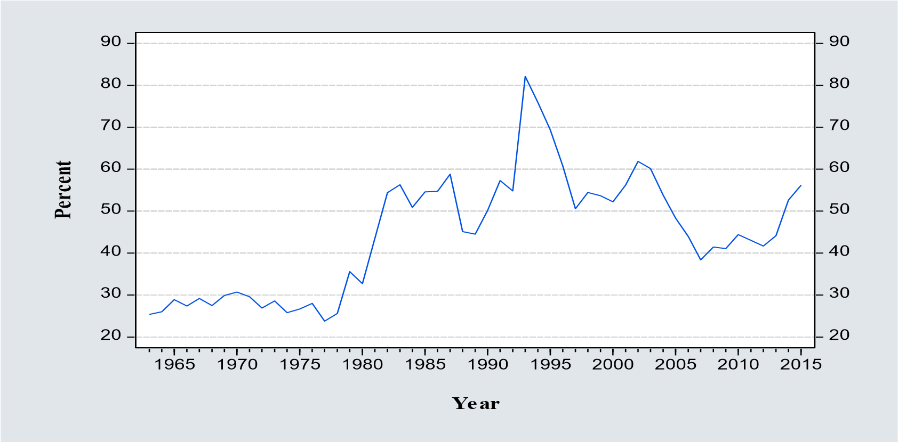

Figure 1: Trends in Kenya’s debt to GDP ratio
The mean debt to GDP ratio between 1963 and 2015 was 44.5 percent with the maximum debt ratio of 82.1 percent recorded in 1993 and the lowest debt ratio of 23.8 percent recorded in 1977. Domestic and external debt as a ratio of total debt averaged 36.4 and 63.6 percent between 1963 and 2015 while as a ratio of GDP, they averaged 15.8 and 28.7 percent respectively. In 1993, the country recorded the highest debt levels of 82.1 percent which was attributed to the economic uncertainty due to the 1992 and 2002 multiparty elections, the Goldenberg scandal and suspension of foreign aid leading to foreign exchange crisis and the rapid depreciation of Kenya Shilling against the major currencies resulting to an increase in nominal debt (Republic of Kenya, 1993).The implementation of Economic Recovery Strategy (ERS) for wealth creation between 2003 and 2007 resulted to improved debt position due to stable macroeconomic environment following low levels of inflation, limited public sector deficits, stable exchange rate and low interest rates (Republic of Kenya, 2008). During this period, the debt to GDP ratio averaged 49 percent of GDP with domestic and external debt averaging 21.3 percent and 27.7 percent of GDP respectively.
Since independence, external debt has constituted the largest proportion of public debt but from 1994, the proportion of domestic debt started to increase until 2013 when the domestic debt was 55.5 percent of total debt. From 2009, the period the government started preparing Medium Term Debt Management Strategies, to 2015, domestic and external debt averaged 52 and 48 percent respectively, which was in line with the MTMDS of 2010 recommendation of shifting the composition of debt towards long term domestic debt. The aim was to minimize both the cost and refinancing risks by lengthening the maturity profile of the domestic debt portfolio and minimize the degree of foreign exchange rate risk exposure associated with the external debt portfolio (Republic of Kenya, 2010).
1.1.3 Government Policies on Prudent Macroeconomic and Public Debt Management Kenya has developed various policies aimed at ensuring prudent macroeconomic and public debt management. Sessional Paper No. 10 of 1965 (Republic of Kenya,1965) had the objectives of ensuring rapid growth in trade, easing balance of payment pressure, increasing domestic control of the economy, sustained per capita income growth, protection of foreign exchange reserves and import substitution strategies. As a result of implementation of the strategy, the GDP grew by 6.2 percent between 1963 and 1973, the Central Bank of Kenya was established in 1966 and the issue of the Kenya shilling (Rono, 2002). Sessional Paper No. 1 of 1986 (Republic of Kenya, 1986) aimed to address economic stagnation by promoting the private sector investment, managing high budget deficits and correcting restrictive foreign trade policies. When the import substitution strategy failed, the government began embracing trade reforms under Structural Adjustment Programmes (SAPs) which advocated for a shift from import substitution to export promotion strategy and conversion of quantitative restrictions to tariffs equivalent (Were, Sichei & Milner, 2009). A number of export incentive and promotion programmes were initiated to encourage exports such as Manufacturing under Bond (MUB) of 1988, Export Processing Zones (EPZ) in 1990 and the revival of the Kenya Export Trade Authority programmes to ease the shortages in foreign exchange because the traditional exports could not be relied upon to provide substantial quantities of foreign exchange (Rono, 2002).
Poverty Reduction Strategy Paper (PRSP) (Republic of Kenya, 2001) aimed at reducing the level of public expenditure and debt levels. It developed a debt sustainability plan focusing on maintaining budget surpluses or minimal deficits to ensure debt to GDP ratio declines significantly, reducing reliance on treasury bills as a budget financing instrument, developing long term financing instruments, reversing the net out-flows reflected in the external debt repayments and restricting the Government to concessional external borrowing in order to reduce overall interest (Republic of Kenya, 2001). Economic Recovery Strategy (ERS) for Wealth and Employment creation (2003-2007) aimed at restoring the economic growth by ensuring stable macroeconomic environment. Key ERS targets were to increase GDP growth to seven (7) percent, maintain annual inflation rate below five (5) percent, maintain an average fiscal deficit of 3.2 percent of GDP and maintain current account deficit to an average of 6.2 percent of GDP (Republic of Kenya, 2003). The economy grew by an average of 5.4 percent, inflation levels averaged 8.4 percent, fiscal deficit to GDP ratio averaged 2.2 percent while the current account deficit averaged 1.8 percent of GDP.
Kenya Vision 2030 aims to transform the country to a newly industrializing middle-income country providing a high quality of life by 2030. The vision recognizes that maintaining macroeconomic stability to attain a 10 percent economic growth will be a challenge but the government will pursue a macroeconomic framework that will facilitate low and stable inflation and interest rates, sustainable public-sector debt position and a competitive real exchange rate to support an export-led economic growth (Republic of Kenya, 2007). The Vision is being implemented through 5-year Medium Term Plans (MTP). The first MTP from 2008 to 2012 (Republic of Kenya, 2008) aimed at realizing a higher and sustainable economic growth with a target of increasing GDP growth to 10 percent, reducing public debt to 40.6 percent of GDP by 2012/13 FY. The actual GDP growth averaged 3.8 percent while debt to GDP ratio was 44.2 percent in 2013 FY (Republic of Kenya, 2013). The reasons for missing the targets were attributed to the post-election violence of 2007/2008, drought, global financial and economic crisis and rising commodity prices. These shocks had a negative impact by reducing inflow of remittances, lowering demand for exports of horticulture and reduced tourism earnings (Republic of Kenya, 2013).
To ensure prudent management of public debt, the government has been preparing three-year Medium Term Debt Management Strategy (MTDMS) whose objective is to meet the government’s financing requirements at the least cost, facilitate government’s access to financial markets, support development of a well-functioning vibrant domestic debt market, seek new funding sources, support macroeconomic stability and achieve debt sustainability (Republic of Kenya, 2015). The MTDMS have recommended a shift in the composition of debt portfolio towards long term domestic debt over the medium term, prioritizing external financing on concessional terms to reduce exchange rate exposure, maintain a diversified source of financiers, prudent management of the debt amortization profile to absorb fiscal shocks, provision of a limited window for borrowing on commercial terms to minimize costs and refinancing risks and the need to develop the domestic debt markets with 55 percent of total debt being through domestic borrowing while 45 percent being from external borrowing. Public Financial Management Act (2012) established public debt management office in order to minimize the cost of public debt management and borrowing, promote development of market institutions for government debt securities, ensure the sharing of the benefits and costs of public debt between the current and future generations, prepare and update the mediumterm debt management strategies, prepare and implement the national government borrowing plan, processing the issuance of loan guarantees and monitoring and evaluating all borrowing and debt-related transactions to ensure that they are within the guidelines and risk parameters of the debt management strategy (Republic of Kenya, 2012).

1.2 Statement of the Problem
Kenya’s macroeconomic environment is highly uncertain and depicts an increasing fiscal pressure resulting from the implementation of government programmes especially devolution and growing current account deficit. The economic growth remains vulnerable to external shocks especially developments in the global economy, regional stability, security and weather-related supply shocks (KIPPRA, 2013). Movements in these macroeconomic variables are sometimes correlated which magnifies the uncertainty associated with a given pattern of shocks making it difficult to predict the future. For instance, a shock in the terms of trade will have a negative effect on GDP growth, the exchange rate and raise the risk premium on interest rates leading to an explosion in public debt (Ferrucci & Penalver 2003).
Debt stabilization is an indicator of the effectiveness of the policies implemented by government, improves investor confidence and reduces the risk of speculative attacks against the country’s stock of debt and the perception by investors which can trigger debt crisis
(Sardoni, 2013). Kenya’s debt to GDP ratio rose from 25.4 to 56.2 percent between 1963 and 2015 against a target of 41.4 percent in 2015. The continued build-up of public debt coupled with the volatile macroeconomic environment will have serious implications in achievement of various national targets such as GDP growth of 10.6 percent and reducing debt to GDP ratio to 39.2 percent by 2017 (Republic of Kenya, 2013). Debt stabilization depends on macroeconomic performance but with unstable macroeconomic environment, it is difficult to stabilize the debt ratios, predict the future debt levels with certainty and difficult for the government to prepare policies that will stabilize the debt levels. The debt sustainability assessment by International Monetary Fund and the World Bank focuses on the deterministic simulation of public debt path with less focus given to debt stabilization strategies and stochastic debt simulation, therefore the objective of this paper is to estimate the levels of GDP growth rate that the government should target in order to stabilize debt levels and carry out a stochastic debt simulation to determine the future path and distribution of debt in Kenya.

2.0 SELECTED EMPIRICAL LITERATURE REVIEW
Celasun, Debrun and Ostry (2006) proposed a probabilistic simulation algorithm for the public debt path using fan charts using data from 34 emerging market economies between 1990 and 2004. The algorithm consisted of a joint distribution of shocks estimated by a VAR model describing co movements among the determinants of debt dynamics (GDP growth, interest rates and exchange rates); estimating fiscal reaction function to determine fiscal behavior and simulation of annual public debt paths. The results show that the fiscal reaction functions in five countries (Argentina, Brazil, Mexico, South Africa and Turkey) responded sufficiently to the public debt implying a sustainable debt path but the response was proved to be too weak to prevent growing debt ratios. The risk profiles for different countries reflected the volatility of their economies with less volatile economies such as South Africa reflecting narrower confidence intervals than others while wide confidence intervals reflected past crises.
Nandelenga (2010) carried out a study to analyze sustainability of Kenya’s debt and determine the optimal debt levels which are necessary to achieve the desired 10 percent GDP growth rate as envisioned in the Vision 2030. The study used monthly time series data on government expenditure, revenue, public debt and interest on public debt from 1985 to 2008 applying co integration testing of the present value budget constraint to empirically analyze the sustainability of the historical fiscal process at the same time carrying out simulation to determine the optimal debt that could lead to the achievement of 10 percent GDP. The study found that Kenya’s public debt has been sustainable and that the debt to GDP ratio of 35.2 percent is optimal to achieve the desired 10 percent GDP growth and recommended for a prudent public sector policy.
Cherif and Hasanov (2012) examined the effects of macroeconomic shocks on the United States of America public debt dynamics using quarterly time series data from 1980 to 2007 focusing on the effects of austerity, inflation and growth shocks on reducing public debt using a modified Vector Auto Regression (VAR) framework with debt feedback which was estimated using Ordinary Least Squares (OLS). The results showed that in the medium term, an austerity shock reduces the debt ratio on average but there is a large uncertainty about the projected debt impulse response, especially in a weak economic environment. An exogenous primary surplus shock of 1 percent of GDP leads to a fall in the debt to GDP ratio by about 4.5 percent of GDP in about 3 years. An inflation shock leads to an increase in debt ratio after only a few quarters, whereas a positive growth shock lowers the stock of debt substantially.
Saxegaard (2014), carried a study to estimate the optimal public debt levels that would allow countries to remain below sustainable debt limit, taking into account the impact of various shocks to the economy by combining the existing methods for estimating debt ceilings and stochastic debt simulation to estimate the gap between the sustainable debt ceiling and the safe level of debt that fiscal policy should target. A three (3) variable VAR model was simulated to create a stochastic projection of debt using South African quarterly data from 1983 to 2012. The study estimated South African debt ceiling to be around 60 percent of GDP but with very high uncertainty and concluded that the government should target to reduce the debt-to GDP ratio to 40 percent to allow space for the economy to absorb any shocks at the same time increase potential GDP growth to 3.75 percent, which would be sufficient to achieve fiscal consolidation and maintain debt to GDP ratio below the 60 percent debt ceiling until 2020.
Mupunga and Roux (2015) assessed the sustainability of public debt management policies in Zimbabwe using a dynamic stochastic simulation method to simulate public debt path with time series data from 1980 to 2012. The median debt projections showed a declining path of Zimbabwe’s public debt indicating that the public debt will be within the recommended thresholds and can be deemed to be sustainable over the medium to long term. In its analysis, the study noted the high dependence of Zimbabwe on primary commodities and the exposure to terms of trade shocks which negatively affects the country’s current account.
Chitiga, Mabugu and Maisonnave (2015) carried out a study to examine different policy simulations with an aim of analyzing the appropriate public debt management in South Africa, assessing the debt paths that are sustainable over time, assessing the impact of the movement in debt and alternative policy responses in the economy and computing thresholds beyond which debt can be considered to be detrimental to the economy. The study found out that a shock in real growth of GDP led to high unemployment, a decrease in the volume of investment, decrease in government revenues and decrease in government savings which increases the level of domestic debt and reduces the level of private investment.

3.0 METHODOLOGY
The study adopted Domar (1944) model under the Keynesian theory of public debt which advocates for governments to run budget deficits and that there is no need for the debt to
GDP ratio to grow indefinitely. From the inter temporal budget constraint
(1)

is outstanding debt in period t, is government expenditure in period t, is government tax revenue in period t, i is the nominal interest rate on government debt. Given fiscal balance is the difference between tax revenues and government expenditures, (), where
=
(2)
is the fiscal balance in period t, then:

Dividing equation 2 by the nominal GDP (), to express the variables as ratios of GDP and by and rearranging:

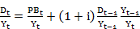 (3)
Using lower case to denote ratios to GDP:
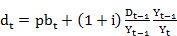
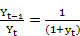
(4)

then

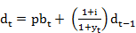 (5)
The variables in equation 5 were deflated by the inflation rate to get real values as expressed in equation 6.
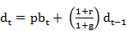 (6)

Where r represents real interest rates while g is real rate of GDP growth. Equation 6 represents the equation of motion of debt accumulation and it shows that the growth of debt depends on the fiscal balance to GDP ratio, real interest rates, the GDP growth rate and previous debt levels. A stable debt implies that the debt reduces or remains constant over time, that is, . Subtracting on both sides of equation 6 to get the expression of change in debt ratio:
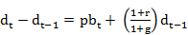
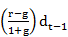
(7)
-
∆
=
+

(8)
Equation 8 gives the Domar stability condition which implies that debt to GDP ratio will be stable if the rate of GDP growth is greater than interest rates on debt. According to Horska
(2011), 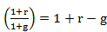 and that for a stable debt therefore equation
=
∆
8 can also be expressed as:
(9)

(10)
To estimate the optimal level of GDP growth rate necessary to stabilize debt levels in the country in time t with respect to real interest rates, fiscal balance to GDP ratio and debt to GDP ratio, this paper modified equation 10 and estimated equation 11

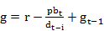 (11)

Where g is the real GDP growth, r is the real interest rates, pb is fiscal balance to GDP ratio and d is debt to GDP ratio. To capture the effects of exchange rate in debt accumulation, equation 6 was modified to differentiate between the share of public debt in domestic and foreign currency where the real exchange rate affects the debt to GDP ratio through the foreign currency denominated debt.

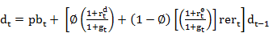 (12)

Where is the share of the total public debt denominated in domestic currency (Domestic debt), 1- is the share of total public debt denominated in foreign currency (external debt), is the real exchange rate (KES/USD), is the real interest rates on domestic debt (real interest rates), is the real interest rates on external debt and .
Equation 12 represents the modified equation of motion of debt accumulation and it is the equation which was used to simulate the future path and distribution of the debt levels in Kenya. Celasun et al. (2006) carried out a simulation of debt paths for emerging countries by combining an estimated fiscal policy reaction function and country specific VAR models with non-fiscal determinants of debt dynamics expressed as:
(13)

Where , and denotes real interest rates on foreign debt, r_{t},
denotes the real interest rate on domestic debt, the real GDP growth (g), the real exchange rates (rer) while is a vector of a well behaved error term. The aim was to generate forecasts of Y and variance co-variance matrix of shocks to the determinants of public debt dynamic. To simulate the future path and distribution of public debt in Kenya, the paper adopted and modified the Favero and Giavazzi (2007) VAR model specified in matrix notation as

(14)

Where is an nx1 matrix, that is 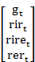 and represents the non-fiscal determinants of

public debt that enter the modified equation of motion of debt accumulation (12), A_{i,} and β_{k} represents matrix of coefficients, p and k is the number of lags to be used and ~ N (0,Ώ) is a vector of well-behaved error term which is normally distributed, has a mean of zero (0), constant variance and variance -covariance matrix of residuals Ώ. To forecast the endogenous variable (debt to GDP ratio) in the modified equation of motion of debt from 2016 to 2030, a forecast of the values of the exogenous variables in the model was necessary. After estimating the VAR model in equation 3.5, a simulation process followed to forecast the future values of the real GDP growth rate, real interest rates, real interest rate on external debt and real exchange rates.
The stochastic debt to GDP ratio simulation process followed two steps. Extraction of the variance - covariance structure of shocks to the non-fiscal determinants of debt which involved generating random shocks to each of the non-fiscal determinants of public debt (Y_{t}) entering the modified equation of motion of debt accumulation for each projection year using historical annual data from 1963-2015 and applying Monte Carlo simulation that combined the extracted shocks with the modified equation of motion of debt accumulation and repeated 10,000 times over the forecast period 2017, 2018, 2019…… 2030 which separately simulated paths for each of the determinants of debt which are needed for the construction of the fan chart. The simulated values of these variables were then used to estimate and forecast the debt to GDP ratio using the modified equation of motion of debt from 2016 to 2030.

3.1 Definition and Measurement of Variables
Debt to GDP ratio (d): The rate of a country’s indebtedness which compares the country’s outstanding public debt and her GDP in each year.
Real GDP growth rate (g): The rate of change of a country’s Gross Domestic Product (GDP) from one year to another after adjusting for inflation.
Real Interest Rates (RIR): Interest rates adjusted for the effects of inflation to reflect the real cost of funds and measured as the difference between nominal interest rates on funds borrowed domestically and the annual average inflation rate.
Real exchange rate (RER): Nominal exchange rates adjusted for differences in price levels between two countries and measured as a product of the nominal exchange rate (Kenya Shilling against the US dollar) and the ratio of the consumer price index, with year 2010 taken as the base year in both countries.
Real Interest Rates on External debt (RIRE): Interest rates charged on external loans adjusted for the effects of inflation to reflect the real cost of funds and measured as the difference between the nominal interest rates charged on the loans borrowed externally and annual average inflation rate.

3.2 Data type and source
Annual time series data from 1963 to 2015 was used for analysis. The data consisted of annual observations of current account balance to GDP ratio, fiscal balance to GDP ratio, public debt to GDP ratio, output gap, real GDP growth and real interest rates. The data was obtained from Statistical abstracts, Economic surveys published by Kenya National Bureau of Statistics, Central Bank of Kenya, Annual debt reports published by the National Treasury’s, Kenya Institute of Public Policy Research and Analysis (KIPPRA) reports, International Monetary Fund financial statistics, African Development Bank and World Bank’s African Databases.

3.3 Estimation technique and time series properties of data
The time series data used in this paper was subjected to various diagnostic tests to test for stationarity, cointegration, autocorrelation, heteroscedasticity and normality. Equation 11 was estimated using OLS method while VAR approach was used to model equation 13 because there are insufficient macroeconomic theories linking the variables used in the equation. In order to get the forecast of the dependent variables from 2016 to 2030, it was necessary to provide the values of the independent variables for this period using Auto Regressive Moving Average (ARIMA) approach to make predictions of the values of each of these independent variables. Kwiatkowski–Phillips–Schmidt–Shin (KPSS) method was used to test for stationarity instead of Augmented Dickey-Fuller (ADF) method because the ADF test has very low power against I (0) alternatives that are close to being I (1). The unit root tests established that the variables were of different order of integration and used the Auto Regressive Distributed Lag (ARDL) bound test procedure to test for the presence of short and long run relationships among the variables. Pesaran and Shin (1999) approach for bound test was used. It uses Wald or F-statistic to test for the joint significance of lagged variables in an unrestricted Error Correction (ECM) regression. If the computed Wald or F-statistic falls below the Pesaran critical lower bound value, there is no long-run relationship (no cointegration) but if it falls above the Pesaran critical upper bound value, then there is no long-run relationship (there is cointegration). However, when the computed F-statistic falls between the lower and upper bound, then the results were inconclusive and knowledge of the order of integration of the variables will be needed before conclusive inferences are made.
4.0 STUDY RESULTS
4.1 Descriptive Statistics

Table 1: Summary descriptive statistics Variables Real Debt to GDP Real Real Real Fiscal GDP exchange interest interest rate balance to growth rate rate on external GDP (%)

 |  |  |  |  | debt
Mean | 4.5 | 44.5 | 24.9 | -0.2 | -6.8 | -4.7
Median | 4.6 | 44.4 | 2.8 | 0.1 | -4.8 | -4.8
Maximum | 9.5 | 82.1 | 135.7 | 17.4 | 4.0 | 1.8
Minimum | 0.2 | 23.8 | 0.4 | -15.3 | -43.7 | -11.2
Std. Dev | 2.5 | 14.2 | 35.3 | 7.1 | 8.6 | 2.9
Observations | 53 | 53 | 53 | 53 | 53 | 53

Source: Authors’ calculations (2018)
Table 1 shows that the average real GDP growth was 4.5 percent between 1963 and 2015 with the highest and lowest growth being 9.5 percent and 0.2 percent recorded in 1977 and 2008 respectively. A standard deviation of 2.5 indicates low variations from the mean of 4.5. The mean debt to GDP ratio was 44.5 percent with the maximum debt ratio of 82.1 percent recorded in 1993 and the lowest debt ratio of 23.8 percent which recorded in 1977. The standard deviation of 14.2 shows a very high variation from the mean value of debt ratio. The high debt ratio can be attributed to the depreciation of the local currency and the high inflation rates during the period. The mean real exchange rate was 24.9 with a maximum of 135.7, a minimum of 0.4 and a standard deviation of 35.3. The mean value for the real interest rates was -0.2 percent with minimum and maximum values of -15.3 and 17.4 percent respectively. The standard deviation of 3.9 shows low variation from the mean value. High real interest rates may crowd out private sector activities which will have an impact in the economic activity and accumulation of domestic component of the public debt in the economy. The average real interest rate on external borrowing was – 6.8 percent and ranged between -43.7 and 4 percent in 1993 and 1969 respectively with a high standard deviation from the mean of 8.6 percent. Real interest rates on external debt was used to capture the real cost of funds sourced externally. The low real interest rates on external debt recorded in 1993 was as a result of high inflation rate recorded in 1993 which was attributed to excessive money supply, low aggregate demand, depreciation of the Kenyan shilling with a low investor confidence due to uncertainties surrounding transition to multi party politics in 1992.
4.2 Study Results
4.2.1: Time series properties
The results of the KPSS test are shown in tables 2 and 3.

Table 2: KPSS Unit root test results at level
Variable | Form of test | t- statistic | CV at 5 % | Conclusion
Debt to GDP ratio (d) | Intercept | 0.5170 | 0.4630 | Non-stationary
 | Trend & Intercept | 0.1836 | 0.1460
Real GDP Growth (g) | Intercept | 0.2642 | 0.4630 | Non-
 | Trend & Intercept | 0.1588 | 0.1460 | Stationary
Real interest rates on external debt (RIRE) | Intercept  Trend & Intercept | 0.0631  0.1011 | 0.4630  0.1460 | Stationary
Real Exchange Rates (RER) | Intercept | 0.8194 | 0.4630 | Non-stationary
 | Trend & Intercept | 0.1764 | 0.1460
Real Interest Rates (RIR) | Intercept | 0.3292 | 0.4630 | Stationary
 | Trend &Intercept | 0.0904 | 0.1460
Fiscal Balance to GDP ratio (pb) | Intercept  Trend & Intercept | 0.2350  0.1309 | 0.4630  0.1460 | Stationary

Source: Authors’ calculations (2018)
Table 2 shows that real interest rates on external debt, real interest rates and fiscal balance to GDP ratio were stationary at levels at 5 percent significant level but debt to GDP ratio, real GDP growth rate and real exchange rates were non-stationary at levels.

Table 3: KPSS Unit root test results at first difference Variable Form of test t- statistic CV at 5 % Conclusion
Debt to GDP (d) | Intercept | 0.0715 | 0.4630 | Stationary
 | Trend &Intercept | 0.0531 | 0.1460
Real Exchange Rates (RER) | Intercept | 0.1611 | 0.4630 | Stationary
 | Trend &Intercept | 0.1074 | 0.1460
Real GDP Growth (g) | Intercept | 0.1495 | 0.4630 | Stationary
 | Trend & Intercept | 0.1048 | 0.1460

Source: Authors’ calculations (2018)

Table 3 shows that the non-stationary variables at levels became stationary after first difference.
The paper carried out diagnostic tests, before establishing the short and long run relationships, with an aim of establishing if the ARDL model is statistically significant. The estimation results are presented in Table 4.

Table 4: ARDL General model
Dependent Variable: Real GDP growth rate
Included observations: 51 after adjustments
Dynamic regressors (4 lags, automatic): DEBT PB RER RIR RIRE
Selected Model: ARDL (2,1,0,0,2,0)
Variable | Coefficient | Std. Error | t-Statistic | Prob.*
First lag of real GDP growth | 0.342368 | 0.144334 | 2.372047 | 0.0226
Second lag of real GDP growth | -0.172202 | 0.144847 | -1.188858 | 0.2415
Debt to GDP ratio | -0.101602 | 0.062680 | -2.620969 | 0.0729
First lag of debt to GDP ratio | 0.059132 | 0.051860 | 1.140227 | 0.2610
Fiscal balance to GDP ratio | 0.066458 | 0.133481 | 2.497885 | 0.0621
Real Exchange Rate | 0.006839 | 0.008231 | 0.830952 | 0.4109
Real Interest rate | 0.057859 | 0.071278 | 2.811741 | 0.0427
First lag of Real Interest rate | -0.051203 | 0.056124 | -0.912326 | 0.3671
Second lag of Real Interest rate | -0.091823 | 0.051059 | -1.798372 | 0.0797
Real Interest rate on external debt 0.086882 |  | 0.054258 | 1.601275 | 0.1172
C | 6.397686 | 12.251743 | 2.841215 | 0.0070
R-squared | 0.610617 | Mean dependent var |  | 4.450980
Adjusted R-squared | 0.541401 | Akaike Info Criterion |  | 4.383128
F-statistic | 4.014427 | Schwarz Criterion |  | 4.799796
Prob(F-statistic) | 0.000749 | Durbin-Watson stat |  | 1.798204

Source: Authors’ calculations (2018)
The model used Akaike's Information Criterion automatic lag selection criteria and estimated a model with optimal lags 2,1,0,0,2,0. The fitted model had a R-squared and Adjusted Rsquared of 61 per cent and 54 per cent respectively. The estimated F statistic of model is 4.014427 with a probability of 0.000749 implying the joint significance of all independent variables in the model.
The Breusch-Godfrey correlation LM and heteroscedasticity test tested null hypothesis of no residual serial correlation and no heteroscedasticity with the residuals being normally distributed as shown in Table 5.

Table 5: Summary of tests on ARDL model
Test |  | Statistic | Result
Residual Normality |  | JB statistic 1.799  P value 0.407 | Accept null hypothesis: residuals are normally distributed
Breusch-Godfrey correlation LM | serial | Obs* R squared 4.242  P value 0.1199 | Accept null hypothesis that there is no serial correlation
Breusch-Pagan-Godfrey heteroscedasticity |  | Obs* R squared  11.948  P value 0.2885 | Accept null hypothesis that there is no heteroscedasticity

Source: Authors’ calculations (2018)
The bound test resulted to an F statistic value of 5.3037 which is greater than the upper bound value of 4.15 at one per cent significance level as shown in table 6. Table 6: ARDL Bound test

Sample: 1965 2015
Null Hypothesis: No long-run relationships exist
Test Statistic Value k
F-statistic 5.3037 5

Critical Value Bounds

Significance I(0) Bound I(1) Bound
10% | 2.08 | 3.38
5% | 2.39 | 3.73
2.5% | 2.70 | 3.73
1% | 3.06 | 4.15

Source: Authors’ calculations (2018)
The paper concluded that there exists a long run relationship among the variables therefore using ARDL to establish the short run effects and interpret the speed of adjustments as per the coefficient of the Error Correction Term (ECT). The result of ARDL cointegrating and long run form is shown in Table 7. The coefficients in the model shows short run and long relationship while ECT coefficient represents the speed of adjustment towards equilibrium and it shows the amount of disequilibrium in the model that is corrected in each year. The results of estimating the short run model gives short run marginal effects among the variables, that is, the short run changes in the dependent variable due to changes in the previous in independent variables.

Table 7: ARDL Cointegrating Short and Long Run Form
Short-run effects on Real GDP growth rate
Dependent Variable |  | Real GDP growth rate
Regressors |  | Coefficients |  | t-Statistic |  | P value
Δ Real Interest Rate |  | 0.079696 |  | 1.311488 |  | 0.1968
Δ Real Interest Rate lagged once |  | -0.106642** |  | 2.025187 |  | 0.0492
Δ Debt to GDP ratio |  | -0.094050* |  | -1.790554 |  | 0.0806
Δ Real Interest Rates on External Debt |  | -0.093666*** |  | 2.153372 |  | 0.0371
Δ Fiscal Balance to GDP ratio |  | -0.066458 |  | 0.497885 |  | 0.6213
Δ Real Exchange Rate |  | 0.004121 |  | 0.514486 |  | 0.6096
Error Correction Term (ECT)  Long-run effects on Real G |  | -0.718689  DP growth rate |  | -5.367188 |  | 0.0000
Real interest rate | -0.152467 |  | -1.314834 |  | 0.1957
Debt to GDP ratio | -0.030295* |  | 2.662401 |  | 0.0513
Real Interest Rates on External Debt | -0.130329* |  | 2.012579 |  | 0.0506
Real Exchange Rate | 0.005734 |  | 0.520436 |  | 0.6055
C | 6.781306 |  | 3.987552 |  | 0.0003

Source: Authors’ calculations (2018)
Notes: [***], [**] and * denote significant at levels 1%, 5% and 10% respectively. Δ denotes the first difference operator .
Table 7 shows that the coefficient of the first lag of real interest rate, debt to GDP ratio and real interest rate on external debt are negative and significant at five, ten and one per cent respectively. This implies that a unit increase in real interest rate, debt to GDP ratio and real interest rate on external debt led to a decrease in real GDP growth in the short run. The coefficient of ECT was -0.72 and significant at one percent level implying presence of longrun relationship among the variables and that the disequilibrium in the model was adjusted to its long-run level at a rate of 72 per cent. The coefficients of debt to GDP ratio and real interest rate on external debt are negative and significant at ten percent implying that a unit increase in debt to GDP ratio and real interest rate on external debt led to a decrease in real GDP growth in the long run.
4.2.2 The optimal GDP growth rate necessary to stabilize future debt to GDP ratio The study used ARIMA approach to carry out an out of sample forecast with an aim of estimating the values of the independent variables from 2016 to 2030. The model then used the forecasted series of the independent variables to estimate and forecast the values of GDP growth rate that will be required to stabilize debt levels in the country. Figure 2 plots the simulated path of the real GDP growth rate required to stabilize the debt levels in the country.
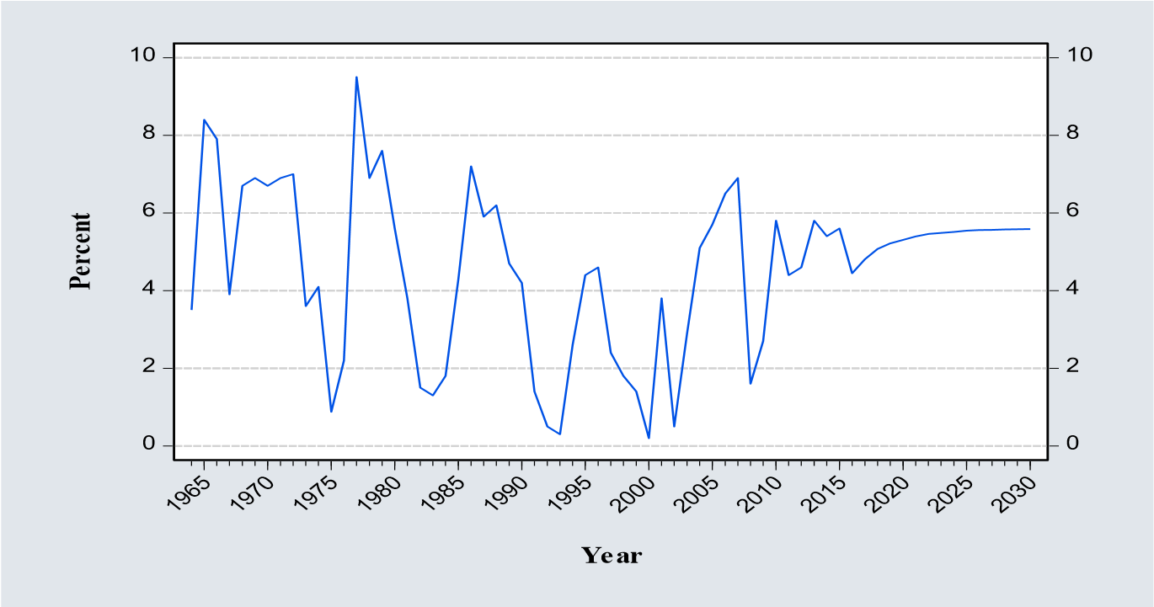

Figure 2 Forecasted real GDP growth rate to stabilize debt ratio
The results imply that the government needs to maintain an average real GDP growth rate of 5.4 percent between 2016 and 2030. This is in line with the objectives of the Vision 2030 and Medium-Term Plan which envisages attaining and maintaining economic growth of 10 percent from 2012 to 2030. The government has pursued the twin objectives of attaining higher economic growth and reducing public debt levels as it has been envisaged in its key policy documents, however, the government has not been able to achieve its own set target on economic growth and public debt. High and continuous economic growth will depend on the government’s continuous investment to create a conducive business environment to promote investments and job creation, investing in infrastructural development, lowering fiscal deficit over the medium term while at the same time providing sufficient room to finance productive expenditure to sustain equitable growth. The results conform to the findings by Saxegaard (2014) who established that an increase in potential economic growth to 3.75 percent would be sufficient to achieve fiscal consolidation and maintain debt to GDP ratio below the 60 percent debt ceiling till 2020.

4.2.3 Simulating future path and distribution of public debt in Kenya
The paper estimated a VAR model expressed in equation 14 which was followed by the Monte Carlo simulation process to forecast the future values of the determinants of public debt that enter the modified equation of motion of debt accumulation in equation 12. Various VAR diagnostic tests were carried out and summarized in Table 8.

Table 8: Summary of VAR diagnostic statistics
VAR condition check | Statistic | Result
Stability condition | Roots of polynomials are within unit cycle with highest root being 0.5574 | The VAR model is stable
Residual serial  correlation LM | LM test statistic 35.2567 P value at lag 2 is 0.1837 | Accept null hypothesis that there is no serial correlation
Residual heteroscedasticity | Joint Chi-Square = 154.4280 P value= 0.3853 | Accept null hypothesis that there is no  heteroscedasticity
Residual Normality | Jarque-Bera (Joint) statistic  224.0319  P value= 0.000 | Accept alternate hypothesis: residuals not multivariate normal

Source: Authors’ calculations (2018)
Brooks (2014) explained that if residual normality is rejected in VAR analysis, the inferences on coefficient estimates could be wrong. However, since the aim of the paper was not to interpret coefficients rather than ascertain the impact of shocks, then violation of normality therefore did not pose a major challenge. The estimated VAR model first generated a joint dynamic response for all the variables from 1963 to 2015 then over the forecast period 2016 to 2030. Stochastic simulation was later used to carry out of sample simulation for the variables over the forecast period 2016 to 2030. The simulated values of the variables were then used to simulate the future path of debt to GDP ratio by estimating and forecasting the equation of motion of debt accumulation. The simulated values showing the future path of debt to GDP ratio are shown in figure 3.
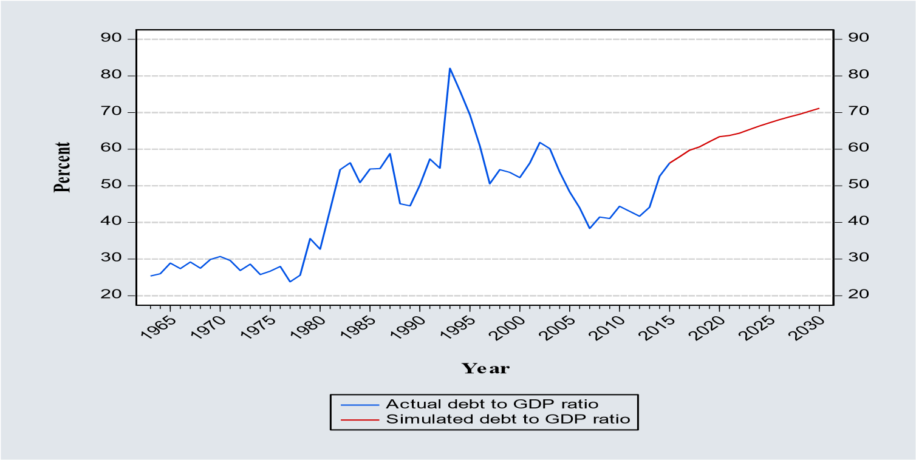

Figure 3 Simulated path of debt to GDP ratio
Figure 3 shows that the simulated debt to GDP ratio will take an upward path and reach 71.2 percent in 2030 which is very close to Kenya’s debt threshold of 74 percent according to the World Bank and IMF. This puts Kenyan economy at high risk because any shock to the economy will likely lead to the debt levels exceeding the debt ceiling which will have negative effects on the economy including investor confidence resulting to capital flight hence depressing private investment, higher risk premium and associated higher long term real interest rates which in turn discourages investments.

4.2.4 Debt fan chart
A fan chart shows the probability distribution of the forecasted debt to GDP ratio, depicting the estimates of the intervals in which the forecasted economic variable (Debt to GDP) ratio will lie.
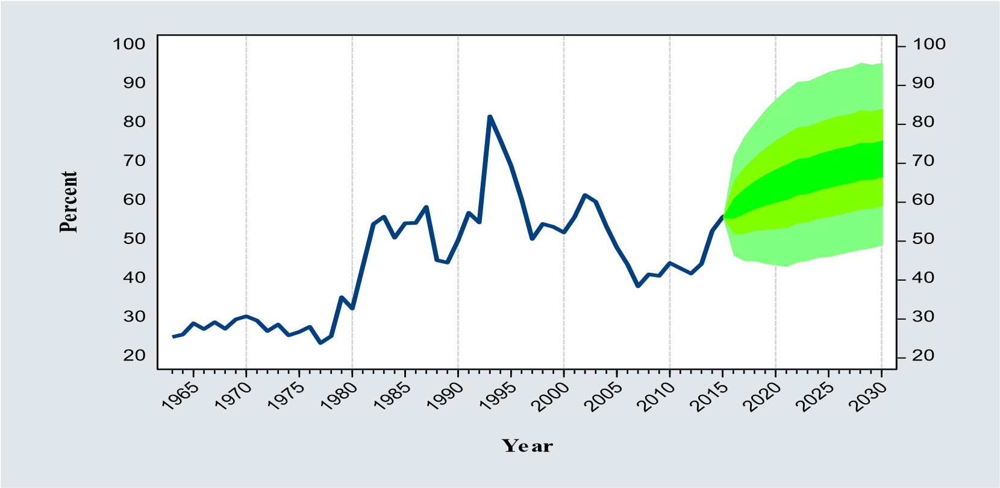

Figure 4 Debt fan chart
The chart shows that with a 30 percent probability, the debt to GDP ratio will lie between 67 percent and 76 percent and with 90 percent probability, the debt to GDP ratio will lie between 49 and 96 percent by 2030.

4.2.5 Dynamic policy simulation for debt to GDP ratio
To give policy directions, the paper considered a scenario where the government deliberately pursues a policy to increase real GDP growth rate by five (5) percent of the previous period. The paper modified the simulated values of the real GDP growth rate (g) to reflect a five (5) percent growth of the previous period from 2016 to 2030 and used the new values to simulate the equation of motion of debt accumulation. The results of the new values of debt to GDP ratio are shown in figure 5
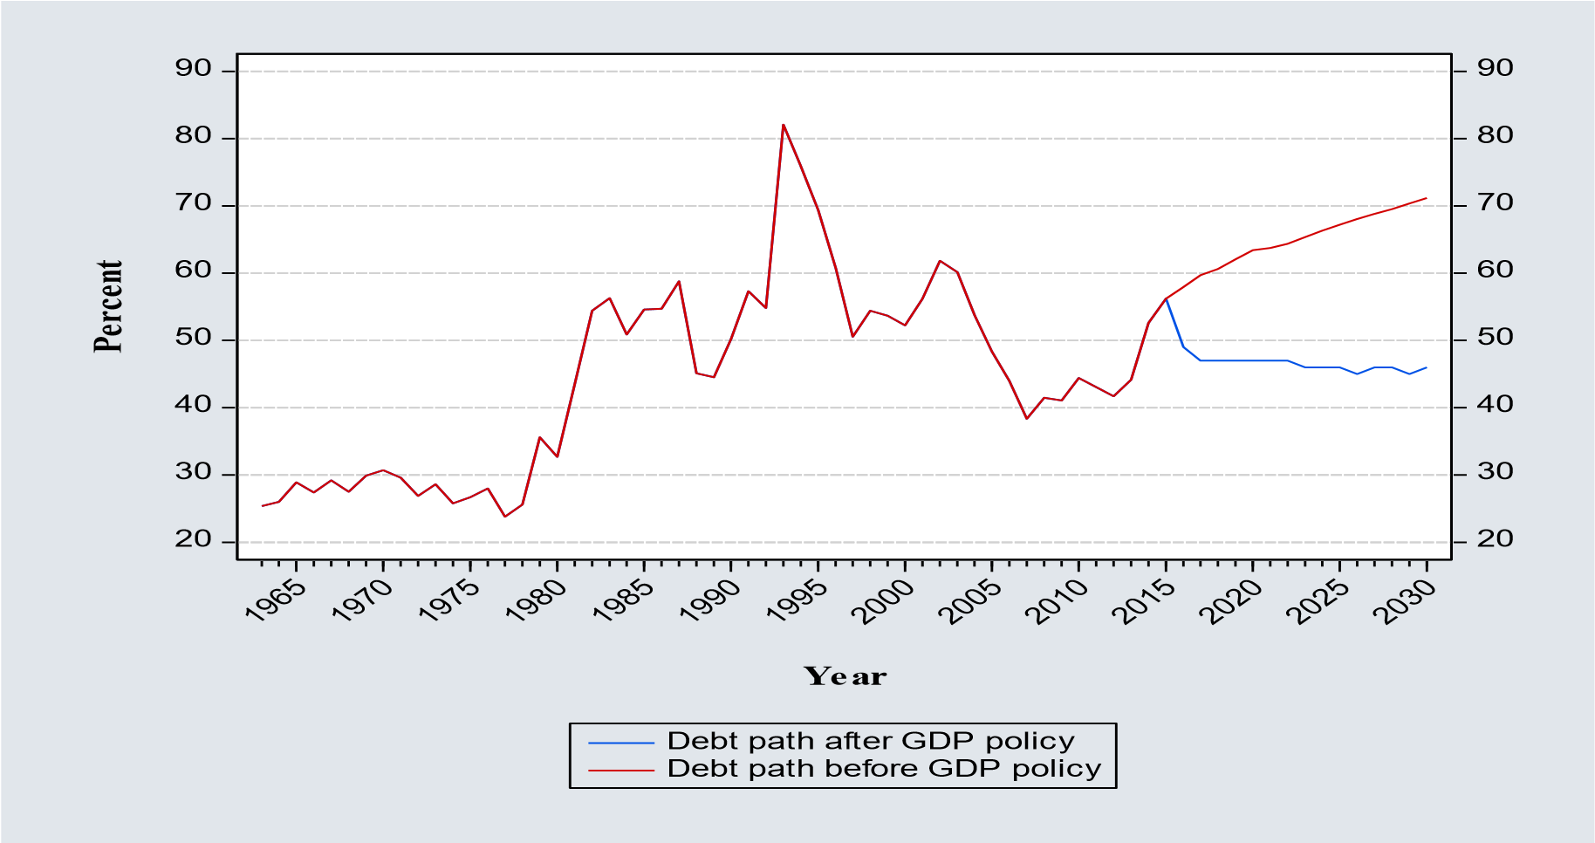

Figure 5 Simulated path of debt to GDP ratio before and after policy on GDP
Figure 5 shows that a deliberate policy to increase real GDP growth rate by five (5) percent of previous period results to a drastic reduction of debt to GDP ratio from 56 percent in 2015 to 46 percent in 2030 compared to the increase in debt from 56 percent in 2015 to 71 percent in 2030 without the GDP policy. Therefore, if the government ensures a sustained GDP growth of just five (5) percent of the previous period starting in 2016 would sufficiently lead to the reduction of public debt to GDP ratio to below 50 percent of GDP which can be termed as a safe and sustainable debt levels for the country.

5.0 CONCLUSIONS
Kenya has faced an unprecedented series of adverse shocks to her economy which has increased uncertainty about the country’s future economic prospects. Performance of the economy remains vulnerable to external shocks especially developments in the global economy, regional stability, security and weather-related supply shocks. Key macroeconomic variables such as the economic growth, inflation, interest rates and exchange rates are highly volatile and in some cases movements of these variables are correlated which magnifies the uncertainty in the economy. The paper established that the government needs to maintain an average real GDP growth rate of 5.4 percent between 2016 and 2030 in order to stabilize her debt levels. The simulation results show the debt levels increasing from 56.2 percent in 2015 to 71.2 percent in 2030 putting the economy at high risk because any shock to the economy will likely lead to the debt levels exceeding the debt ceiling which will have negative effects on the economy. The probability distribution of the simulated debt using fan chart revealed that with a 30 percent probability, the debt to GDP ratio will lie between 67 percent and 76 percent and with 90 percent probability, the debt to GDP ratio will lie between 49 and 96 percent by 2030. Further, a deliberate policy to increase real GDP growth rate by five (5) percent of previous period results to a drastic reduction in debt to GDP ratio from 56 percent in 2015 to 46 percent in 2030 implying that a sustained GDP growth of just five (5) percent of the previous period would sufficiently lead to the reduction of public debt to GDP ratio to below 50 percent of GDP which can be termed as a safe and sustainable debt levels for the country.
There is for National Treasury should strike a balance between achieving rapid economic growth through infrastructural development and its objective of ensuring public debt sustainability which can be achieved by exploring other innovative financing mechanisms for the desired infrastructural projects and other public investment such as Build Operate and Transfer approach of Public Private Partnership where the government will be able to develop its infrastructure projects without having to borrow to finance them. The key innovation of this paper is the model of motion of debt which uniquely captures the contribution of domestic and external debt, when simulating the future path of public debt. During the simulation process, the model factors in the governments’ desired proportion of domestic and external debt to total debt as articulated in key policy documents, which can vary from time to time as the government priorities changes over time.

REFERENCES
Brooks, C. (2014). Introductory econometrics for finance. Cambridge university press.
Celasun, O., Debrun, X., & Ostry, J. D. (2006). Primary Surplus Behavior and Risks to Fiscal Sustainability in Emerging Market Countries: A 'Fan-Chart' Approach.
Cherif, R., & Hasanov, F. (2012). Public debt dynamics: The effects of austerity, inflation, and growth shocks.
Chitiga, M., Mabugu, R. & Maisonnave, H. (2015). Real effects of public debt on national development
Domar, E.D (1944). The burden of debt and the national income. The American Economic Review, 34 (4), 798-827.
Durevall, D., & Ndung'u, N. S. (2001). A dynamic model of inflation of Kenya, 1974-96. Journal of African Economies, 10(1), 92-125.
Favero, C., & Giavazzi, F. (2007). Debt and the effects of fiscal policy (No. w12822). National Bureau of Economic Research.
Ferrucci, G & Penalver, A (2003), ‘Assessing sovereign debt under uncertainty’, Financial Stability Review, Bank of England, 15, 151-59.
Horská, H. (2011). Fiscal Policy, Government Budget, Public Debt. Institute of World Economics.
Kenya Institute for Public Policy Research and Analysis (KIPPRA) (2013). Kenya Economic Report.
McKinnon, R.I., & Ohno, K. (1997). The Foreign Exchange Origins of Japan’s Economic
Slump and Low Interest Liquidity Trap. The World Economy
Mupunga, N., & Le Roux, P. (2015). Stochastic simulation analysis of sustainable public debt in Zimbabwe. Journal of Economics and International Finance, 7(5), 98-111.
Musyoki, D., Pokhariyal,P, & Pundo, M.(2012). Real Exchange Rate Volatility in Kenya.
Journal of Emerging Trends in Economics and Management Sciences, 3(2), 117-122.

Nandelenga, M.W (2010). Debt Sustainability and the Optimal Debt in Kenya. Unpublished Master's thesis submitted to the School of Economics, Kenyatta University.
Ndung’u, N. (2000). Monetary and Exchange Rate Policy in Kenya. African Economic Research Consortium.
Ngugi, R.W (2001): An empirical analysis of interest rate spread in Kenya: University of Nairobi. AERC Research Paper 106, African Economic Research Consortium, Nairobi May 2001
Pesaran, M.H. & Shin, Y. (1999). “An Autoregressive Distributed Lag Modelling Approach to Cointegration Analysis.” Econometrics and Economic Theory in the 20th Century: The Ragnar Frisch Centennial Symposium, Strom, S. (ed.) Cambridge University Press.
Republic of Kenya, (1965). African Socialism and its Application to Planning in Kenya: Government Printer
Republic of Kenya. (1986). Economic management for renewed growth. Nairobi, Kenya: The Government printer.
Republic of Kenya. (various issues). Economic Surveys. Nairobi, Kenya: The KNBS.
Republic of Kenya. (2001). Poverty Reduction Strategy Paper. Nairobi, Kenya: The Government printer.
Republic of Kenya. (2003). Economic Recovery Strategy for Wealth and Employment Creation, 2003-2007. Nairobi, Kenya: The Government Printer.
Republic of Kenya. (2007). The Kenya Vision 2030; A globally competitive and prosperous Kenya. Nairobi, Kenya: The Government Printer.
Republic of Kenya, (2010). Medium Term Debt Management Strategy. Nairobi, Kenya: The Government printer.
Republic of Kenya. (2012). Public Finance Management Act. Nairobi, Kenya: The Government Printer.
Republic of Kenya. (2015). Medium Term Debt Management Strategy. Nairobi, Kenya: The Government Printer.
Rono, J.K. (2002). The impact of the structural adjustment programmes on Kenyan society. Department of Sociology, Moi University. Kenya: Vol 17 No 1. Journal of Social Development in Africa.
Sardoni, C. (2013). How to deal with public debt: Ideas from Keynes, Lerner, Domar and Hicks. Sapienza University of Rome.
Saxegaard, M. (2014). Safe Debt and Uncertainty in Emerging Markets: An Application to South Africa.
Sims, C. (1980). Macroeconomics and Reality. Econometrica, 48(1), 1-48.
doi:10.2307/1912017
Were, M., Sichei, M., & Milner, C. (2009). Trade policy in Kenya. Retrieved from http://csae.or.ac.uk/conferene/2009-edia/papers/510-were.pdf.

